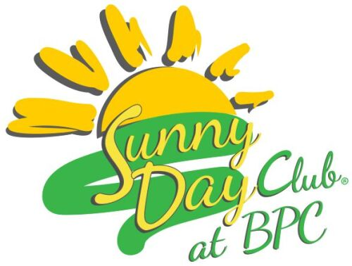

Sunny Day Club Volunteer Packet

* Sunny Day Club Volunteer Packet Table of Contents
* Sunny Day Club Volunteer Questionnaire (Fill out and return to coordinator)
* Sunny Day Club Volunteer Covid-19 Acknowledgment
* Bellevue Presbyterian Church: Auithorization and Request for Criminal Records Check (Fill out and return to coordinator)
* Safe Sanctuary Participation Covenant (Watch the video listed on the form, sign, and return to coordinator)
* Sunny Day Club Photo Release
* BPC Resource Center Patron Entry Form

**For You to Keep:**

* Responsibilities of Volunteers
* Sunny Day Club Schedule
* Sunny Day Club Brochure
* BPC Business Card