Maimin manufactures custom and semi-custom racks, storage racks and rolling racks for countless uses in manufacturing, storage and clean room applications. Racks are designed and built out of aircraft grade aluminum extrusion or painted steel weldment. Rack sizes, widths, heights and capacity are determined according to the customer needs. Below are a few examples of the design possibilities, however, virtually any storage rack solution can be offered.
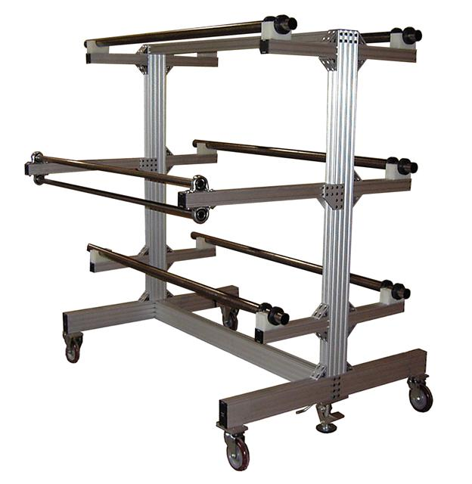
On the left is a portable roll rack system designed to hold five rolls of material. The two rollers on the front of the rack guide the material evenly onto a table. The rack arms are height adjustable to allow roll diameter changes. The casters and floor brake system create easy transport and storage. They also provide stability from movement in the direction that material is pulled from the rack.

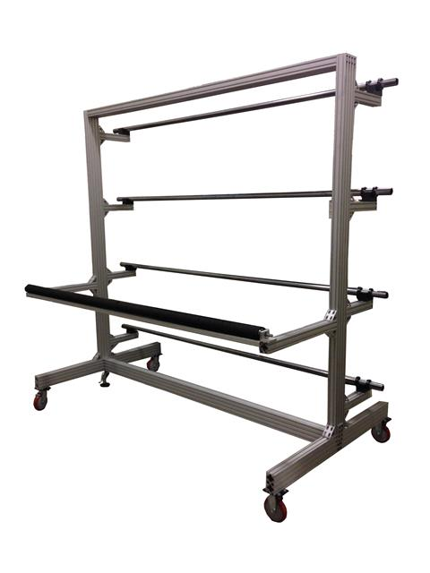
On the right is a four roll rack system with a one way adjustable pinch roller. Material is pulled through the pinch roller on to a table. The one way pinch roller will allow material to pass in the working direction, however, will not allow the material to fall back towards the rolls. It pulls one to four rolls of materials simultaneously.

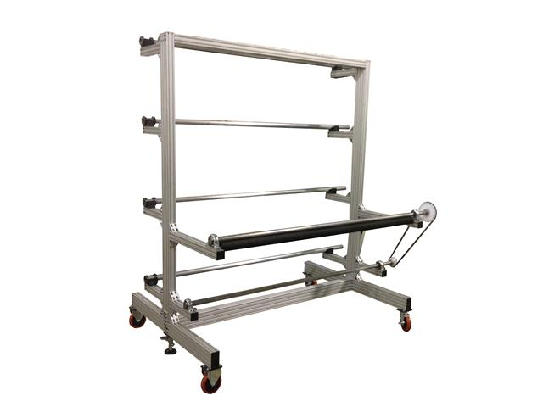
This four roll rack is designed with a dual one-way roller system that is mechanically linked to a scrap rewind bar. Rolls of material are fed through the adjustable pinch and the material is peeled away towards the scrap rewinder. This rack is often used with pre-preg, fiberglass, carbon fiber, or other types of materials.

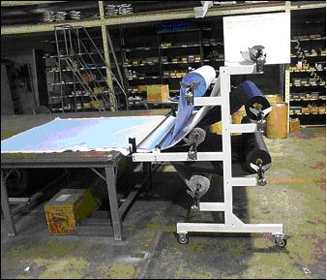
Our racks are manufactured with any number of rolls and according to the customer needs. The above rack shows a ten roll capacity and incorporates a table guide for even and accurate unwinding of the rolls.
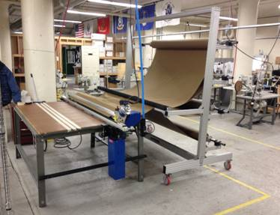
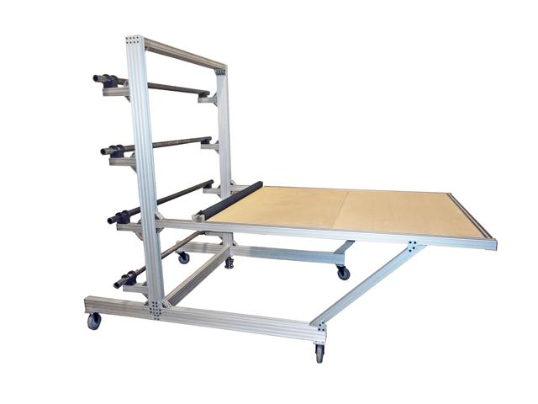
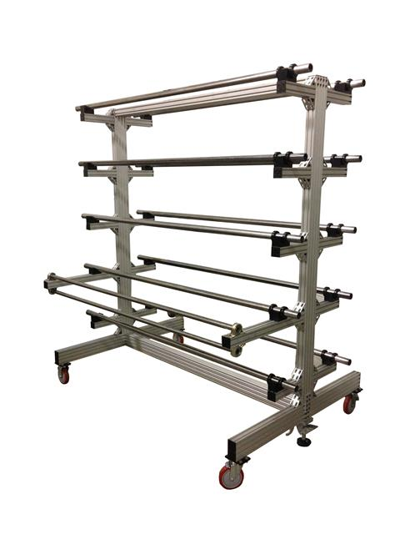
Pictured here is a four roll rack with a one-way pinch roller and integrated table. The pinch roller will allow material to be pulled onto the table, and will not allow it to "back roll" back towards the rolls or onto the floor. This rack is available without the integrated table.
This is a simple depiction of how a steel multi-tier weldment rack with table guides would look using a standard cutting table. The number of rolls, heights, options and capacities are customized to accommodate your needs.

The roll rack, end cutter system and cutting table are all available from Maimin. We will custom build your roll rack for any weight roll, core diameter, and roll diameter. Standard features include roll bars and industrial grade castors. Both designs offer high quality construction with a narrow design for ease of movement.

