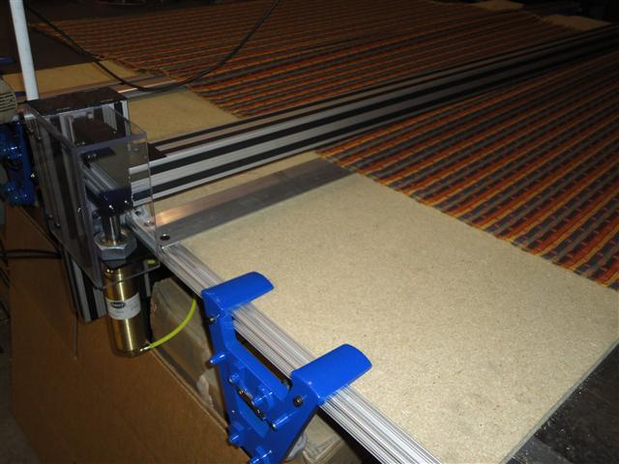
Maimin Technology has recently introduced a new end cutter clamp used to secure material in place while cutting while preventing blockage of the material after cutting. The clamp is available on all semi-automatic and fully-automatic L and M series end cutters. It is triggered automatically during the cutting process and releases manually when triggered by the operator.

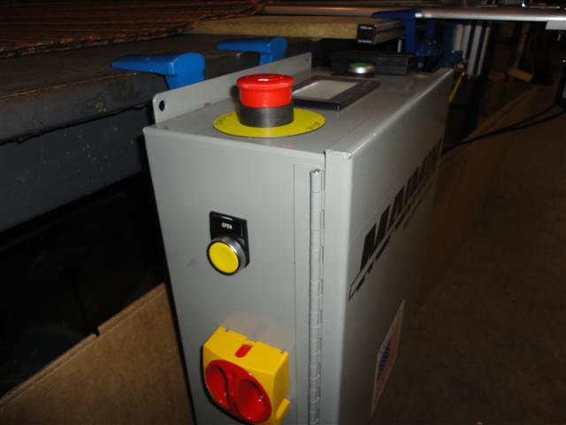
The material clamp engages when the operator presses the start button on the control box (or remote start control if installed). The clamp remains engaged until the operator presses the "open" button located on either side of the control box (pictured below).
The control box (made in the USA) features the highest quality electronics utilizing a PLC (programmable logic controller) and a touch screen operator interface. On the touch screen, the operator can program cut speed, number of plies, track production, manually turn on the machine for blade sharpening. The operator may also slow the cross-cut down to allow for cutting of thicker lays, industrial fabrics, and reduce heat on fusible materials. The new end cutter clamp is also controlled through the PLC ensuring proper operation and clamping during the spreading process.

