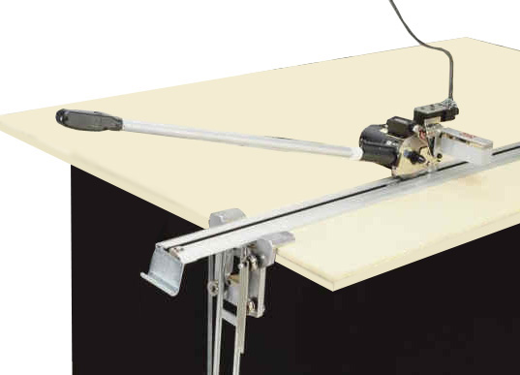
K-105 Manual End Cutter
This fast, simple, money-saving system eliminates end waste and allows one person to do the work of two. An end-rail holds the fabric, allowing the operator to quickly and accurately cut along the cutting rail at the other end of the lay. Each ply receives a right angle cut at the same length. The system is, also, adjustable to any length of lay. The long-handled cutter has a round blade and a counter cutting blade, a built-in sharpener and a ply counter.
K-205 Semi-Automatic End Cutter

Similar in function to the K-105, but the cutting operation is automated. The K-205 features an electronic ply counter, width control and blade sharpener. The K-205 is ideal for cutting natural fibers and industrial fabrics. Any width of table is available.

K-405 Fully-Automatic End Cutter
For ultimate efficiency, this end cutter offers all of the features of the K-205, plus completely automatic cut and lift functions. The operator sets the machine to cut only the exact number of plies required. He then draws the material from the roll, over the cutting track, to the end of the table (or pull). A touch of the button sends the cutting head across the track, cleanly cutting the fabric. The machine then automatically lifts and lowers, locking the newly cut fabric into place.

