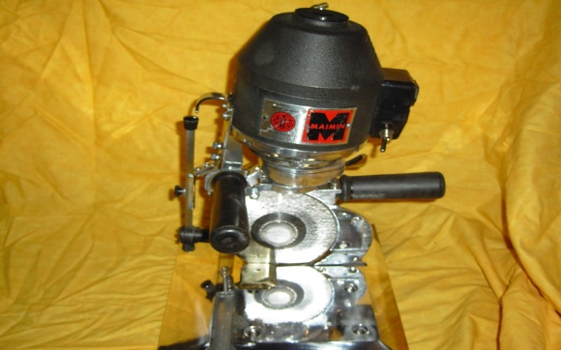

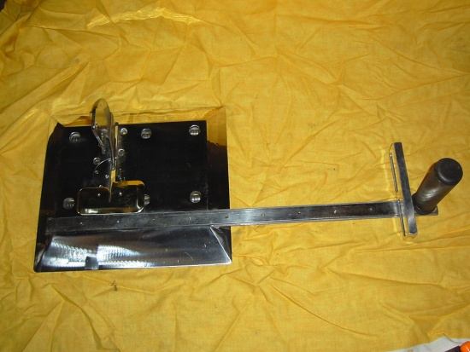
Maimin round knife cutting machines are 100% US made using today’s most advanced components and the latest manufacturing techniques. The Maimin Strip-o-matic is our newly redesigned high power slitter. It was designed to cut through the toughest of materials and can handle materials such as cured and uncured rubber, foam, urethane, neoprene, and gum rubber. It is also being used for a variety of other functions such as cutting bamboo, cardboard, fiberglass, and many Space-Age polymers.

Adjustable Guage
The custom width gauge is adjustable for any size cutting or slitting. The guage features an additional handle to help with machine guidance. The rollers are strategically placed under handle to create ease of movement. The side guide is available in custom sizes and is adjustable to be positioned towards the front or back of the baseplate.
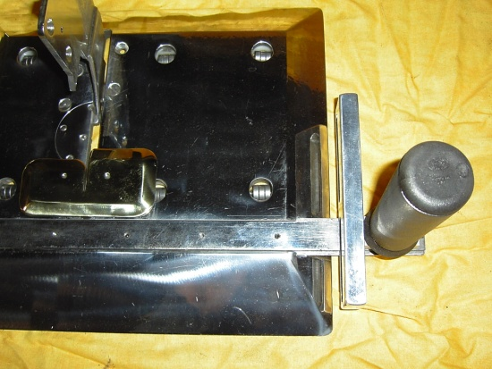
Wide Baseplate
The wide baseplate allows for stability and keeps a lower center of gravity, making the it virtually impossible to tip over. There are six sets of sealed ball bearing rollers for a straighter cut and ease of glide. The sets of rollers are positioned so the machine will perform evenly if partially hanging over the edge of the table.
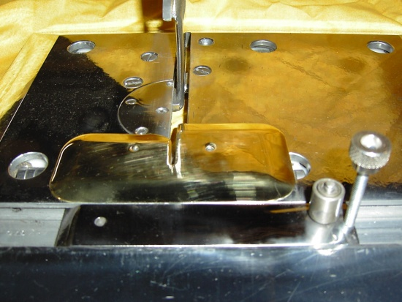
Small Gauge
The small guage, used for narrowed slitting or easier cutting, locks down in to position with a knurled knob. Features a roller mounted at the end to easily move the material along (also available with an L bracket instead of the roller). The small guage can be custom manufactured made to any size for virtually any need.
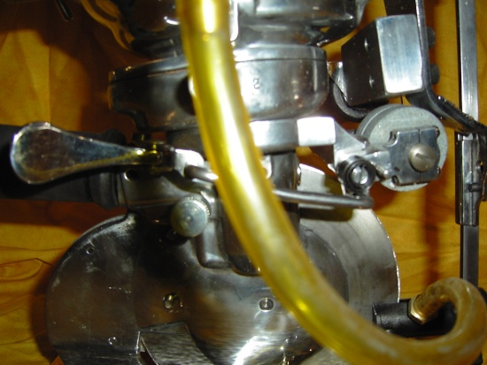
Built in Sharpener
The built in sharpener is easily engaged with one finger, using the trigger on the side of the machine near the rear handle. The stones flip down on to the blade allowing easy alignment. The built in sharpener also allows for free sharpening when needed; before, during or after a cut.

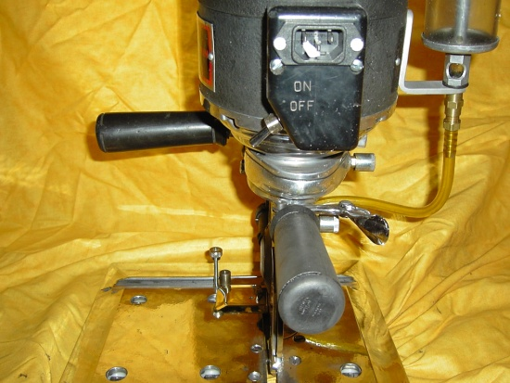
Multiple Handles
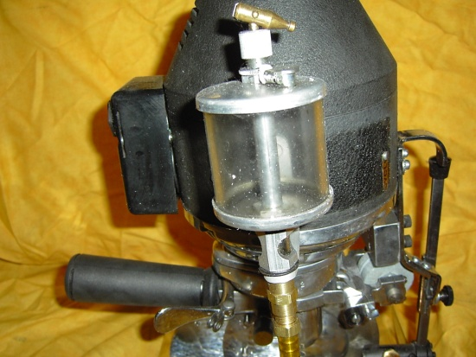
The rear handle endures the majority of the work while the operator pushes and guides the machine. The side handle allows for additional accuracy and guidance. The handle on the long strip gauge provides additional support for greater accuracy on the wide cuts. The finger handle on the front of the motor makes it easy to transport from table to table.

Oiler – Lubricator
For when the toughest materials need help, the blade lubricator is mounted to the side of the machine. Lubricates with oil, silicon, soap or water.
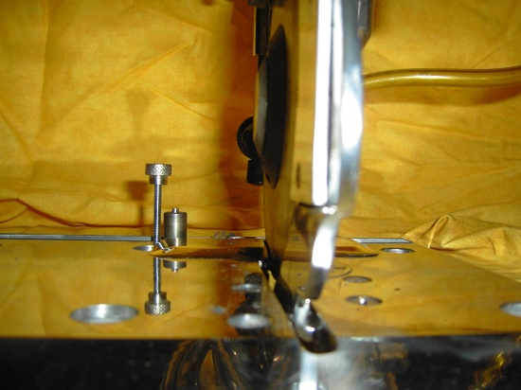

Narrow Slitter Standard
The narrow slitter standard allows for ease of pass through the material. The slitter standard is barely thicker than the blade and reduces friction.

