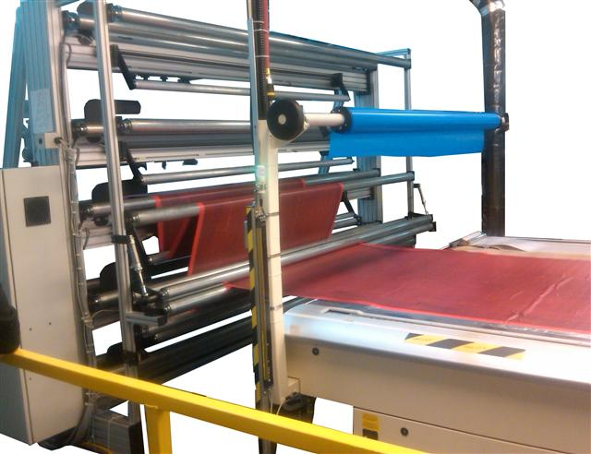

***Five Roll Feeder***

Maimin Technology manufactures a full line of **roll feeder and handling systems**, **power feed cradles**, **A-frames** and **multi-tier roll racks**. With our **extensive selection** of roll handling equipment, we can offer the **perfect solution to fit any application or budget**.

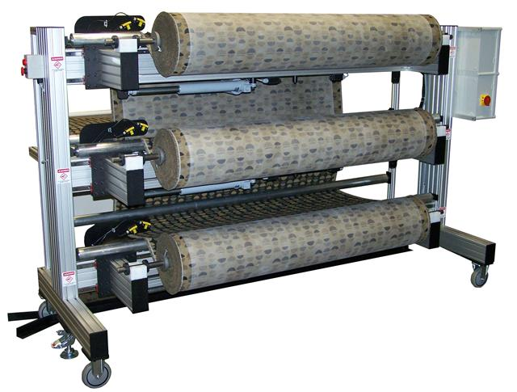

With technology similar to our Power Feedl Cradles, the vertical and horizontal roll feeders incorporate a **dual laser edge guide tracking system**.  This new configuration is **accurate** to within a 1/16th of an inch. The edge guide system length of travel can be manufactured from three to twelve inches to **accurately and efficiently** feed even the worst telescoping rolls.

***Three Roll Feeder***

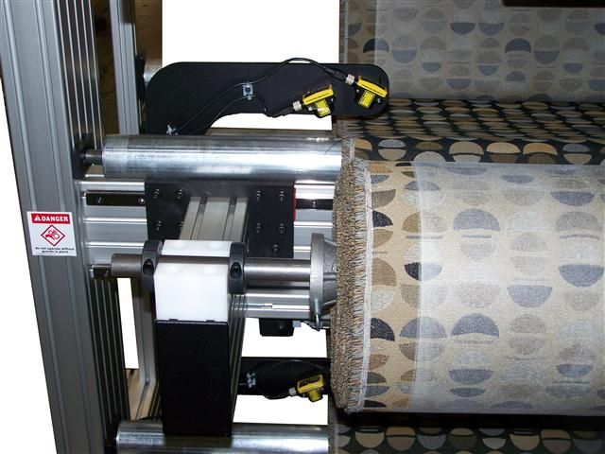

Maimin roll feeders are available in configurations from a **single roll to up to eight rolls** at a time (the three roll feeder is pictured above).  The roll feeders are available with **optional edge guide** and **power feed**. For multiple roll feeder applications, the feeders can be **manufactured to** **easily slide** in and out for **ease of loading new rolls** (see floor track in photo above).

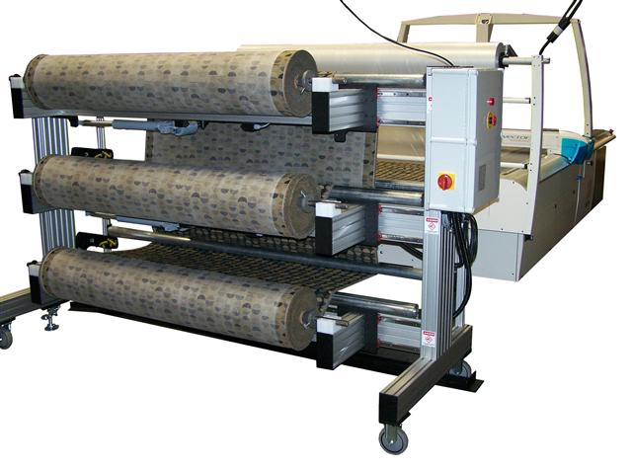

Maimin roll feeder systems are **ideal for feeding both single-ply and multi-ply cutting** **systems** where edge guiding is a must.  Our roll feeder will keep every layer of the material **placed perfectly** over the next and on target for your cutter. The configuration in the photo to the left displays a **three roll feeder with edge guide feeding a Lectra multi-ply cutter.**

***Three Roll Feeder***

An optional **out of cloth sensor** (outputs a momentary signal to the stop the cutter) can be added to make the operator aware when a roll has finished. The Maimin roll feeder can be manufactured with **power feed for delicate and stretchy material**. Our **adjustable cone option** allows one operator to load rolls of material with the use of a **foot pedal adjustment**.

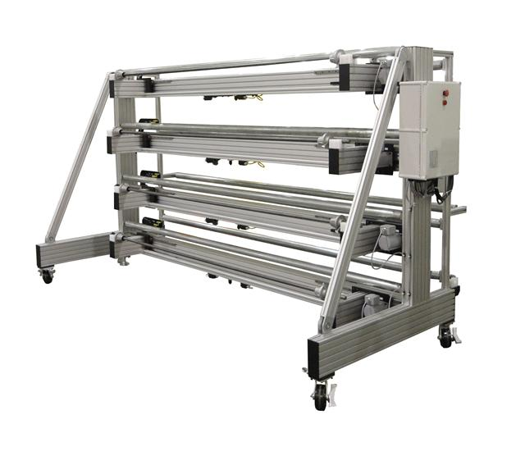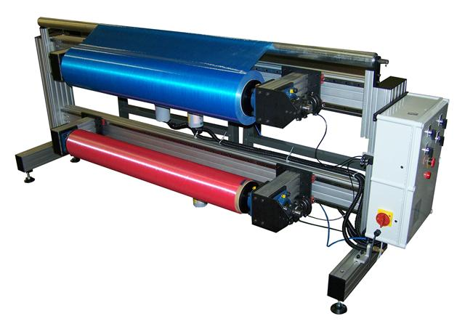

***Two Roll Feeder Four Roll Feeder***