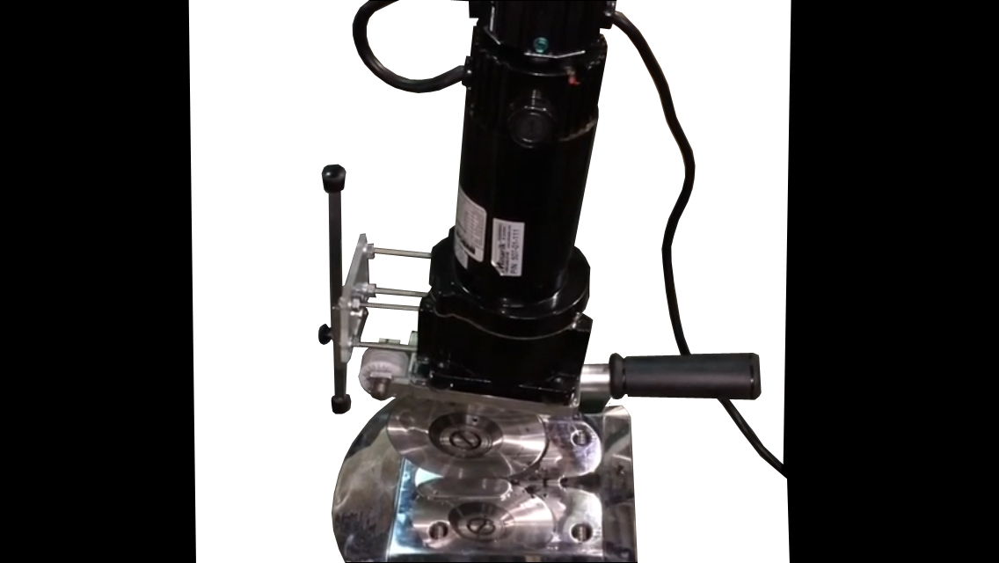

Maimin round knife cutting machines are **100% US made** using today’s most **advanced components** and **the latest manufacturing techniques**. The Maimin Model 59 Varispeed Cyclone is our **newest high power slitter**. It was designed to cut through the toughest of materials and can handle materials such as **cured and uncured rubber, neoprene, carbon fiber, fiberglass, Kevlar and gum rubber**. It is also being used for a variety of other functions such as **cutting bamboo, cardboard, and many Space-Age polymers**.

The baseplate is our standard aluminum baseplate with front lip and rollers underneath for ease of movement. The baseplate can be used freely or mounted for slitting. Custom baseplate sizes and shapes are available.

Weight: 21 pounds

Motor: Variable Speed DC Motor

Speed Control: Built in potentiometer

Cutting Blade: 5.25”

Sharpener: Built in dual stone sharpener

Available Voltages: 110 / 220 single phase