L-205 Semi-Automatic End Cutter
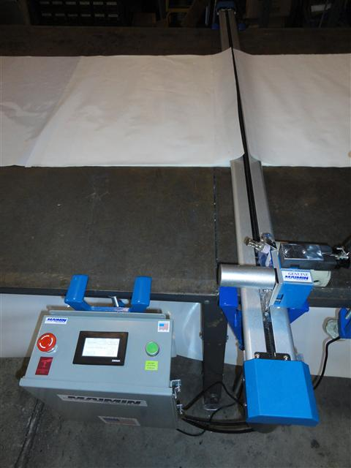
The new L series (made in the USA) features the highest quality electronics and a touch screen operator interface. On the touch screen, the operator can program cut speed, number of plies, track production, manually turn on the machine for blade sharpening. The operator may also slow the cross-cut down to allow for cutting of thicker lays, industrial fabrics, and reduce heat on fusible materials.

As with all Maimin end cutters, the L series is fast, simple, money-saving system eliminates end waste. An end-rail holds the fabric, allowing the operator to quickly and accurately cut the fabric along the cutting rail at the other end of the lay. Each ply receives a right angle cut at the same length, and the system is adjustable to any length of lay.

L-405 Fully-Automatic End Cutter
For ultimate efficiency, this end cutter offers all of the features of the L-205, plus completely automatic cut and lift functions. The operator sets the machine to cut only the exact number of plies required. He then draws the material from the roll, over the cutting track, to the end of the table (or pull). A touch of the button sends the cutting head across the track, cleanly cutting the fabric. The machine then automatically lifts and lowers, locking the newly cut fabric into place.

