MiniShere
ERGONOMICALLY DESIGNED

HAND-HELD CUTTING MACHINES
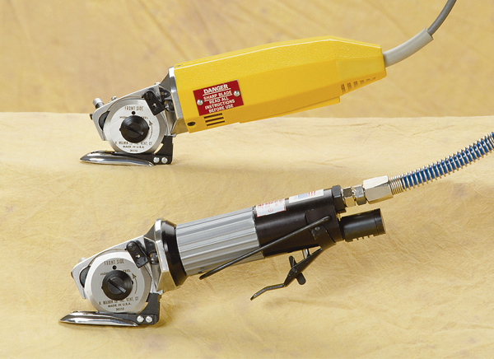

MiniShere (top)
Air MiniShere (bottom)

The most reliable, versatile and lightweight tool for the cutting room, featuring:
5/16 inch capacity: 2 inch blade cuts all types of material from Cotton to Kevlar
Recessed Sharpener: Protects stone and provides unobstructed view of cutting line
Built-in Lubricator: For cutting special materials like vinyl or coated fabrics
3-in-1 Cutting Guide: Baseplate converts easily for slitting/trimming plastics or knits
Choose From 3 Models
MiniShere: Fast and powerful, 2400 RPM, 120V or 220V electric-motor, double insulated for safety and convenience, 1.75 lbs.
Air MiniShere: Ultimate power and speed. 4800 RPM, 90 psi, 1.5 lbs.
Stretch MiniShere: A MiniShere extended 32 inches, with our unique balanced ergonomic design to prevent wrist or arm strain. 8 lbs.

