**July 28, 2019**

**Daniel 3:1-30**

Today we move to the prophet Daniel, a wise man whose life was very different from Amos (whose book we read the past 2 weeks in worship). Daniel was an educated man from the upper class. When the Jewish people were conquered and taken into exile, Daniel was selected to serve in the Babylonian king’s court. He was lucky in that regard; he lived a privileged life at home, and landed in the lap of luxury in exile. He had access to good food and wine and education – so much more than most of his Jewish friends and family. Unfortunately, the luxury he received came with a less than benevolent ruler: King Nebuchadnezzar.

Read Daniel 1:1-7.

King Nebuchadnezzar besieged Jerusalem, ransacked the Temple, and took some Jewish people home to Babylon as servants of his empire. Among those handsome young men chosen were Daniel and Hananiah, Mishael, and Azariah who, upon their arrival in Babylon, were renamed Shadrach, Meshach, and Abednego.

Someone’s name is a significant piece of their identity. It tells part of their story. And inasmuch, it’s one thing for people to decide to change their own name and flavor their own story, but a whole ‘nother story is told when someone else assigns you a name.

Historically, slaves are given names by their owners, disregarding whatever life or story they had previously. These names were usually painful and disrespectful, full of negative connotations because they were assigned by people who claimed to own them, disconnected from their families, parents, home and other individual stories. Slave names were given out of convenience and whimsy. Slave names were assigned by those who held power over them, not by those who loved them. This was the case with Hananiah, Mishael, and Azariah. Their Jewish identity and personal histories were washed over when the conquering Babylonians said, “No, no, no. *We* shall call you Shadrach, Meshach, and Abednego.” (pause)

I was named for both of my grandmothers. “Mary” from my maternal grandmother and “Margaret” from my paternal grandmother. Both of these women were formative in my life; sharing their names connected us in a special way. Their very names seemed to infuse me with their strengths and joys and interests, and family memories of these two women. Such that I have felt pride and delight whenever my full name has been used: “Mary Margaret Flannagan.” Each of my names is common by itself, but together, and connected to my grandmothers, they make me feel unique and somewhat magical. These names and the way that I wear them are very much a part of my identity.

But there are other names people have called me that don’t have any connection to my identity at all. Names that I haven’t enjoyed or felt represented who I am. Usually, these names are assigned to me by people who never asked what I wanted to be called. Whether a stranger calling me “sweetheart” or people wrongly assuming my name is “Megan,” people have called me names that offend or hurt me. Their attempts to rename me – whether in fun or with the intention of causing harm – suggest a power and privilege that they don’t actually have over me. The name they bestow upon me does not reflect *me*, but reflects their ignorance of me and my story.

There is power in claiming your name and thus claiming your story.

My best friend was known as “Sally” when she was a little girl, but declared at the ripe age of 5 that she didn’t like *that* name. She demanded everyone call her “Sarah,” and thus we have for the past 35 years. “Sally” had a very different story from the “Sarah” I know and love today.

Grandparents take delight in choosing their name after a first grandchild arrives. Some want to repurpose a predecessor’s beloved name and identity – “Mimi” or “Papa” or “Nanny” – while others want something fresh and new, or something that suggests they aren’t so old or stodgy as many grandparent names convey.

Refugees and immigrants often take a new name when they arrive in a new country. They choose a name that represents who they’d like to be in their new home, or something that sounds close to their home name, but is easier for new neighbors to say.

ASK people to tell someone near them: their whole name, if there’s a story, how they feel about their name.

THEN, ask people to share a nickname (or other moniker) that they were given later in life, the story, and how they feel about that name.

Now, for the rest of the story… Daniel and the 3 young men (whom I will not refer to by their Babylonian slave names, but intentionally use their Jewish names: Hananiah, Mishael, and Azariah) were forced into serving King Nebuchadnezzar’s court. They were given special food and special attention, education, and care. … Meanwhile, King Nebuchadnezzar built a gold statue to which he expected all people in his kingdom to bow down and worship. Anyone who didn’t do so at the sound of the royal band (horns and drums and such) would be thrown into a furnace of blazing fire. But Hananiah, Mishael, and Azariah refused.

READ Daniel 3:8-30

King Nebuchadnezzar was enraged that anyone would disobey his command. Nevermind that he probably didn’t know these guys existed before these complaints were made. Their refusal to worship the gold statue challenged the King’s power and ability to keep his subjects in line. He called the young men in to personally confront them. “Did you know that I commanded people to worship that statue? If you don’t bow down to that status, I will throw you into a furnace.” To which they replied, “We don’t need to defend ourselves. If our God is able to deliver us from the furnace (note: not if God is able to change your mind or make this problem go away, but *if our God* delivers us from the furnace), then let God do so. But if not, we still won’t worship your statue.” So powerful, these slaves. So confident, these educated Jewish men. They refused to engage Nebuchadnezzar. They washed their hands of the whole matter, like Jesus before Pilate. They weren’t troubled by Nebuchadnezzar’s threat. They didn’t care what King Nebuchadnezzar did. Hananiah, Mishael, and Azariah’s faith wasn’t dependent upon what *they* wanted for themselves. Their faith wasn’t even dependent upon God’s response to their particular needs or prayers. Their faith declared that God was God no matter what.

When Rev. Dr. Martin Luther King, Jr. preached on this text in 1967, he said, “there comes a time when a moral man can't obey a law which his conscience tells him is unjust… history has moved on, and great moments have often come forth because there were those individuals, in every age in [and?] every generation, who were willing to say ‘I will be obedient to a higher law.’ [Hananiah, Mishael, and Azariah] were saying "I must be disobedient to *a* king in order to be obedient to *the* King." [1]

They had been silenced long enough. They had been overlooked and oppressed and renamed Shadrach, Meshach, and Abednego, and thus counted as part of Nebuchadnezzar’s machine. But they had never stopped being Hananiah, Mishael, and Azariah. They never stopped being faithful Jewish men, chosen by God as a light to the nations. The Babylonians may have tried to silence them by renaming and re-educating them, but Hananiah, Mishael, and Azariah never lost sight of their true identity. So when a roadblock was presented to the heart of their identity – their faith – they stood up and spoke truth to power.

Each of us is named “child of God” at our baptism. Without a family last name, we are called by our true identity: sons and daughters of the Most High God. At funerals, flags are removed from Christians’ coffins, instead covered with a pall to signify again that we are not our family’s, we are not our country’s, we are a child of God. No one else owns or claims us as God does. No one else knows or keeps us as God does.

The trouble is, we forget this essential piece of our identity in our day-to-day living. As Dr. King said, there must be times when we are willing to be disobedient to *a* king – break the rules, go against the tide – in order to be obedient to *The* King. To live into the heart of our identity as children of God, we must be willing to see through the dirt and grime and manipulation of the world. We must be willing to stand up and speak truth to power. We must be able to say, “No. That’s not right. That’s not who I – that’s not who *we* – were called to be.” And, of course, in order to do these things, we must also know who we are. We must know the sacred name that God gave us. We must maintain a relationship with God – following God’s commands, speaking with God, listening to God – each and every day so that we know that we are children of the Most High God.

We protest inhumane treatment of refugees and inhospitable policies against immigrants because those behaviors go directly against God’s commandments for God’s children (inviting strangers and welcoming the outcast). We recycle and limit use of fossil fuels and make personal sacrifices that benefit the environment because those behaviors are exactly what God asked God’s children to do (practicing stewardship of the earth). When we do these and other things, we are living into our true identity as Christians and children of God. When we do these things, we are remembering well *who* we are and *whose* we are. Many people, institutions, and structures will try to claim us and rename us and redirect our stories. The world will not always work as we wish or think it should. God may not intervene in the ways we hope God will. And if not, we still won’t give up. Regardless of whether God’s actions match what we hope or wish them to be, we know that God is God, and we are God’s children. May God give us strength to be faithful followers each and every day. Amen.

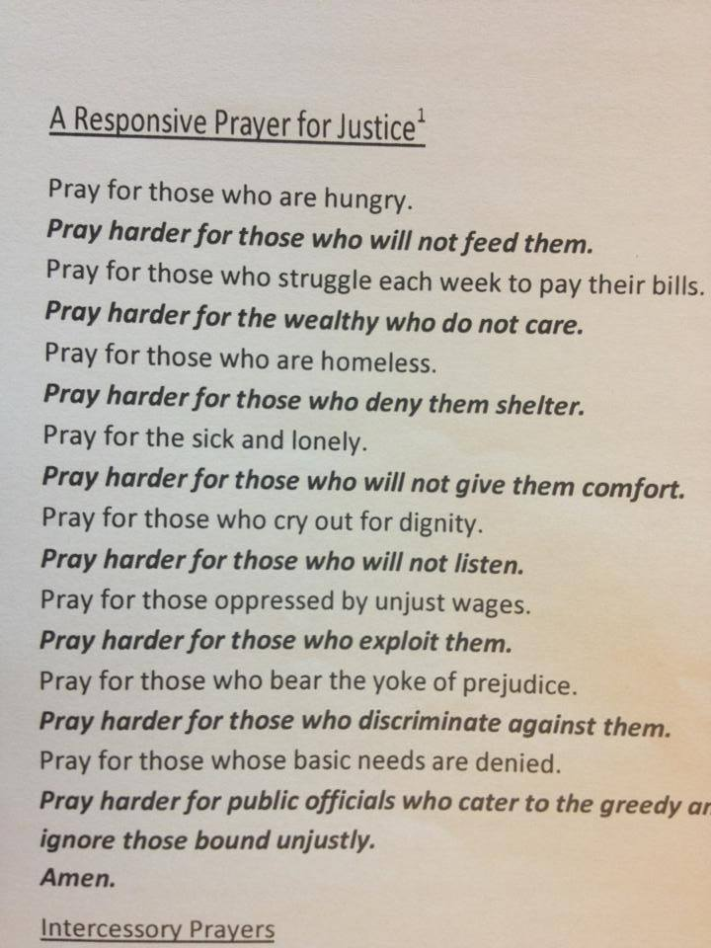

1. <http://notoriousbiggins.blogspot.com/2010/01/but-if-not-sermon-by-martin-luther-king.html>