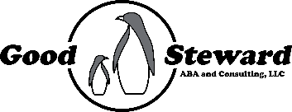

Good Steward ABA and Consulting, LLC SMS Opt-In

Good Steward ABA and Consulting, LLC uses SMS messaging to enable rapid notifications to clients and staff when a planned session is cancelled to improve communications. By opting in to this service, you are agreeing to receipt of SMS messages from our company for these notifications. You may opt out at any time by replying “STOP” to the message or by contacting our office directly at (757) 256-2242. You may also request assistance by replying “HELP” to the message or by contacting our office directly.

Please note that message and data rate may apply when these messages are sent to you.

☐ Please check the box if you choose to OPT IN to SMS message from Good Steward ABA and Consulting, LLC

______________________________________
Phone Number(s) to receive messages

______________________________________
Printed Name

______________________________________
Signature

________________
Date

