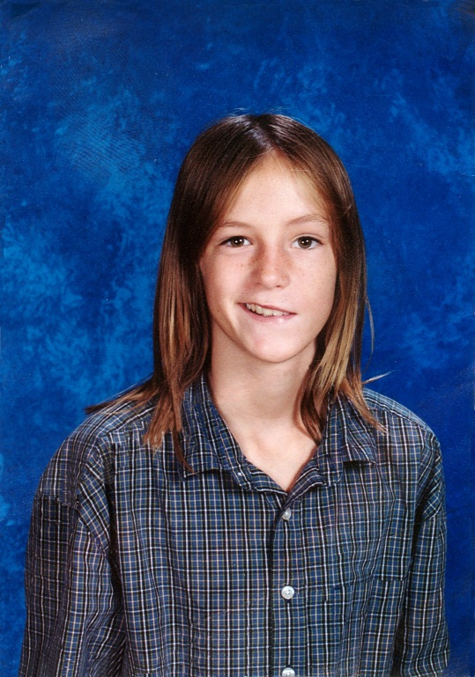
Michael Abt Jr. Have a Heart Foundation
1322 U.S. Highway One
Sebastian, FL 32958
www.haveaheartformichael.org
CH21741

November 1993------------March 2006
AED Application Questionnaire
Facility Name: __________________________________________ Date: _________
Contact Person: __________________________ Title: _________________________
Phone________________________ Email: __________________________________
Why do you want an AED? ________________________________________________________________________________________________________________________________________________________________________________________________________________________________________________________________________________________
Do you currently have any AED’s? Y_____ N_____
If so, how many, and what brand? _____________(Qty) ____________________________(brand)
Who maintains the AED’s-checks and replaces the batteries and pads and how often? ____________________________________________________________________
Approximately how many students/children are in attendance? ___________________
Approximately how many staff are CPR/AED trained? __________________________
Will you be seeking new or additional CPR/AED training? Y _____ N _____
Do you have a Cardiac Emergency Response Plan in place? Y____ N____
Do you practice a drill of this CERP?
If so, please describe in short detail what you do and how often __________________________________________________________________________________________________________________________________________________________________________________________________________________
If not, would you be willing to implement a plan into your program? Y _____ N _____
If we should donate an AED to your facility, is there a specific brand that you, your school, or the school district prefers? ________________________________________
Any additional comments that you feel may help your application?__________________________________________________________________________________________________________________________________________________________________________________________________________________________________________________________________________________________________________________________________________________________________________________________________________________________

