
APPLICATION FOR EMPLOYMENT
(Pre-Employment Questionnaire) (An Equal Opportunity Employer)
PERSONAL INFORMATION
DATE

NAME
LAST
FIRST
CITY
MIDDLE
STATE
PRESENT ADDRESS
PERMANENT ADDRESS
PHONE NO.
STREET
STREET
ZIP
CITY
STATE
ZIP
ARE YOU 18 YEARS OR OLDER?
Yes ❑
No ❑
ARE YOU PREVENTED FROM LAWFULLY BECOMING EMPLOYED
IN THIS COUNTRY BECAUSE OF VISA OR IMMIGRATION STATUS?
Yes ❑
No ❑
EMPLOYMENT DESIRED

POSITION
ARE YOU EMPLOYED NOW?
MAY WE INQUIRE OF YOUR PRESENT EMPLOYER?
DATE YOU CAN START

*NO OF
EDUCATION
GRAMMAR SCHOOL
HIGH SCHOOL
COLLEGE
NAME AND LOCATION OF SCHOOL
YEARS
*DID YOU
GRADUATE?
SUBJECTS STUDIED
ATTENDED
TRADE, BUSINESS OR
CORRESPONDENCE
SCHOOL
EXPERIENCE
PREVIOUS EXPERIENCE IN FIELD (IF ANY)

.
U. S MILITARY OR
NAVAL SERVICE
PRESENT MEMBERSHIP IN
NATIONAL GUARD OR RESERVES
RANK
*This form has been revised to comply with the provisions of the Americans with Disabilities Act
and the ﬁnal regulations and interpretive guidance promulgated by the EEOC on July 26. 1991.
TOPS FORM 3285 (92-8)
(CONTINUED ON OTHER SIDE)
LITHO IN U.S.A.
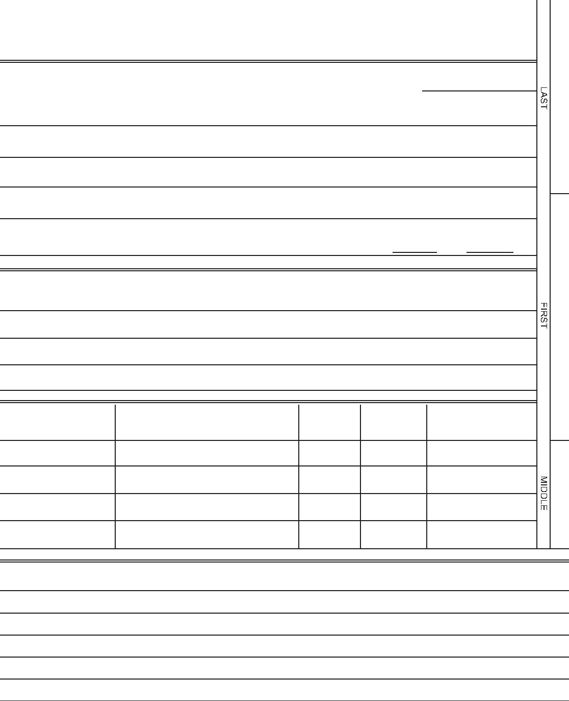

Zqrj7p/89’
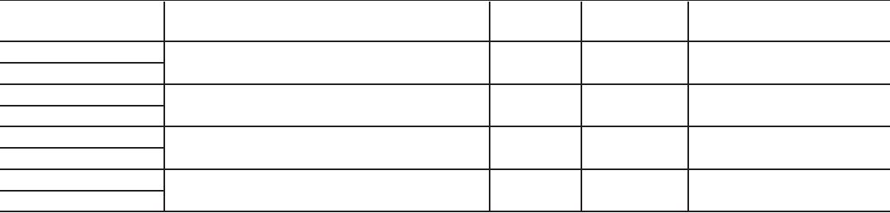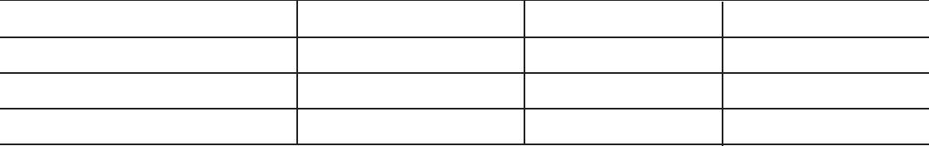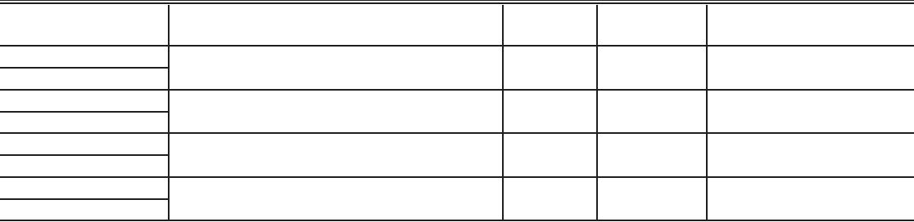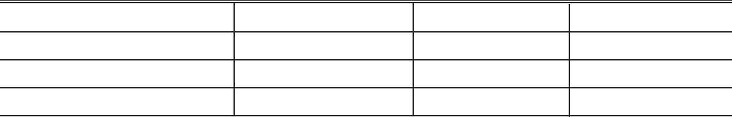

FORMER EMPLOYERS (LIST BELOW LAST THREE EMPLOYERS, STARTING WITH LAST ONE FIRST).
DATE
MONTH AND YEAR
NAME AND ADDRESS OF EMPLOYER
SALARY
POSITION
REASON FOR LEAVING
FROM
TO
FROM
TO
FROM
TO
FROM
TO
WHICH OF THESE JOBS DlD YOU LIKE BEST?
WHAT DlD YOU LIKE MOST ABOUT THIS JOB?
REFERENCES:
GIVE THE NAMES OF THREE PERSONS NOT RELATED TO YOU, WHOM YOU HAVE KNOWN AT LEAST ONE YEAR.
YEARS
NAME
ADDRESS
BUSINESS
ACQUAINTED
1
2
3

