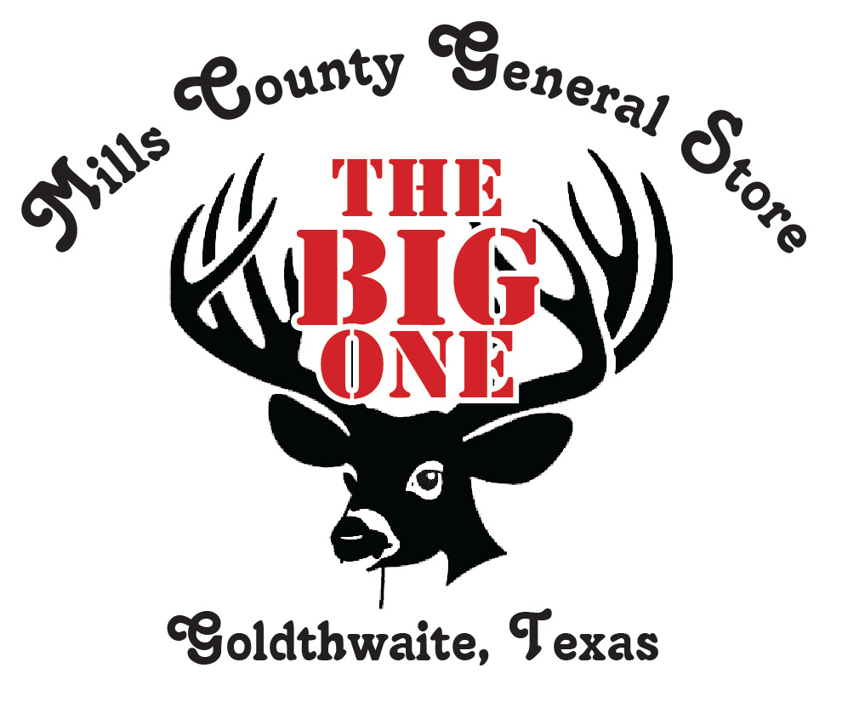
The Big one
BIG BUCK CONTEST 2020-2021
- Only whitetail deer legally harvested in Bosque, Brown, Burnet, Coleman, Comanche, Coryell, Eastland, Erath, Hamilton, Lampasas, Llano, Mason, McCulloch, Mills, or San Saba counties.
- Must enter prior to harvesting deer. Deer must be legally harvested by entrant. Entries must be submitted within 48 hours of harvest.
- High fence not eligible. No MLDP deer. Deer must be shot during respective seasons.
- Deer must be brought to Mills County General Store for B & C scoring. Must include cape. Scoring hours Monday thru Saturday 8:00 a.m. to 6:00 p.m. and Sunday 12:00 p.m. to 4:00 p.m. until 1/3/2021.
- Winners will be announced January 19, 2021.
Categories:
Biggest Buck: Rifle, Bow, or Crossbow, B & C scoring, no deductions
Biggest Bow Buck: Bow or Crossbow only
Biggest Gun Buck Men: Long Gun or Handgun
Biggest Youth Buck: Bow, Crossbow, or Rifle, 16 and under
Biggest Ladies Buck: Bow, Crossbow, or Rifle
Lucky Buck: Every buck scored entered into drawing (Special Prize)
Entry fee: $30.00 for adults, $15 for youth
You receive one B & C score
Gift

Prizes: Grand Prize is a Ruger American 308 with a Vortex scope package, 2 boxes of ammo, and carrying case.
Lucky Buck wins game camera.
Category winners get a $150 Shopping Spree.

All scored buck photos will be displayed on the Mills County General Store/Ace Hardware page. Name, photo, and gross B&C score will be included. Also we plan to put photos on a bulletin board in the store.

