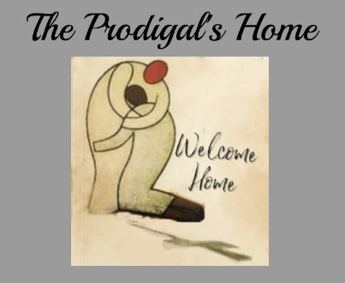

RULES
Morning Routine
530AM wake up – Get up and make your bed and eat breakfast
630AM Bible Study
Cell Phones
No cell phones permitted for the first 30 days of the program
Cell phones are awarded after completion of the phase 1 (first 30 days of program)
Cell phones are permitted from 5pm until 9pm Mon thru Fri Phase 2 (30th to 90th day)
Cell phones are permitted Friday evening thru Sun evening (must be turned in Sunday 9pm)
Cell phone privileges are awarded permanently after the completion of phase 2 (90th day)
House Rules
The houses must be kept in excellent condition
Each week you will be given a daily chore schedule
A House Manager will be appointed weekly to enforce the daily chore schedule
Only after 90 days will you be eligible to act as House Manager
A house manager makes sure the house and yard is clean and in order
You must follow your daily chores schedule
Your personal living space must be cleaned every morning before 6:30 am bible study
Your personal living space can be searched by leadership at any time
No damage to the property
All TV shows and DVDS must be approved by leadership (No cussing, sexual content, vulgarity, or misuse of Jesus’ name)
Vehicles
No vehicles permitted without first approval of Leadership
Medication
Only over the counter medicine permitted unless approved by leadership – NO NARCOTICS or mind-altering medication
Visitation
All visitation must be approved 24 hours prior to visit
After 30 days (phase 1) you are awarded on site visitation (at the Cabin and common areas)
Visitation is each Saturday from 12pm until 8pm (only 3 hours per visit) (Phase 2)
After 60 days (Phase 2) you are awarded off site visitation from 10am until 8pm (Saturday only)
After 90 days (Phase 3) you are awarded a weekend pass (Friday evening to Sunday morning) ~ You Must return before 9am for Church
You must sign out when you leave and sign in when you return every time (Make your case manager aware when you depart and when you return IMMEDIATELY)
Sign In/Out sheet is located at the Cabin
The Cabin is the designated departure and return location
No visitor vehicles are allowed at any of the residential housing facilities at any time

Initials _______

Tobacco Products
Smoking is permitted in designated smoking areas only
No smoking or vaping in the any of the Prodigal’s Home vehicles or houses
Cigarette butts must be put in the butt cans and must not be thrown on the ground
Butt cans must be emptied into designated metal bins each night
Dip and chewing tobacco are permitted within the house
Spit cans and bottles must be disposed of immediately
Phase 1 Classroom
8am -12pm you must attend class and counsel
1pm you must attend life skills classes and Job training at the workshop (Tuesdays and Thursdays)
3pm You must attend Studies at Cabin (Mondays Wednesdays and Fridays)
Phase 2 Work Program
8am – 3pm you are required to meet at workshop for Property maintenance and work
3pm You must attend studies at cabin (Mondays Wednesdays and Fridays)
Phase 3 Work Program
You must work daily in the rehab work program
These are residential jobsites
The work program consists of house renovations and any work we do within our community
You must work in a safe, professional, and productive manner
At the Jobsite You must always wear your PPE, (closed toed shoes, Jeans, Safety goggles etc.)
No cell phones during work without permission first
Meetings and Activities
You must attend all church functions, activities, meetings, and studies
No leaving the sanctuary while church is in session
No sleeping during church functions, activities, or studies
You must attend Bible study every morning at 630AM Monday – Friday
General Rules
Violation of any of the following will result in immediate expulsion
Use or possession of drugs, paraphernalia, alcohol and/or banned substances on or off property
Weapons of any kind
Violence or threats of violence
Sexual harassment
Stealing of any kind
Destruction of property
Abuse of OTC or prescription medication
Smoking or vaping inside the houses
Refusing to take a drug test
After 6 write ups

If asked to leave The Prodigal’s Home you will have to arrange transportation and vacate the premises immediately

By signing I agree to all rules and regulations and will abide by these rules as a standard of living during my time in The Prodigals Home Men’s Addiction Rehabilitation Center

Print Name X___________________________

Signature X___________________________

Date _______________

