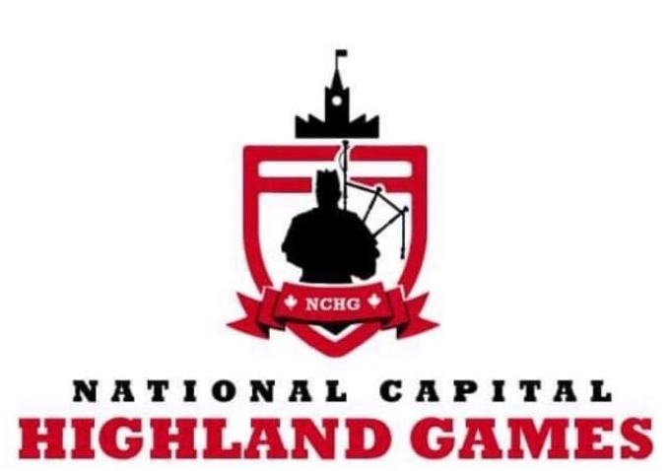

**HEAVY EVENTS INFORMATION, APPLICATION FORM & WAIVER**

Heavy Events, also known as Highland Games Heavy Events or Scottish Athletics, have been part of Highland Games for centuries. At the National Capital Highland Games there will be **nine** events:

1. Braemar Stone
2. Open Stone
3. Heavy Weight For Distance
4. Light Weight For Distance
5. Heavy Hammer
6. Light Hammer
7. Caber
8. Weight Over Bar
9. Sheaf

Please complete the on-line application form and email it to:

**Athletic Director: John Jans at opietech@hotmail.com**

No later than July 1st, 2022.

**Please note**: You will be contacted once your application is received and processed. Only those who have received an invitation will be allowed to compete. If you are new to the Games the Athletic Director will call you to verify qualifications to ensure both athlete and spectator safety. We will be offering a Newbie/Tune-Up session on Friday, August 19th with the Athletic Director. Please mention your interest in this session with your application.

**Waivers**:

When you check in to participate for the events on August 20th, 2020 you will be **required** to sign a copy of the attached waiver. This is **mandatory** and participation you will not be permitted without it.

# **NATIONAL CAPITAL HIGHLAND GAMES 2022**

# **ACKNOWLEDGMENT, RELEASE AND WAIVER**

**HIGHLAND GAMES COMPETITOR/ PRACTICE**

**Heavy Events**

## PLEASE READ CAREFULLY

In consideration of being allowed to participate in any way in **National Capital Highland Games** athletic sports program, related events and activities, the undersigned acknowledges, appreciates, and agrees that:

1. The risk of injury from the activities involved in this program is significant, including the potential

for permanent paralysis and death, and while particular rules, equipment, and personal

discipline may reduce this risk, the risk of serious injury does exist; and,

1. I KNOWINGLY AND FREELY ASSUME ALL SUCH RISKS, both known and unknown,

EVEN IF ARISING FROM THE NEGLIGENCE OF THE RELEASEES or others,

and assume full responsibility for my participation; and,

1. I willingly agree to comply with the stated and customary terms and conditions for participation.

If, however, I observe any unusual significant hazard during my presence or participation,

I will remove myself from participation and bring such to the attention of the nearest official

immediately; and,

1. I, for myself and on behalf of my heirs, assigns, personal representatives and next of kin,

HEREBY RELEASE AND HOLD HARMLESS The National Capital Highland Games, their officials, board members, agents, and/or employees, other participants, sponsoring agencies, sponsors, advertisers, and if applicable, owners and lessors of premises used to conduct the event

(“RELEASEES”), WITH RESPECT TO ANY AND ALL INJURY, DISABILITY, DEATH,

or loss or damage to person or property, WHETHER ARISING FROM THE NEGLIGENCE OF

THE RELEASEES OR OTHERWISE, to the fullest extent permitted by law.

**I HAVE READ THIS RELEASE OF LIABILITY AND ASSUMPTION OF RISK AGREEMENT, FULLY UNDERSTAND ITS TERMS, UNDERSTAND THAT I HAVE GIVEN UP SUBSTANTIAL RIGHTS BY SIGNING IT, AND SIGN IT FREELY AND VOLUNTARILY WITHOUT ANY INDUCEMENT.**

PRINT NAME: Date:

# Participant's Signature:

# **NATIONAL CAPITAL HIGHLAND GAMES 2022**

# **RELEASE AND WAIVER**

## HIGHLAND GAMES COMPETITOR/ PRACTICE

## FOR PARTICIPANTS OF MINORITY AGE (UNDER AGE 19 AT THE TIME OF REGISTRATION)

This is to certify that I, as parent/guardian with legal responsibility for this participant, do consent and agree to his/her release as provided above of all the Releasees, and for myself, my heirs, assigns, and next of kin, I release and agree to indemnify and hold harmless the Releasees from any and all liabilities incident to my minor child's involvement or participation in these programs as provided above, EVEN IF ARISING FROM THEIR NEGLIGENCE, to the fullest extent permitted by law.

SIGNED:

(Parent/Guardian Signature)

DATE:

# Parent/Guardian Name: ___

(Please Print)

Emergency Phone Number:( ) Name:

# **NATIONAL CAPITAL HIGHLAND GAMES 2022**

**August 20th 2022**

**HEAVY EVENTS APPLICATION**

The National Capital Highland Games would like thank all applicants in advance.

Please complete this application in full.

This application DOES NOT GUARANTEE acceptance as a competitor.

|  |  |
| --- | --- |
| **Participant’s Name:** |  |
| **T-Shirt Size:** |  |
| **Full Mailing Address:** | Street: Town: Prov:  Postal Code: |
| **Phone Number:** |  |
| **Email Address:** |  |

**Birth Date (DD/MM/YYYY): / / Please check the box which best applies:**

1. Which section are you interested in competing in?

* **Men’s Open** **□ Women’s Open □ Junior □ Ams □Masters**

1. I have competed in a Heavy Events competition before.

* **Yes □ No**

If yes, when and where was the last competition you competed?

How did you hear about the games?