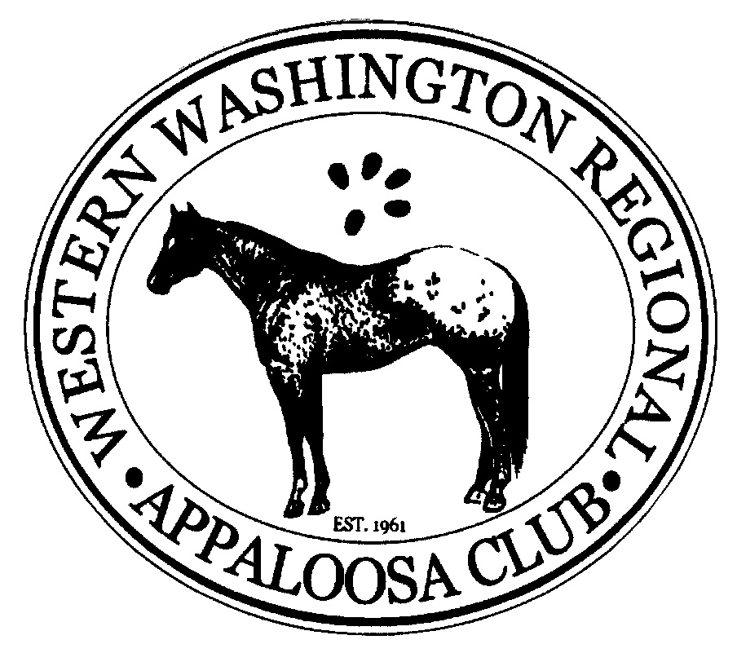
Western Washington Regional Appaloosa Club Enrollment Form
Individual Dues $20.00 Junior Dues $15.00 (ages 17 & under as of November 2019)
Name(s):____________________________________________________________________
Address:____________________________________________________________________
City:____________________________________________ State:_______________________
Zip Code:____________________________ Telephone:_______________________________
E-mail Address:________________________________________________________________
National ApHC Number (if applicable):_______________ Referred by?:_____________________
Liability Release: I/We do hereby release the Western Washington Regional Appaloosa Club, its officers, directors, and members from any liability claim or right for damages which might occur to me, my children, or horses while participating in any way in a club function. I also assume full responsibility and liability for any damages by myself, my minors, or my horses while partaking in any club function.
Signed____________________________________________ Date:______________________
Please make checks payable to WWRAC and submit payment to Dick Sanderson, 1446 Greenville Dr, Bellingham, WA 98226

