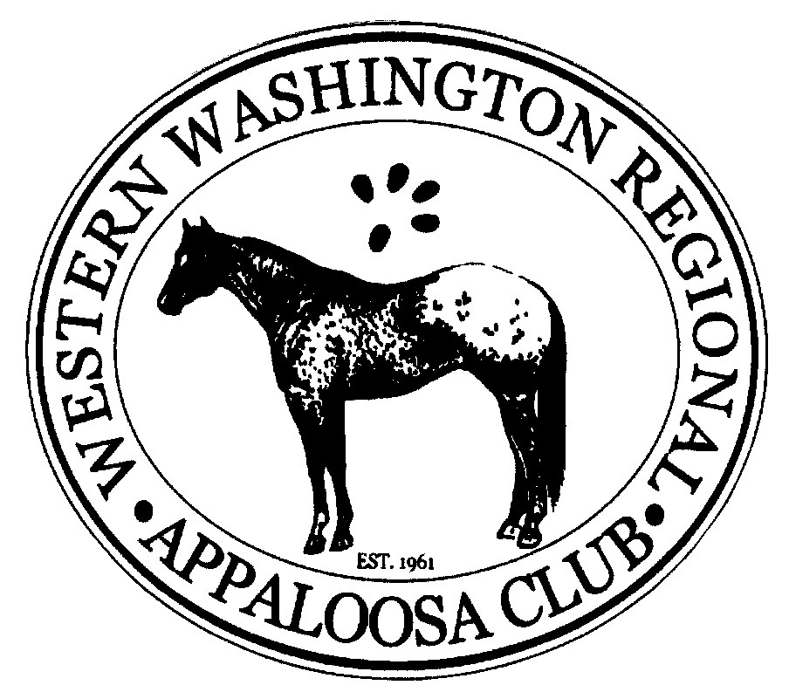
Western Washington Regional Appaloosa Club
2019 Year-End Senior Trail Riding Award Registration Sheet and Rules

Rider’s Name________________________________________________ Phone Number___________________________

Address____________________________________________________________________________________________

E-mail _____________________________________________________ Date____________________________________
- Rider must be a member of WWRAC and 18 years of age or over.
- Cut-off date for submitting rides for the year-end award is October 31st of the current year. Rides that occur after that date shall be counted towards the following year.
- Participant must ride an ApHC registered Appaloosa and a copy of the registration papers must accompany this form.
- Participant must be enrolled in the trail riding award program prior to accumulating hours towards the year-end award.
- Logged hours are to be kept by the honor system. Any person who knowingly falsifies any information will automatically be disqualified.
- Report forms must be submitted for every month for which hours were logged. This includes hours logged at the WWRAC-sponsored rides. The high point chairperson is not responsible for recording points from any of these events without the submission of the completed report form. In addition, all placing sheets must be completed, signed, post marked or received by the 15th of each month, and returned via postal service, scanned email, or hand transfer to the High Point Chairperson in order to count for year-end high points. There will be no exceptions.
- The annual participation fee is $40.00 per rider. The participant must attend two Meetings and assist at one major function or otherwise pay an opt-out fee of an additional $40.00 per rider, per year.
- Monthly saddle logs must be completed, signed, and submitted to the High Point Chairperson, postmarked by the fifteenth of the following month, in order to qualify for high point awards. The final saddle logs for the year must be received no later than November 15th for the awards to be presented at the Awards Banquet in December.
- It will be your responsibility to copy and return any forms in a timely manner. WWRAC shall not be held responsible for the loss of points resulting from paperwork that they did not receive. Official year-end high point exhibitor’s forms will be distributed to high point competitors at the time of enrollment. Any report forms required in excess of those provided may be obtained off the club’s website at www.wwrac.org. If you do not have access to the webpage and require hard copies of the report forms to be sent to you, please contact the High Point Chairperson or photocopy a report form from one of those previously provided. Illegible reports or reports submitted on notebook paper or any other resource other than the official WWRAC Year-end High Point Exhibitor report form will not be accepted.

Send the top portion of this form to the High Point Chairperson to enroll in the Trail Riding Program. Log saddle hours on the form below. MONTHLY SADDLE HOUR LOGS MUST BE POSTMARKED NO LATER THAN THE 15TH OF EACH MONTH. Please photocopy if you need more room for rides.

--------------------------------------------------------------------------------CUT HERE------------------------------------------------------------------------

Rider’s Name _________________________________________________________________

I certify that the information & hours reported below are correct X________________________________________________
DATE | HORSE’S NAME AND REGISTRATION | HOURS | LOCATION OF RIDE
Send this completed sign-up sheet along with remittance to: Kristen Reiter, DVM, WWRAC High Point Chairperson, 160 W Crescent Harbor Road, Oak Harbor, WA 98277, (360) 320-0941, or email kris_daren@yahoo.com.

