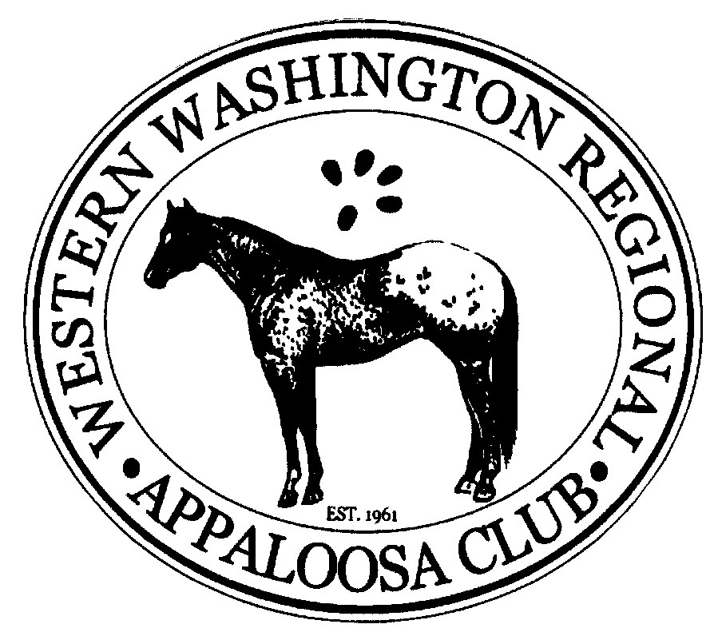
WWRAC High Point Awards Application
ApHC Approved Breed and Open Show and Gaming Year-End High Point Award Rules 2019

- Participant must be a Member of the WWRAC prior to any show to count for Year End Awards.
- Member must attend 2 meetings and assist at one major function. Members who cannot meet the above requirements may choose to pay “opt-out” charges of an additional $40.00 for each Senior division or $25.00 for each Junior division for each discipline enrolled.
- The normal class enrollment fee is $40.00 for Senior participants (18 & over), per horse, per division, per year. The fee is $25.00 for Junior participants (13 and Under and 14-17 Age Groups), per horse, per division, per year.
- A photocopy of each horse’s original registration papers must accompany this form. Please submit one form per horse and rider combination.
- All horses must be Appaloosas registered with the ApHC and owned and shown by a WWRAC member or family member. WWRAC Members leasing a registered ApHC Appaloosa must have an official recorded lease on file prior to the show for which they wish to qualify their horses. If a horse is sold or its lease transferred, the new owner or lessee must be become a member of WWRAC in order to continue that horse’s points.
- Junior Members of the WWRAC 17 & under division are prohibited from riding/handling stallions for Year End High Point.
- Points must be earned at an Open Show or an ApHC-approved breed show that is sanctioned and supervised by an established record-keeping equine-related governing body or specialty association.
- Double points are earned for placings in any of the WWRAC-sponsored shows.
- Any person who knowingly falsifies any information on the placing sheets will be disqualified.
- Report forms must be submitted for every show attended at which points were earned. This includes points earned at the WWRAC-sponsored shows. The high point chairperson is not responsible for recording points from any of these events without the submission of the completed report form. In addition, all placing sheets must be completed, signed by the Show Secretary, post marked or received within 15 days of the date of the show’s conclusion, and returned via postal service, scanned email, or hand transfer to the High Point Chairperson in order to count for year-end high points. There will be no exceptions.
- Placings to count towards Year-end High Points shall be accumulated from November 1 through October 31 of the following year. Forms are to be submitted to the High Point Chairperson in the following weeks, no later than November 15th for the awards given at the Awards Banquet in December.
- Points earned from ApHC classes shall count for WWRAC High Point Awards.
- Participant must be enrolled in the year-end division prior to the date of the show in order for those points to count towards the current season.
- It will be your responsibility to copy and return any forms in a timely manner. Forms must be filled out completely and include all necessary signatures in order for the points to be counted. WWRAC shall not be held responsible for the loss of points resulting from paperwork that was not received or from the submission of incomplete paperwork. Official year-end high point exhibitor’s forms will be distributed to high point competitors at the time of enrollment or can be sent via email. If you do not have email access and require hard copies of the report forms to be sent to you, please contact the High Point Chairperson or photocopy a report form from one of those previously provided. Illegible reports or reports submitted on notebook paper, the back side of show class forms, or any other resource other than the official WWRAC Year-end High Point Exhibitor report form will not be accepted. The only exception to this rule shall be those riders who exhibit and earn points for the ApHC ACAAP program. These riders shall be permitted to submit their completed ACAAP form in place of the WWRAC form.

SHOW PLACINGS
# Of Horses | 1st | 2nd | 3rd | 4th | 5th | 6th | 7th
2 | ½
3-7 | 1 | ½
8-12 | 2 | 1 | ½
13-17 | 3 | 2 | 1 | ½
18-22 | 4 | 3 | 2 | 1 | ½
23-27 | 5 | 4 | 3 | 2 | 1 | ½
28 and over | 6 | 5 | 4 | 3 | 2 | 1 | 1/2
Divisions Eligible for High Point Awards
Please mark the division(s) for which you are enrolling and the appropriate age group
Halter  English  (To cover any classes ridden in Hunt Seat, Saddle Seat, Dressage or Driving, including, but not limited to:  Equitation, Pleasure, Hack Classes, Hunter/Jumper, English Trail, etc)  Western  (To cover any classes ridden in Western tack, including, but not limited to: Equitation, Pleasure, Western Riding, Reining, Cutting, Working Cow Horse, Western Trail, Team Penning, etc.)  Gaming  (To cover any classes consistent with those offered at gymkhanas, play days, o-mok-sees, and speed or gaming shows, including, but not limited to: Barrel Racing, Pole Bending, Plug, Flag Race, Keyhole, Water Race, etc.) | _____  _____  _____  _____ | Junior Division (Under 18) ____  Senior Division (18 & Over) ____  Halter Division (All Ages) ____
Please Type or Print

OWNER/LESSE_____________________________________________________________________ PHONE ______________________________________

ADDRESS________________________________________________________________________CITY, STATE, ZIP________________________________

NAME OF HORSE _____________________________________________#_______________SEX__________________YEAR FOALED ________________

YOUTH RIDER _____________________________________________Email________________________________BIRTHDATE_______________________
Liability Release: I/We do hereby release Western Washington Regional Appaloosa Club, its officers, and members from any liability claim or right for damages which might occur to me, my children, or horses while partaking in any way in a club function. I also assume full responsibility for any damages by myself, my minors, or my horses while partaking in any club function.

______________________________________________________________________ _________________________________________________________________
Liability Release Signature (Must be Signed) Parents/Guardian of Youth rider signature

Mail to: Kristen Reiter, DVM
WWRAC High Point Chairperson $40.00 Per Senior or Halter Division _____________
160 W Crescent Harbor Road $80.00 Per Senior or Halter Division (Opt-out Option) _____________
Oak Harbor, WA 98277 $25.00 Per Junior Division _____________
(360) 320-0941 $50.00 Per Junior Division (Opt-out Option) _____________
kris_daren@yahoo.com Total Fees Included _____________
*** See Rules for Fees information****

