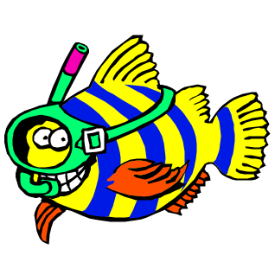
Swim Lesson Application

Contact Person / Parent
Last Name_________________________________
First Name_________________________________
Phone# (home)______________________________
(cell) _______________________________
E-Mail____________________________________
Mailing Address
Street_____________________________________
City_______________ZIP____________________

Child#1_______________________________ Child#2_____________________________
Age________________Sex M/F___________ Age_______________Sex M/F__________
Birthday_____/_______/_________________ Birthday______/________/___________
Had lessons previously? Y/N______________ Had lessons previously? Y/N____________
Where / When? ________________________ Where / When? ______________________
Circle One: Circle One:
Non-Swimmer Beginner Swimmer Non-Swimmer Beginner Swimmer
Intermediate Swimmer Baby & Me Intermediate Swimmer Baby & Me

Circle preferred start month for lessons: May June July August/September

List below the dates and times you are/are not available for lessons (ex: am only, eve only, June only, M/W, T/TH, etc.) Please remember family vacations and appointments. Be as flexible and clear as possible. _______________________________________________________________________________________________________________________________________________________________________________________________________________________________________________________________________________________
_____________________________________________________________________________________________

Please mail this form along with your $100 dollar deposit per child:
Amy Morris 1757 Jordan Avenue Clovis, CA 93611
- Make checks payable to: Amy Morris Swim School
- Remaining balance due in full upon first lesson
- After we receive your form/deposit, we will contact you to confirm and accept your schedule.

See you at the pool!!
Questions? – Amy Morris (559) 299-8080

