Simon Scores Again! 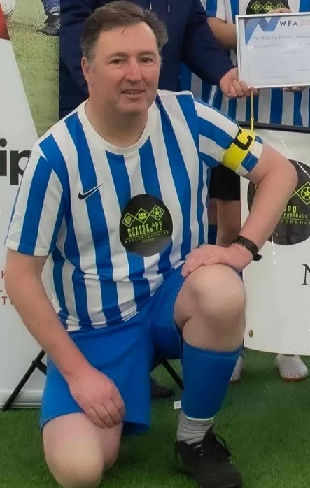 

The Walking Football Association has awarded Simon Forrest the 2023 Grassroots Impairment Coach of the Year. Simon, 55 who is the Player/Coach for the Worcester based ‘Movers and Shakers FC’ spoke about hearing the news of the Award earlier this week, ‘I am immensely proud to be the recipient of such a prestigious Award, especially as ‘Movers and Shakers’ were voted Impairment Club of the Year for 2022 having only being formed two years earlier as an inclusive activity for people with Parkinson’s and other Neurological conditions’

Since joining ‘Movers and Shakers FC’, Neuro Walking Football Worcester only just over a year ago, Simon has made a tremendous contribution to the Club, whose membership is rapidly approaching 30 plus carers and associates, all of whom look forward to their weekly training and playing sessions. Simon also arranges participation in Regional and National tournaments with other Parkinson’s teams.

Simon’s talents have also been recognised Internationally following his appointment as the Captain of the England Walking Football Team who have played in tournaments in Belfast, Singapore, Guernsey and Malta.

Simon is a vocal advocate for inclusivity, providing gentle and sensitive encouragement and guidance for players of all abilities, ages and gender. He has recently been appointed as Chairman of Neuro Walking Football Worcestershire and is championing their application to become a Charitable Incorporated Organisation.

He has recently taken up a position as Impairment Director for the WFA

Want to find out more about the ‘Movers and Shakers FC’? Visit our website [www.moversandshakersfc.co.uk](http://www.moversandshakersfc.co.uk) or Email moversandshakersfc@gmail.com