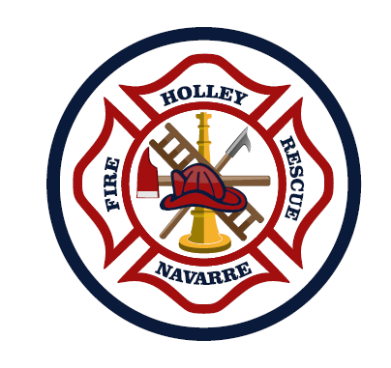
Holley-Navarre Fire District
Board of Fire Commissioners Meeting

Agenda

April 25, 2022

Opening Pledge

Public Comments

Chairman’s Comments

Meeting Minutes: March 31, 2022

Treasurer’s Report: April 2022

Chief’s Report

Commissioner’s Comments

Old Business:
- Sutphen Tower Status
- Assessment Committee Update

Action Register:
- Options to phase in ALS, single medic on rescue truck as a temporary possibility? Is that possible and how to accomplish this? (2/21)
- Plan to build station in Holley? Need 3 different options with associated costs. C.Schumpert wants to know if we have any other options to decrease the cost of the building. Could we share building with SO? Commercial business to use as storefront with station behind? Temporary modular building? (10/21)
- C.Schumpert would like Chief Norton to work on a plan to hire an assistant chief to put in his place when he retires. (11/21)
- Chairman Stone asked if Chief Norton could get in touch with GSG to do a study regarding all our targeted goals and if we can meet those goals by going ad valorem vs non-ad valorem. (11/21)
- C.Tolbert would like to see minimum wage increase scale without including the annual 2.5%. (11/21)
- C.Tolbert would like to prioritize and make a plan for if the referendum fails. He would like to see a mock budget for if the vote fails. Tolbert asked Chief Norton to email a timeline from GSG regarding what should be done with the referendum. He would also like Chief Norton to work on a budget if the referendum does not pass. (11/21)
- C.DJ Stone would like the Board to complete the 360 evaluation in a timely manner. He would like the Board to be provided the survey digitally to expedite completion of them. (2/22)
- C.DJ Stone would like Chief Norton to do research on a used back-up engine as a reserve and how to fund it. (3/22)
- C.Tolbert would like to know the average median home value in the District so that we will know the potential impact to the public if the ad valorem referendum goes through. (3/22)
- C.DJ Stone would like reports to be completed before the end of each crew’s shift. (3/22)
- C.DJ Stone would like Chief Norton to meet with Chief Fureigh about 49 responding to secondary Delta and Echo calls east of Hwy 87 on 98. (3/22)
- C.DJ Stone would like to move Midway up and Ocean City down on the run cards for responses. (3/22)
- C.Tolbert would like it to be a priority to update the disciplinary policy in the CBA. (3/22)

Next Meeting: Next meeting Monday, May 23, 2022

Any person who decides to appeal any decision made with respect to any matter at this meeting will need a record of the proceedings, and for such purpose may need to ensure that a verbatim record of the proceedings is made, which record includes the testimony and evidence upon which the appeal is to be based. The Holley - Navarre Fire District adheres to the Americans with Disabilities Act and will make reasonable modifications for access to this meeting upon request. Please call 850-939-5236 to make a request. For Hearing Impaired dial 1-800-955-8771 (TDD) or 1-800-955-8770 (Voice). Requests must be received at least 48 hours in advance of the meeting in order to allow the District time to provide requested services.

