Support Our Veterans
"Guard Our Guardians" Benefits the Resurrecting Lives Foundation
A tribute to service, sacrifice, and the families who stand beside our nation’s guardians.
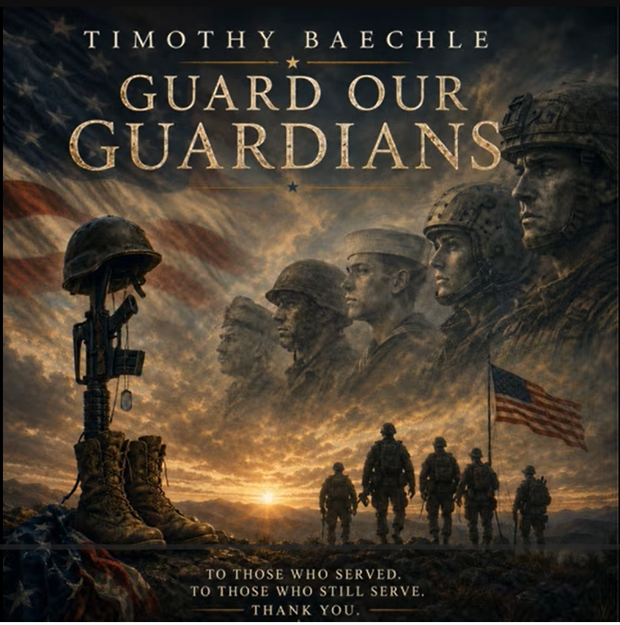

This song was written in honor of those who served, those still serving, and the families of those who made the ultimate sacrifice. Proceeds from this single help the Resurrecting Lives Foundation continue its vital work in the veterans community, including healthcare access, support services, and the journey from deployment to employment.
Listen, share, and help uplift our veteran community.
Watch “Guard Our Guardians” on YouTube
With gratitude and appreciation, Timothy Baechle

