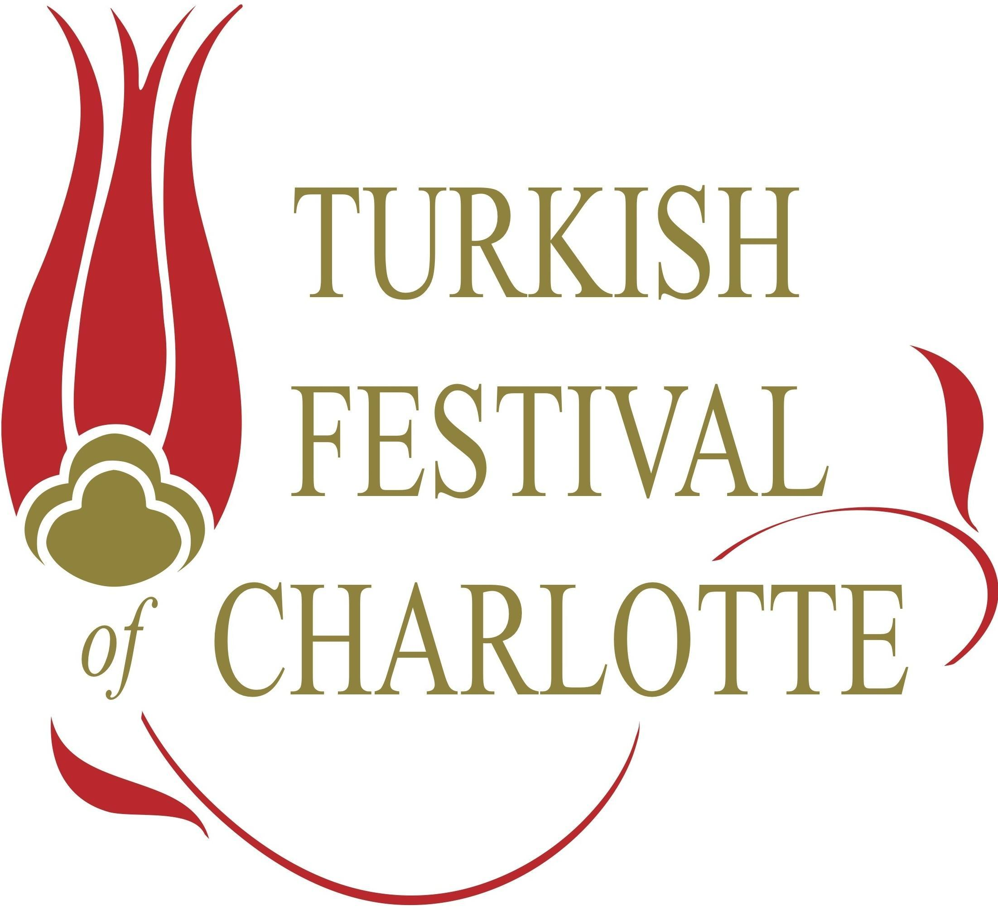
Peace at Home and Peace in the World” – Mustafa Kemal Atatürk, founder of the Turkish Republic

November 13, 2018
ATA-NC-Charlotte has successfully completed its 5th Charlotte Turkish Festival held at the Extravaganza Depot on Saturday, November 3, 2018. More than 1,500 guests attended the festival and celebrated the rich Turkish culture with live music, folk dancing, and enjoyed delicious Turkish cuisine. Children participated in activities, such as Hacivat & Karagoz shadow play, an animation video created exclusively for the event, ebru art marbling and other activities. Souvenir items and groceries from Turkey were a big hit for our guests. Many gifts were raffled throughout the festival, including a grand prize of a 2-3 day Bahamas cruise for two, courtesy of I-Cruise.
We would like to take this opportunity to extend our deepest gratitude to sponsors who generously contributed and supported this year’s festival. Our Gold Sponsors were Glemco Parts, a government contractor supplying parts to the US military, Ozen Air Technology, a new venture to Charlotte, involved in assembling and distribution of compressed air equipment. Our Silver Sponsors included I-Cruise, a Florida based travel company specializing in cruises and resort vacations, Bridge To Turkiye Fund, a North Carolina-based philanthropic organization that supports projects in the fields of education and public health care for children in Turkey, and Cam Creations, a fine jewelry designer. And finally, our kind sponsors who contributed either funds or in-kind merchandise included Concord Global, Ozdil Translations, DOEA Real Estate, Milano’s Pizza, Susa’s Ice Cream, Premier Yarns, Salman Family and Aleckson Family.
This festival would not have been possible without the tremendous support of our organization’s board members and many volunteers from our community. We also like to extend our appreciation to our guest performers who joined us from ATA-NC-Raleigh.
Thank you again for attending the Turkish Festival and making it a huge success. We hope to see you again at future ATA-NC Charlotte events.
Sincerely,
Haluk Telimen
President, ATA-NC-Charlotte

