2017 NFHS Rules Three-Man Pre-Game  KEYS TO SUCCESS:  - Communicate with partners, table, coaches & players.  - Practice preventative officiating; eyes are always on the players!  - Set tone early; reassess often. Be consistent as a crew.  - Keep the game safe, fair and fun.  - Don’t ref the rules, ref the game.  SITE ADMINISTRATOR Identify who has lightening detector.  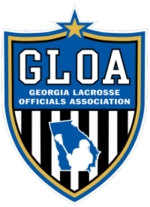  COACH’S MEETING you may Certify both, get it done early and let teams warm up.  CERTIFICATION - Captains, In-Home, Crew Card, game time, issues?  R’s INSTRUCTIONS with Head Coach, decorum, sportsmanship, time you will grab captains  NEW RULES & INTERPRETATIONS be willing to answer questions.  COIN TOSS R at center X, U has home walks out first, then FJ with visitors, U and FJ repeat call.  FOGO CONFERENCE meet with all FOGOS prior to game to set expectations. Check for tape/paint.  TABLE PERSONELL Start/stop on whistle, 5-minute personals, stacking, release on FO, double horn.  CHECK FIELD, GOALS, WATCH PLAYERS Wait for warm-ups to end; stick checks on far side.  HALFTIME watch mixed colors, clear field, start clock, horn at 4 minutes. Check with table.  OVERTIME – One Timeout per OT Period, Coin Toss for Direction Only, AP stays same, 1st goal wins.  POSTGAME Eyes on players. R approves score, watch teams cross, walk off as crew.  MECHANICS  ALWAYS COUNT PLAYERS & CHECK CLOCK no dead ball restarts with too many or too few.  COMMUNCIATION  ECHO Flag Down, He’s in, Reset, GIKI, AP, Tip, Game Time, All Even.  MIMIC Point ready, stop sign, direction, GIKI, Gained Attack Box, Possession.  EYE CONTACT be aware of where your crew, are they ready?  PENALTIES Relay to crew, move to open area, stand still, clean and crisp, CNOTE.  MAN DOWN always let keeper know where ball is before restart.  ENDING COUNTS make sure single stops count, verbalize “He’s in.” Key for Over & Back.  AP Signal Face-off & Point Direction. Make sure everyone know what is happening.  TIME always be aware of the game clock, verbalize.  BE AWARE understand the situation; know the game you’re working & how it’s changing.  RESTARTS No Player within 5 and partner ready. B can restart in box/crease, A is always out.  COMMUNICATE let partner and players know where the ball is. ALWAYS point or hold.  QUICK but don’t rush. No running starts.  WHERE Defense may restart in box or crease (5 yards). A is always outside box.  REPOSITION Only if Improper position gains advantage.  GOALIE has 5 seconds.  OFFSIDES count forwards! A 1st (whistle), then B (FDSW), Lead, Single and Trail count, then recount!  COUNTS Signal with twirl, yell “reset!” on change of possession.  SINGLE has ALL ten and twenty counts.  FOUR Trail has visual count, starts with GK possession in crease.  FACEOFF possession begins either a 10 or 20 count. | STICK & EQUIPMENT CHECKS ALL required equipment? Minimum 2 checks.  WHEN at dead balls, don’t double check. No one in box.  BENCH SIDE Lead and Trail grab stick in front of your bench.  MECHANICS: At midfield: R faces out, U & FJ face in.  CHECK length and width, shootings strings within 4’, deep pocket, roll front, side, 90°.  CONFIRM with R before flag, R brings to table. “It’s close” vs “Oh shit!”  TAPE, STRINGS, CAP No tape on plastic except GK. Get off and fix: 2’ max, manufactured cap.  FACEOFFS Singe take all FO; must get to far sideline. Be consistent.  SCORECARD always mark; wait until in position.  TAPE: FOGO needs 6’ contrasting color up to plastic. Delay if none.  MECHANIC: [Whistle in mouth, point] Down [adjust; place ball] set [back out] whistle.  LEAD LEFT Do not adjust crosses; check Neutral Zone. Get in position and freeze.  WING Timer on! Hold until field ready for play; focus on wing play. Goal coverage.  PREWHISTLE FOUL No whistle; stand players up, point. Trail has restart! Free Clear.  FACEOFF VIOLATION Ball restarts at spot. No release until whistle.  LEAD RUN. Lead MUST beat ball downfield. NEVER WALK.  POSITION GLE to endline, work in as closely as possible, open shoulders to field.  COVERAGE Goal is primary. Endline on shot or contested play; Single takes goal.  BOUNDARIES Lead has sideline until Trail arrives  RESTARTS endline, let Trail take sideline restart.  GOALS Blow Whistle, Run To Crease and then signal, Keep eyes on players after score!  SINGLE Hustle, don’t hurry. Move to spot, stop, and move to next spot. NEVER WALK.  TRANSITION Get to midline ASAP, initial offsides, count forwards. Let ball pass you at midfield.  POSITION Move from cone to 5 Yards Above GLE.  COVERAGE Hybrid Trail/Lead: Offsides, Late hit on shooter, cover goal when needed.  COUNTS all 20 and 10 second counts.  FACEOFF cover Leads goal on fast break.  CREASE cover goal if Lead moves to Endline.  SHOT If not on goal: Watch shooter/passer.  TRAIL Hustle, don’t hurry. Move to spot, stop, move to next spot. NEVER WALK.  POSITION 5 Yards Above Box, Primary concern is return to Lead.  COVERAGE Offsides & substitutions, your alley, above box, Watch the shooter! Late hits!  COUNTS 4 second count.  TRANSITION Primary key is goal behind you, good time to talk to bench, announce “I’m in.”  SUBSTITUTIONS Player on field has right of way, watch for delayed subs.  SIDELINE cover sideline for Lead when in position.  KEY Crew saver: Watch shooter, Watch shooter, Watch shooter!  ON/OFF NEVER ball watch, if unsure of who has ball, verbally communicate!  SPECIAL SITUATIONS  PLAY-ON Don’t disadvantage offended team. Keep it short!  CREASE COVERAGE Player coming towards you = feet and goal, Back = push. Must have flag!  DEAD BALL Eyes on the inmates, set field for play: find ball, announce location, penalty time.  TIMEOUTS Trail Has 1:40 Timer, wait till teams are in huddle, watch mixed colors.  GIKI Communicate, create opportunity, don’t penalize good defense, Even if uneven. Not if 4+.  OVER & BACK Unless shot or tipped by B immediate whistle if contested. Treat as play-on. FIGHTING Officials closest controls fight, partner freezes benches. Get numbers.
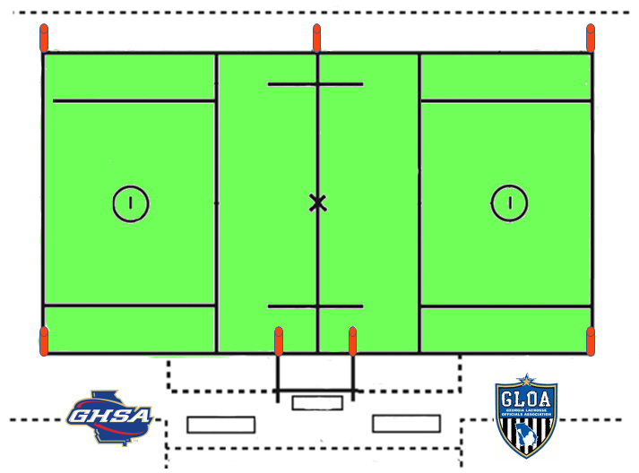
2016 NFHS Points of Emphasis  - Contact  - Equipment Checks  - Properly Fitted Helmet  Overtime Procedure  - 2 minute intermission(s)  - Coin Toss: winner determines goal to defend  - AP carries over  - 4 minute periods until goal scored  - 1 TO per team per period  - No stick checks once a goal is scored; game is over  Game Termination  If lightning is detected, the game manager notifies the head official and play is suspend  If officials spot lightning before being notified, they may suspend play.  All contests involving teams of the same classification will be played to completion. There will be no mandatory two-hour delay and no 11:30 pm curfew.  Administrators from the competing schools may agree to terminate the contest and resume competition at the point of interruption at a later time.  R should record ALL game information and submit report. | 2016 NFHS Rules Changes  1-6-1: ART. 1: Shooting strings within 4’ of top pf crosse. New crosse dimensions in 2018 (NCAA).  1-8: One sidewall string, no pull strings.  4-3-3: ART. 3 FOGOs need 6’ of single wrap tape of contrasting color up to plastic. NCAA faceoff mechanic: Down, Adjust, Set with ball in hand. Back away, whistle. On a faceoff, a player may carry ball in back of crosse for one step only; otherwise a turnover.  4-14-3: ART. 3 Over and Back. A must gain attack area. May not cross or touch midline; unless tipped by defense or shot. A may bat ball back into offensive half, but may not possess. Treat as a play on.

