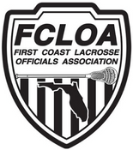

2020 FHSAA Committees

Evaluation - Peter Dellavecchia, Ray Bernard, David Goode

Assignments - Jody Ticer, Ken Vernoski, Aaron West

Recommendations -  Alex Tredinnick, Kevin O'Leary, Jeff LaVangie

Grievance - Nick Vernoski, Scott Petersen, James DeArman

Training - Bob Pradella (Chair) Jacksonville, Brody Sauers (Gainesville), Jeff Sherman (Panhandle West)