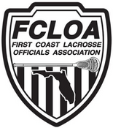

2021 FHSAA Committees

Evaluation - Peter Dellavecchia, Jake Leitch, Eric Applegate

Assignments - Jody Ticer, Aaron West, David Goode

Recommendations - Alex Tredinnick, Kevin O'Leary, Jeff LaVangie

Grievance – Jeff Sherman, Brian Johnsey, Garrett Popovich

Training - Bob Pradella, Brody Sauers, Colin Smith

