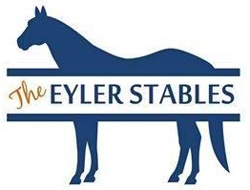
The Eyler Stables Horse Auction
Consignment Form
(Complete the form by typing your information on the lines provided and save file with the name of “Consignment info for Your Name”. You can also print the form out, complete and then scan using the same file naming as above. After completing
the form email to “theeylerstables@gmail.com)
Name of consignor:
Mailing Address:

Phone #:
Email address:
Horse Information:
Age:
Breed:
Registered or grade:
Sex:
Color:
Height (if known):

Please give detailed description of horse:

Selling horse (circle one): Sound or AS IS
COMPLETED AND SUBMITTED NO LESS THEN 24 HOURS PRIOR TO EACH SALE

