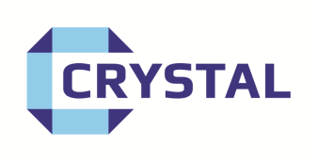**Crystal Paints   
5 Curban St, Underwood QLD 4119  
PH: 07 3341 3566**

**Silvercoat**

**One Coat Wonder – Roof & Metal Paint**

**High-Quality Silver Coat with Exceptional Coverage Strength**

* Suitable for most metal surfaces, including **roofs, structural steel, and more**
* Easy application by **brush, roller, or spray**
* If spraying, you may need to **thin with mineral turps** to suit your spray gun
* **Recoat time:** 3 to 8 hours, depending on conditions

**Surface Preparation:**

* **Raw steel** must be primed with **Grey Oxide Primer**
* **Bare timber** requires a suitable **primer or undercoat**
* Always apply a **test patch** to the prepared surface before full application

**Coverage:**  
8–16 square metres per litre (depending on surface and application method)

**Thinning & Clean-Up:**  
Use **mineral turps only**  
**Do not mix with other paints**

**Available Sizes:**

IF YOU ARE UNSURE ABOUT ANYTHING TO DO WITH THIS PRODUCT DO NOT USE IT AND CONTACT YOUR CRYSTAL STOCKIST OR THE FACTORY DIRECT

