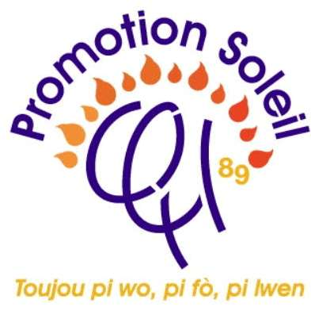
SPONSORSHIP OPPORTUNITY

2026 Fundraising Gala
Build a School | Expand Your Brand | Connect With the Community
Supporting the construction of École Notre-Dame de Lourdes in Gros-Saut, Léogâne, Haiti

SATURDAY | THE EVENT CENTER
November 14, 2026 | 6101 NW 31st Street, Margate, FL 33063
A sponsorship that creates educational impact while placing your organization before an engaged community.

THE BUSINESS OPPORTUNITY
Purpose With Strong Marketing Value
Sponsoring Promotion Soleil's 2026 Fundraising Gala is both a meaningful investment in education and a strategic opportunity to strengthen your organization's community presence. The campaign is designed to give sponsors sustained visibility before, during, and after the gala.
Exposure Access Visibility Connection
• Present your brand to gala guests and members of the South Florida Haitian community.
• Build relationships with professionals, families, entrepreneurs, community leaders, and representatives of local organizations.
• Promote your organization through radio advertising, printed materials, diverse social media channels, and year-round website promotion.
• Connect directly with potential customers and referral partners through gala participation and selected sponsor engagement opportunities.
• Demonstrate visible support for education, children, and community development.
The Audience
Planned attendance | Community reach | Business relevance
A gala designed for approximately 200 to 400 guests | South Florida's Haitian community and its broader professional and social networks | Opportunities to meet potential customers, advocates, and referral sources
Community Impact
The former school serving Gros-Saut was destroyed in the 2010 earthquake and was never rebuilt. Gala proceeds will support construction of a safe and dignified learning environment where local children can learn, grow, and prepare for a better future.
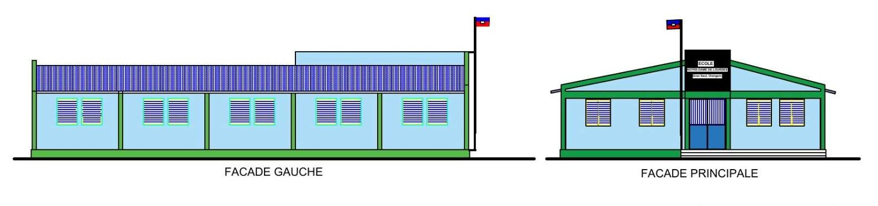
Proposed École Notre-Dame de Lourdes school design

YEAR ROUND PROMOTION
A Full Campaign of Sponsor Visibility
Sponsor recognition will extend beyond gala night. Promotion Soleil will use multiple communications channels throughout the campaign year to promote the event, recognize participating sponsors, and maintain public awareness of the school project.
Channel | Planned exposure | Value to sponsors
Radio | Gala advertising and sponsor acknowledgments, according to the selected sponsorship level | Brand awareness among listeners beyond the event venue
Print | Flyers, banners, event program, signage, and other promotional materials | Repeated name and logo visibility in community-facing materials
Social media | Event promotion, sponsor recognition, selected spotlight posts, and post-event appreciation | Shareable exposure and opportunities for digital engagement
Website | Year-round gala and sponsor promotion, with recognition based on sponsorship level | Sustained online visibility and a path for visitors to learn about participating organizations
Gala night | Stage recognition, program advertising, signage, reserved seating, and selected engagement opportunities | Direct access to guests and opportunities to begin new relationships
Three Stages of Exposure
Before the gala Campaign advertising builds awareness and associates sponsors with the event's purpose.
During the gala Recognition and selected on-site benefits help sponsors engage directly with guests.
After the gala Thank-you communications and continuing website visibility extend recognition beyond the event.
Sponsor benefits depend on the selected level and the timely receipt of payment, logo files, advertisements, links, and other required materials. The package offers marketing exposure and opportunities to connect; it does not guarantee a specific number of impressions, leads, or sales.

SIGNATURE SPONSORSHIPS
Lead the Campaign
Designed for organizations seeking the greatest visibility, strongest gala presence, and direct opportunities to engage with guests.
Presenting Sponsor  $10,000 Premier Level  • Exclusive recognition as the event's highest-level sponsor  • Premium seating for 20 guests  • Brief speaking opportunity and special stage recognition  • Premium full-page advertisement in the event program  • Most prominent logo placement across flyers, banners, website, and social media  • Featured sponsor recognition in radio promotion and campaign communications  • Prominent event display and an on-site sponsor engagement table  • Website link or QR code placement and inclusion in media releases  • Commemorative plaque and post-event appreciation | Platinum Sponsor  $5,000  • Premium seating for 10 guests  • Brief speaking opportunity during the program  • Full-page advertisement in the event program  • Prominent logo placement on printed materials, website, and social media  • Sponsor spotlight through selected digital promotion  • Radio acknowledgment, stage recognition, and an on-site engagement table  • Website link or QR code placement and sponsor appreciation certificate

MORE WAYS TO PARTICIPATE
Choose the Right Level of Visibility
Gold Sponsor
$3,000
• Reserved seating for five guests
• Half-page advertisement in the event program
• Logo placement on printed and digital event materials
• Website sponsor listing with link and selected social media recognition
• Radio acknowledgment, stage recognition, and sponsor appreciation certificate
• Opportunity to provide approved promotional materials for guests
Gala Table Sponsor  $1,500  • Reserved table for 10 guests  • Sponsor name displayed at the table  • Recognition in the program, website sponsor listing, and gala acknowledgment  • Ideal for colleagues, families, alumni groups, and community organizations | Silver Sponsor  $1,000  • Reserved seating for three guests  • Quarter-page program advertisement  • Logo on selected print materials and website sponsor listing  • Social media recognition, event acknowledgment, and certificate
Bronze Sponsor  $500  • Reserved seating for two guests  • Name or logo in the event program  • Website sponsor listing and selected social media recognition  • Recognition during the event and appreciation certificate | Connection Opportunities  Available by level  • Sponsor display or engagement table  • Website link or QR code placement  • Approved promotional material distribution  • Direct conversations with interested guests; attendee contact information is not shared without consent
Custom sponsorship and in-kind opportunities may be discussed with a Promotion Soleil representative. Benefits must be confirmed in writing and may depend on production deadlines.

SPONSORSHIP COMMITMENT
Become a 2026 Gala Sponsor
Complete this page and return it to a Promotion Soleil representative. Payment instructions, advertising dimensions, artwork specifications, and campaign deadlines will be provided when your sponsorship is confirmed.
Sponsor or organization
Contact name
Telephone
Email
Website
Recognition name
Select a Sponsorship Level
☐ $10,000 Presenting | ☐ $5,000 Platinum
☐ $3,000 Gold | ☐ $1,500 Gala Table
☐ $1,000 Silver | ☐ $500 Bronze
Primary Marketing Objective
☐ Brand awareness ☐ Community engagement ☐ Customer connections ☐ Corporate social responsibility
Promotion Soleil Representatives
Shubert Pierre | Sherley Bertin
Telephone (631) 482-5388  Email shubypam@hotmail.com | Telephone (781) 558-7694  Email sashefe68@gmail.com

