“Outside the Box”¹ Options for the EAA Reservoir/STA Project

by
Jay O’Laughlin, Ph.D.²
and
Joseph L. Gilio^{3, 4}

January 22, 2018
(revised from January 4, 2018)

_______________
1. Florida Senate President Joe Negron said he wanted “state engineers to think outside the box and outside the ‘footprint’ they’re considering for a reservoir south of Lake Okeechobee” (interview in TCPalm, December 14, 2017, emphasis added). As yet South Florida Water Management District (SFWMD) engineers have not done so.
2. Jay O’Laughlin, Ph.D., is Professor Emeritus and Director Emeritus, Policy Analysis Group, College of Natural Resources, University of Idaho. He lives in Hobe Sound adjacent to the Indian River Lagoon, and writes water policy analyses* for The Guardians of Martin County, a 501(c)3 organization committed to educating Martin County residents about balanced use of natural and man-made resources. Contact: jayo@uidaho.edu
3. Joseph L. Gilio is a Professional Wetlands Scientist Emeritus, with 40 years of experience designing and maintaining constructed wetlands and lakes achieving TMDL for total phosphorous. He lives in Palm City on the South Fork of the St. Lucie River. Contact: www.jlgilio.com
4. The authors acknowledge with thanks help from Gary Goforth, P.E., Ph.D., consulting water resources engineer in Stuart, Florida, with 35 years of experience including design, construction, and operation of 41,000 acres of constructed wetlands. Contact: www.garygoforth.net
* For example, “Florida’s Future Water Supply Depends on Improved Surface Water Management” (December 2016) and “Arguments Against the EAA Reservoir and Rebuttals” (April 2017). These documents can be read or downloaded at, respectively:
http://theguardiansofmartincounty.com/wp-content/uploads/2016/12/GMC_Water_Position.pdf
http://theguardiansofmartincounty.com/wp-content/uploads/2017/04/arguments-rebuttals_EAA-reservoir_JayOL_04-16-2017.pdf

Table of Contents
Executive Summary 3
Introduction 4
EAA Reservoir/STA Project Goals 4
Assumptions and Analytical Variables 5
Current Options and CERP Goal 1 Attainment 6
SFWMD Options 6
Map 1. EAA Reservoir/STA Project Area 6
Everglades Foundation Option 7
Map 2. EAA Land Ownership with EAA Reservoir/STA
Project Area Overlay 7
Map 3. Exchanging C-139 Annex lands for Holey Land WMA Lands 8
CERP Goal 1 Attainment 9
Table 1. Summary Analysis of Current Options 10
Current Options and CERP Goal 2 Attainment 10
Modified Options and CERP Goal 1 Attainment 11
Hybrid Option R240 H1 11
Hybrid Option R240 H2 11
Map 4. Hybrid Options R240 H1 and H2: Repurposing Rotenberger
and Holey Land WMAs to STAs 11
Table 2. Summary Analysis of Hybrid Options 12
Modified Options and CERP Goal 2 Attainment 12
Analytical Summary of All Options 12
Figure 1. Lake Okeechobee annual discharges to St. Lucie, 1980-2017;
reductions from EAA Reservoir/STA options with 1.5 foot deep STAs 13
Table 3. Summary of All EAA Reservoir/STA Project Options 14
Figure 2. Performance of EAA Reservoir/STA options for improving
flow conditions and attaining CERP goals 15
Benefits from the EAA Reservoir/STA Project 15
Table 4. Employment impacts associated with proposed EAA
Reservoir/STA project (per 1,000 acres) 16
Appendix A. Flow Schematic (FS) Diagrams: Three Current and Two Hybrid Options 18
FS-1. Flow Schematic: SFWMD R240A “Best Buy” Option 18
FS-2. Flow Schematic: SFWMD C360C “Best Buy” Option 18
FS-3A, 3B. Flow Schematic: Everglades Foundation Option 19
FS-4. Flow Schematic: Hybrid R240 H1 Option 18
FS-5. Flow Schematic: Hybrid R240 H2 Option 18
Appendix B. Model Variable Descriptions and Calculation Formulas 21
References Cited 23
Executive Summary
The Florida Legislature passed a law in 2017 authorizing and partially funding the creation of a water storage reservoir and necessary water quality treatment facilities in the Everglades Agricultural Area (EAA) south of Lake Okeechobee. The purposes of the project are a) to send more water south of the EAA into the Everglades Protection Area and b) to reduce the discharge of excess Lake Okeechobee water to the estuaries east and west of the lake. The reservoir is one project component of the Comprehensive Everglades Restoration Plan (CERP).
Current Options. The South Florida Water Management District (SFWMD) is responsible for the project, and has two options for meeting requirements in the law. The Everglades Foundation (EF) has proposed a different project configuration. We call these the current options, and analyze the effectiveness of their designs to meet CERP goals and water quality standards. In addition we identify where the EF water treatment areas could be built on state-owned lands.
All three current options are designed to meet CERP Goal 1 of sending an additional 300,000 acre-feet (ac-ft) of water south of the EAA each year. None of the three current options comes close to meeting CERP Goal 2, which is an 80 percent reduction of discharges from the lake from all authorized CERP projects. We calculate that either of the two SFWMD options alone would reduce discharges by 29 percent, the EF option by 32 percent. Based on SFWMD analysis other authorized CERP projects together would reduce discharges by an additional 23 percent. SFWMD and EF options would reduce discharges by 50-55 percent, well short of CERP Goal 2.
Modified Options. Two hybrid “outside the box” options analyzed herein improve on the performance of the three current options. Both use the same reservoir footprint as the EF option (the A-2 parcel) but with different water quality treatment configurations on state-owned lands near the reservoir. The first hybrid option (H1) would more than double CERP Goal 1 and by itself would reduce discharges by 50 percent. The second option (H2) would send 1.2 million ac-ft/yr south of the EAA, or four times CERP Goal 1 and by itself reduce discharges by 69 percent. H2 is the “optimal configuration” to meet CERP goals without needing to acquire private lands.
When discharge reductions from other authorized CERP projects are added to those of project options, H1 would reduce discharges by a total of 73 percent, and H2 by 92 percent. Flow schematic diagrams for the five options, plus analytical results, are provided in Appendix A.
H1 would repurpose the Holey Land Wildlife Management Area (WMA) for water quality treatment; H2 would add Rotenberger WMA. WMAs are adjacent to the A-2 parcel and are owned by the Internal Improvement Trust Fund. The Board of Trustees is comprised of the governor and cabinet. “The Board has a duty to hold lands in trust for the use and benefit of the people of the state” (Florida Statutes 253.001). Therefore the Board’s duty is to weigh the benefits of repurposing WMAs compared to their current use. The H2 option, for example, would create an estimated 31,000 temporary construction jobs and 1,000 new permanent jobs operating and maintaining infrastructure and providing recreation opportunities.
Introduction
In 2017 the Florida Legislature passed a law authorizing the creation of a water storage reservoir and necessary water quality treatment facilities (such as stormwater treatment areas, or STAs) in the Everglades Agricultural Area (EAA) immediately south of Lake Okeechobee and appropriated $800 million to do so. If the project meets requirements of the Comprehensive Everglades Restoration Plan (CERP), the federal government will also provide $800 million for the project. The law was signed by Governor Rick Scott in May 2017.
This report analyzes three current options for the EAA Reservoir/STA project; two are offered by the South Florida Water Management District (SFWMD) and one by the Everglades Foundation (EF). We offer two “outside the box” options that improve considerably on the performance of the SFWMD and EF options.
EAA Reservoir/STA Project Goals
The Everglades Agricultural Area (EAA) Reservoir project was conditionally authorized in the Water Resources Development Act of 2000 as project component G of the Comprehensive Everglades Restoration Plan (CERP). The EAA is 700,000 acres immediately south of Lake Okeechobee, of which approximately 500,000 acres are farmed, mostly for sugarcane. According to the SFWMD (2018) CERP goals for the EAA Reservoir project are:
- 300,000 acre-feet per year (ac-ft/yr) of additional water moving south from the EAA into the Everglades Protection Area, and
- reduce by 80 percent discharges of excess Lake Okeechobee water to the Northern Estuaries (St. Lucie and Caloosahatchee).
In addition, the EAA Reservoir project must meet water quality standards. Stormwater Treatment Areas (STAs) are constructed wetlands where water flow is controlled so that aquatic vegetation can uptake or absorb phosphorous, the most problematic pollutant in South Florida. The success of the EAA Reservoir project in meeting its goals depends on the adequacy of STAs for treating water stored in the reservoir before it can move south.
In 2017 the Florida Legislature passed Senate Bill 10 and in May 2017 Governor Rick Scott signed it (Florida Statutes 373.4598 Water Storage Reservoirs). The South Florida Water Management District (SFWMD) is charged with designing and constructing the EAA Reservoir, and the law specifies the minimum size as 240,000 acre-feet (ac-ft) of nominal storage and identifies 31,000 acres of lands the state already owns that the SFWMD could use for the reservoir. The law authorizes the SFWMD to acquire additional lands, and if owned privately, only from willing sellers, which means the state cannot exercise its power of eminent domain.

[blank space is intentional]
Assumptions and Analytical Variables
We make several assumptions in this analysis. First, STAs will be filled throughout the year at the depths we specify. Second, the Everglades Protection Area can receive all water flowing out of the EAA STAs that meets water quality standards. Extending the duration of time water is retained in the STA may increase the uptake of phosphorus by vegetation and sediment in the STA (Chen et al. 2015).
Our analytical approach is based on the simple premise that the storage reservoir is not static, but will be managed dynamically so that its effective annual capacity could be several times more than its nominal capacity. Because it does not meet water quality standards, stored water must be treated before it can be sent south. The SFWMD has designed, constructed, and operated six STAs at the southern edge of the EAA. Over the past ten years, the 57,000 acres of STAs in the EAA have treated an average of 1.1 million ac-ft/yr (SFWMD 2017a).
STA effectiveness is a function of area, depth, and rate of flow. We use both 1.5 feet and 4 foot depths, basically doing the analysis twice for each Reservoir/STA configuration. The measure of STA effectiveness we use is the average number of days that water is retained in the STA. The higher the number, the longer water is retained in the STA, and the more time vegetation has to absorb or uptake phosphorous, the major pollutant of concern.
At an average 1.5 foot depth, the 57,000 acres of STAs in the EAA have a Nominal Storage Capacity of 85,500 ac-ft; at a 4 foot depth, 228,000 ac-ft. Dividing the average treatment of 1.1 million ac-ft/yr by the STA Nominal Storage Capacity produces what we call the number of STA Flow Through Cycles per year, which is 12.86 at 1.5 foot STA depth and 4.82 at 4 foot depth. To convert this to number of days the water is retained in the STA, we divide the number of days in one year (365) by the STA Flow Through Cycle, resulting in 28 days at 1.5 foot STA depth and 76 days at 4 foot depth. We can then use these results as a benchmark to compare with calculated STAs for the EAA Reservoir/STA project configuration options. (Descriptions of model variables and calculations formulas are provided in Appendix B.)
This approach can only be used if the quantity of water treated per year is provided. We call this the Reservoir Effective Annual Capacity. In essence, the analyst uses this to force calculation of the STA Flow Through Cycle by dividing the Reservoir Effective Annual Capacity by STA Nominal Capacity, which is acres of STAs times depth. Otherwise, we default to the actual STA Flow Through period in the EAA described above, and use it to force the calculation of Reservoir Effective Annual Capacity.
Reservoir Flow Through Cycle is similar to the STA Flow Through Cycle, in that it tells us how many times water can flow into and out of the reservoir in one year, which is how many times the reservoir can be refilled in one year. The more refills, the more efficiently public funds are being used. The number of Reservoir Flow Through Cycles per year multiplied by the Reservoir Nominal Storage Capacity produces what we call Reservoir Effective Annual Capacity. This quantity is the same as how many additional acre-feet per year of excess Lake Okeechobee water will flow south into the Everglades Protection Area. This can be compared to the CERP Goal 1 target of 300,000 ac-ft/yr stored, treated and sent south.
Reservoir Effective Annual Capacity is used to calculate project option contributions to attainment of CERP Goal 2. We use actual annual discharges of excess Lake Okeechobee water to the St. Lucie River from 1980 through 2017. Because discharges to the Caloosahatchee are double that to the St. Lucie, we take one-third of the Reservoir Effective Annual Capacity for the St. Lucie River and two-thirds for the Caloosahatchee. In the 18 years when discharges exceeded that reduction benefit, we tally the entire benefit. In years when the benefit was greater than the actual discharges, we tally only the actual discharges as the reduction amount.
Current Options and CERP Goal 1 Attainment
Starting with public meetings in October 2017, the SFWMD has presented two main options. In December 2017, the Everglades Foundation, dissatisfied with the SFWMD options, created one of its own. We will call this the EF option and compare it to the SFWMD options in this section.
SFWMD Options. Both SFWMD options are confined to the 31,000 acres identified in the law. These are called the A-1 and A-2 parcels (see Map 1). The State purchased the land from the Talisman Sugar Co. in 1999 to facilitate Everglades restoration. This is the “box” that Senator Negron urged the SFWMD to look outside of for, as the law puts it, the “optimal configuration” of reservoir and treatment areas.
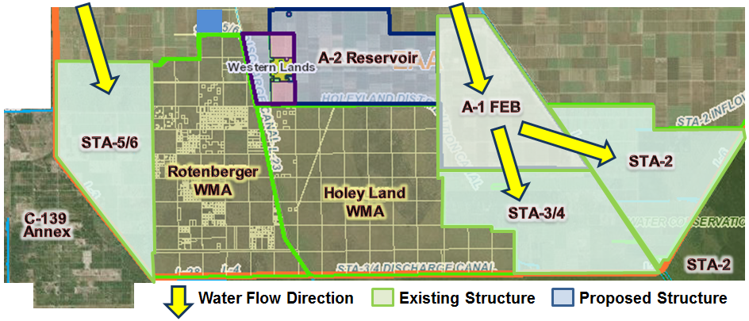
Map 1. EAA Reservoir/STA Project Area

The R240A “best buy” option uses only the A-2 parcel for a 240,000 ac-ft reservoir 23 feet deep and stormwater treatment areas (STAs) to treat the water before it can be sent south. Two alternative configurations were developed, but only the “best buy” variation is considered herein. The C360C “best buy” option uses the A-2 parcel and repurposes portions of the A-1 parcel, which already has a 4 foot deep flow equalization basin (FEB) on it. (An FEB is a constructed impoundment for providing steady flow to STAs.) Three alternative variations of the R360 option call for a 360,000 ac-ft reservoir 18 feet deep. We consider only the District’s C360C “best buy” option.
Everglades Foundation Option. The Everglades Foundation (EF) option calls for constructing a 14 foot deep reservoir on the A-2 parcel and leaving the A-1 FEB functioning as is. The EF stated that 13,000 acres of STAs are needed to treat the stored water before it can be released south, but the EF did not go “outside the box” to identify a location for those STAs. According to a story by Treadway (2018), the EF is expecting the SFWMD to exchange lands it owns for private lands on which to construct the STAs. A large proportion of the private lands that are just north of the project area are owned by Okeelanta Corp., a subsidiary of Florida Crystals Corp. owned by the Fanjul family of Palm Beach, Florida, and indicated by orange circles around the numeral 2 on Map 2.
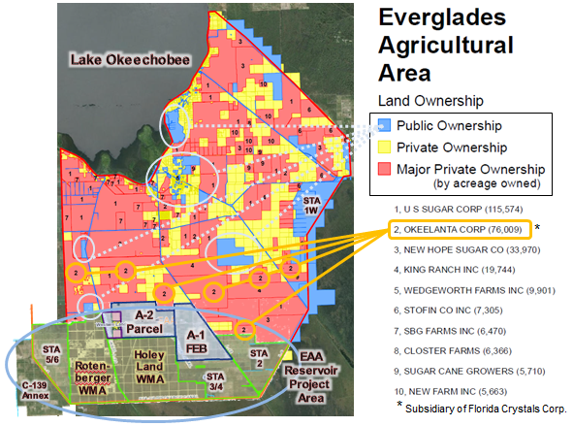
Map 2. EAA land ownership with EAA Reservoir project area overlay, plus C-139 Annex. Ownership information from Treasure Coast Regional Planning Commission http://www.tcrpc.org/departments/MapGallery/2016/1604a_EAA_Private.pd

As Map 2 indicates, the SFWMD itself has more than 18,000 acres, including 17,890 acres in the C-139 Annex and an unidentified section abutting the north side of the Rotenberger Wildlife Management Area (WMA). The Holey Land and Rotenberger Wildlife Management Areas (WMAs) are obvious candidates for STAs, as they are adjacent to the A-2 parcel where the reservoir would be built.
To facilitate the EF option, we make an “outside the box” suggestion that exchanging a 13,000 acres parcel in the C-139 Annex owned by the SFWMD for a similar-sized parcel in the Holey Land WMA owned by the Florida Internal Improvement Trust Fund is a potential opportunity to maintain the A-1 parcel within the “box” as a flow equalization basin (FEB) and build new water quality treatment areas on state-owned lands near the reservoir (Map 3).
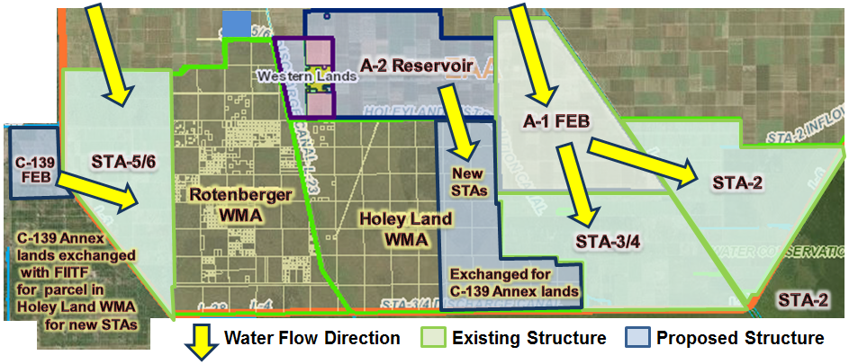
Map 3. Everglades Foundation option possibility for its unidentified STA footprint: Exchanging 13,000 acres of C-139 Annex lands for easternmost portion of Holey Land WMA for STAs
The Board of Trustees of the Florida Internal Improvement Trust Fund is comprised of the governor, attorney general, chief financial officer, and commissioner of agriculture. “The Board has a duty to hold lands in trust for the use and benefit of the people of the state” (Florida Statutes 253.001). “The Board may exchange lands under its control for other lands in the state and may fix the terms and conditions of any such exchange” (Florida Statutes 253.42(1)).
In 1983 the Board signed a Memorandum of Agreement (MOA) with the SFWMD and two agencies (since renamed the Florida Department of Environmental Protection and Florida Fish and Wildlife Commission) allowing the “construction and operation of a water control system that attempts to restore and preserve natural Everglades habitat” on the Holey Land WMA (Kosier and McBryan 2015).
The SFWMD is planning an 11,000 acre-feet FEB (~3,000 acres) as part of the Restoration Strategies program on the northern portion of the C-139 Annex parcel (Map 3). The remaining C-139 Annex lands could provide the 13,000 acres that the EF option needs for its STAs. However it would likely be difficult to convey water from a reservoir on the A-2 parcel to the C-139 Annex lands.
To overcome the conveyance hurdle, an exchange of 13,000 acres of the C-139 Annex for a like amount in the eastern part of the Holey Land WMA would allow creation of new STAs adjacent to the reservoir, as indicated on Map 3. The C-139 Annex was purchased from U.S. Sugar Corporation in 2010 for water quality purposes, including reducing discharges of excess Lake Okeechobee water into the Northern Estuaries.
CERP Goal 1 Attainment. At a public meeting on December 21, 2017, SFWMD hydrologic modeler Walter Wilcox presented a slide stating that “All scenarios [are] close to achieving [the] desired increase of 300,000 ac-ft average annual flow south.” Therefore we will assume that all SFWMD options meet CERP Goal 1 and use that desired increase as a “forcing” variable to calculate a measure of STA effectiveness, which we call STA Flow Through. It is the number of days that it takes for water to flow into and out of the STA. STA Flow Through is the water soak time for reducing pollutants.
If Lake Okeechobee water is being held in the reservoir or in the STAs, then this volume of water is not being discharged to the Northern Estuaries (St. Lucie and Caloosahatchee). This is a great benefit whether or not that water meets water quality criteria for immediate release south of the EAA. Even if the STA cleanses lake water to standards, downstream levels may mean temporary retention before southward flow.
In a letter to the SFWMD dated December 19, 2017, the EF said that its proposal could exceed CERP Goal 1 and send 340,000 ac-ft/yr south of the EAA. We accept that, as we did the similar claim by the SFWMD, and will also use these as a forcing variable to calculate STA Flow Through in days (see Appendix B for details).
Table 1 summarizes analysis of the two main options presented by the SFWMD and that of the EF. The SFWMD R240A “best buy” option is for 240,000 ac-ft of Reservoir Nominal Storage Capacity; the C360C “best buy” option for 360,000 ac-ft; the EF option puts a 240,000 ac-ft reservoir on 17,000 acres (Table 1, Col. [2]). Each option is analyzed at two STA depth scenarios: an average depth of 1.5 feet, and the maximum 4 foot depth.

[blank space is intentional]
The SFWMD R240A option would need 1.25 Reservoir Flow Through Cycles per year to meet the CERP Goal 1; the C360C could do it with 0.83 cycles (Table 1, Col. [9]). Then the model is solved for STA Flow Through (see Table 1, Notes, and a more detailed explanation in Appendix B). As cited earlier (Chen et al. 2015), extending the time water stays in the STA may allow longer contact with vegetation and sediment so that the level of total phosphorous can be reduced. The SFWMD C360C and EF options at 4 ft STA depth both have water retained in the STAs for 56 days (Table 1, Col. [8]). The other options and scenarios may not be able to meet water quality standards because the water may not be retained in the STAs for enough time.
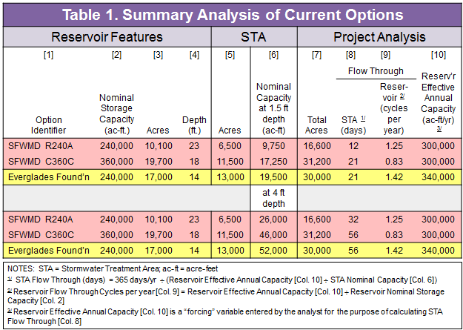
Current Options and CERP Goal 2 Attainment
According to Matt Morrison, SFWMD Federal Policy and Coordination Bureau Chief, CERP Goal 2 is to reduce by 80 percent discharges of excess Lake Okeechobee water to the Northern Estuaries (St. Lucie and Caloosahatchee). During a presentation at a public meeting on December 21, 2017, he said that other authorized CERP projects plus the EAA R240A project option would reduce discharges a total of 50 percent; the C360C option, 54 percent. Using the data set, model variables and methods described above, the SFWMD reservoir options each reduce discharges by 29 percent. Subtracting that from what Mr. Morrison said, the other CERP projects will reduce discharges by an average of 23 percent. The EF option is slightly better than the SFWMD options.
Modified Options and CERP Goal 1 Attainment
Two different hybrid options are considered. Both offer substantial improvements relative to CERP Goal 1 when compared with the current SFWMD and EF options in Table 1 above. Each uses the A-2 parcel for the EAA Reservoir, as does the EF option analyzed above, and the A-1 FEB remains as it is. Then two different STA configurations on state-owned lands are considered.
Hybrid R240 H1. The reservoir is the same as the EF option: 240,000 ac-ft on the 17,000 A-2 parcel. The A-1 FEB remains as it is. The 35,000 acres of STAs are in the Holey Land WMA which would be repurposed by the Board of Trustees as a water quality treatment area (Map 4).
The H1 option would result in a Reservoir Effective Annual Capacity of 684,000 ac-ft/yr with 1.5 foot deep STAs and 672,000 ac-ft/yr with 4 foot deep STAs (Table 2, Col. [10]). The results are not very sensitive to STA depth because flow through time differs.
Hybrid R240 H2. Again the reservoir is the same as the EF option: 240,000 ac-ft on the 17,000 A-2 parcel, and the A-1 FEB remains as it is. The 64,000 acres of STAs results from adding of the 29,000 acres in Rotenberger WMA to the 35,000 acres in the Holey Land WMA (see Map 4).
The H2 option does even better than H1, as its STA system is larger. This option would send more than 1.2 million ac-ft/yr south into the Everglades Protection Area (Table 2, Col. [10]).
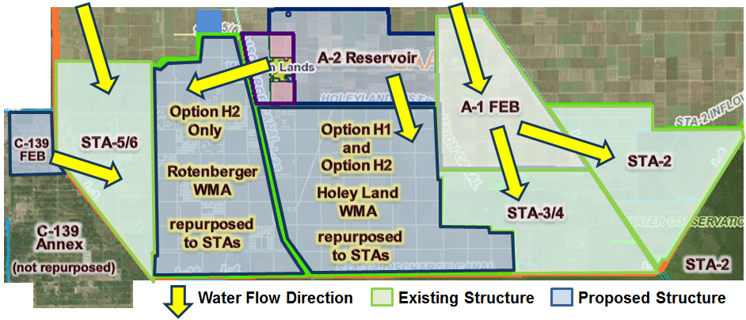
Map 4. Hybrid options R240 H1 and H2: Repurposing Rotenberger and Holey Land WMAs
to STAs
Modified Options and CERP Goal 2 Attainment
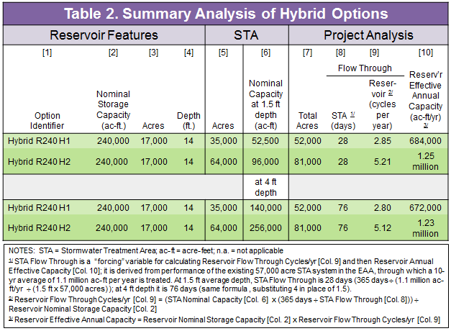
The H1 option by itself would result in a 50 percent reduction of actual discharges during the period 1980-2017. The H2 option would result in 69 percent reduction. In the next section these results are explained in more detail and then compared with those of the three current options.
Analytical Summary of All Options
The average annual discharges from Lake Okeechobee into the St. Lucie were 240,877 ac-ft/yr during the period 1980 to 2017, ranging from near zero to more than one million ac-ft/yr; in 18 of the past 38 years discharges to the St. Lucie exceeded 100,00 ac-ft/yr in 1998 (Figure 1, bars). Reductions in discharges are depicted in Figure 1 as different colored bands overlaying the bar chart. These are the incremental additions to total discharge reductions for each option. Because the model results are not sensitive to STA depth, only the 1.5 foot STA depth is displayed (the 4 foot STA depth chart is nearly identical).

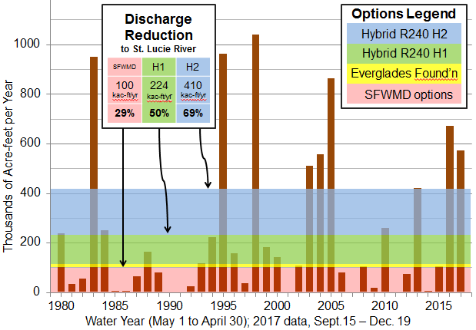
Figure 1. Lake Okeechobee annual discharges to St. Lucie, 1980-2017 (bars), and reductions from EAA Reservoir/STA options (bands), at 1.5 foot STA depth

Caloosahatchee discharges are almost exactly twice that to the St. Lucie, so if reductions in discharges are apportioned that way, with 300,000 ac-ft/yr. moving south from the EAA, then the St. Lucie potential benefit is 100,000 ac-ft/yr, and in the Caloosahatchee, 200,000 ac-ft/yr. In years when actual discharges were less than 100,000 ac-ft/yr in the St. Lucie, then the actual reduction is the amount of the actual discharge. In the 18 years when actual discharges exceeded 100,000 ac-ft/yr, the actual reduction is a maximum of 100,000 ac-ft/yr.
The sum of annual benefits of SFWMD reduced discharges to the St. Lucie during the 38-year period analyzed would have averaged 68,930 ac-ft/yr. In sum, as mentioned above, the SFWMD options would have reduced actual discharges to the St. Lucie by 29 percent (the top of the red shaded area in Figure 1). The EF option is only marginally better, reaching 32 percent (the top of the yellow-shaded area in Figure 1). Because the H1 and H2 options feature more STA acreage and longer duration of the Reservoir Flow Through Cycle, the percent of actual discharges that would have been reduced had these options been in place is 50 percent with the H1 option (top of the green-shaded area in Figure 1), and 69 percent with the H2 option (top of the blue-shaded area in Figure 1). As noted above, the results are not sensitive to STA depth, so Figure 1 displays only the 1.5 foot STA depth.
Table 3 presents summary information and analysis for all options. It is presented in two parts, one for the 1.5-foot deep STAs, and the other for 4-foot deep STAs. Similar to the summary presented in Table 2, the results are not particularly sensitive to STA depth.
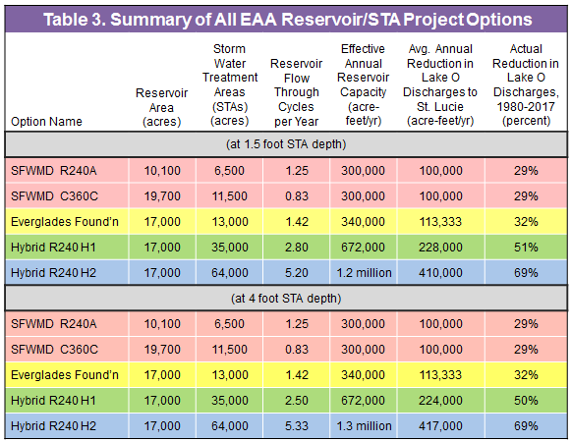

As mentioned above, according to the SFWMD, when the discharge reductions from the EAA Reservoir/STA project are added to discharge reductions from other authorized CERP projects, the sum total of reductions is 50 percent for the R240A option and 54 percent for the C360c option. We calculated the discharge reduction from either of the SFWMD options to be 29 percent. This implies that the discharge reduction from other CERP projects is 21 percent for R240A and 25 percent for C360C. The average of these is 23 percent and is applied to the EF option and the two hybrid options. The EF option then would have total reductions of 55 percent. Recall that CERP Goal 2 is 80 percent reduction. Neither the SFWMD options at an average of 52 percent or the EF option at 55 percent come close to this goal.
Again using the average 23 percent discharge reduction from other authorized CERP projects and adding the reductions from the Hybrid R240 H1 and H2 options, the H1 option attains a total 73 percent reduction, and the H2 option a 92 percent reduction (Figure 2, a format similar to a chart that the SFWMD used on December 21, 2017).
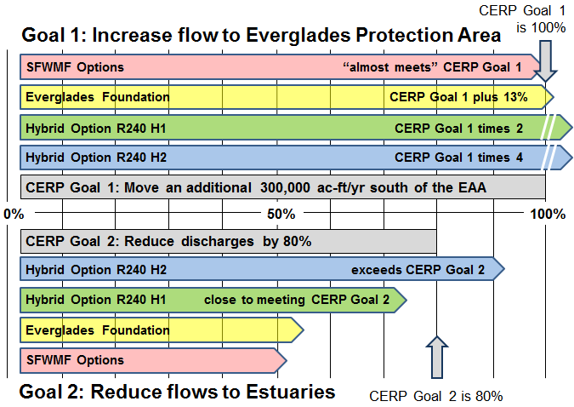
Figure 2. Performance of EAA Reservoir/STA options for improving flow conditions and attaining CERP goals
NOTE: For CERP Goal 2, analysis shows that other authorized CERP projects would reduce discharges by 23 percent, which is added to the reduction from the EAA Reservoir/STA project.
Benefits from the EAA Reservoir/STA Project
As mentioned above, the primary benefit of the EAA Reservoir/STA project is reducing discharges of excess water from Lake Okeechobee in to St. Lucie and Caloosahatchee reservoirs; instead, that water is sent south to be stored and treated before it makes its way south into the Everglades Protection Area where it is needed. There are many types of ancillary benefits that need to be considered.
Public Health. Reduction in discharges has public health benefits because toxic algal blooms such as those experience in recent years coincident with Lake Okeechobee discharges would be reduced, commensurate with the quantity of discharge reduction.
Jobs. Employment is another benefit from this project. Temporary construction jobs would be several times greater than the 1,000 jobs for building the smaller C-44 Reservoir/STA project now under construction in Martin County (see Westlund 2017). After the infrastructure is in place, operations and maintenance would create permanent jobs.
For example, O’Laughlin (2017) estimated employment impacts per 1,000 acres of both reservoir and treatment area footprints (Table 4 below). Applying this information to a 17,000 acres reservoir with 13,000 acres of treatment areas would result in more than 10,000 direct jobs in reservoir construction and 14,000 indirect jobs. Treatment area construction would involve 1,500 direct construction jobs and 1,600 indirect jobs. This total of 27,000 jobs is temporary, and would be spread out over however long it takes to build the project infrastructure. Permanent jobs would include 440 in reservoir operations and maintenance as well as recreation and tourism, and another 440 indirect jobs. New treatment area permanent jobs would be about 100 direct jobs, mostly in recreation and tourism, and another 100 indirect jobs (after some allowance for jobs associated with existing facilities). If larger portions of the WMAs were repurposed to water quality treatment areas, the number of jobs likely would increase proportionately. For example, the hybrid R240 H2 option would create 31,000 temporary construction jobs and, after some allowance for existing jobs around the WMAs, 1,000 new permanent jobs.
Table 4. Employment impacts associated with proposed EAA Reservoir/STA
project (per 1,000 acres)
Economic Sector* | Employment Impacts**  (per 1,000 acres)
 | Direct Jobs | Indirect and Induced Jobs | Total Jobs
Reservoir construction | 593 | 829 | 1,422
Water treatment area construction | 92 | 130 | 222
Reservoir operations & maintenance (O&M) | 12 | 12 | 24
Water treatment area O&M | 2 | 2 | 4
Reservoir recreation & tourism | 14 | 14 | 28
Water treatment area recreation & tourism | 14 | 14 | 28
* Economic sector data sources, methods used to estimate jobs, and employment impact category descriptions are provided in O’Laughlin (2017, Appendix A).
**Direct jobs are those held by construction workers, and people employed to operate and maintain water resource infrastructure and provide goods and services for recreation/tourism opportunities created by new water storage and treatment areas. Indirect jobs are for purchases of goods and services needed by direct employees, such as motor vehicles and their maintenance. Induced jobs are from spending of income by those with direct and indirect jobs, such as restaurants and entertainment.

Real Estate Values. Based on studies conducted for the Florida Realtors (2015) it is safe to say that improved water quality in the St. Lucie and Caloosahatchee areas would increase the economic value of residential real estate by at least $1 billion.
Enhanced Wildlife Habitat. Several endangered species—Everglades kite and Cape Sable seaside sparrow—would benefit if flow-through marshes were part of the design for water quality treatment areas. Ducks and largemouth bass would also thrive in these areas (Gilio 2017). And as noted above, these areas would create jobs for outfitters and guides.
Flow-through Marshes. Water quality treatment areas can be one of three different types: stormwater treatment areas (STAs), flow equalization basins (FEBs), or flow-through marshes (FTMs). STAs are large, constructed wetlands with inflow and outflow structures for controlling water movement. Aquatic plants in the STAs remove and store excess nutrients (phosphorus) found in the stormwater runoff. An FEB is a constructed impoundment for providing steady flow to STAs (SFWMD 2017b). Like the other two types, a flow-through marsh is a constructed wetland. But unlike then, its walls are gently sloping. They are cheaper to build, operate and maintain and provide better habitat for imperiled birds (Gilio 2017).
.
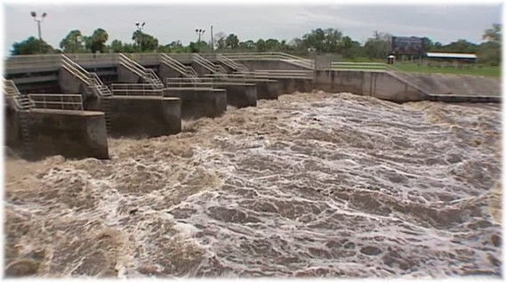
Lake Okeechobee maximum possible release to St. Lucie River, February 6, 2016
totaling 4.9 billion gallons per day (15 million acre-feet per day)
Appendix A. Flow Schematic Diagrams of Three Current and Two Hybrid Options
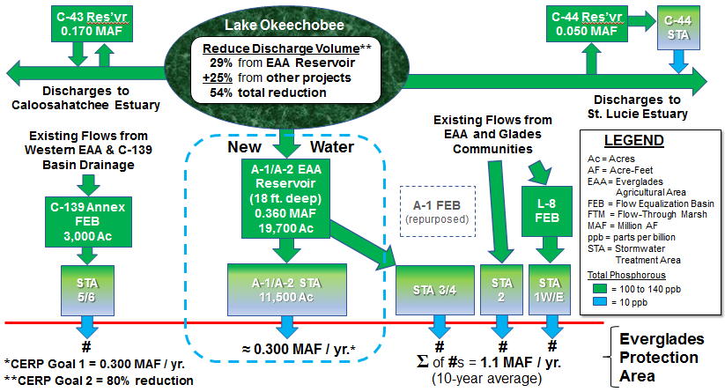
FS-2. Flow Schematic: SFWMD C360C “Best Buy” Option

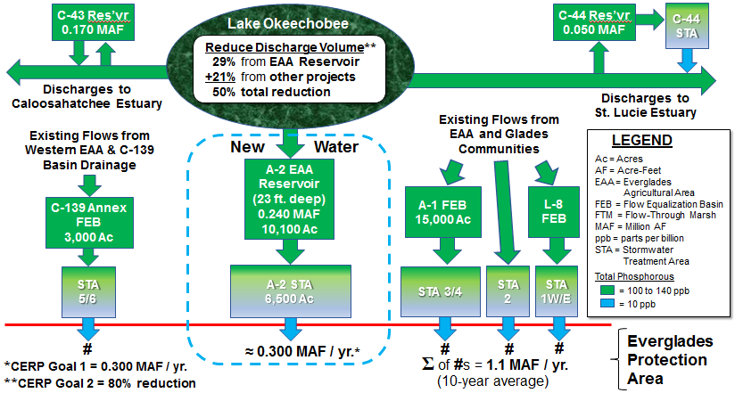
FS-1. Flow Schematic: SFWMD R240A “Best Buy” Option
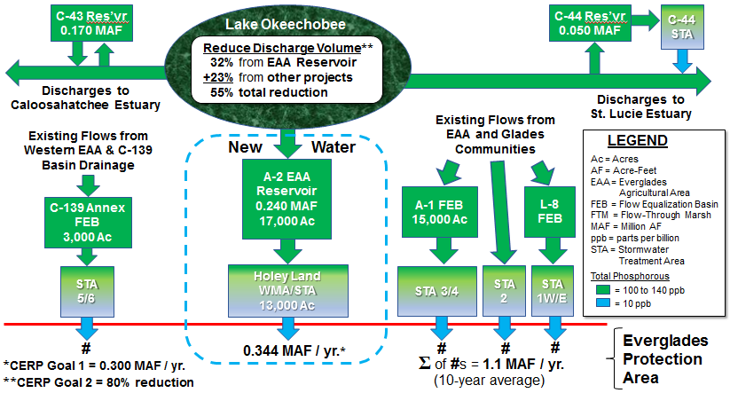
FS-3B. Flow Schematic: Modified Everglades Foundation Option, STA identified

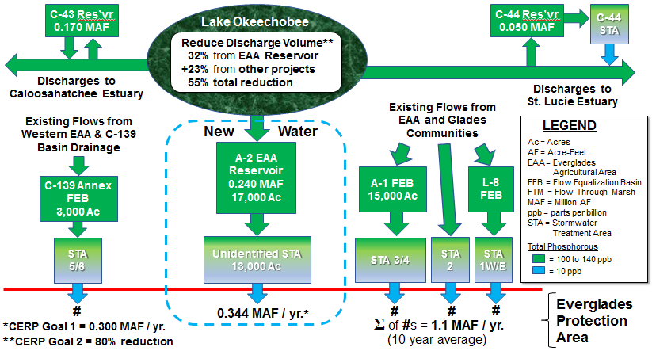
FS-3A. Flow Schematic: Everglades Foundation Option, STA unidentified

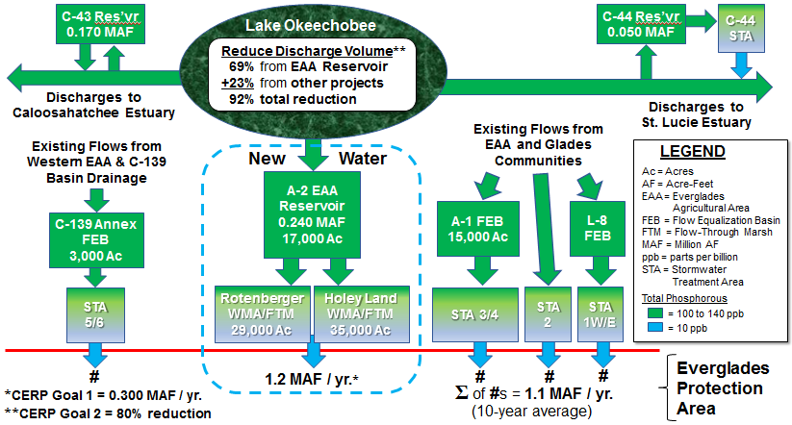
FS-5. Flow Schematic: Hybrid R240 H2 Option

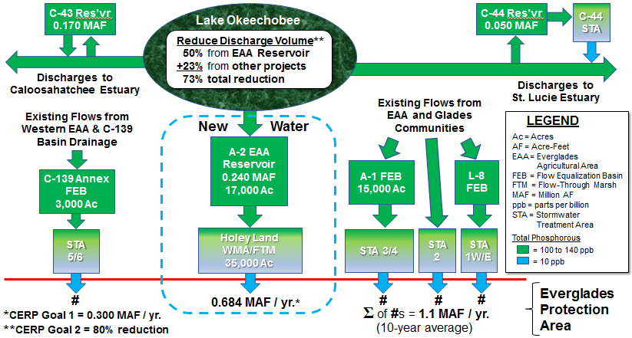
FS-4. Flow Schematic: Hybrid R240 H1 Option
Appendix B. Model Variable Descriptions and Calculation Formulas
Model Variables (bracketed numbers correspond to columns in Table 1)
RES is shorthand for reservoir
RES_{Acres} [3] is Acreage footprint of reservoir
RES_{EAC} [10] is Reservoir Effective Annual Capacity, which is the amount of additional water in one year that will flow out of the reservoir flow through the STAs and flow into the Everglades Protection Area.
RES_{FTC} [9] is Reservoir Flow Through Cycles per year, which is = STA_{NSC} x STA_{FTC} / RES_{NSC}
RES_{NSC} [2] is Reservoir Nominal Storage Capacity, and for the EAA Reservoir project specified in law as either 240,000 ac-ft or 360,000 ac-ft (Florida Statutes 373.4598 (5)(a), (5)(c) (a.k.a. Senate Bill 10)
STA is shorthand for stormwater treatment areas.
STA_{Acres} [5] is Acres of STAs
STA_{Depth} is Depth of STAs, which average about 1.5 feet over the course of a year, and at a maximum are 4 feet deep
STA_{FTC} is STA Flow Through Cycles per year; it is RES_{EAC} [10] ÷ (STA_{Acres} [5] x STA_{Depth}); when divided into 365 days quotient is STA_{FTdays}
STA_{FTdays} [8] is STA Flow Through in days
STA_{NSC} is STA Nominal Storage Capacity, which is the product of STA_{Acres} and STA_{Depth}
Calculation Formulas (bracketed numbers correspond to columns in Table 1)
[5] Although not done in this analysis, it is possible to use the model to calculate the quantity of STA Acres that would meet the CERP Goal of 300,000 ac-ft/yr additional flow from the EAA Reservoir/ STA system (or another goal), using STA_{FTdays} [8] as a “forcing” variable
[5] STA_{Acres} = RES_{FTC} [9] ÷ (365 ÷ STA_{FTdays} [8]) RES_{NSC} [2] ÷ STA_{Depth}
where
STA_{Depth} is 1.5 feet and STA_{FTdays} is 28 days, or
STA_{Depth} is 4 feet and STA_{FTdays} is 76 days
[6] STA_{NSC} = STA_{Acres} [5] x STA_{Depth}
where
STA_{Depth} is 1.5 feet, or
STA_{Depth} is 4 feet
[7] Total Acres = RES_{Acres} [3] + STA_{Acres} [5]
[8] STA Flow Through in days
● for the three current options (SFWMD and EF) this is calculated using RES_{EAC} [10]
as a “forcing” variable:
[8] STA_{FTdays} = 365 days/yr ÷ (RES_{EAC} [10] ÷ (STA_{Acres} [5] x STA_{Depth}))
where
RES_{EAC} [10] = 300,000 ac-ft/yr for SFWMD options or 340,000 ac-ft/yr for
EF option and STA_{Depth} is either 1.5 feet or 4 feet
● for the two hybrid options it is calculated from performance of the entire 57,000 acre
EAA STA system, which treated an average 1.1 million ac-ft/yr over the past ten years
(derived from figure on p. 5B-10 in SFWMD’s 2017 South Florida Environmental
Report)
therefore
[8] STA_{FTdays} when STA_{Depth} is 1.5 feet = 365 days/yr ÷ (1,100,000 ac-ft/yr ÷
(57,000 ac x 1.5 ft) = 28 days
[8] STA_{FTdays} when STA_{Depth} is 4 feet = 365 days/yr ÷ (1,100,000 ac-ft/yr ÷
(57,000 ac x 4 ft) = 76 days
[9] RES_{FTC} is Reservoir Flow Through Cycles
● for current options (SFWMD and EF options)
[9] RES_{FTC} = RES_{EAC} [10] ÷ RES_{NSC} [2]
● for hybrid options RES_{FTC} is calculated using STA_{FTdays} [8] for the entire EAA STA
system as a “forcing” variable (either 28 days at 1.5 foot STA depth, or 76 days at
4 foot depth)
[9] RES_{FTC} = (STA_{NSC} [6] x (365 days/yr ÷ STA_{FTdays} [8])) ÷ RES_{NSC} [2]
[10] RES_{EAC} is Reservoir Effective Annual Capacity
● For SFWMD current options RES_{EAC} is given by SFWMD modelling as the
CERP Goal 1 of 300,000 ac-ft/yr
● For EF current option RES_{EAC} is given by EF modelling as 340,000 ac-ft/yr
● For hybrid options RES_{EAC} is calculated using STA_{FTdays} [8] for the entire EAA STA
system as a “forcing” variable (28 days at 1.5 foot STA depth; 76 days at 4 foot depth)
[10] RES_{EAC} = RES_{NSC} [2] x RES_{FTC} [9]
= STA_{NSC} [6] x (365 days/yr ÷ STA_{FTdays} [8])
References Cited
Chen, H., D. Ivanoff, K. Pietro. 2015. Long-term phosphorus removal in the Everglades stormwater treatment areas of South Florida. Ecological Engineering 79:158-168.
Florida Realtors. 2015. The impact of water quality on Florida’s home values. Florida Realtors, Orland, Florida. https://www.floridarealtors.org/ResearchAndStatistics/Other-Research-Reports/upload/FR_WaterQuality_Final_Mar2015.pdf
Gilio, J.L. 2017. Guest column: Three win-win options for Senate Bill 10. TCPalm, April 12. https://www.tcpalm.com/story/opinion/contributors/2017/04/12/guest-column-three-win-win-options-senate-bill-10/100369532/
Kosier, T., and J. McBryan. 2015. Holey Land Wildlife Management Area: new pumps and operations. PowerPoint presentation, South Florida Water Management District, February 22. https://www.sfwmd.gov/sites/default/files/documents/ltpmtg25feb2015_holey_land_mcbryan_kosier.pdf
O’Laughlin, J. 2017. Arguments against the EAA Reservoir and rebuttals. Paper prepared for The Guardians of Martin County, April 16. Available online at http://theguardiansofmartincounty.com/wp-content/uploads/2017/04/arguments-rebuttals_EAA-reservoir_JayOL_04-16-2017.pdf
SFWMD. 2017a. Total STA water volume inflows, 1995-2016. Chart on p. 5B-10 in 2017 South Florida Environmental Report. South Florida Water Management District, West Palm Beach, Florida. derived from the chart on p. 5B-10 in the SFWMD’s 2017 South Florida Environmental Report). Available online at http://apps.sfwmd.gov/sfwmd/SFER/2017_sfer_final/v1/chapters/v1_ch5b.pdf
SFWMD. 2017b. 2017 South Florida Environmental Report. South Florida Water Management District, West Palm Beach, Florida. Available online at https://www.sfwmd.gov/sites/default/files/documents/2017_sfer_highlights.pdf
SFWMD. 2018. Progress report on SFWMD implementation of Senate Bill 10 (Section 373.4598 Florida Statutes). South Florida Water Management District, West Palm Beach, Florida. Available online at https://www.sfwmd.gov/sites/default/files/documents/eaa_res_progress_report_fl_leg.pdf
Treadway, T. 2018. Everglades Foundation: SFWMD reservoir to cut discharges won't clean water; ours does. TCPalm, January 2. Available online at https://www.tcpalm.com/story/news/local/indian-river-lagoon/health/2018/01/02/everglades-foundation-sfwmd-reservoir-cut-discharges-wont-clean-water-ours-does/989831001/
Westlund, R. 2017. Innovation: Massive C44 project will benefit St. Lucie Estuary. TCPalm, Progress & Innovation (insert), February 20. Available online at: http://www.tcpalm.com/story/specialtypublications/progressandinnovation/2017/02/20/innovationmassivec44projectbenefitstlucieestuary/97009780/

