Trinity United Methodist Church
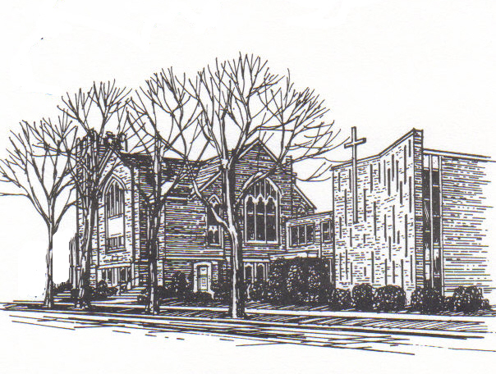
424 Smith St.; Algonac, MI 48001
Church: (810) 794-4379
Email: 3UMCTrinity@att.net
Web-site: AlgonacTrinity.org
Sunday Worship Service 9:30 a.m.
Pastors Pond'rings
Happy New Year!
The new year always gives us an opportunity for a fresh start. But we need to be open to those opportunities.
Take the example of a goldfish raised in a small fishbowl. One day the owner purchased a much larger bowl. When he placed the goldfish in the larger bowl, the goldfish continued to swim in little tiny circles because that’s all it knew and it didn’t recognize the vastness of the new bowl.
We live in a world that needs to know God’s transformative love. We, as the church need to keep our eyes and ears open to new and different ways to serve our community and those in need this year.
We need to swim in a bigger circle!
May the (expanding) circle of blessings continue,

Pastor John
Sermon Topics for Jan/Feb
Jan 5 Epiphany Sunday/Holy Communion
Scripture: Matthews 2:1-12
“The Wise Men”
Jan 12 Baptism of Our Lord
Scripture: Matthew 3:13-17
“Baptism”
Jan 19 2nd Sunday after Epiphany
Scripture: John 1:29-42
"What’s in a Name"
Jan 26 3rd Sunday after Epiphany
Scripture: 1 Corinthians 1:10-18
”Conflict? In a Church?”
Feb 2 4th Sunday after Epiphany
Holy Communion
Scripture: Matthew 5:1-12
“The BE-attitudes”
Feb 9 5th Sunday of Epiphany
Scripture: 1 Corinthians 2:1-16
“The Mind of Christ”
Feb 16 6th Sunday of Epiphany
Scripture: 1 Corinthians 3:1-9
"Human or Spiritual People?"
Feb 23 Transfiguration Sunday
Scripture: Matthew 17:1-9
"The Transfiguration"
Feb 26 Ash Wednesday


Finance Committee
- The Finance committee meets the 2nd Tuesday of every month at 9 am. The goals include preparing an annual Budget, presenting an annual stewardship campaign, conducting fundraisers, and special offerings. They prepare a yearly calendar on how to meet these goals. The committee reports to the Church Council and also to the Conference.
- We are now part of the Community Rewards programs at Kroger and Amazon Smile. If you shop at Kroger, either 1) sign in on-line at Kroger.com, choose the rewards tab, then the Community rewards, Individual Info, search and choose Algonac Trinity; or 2) go to the office in Kroger and ask them to sign you up. Kroger will send us a check quarterly. This does not affect prices, fuel rewards or your shopping in any way. If you’re part of Amazon Smile, you can also put Algonac Trinity as your charity of choice.
- Many thanks to all who donated to the Food Pantry the Last Sunday of 2019! And to all who donated throughout the year. The Pantry continues to give out about 4000 lbs. of food per month.
- Expect an Energy Letter, requesting a donation toward Utility costs the first time we get bad winter weather. We spent a total of $8127 for heat in 2019 and $2746 for electricity. This is down slightly from 2018, thanks to God’s gift of a mild Autumn after last winter’s brutal cold and the Trustees,
- We are so grateful to be part of a generous church. Your presence, prayers and financial support is greatly appreciated.
Thank You for your Support and God Bless,
Marion Avers Finance Committee

Pastor’s Note on Finance
Dear church,
The Finance Committee and I feel it is important for you to see the financial position of our church. Please understand these are averages. We also know budgets are a guide. However, these figures do show a trend. There are fixed costs and missional costs. All are important. Please see me or any member of the Finance Committee with questions or comments.
Pastor John

Weekly Monthly
Avg Rec’d Oct/Nov $1020 $4592
Avg Dist. Oct/Nov $1260 $5671
Avg Budgeted $1842 $7982
Women’s Christian Fellowship
I can’t believe I’m writing this article and another year has slipped by.
2019 was a very good year for our women’s group. We made some changes, starting with our name, we are now known as The Women’s Christian Fellowship Group. We voted to discontinue our membership with the United Methodist Women’s Conference. When investigating our history with the conference we had not been recognized by them since 1996.
Our two main fundraisers (The Surprise Auction and the Christmas Bazaar & Luncheon) were both a lot of fun as well as very lucrative and because of all the hard work put into them, we were able to donate to the following missions:
TUMC GENERAL FUND. $600.00
ALGONAC/CLAY/IRA FOOD PANTRY. $100.00
MICHIGAN SPECIAL OLYMPICS. $100.00
ALGONAC/CLAY GOODFELLOWS. $100.00
NEW HORIZONS $100.00
UMCOR. $100.00
CARE BAG MOVEMENT. $50.00
KOC LADIES AUXILIARY.( PILLOWCASES). $50.00
TOTAL. $1200.00
We feel so blessed to be able to give to these missions.
We did not meet during the summer months this year, but were very pleased to have our September meeting at the home of Pam and Patty Allen. Thank you, ladies, for a wonderful get together.
I would like to also thank the Men’s Christian Fellowship Group for purchasing more rectangular tables, for the church. These tables make our functions that much easier to do. God Bless our men’s group.
To close our year, we did not have a regular meeting in December, but went to lunch at The Little Bar in Marine City on December 18th. All the women of the church were invited to this.
If you are interested in our group, we meet on the first Wednesday of the month in the Fellowship Hall at 11:30 AM. (Due to the first Wed. of January being New Year’s Day, our next meeting will be January 8th.)We bring our own lunch and beverages and dessert are provided. See me or any of the CWF members if you have any questions.
I hope you all have a Blessed Christmas and a Safe, Healthy, Prosperous and Happy 2020.
May our Father’s Favor be with you now and forever
Sue Kennedy
ask116655@gmail.com
586-232-3553

Happy Anniversary to:
JANUARY
Pam & Mike Dooling 12
Jackie & Ross Brown 21
FEBRUARY
Gail & Bill Warner 4

Happy Birthday to:
JANUARY
Gwen Delonnay 4 Tony Pajak 7
Larry Mullins 10 Roy Moore 11
Margie Arpan 12 Chari Lawton 12
Thomas Dunlap 13 Lynda Smith 20
Chase LaParl 28 Brian McCullough 29

FEBRUARY
Asia Rose Duvernay 1 Connie Currie 1
Ducky Issacs 1 Cali Reams 2
Melissa Osborne 2 Richard Polcyn 2
Donna Falls 4 Samantha Ingles 4
Toni Laidley 4 Diane Viger 8
Lili Kaatz 9 Fred Kleintjes 12
Josh Arpan 13 Lindsey Ingles 13
Yola Dawson 13 Kristin Reams 14
John Pajak 16 Joe Arpan 17
Jackie Cotney 18 Kathy Johns 20
Ted Baranski 20 Maria Evans 22
Edna Lazarz 29

Food Pantry
The Pantry served 2339 individuals with 34,659 pounds of food during 2019 Year!
Many Thanks! The pantry wouldn't be successful without the help of our volunteers and all the hours they donate.
Thank You and God Bless you, Marion & pantry volunteers
The Food Pantry is open to residents of Algonac, and Clay & Ira, every Friday from 10 - 2 pm and the 3rd Tuesday of each Month from 6 - 7 pm. Each family can send a representative once per month at 4-week intervals.

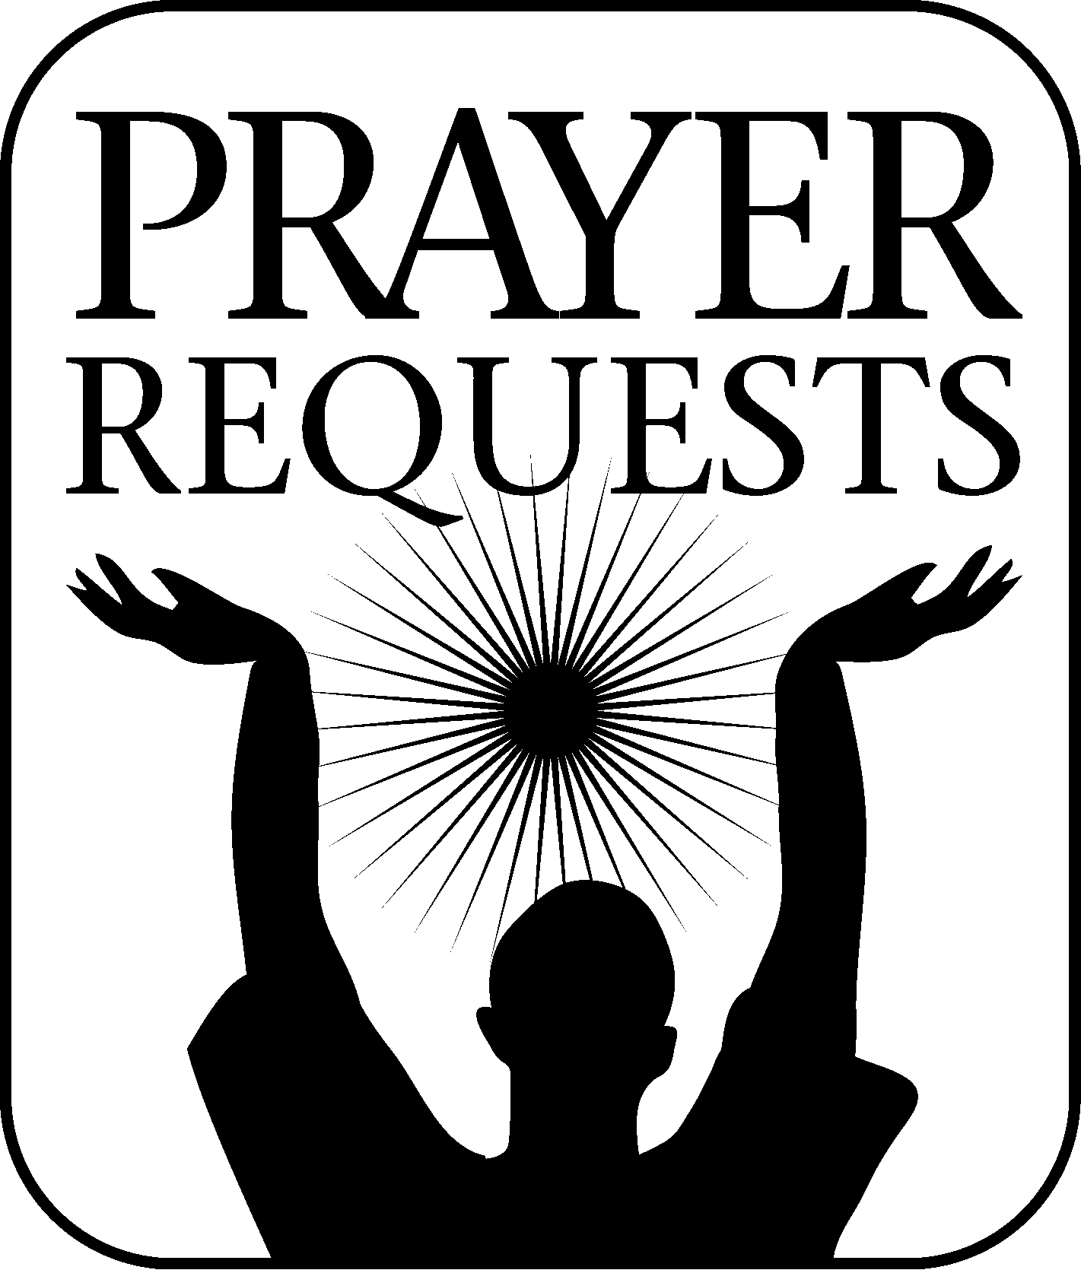

Ruth Frederick Robin/Jeff Ingles
Anne DeLong Chuck Cameron

Janet Wade Blanche Sutton
If you have any updates, anyone you want added to the Prayer Request List. Please call Lynda Smith or the office and leave a message. 810 794-4379

PLEASE HAVE ANNOUNCEMENTS
For the next edition of the ANCHOR into the office by February 15th – Anything handed in after that date (LOL) may go into the following Anchor!!! (or the Anchor won't be in the mail in time for the monthly Women’s Christian Fellowship meeting)

