Trinity United Methodist Church
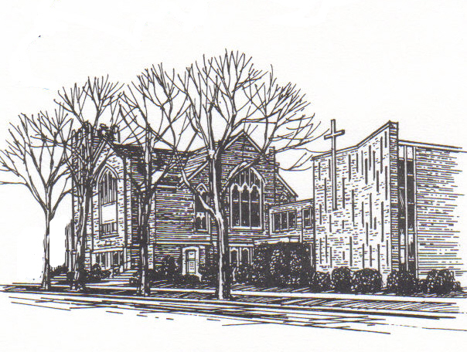
424 Smith St.; Algonac, MI 48001
Church: (810) 794-4379
Email: 3UMCTrinity@att.net
Web-site: AlgonacTrinity.org
Sunday Worship Service 9:30 a.m.
Pastors Pond'rings
Resolutions
It is finally here! 2021! Do you ever make New Year’s Resolutions? Why do we make them? Usually, it is because we see something that we want to improve in our lives, but changes are always difficult. We are comfortable, and we like it that way. Change is always difficult, but sometimes these changes are needed and good.
As you ponder any resolutions that may be needed in your life, let me encourage you to seek God’s direction in your spiritual lives as well. Is God prompting you to read your Bible more often? Is He calling you to be more forgiving of others, or to become more involved in ministries to spread the love of Christ in our community?

Maybe you feel the nudge to give up something that is driving you away from God in your life. Whatever it is, take this time to wrestle with ways to grow in your faith as we move into a new year.
As a church, I feel the need to make resolutions as well. We all know that churches are declining rapidly in today’s age, and many times it is because we are unwilling to change when God prompts us to do so. Change is scary, but sometimes these changes are needed and good. As we enter a new year, I am praying that God reveals the ways our church can meet the needs of this community. I ask you to be in prayer with me as we listen for God’s guiding voice. I believe He has a great plan for us and will provide the means to be a church who changes lives.
God’s blessings to you in 2021!
Pastor Chris

Finance Committee
- The Finance committee meets the 2nd Tuesday of every month at 9 am. The goals include preparing an annual Budget, presenting an annual stewardship campaign, conducting fundraisers, and special offerings. They prepare a yearly calendar on how to meet these goals. The committee reports to the Church Council and also to the Conference.
- Church Envelopes are ready, stop by the office on Wednesday morning or Friday to get them.
- We are now part of the Community Rewards programs at Kroger and Amazon Smile. If you shop at Kroger, either 1) sign in on-line at Kroger.com, choose the rewards tab, then the Community rewards, Individual Info, search and choose Algonac Trinity; or 2) go to the office in Kroger and ask them to sign you up. Kroger sends us a check quarterly. This does not affect prices, fuel rewards or your shopping in any way. If you’re part of Amazon Smile, you can also put Algonac Trinity as your charity of choice. Last Quarter Kroger sent $42.
- Save up your change: January has a 5th Sunday and the Loose Change offering will go toward Church Insurance, Inspections and Licensing, necessary to keep the doors open.
- If you give on-line, please add 2.5% to cover the fees.
- Expect an Energy letter, and a Lenten letter in the mail before the next Newsletter.
- We are so grateful to be part of a generous church. Your continued presence, prayers and financial support is greatly appreciated.
Thank You for your Support and God Bless,
Marion Avers Finance Committee

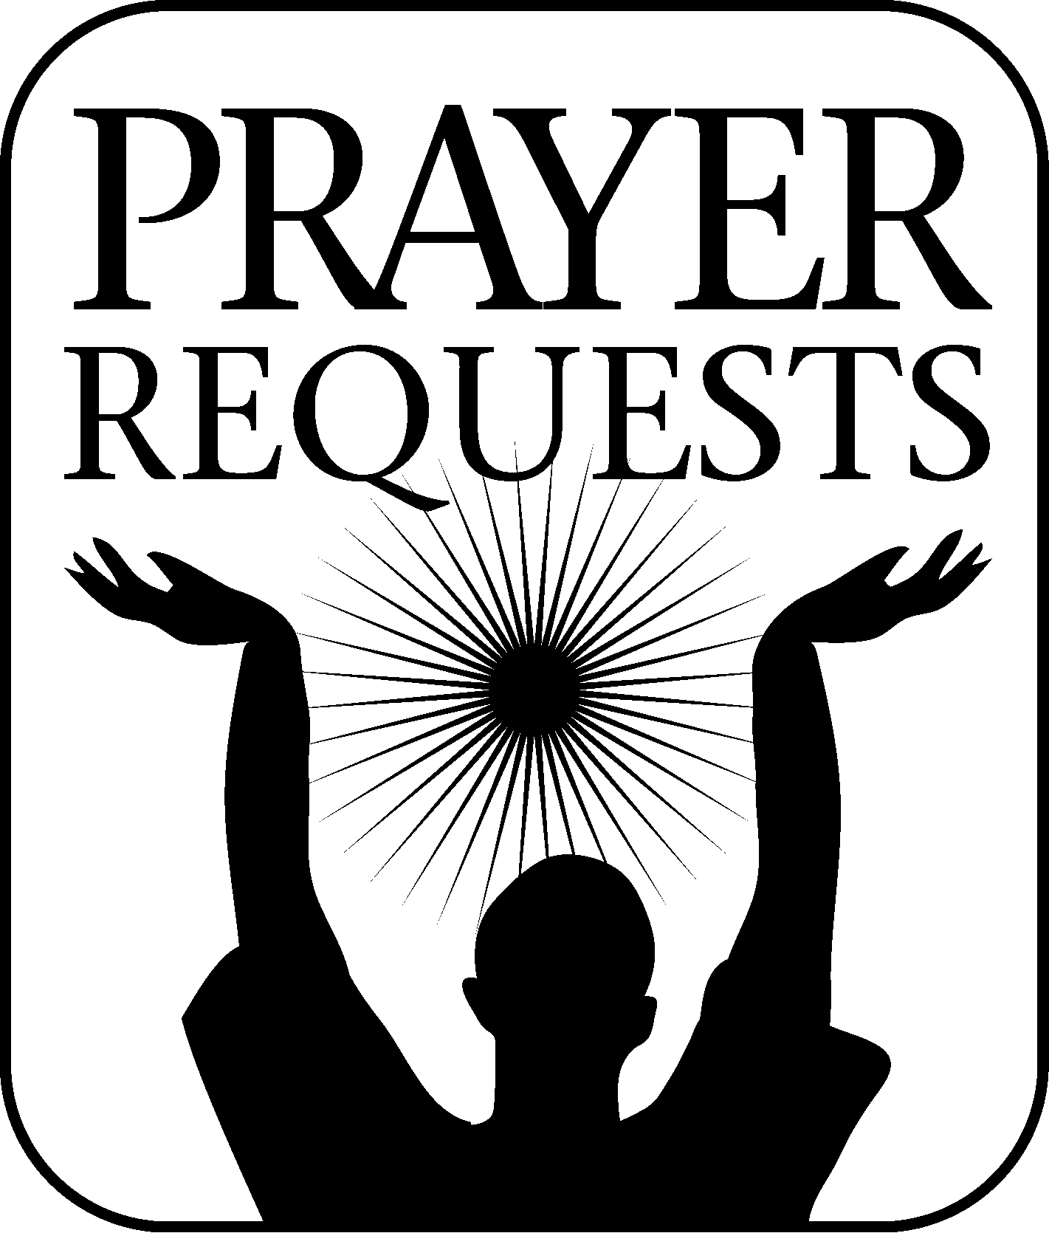

Karen Baranski Robin/Jeff Ingles
Anne DeLong Chuck Cameron
MaryAnne Tiley Blanche Sutton
Skip Warner
All those whose family members went to Glory last year. Ted Baranski and Bill Laparl joined the others in Glory this quarter.
If you have any updates, anyone you want added to the Prayer Request List. Please call the office and leave a message. 810 794-4379
Women’s Christian Fellowship
(changing of the guard….)
It’s difficult to imagine my 4-year tenure has come to an end. It has been quite an experience and certainly a time of learning.
I would like to thank ALL of the UCW members who have helped me. Without these women, I know we would never would have accomplished the many missions to do Our Precious Father’s work.
November is the month we choose our new executive members.
The following women will hold these positions.
President Carol Clever
Vice President Judie Reams
Secretary Ruth Dunlap
Treasurer Linda Mesclier
I thank all of you for taking on these roles.
November is also the month we decide on which missions we donate to. The following are receiving monetary donations from the UCW group:
Trinity United Methodist Church General fund
Algonac Clay Ira food pantry
The Algonac/Clay Goodfellows
The Michigan Special Olympics
The Care Bag Movement
The Algonac KOC Pillowcase movement
The United Way
UMCOR
Blue Water Safe Horizon
If you would like to join us or attend a meeting, we meet on the first Wednesday of every month at 10:30 AM, in the Fellowship Hall. We usually enjoy coffee/tea and a dessert, but have not been doing so since the COVID rules do not allow this. Hopefully these restrictions will be behind us in the near future.
May you be Blessed with the Favor of Our Heavenly Father now and forever more.
--Sue Kennedy

Happy New Year! Let us have faith in our Father to calm this Covid down, so that we can start our New Year looking ahead to brighter days and enjoying each other in Fellowship.
You (all women) are invited to come to our meetings (hopefully). Wednesday, January 6 will be our first meeting of the year at 10:30 am.
Come refreshed and renewed with lots of ideas for events or missions we can do through-out the year.
Since our luncheon in December was cancelled, that will be on our agenda for January.
Keep those Campbell soup labels coming!
Thank you & God Bless Everyone,
Carol Ann Clever (President)
Happy Anniversary to:
JANUARY
Pam & Mike Dooling 12
Jackie & Ross Brown 21
FEBRUARY
Gail & Bill Warner 4
MARCH
Anita & John Rzeppa 13
Yvonne & Jay Bruce 15

Happy Birthday to:
JANUARY
Gwen Delonnay 4 Tony Pajak 7
Larry Mullins 10 Margie Arpan 12
Chari Lawton 12 Tom Dunlap 13
Chase LaParl 28 Brian McCullough 29

FEBRUARY
Asia Rose DuVernay 1 Connie Currie 1
Cali Reams 2 Melissa Osborne 2
Rich Polcyn 2 Donna Falls 4
Samantha Ingles 4 Toni Laidley 4
Emily Heldt 7 Diane Viger 8
Lili Kaatz 9 Fred Kleintjes 12
Josh Arpan 13 Lindsey Ingles 13
Yola Dawson 13 Kristin Reams 14
John Pajak 16 Joe Arpan 17
Jackie Cotney 18 Kathy Johns 20
Edna Lazarz 29

MARCH
Chuck Cameron 1 Art Kennedy 3
Sue Dentel 6 Lisa Copp 7
Carol Thiedeman 8 Yvonne Bruce 9
Heidi Theisen 13 Matt Costello 14
Jackie Brown 21 Carl Reams 22
MaryAnne Tiley 25 Ruth Dunlap 26

PLEASE HAVE ANNOUNCEMENTS
For the next edition of the ANCHOR into the office by March 15th – Anything handed in after that date (LOL) may go into the following Anchor!!!
Food Pantry
- Thank You to all who have supported the Food Pantry and the volunteers for their service.
- The New Arrangement of receiving food has worked out well, we had hoped by cold weather we could go back to the old system of people entering the building and filling out the form of the foods they need. Alas, that hasn’t happened.
- We continue to be Blessed with bulk foods from a Gleaners Mobile Pantry in New Baltimore
- We Served a grand total of 2339 individuals with 39,052 pounds of food in year 2020.
- We all must stay safe to stay healthy: Avoid large crowds, stay a distance, wash hands & wear a mask.
- Thank You and God Bless you, Marion & pantry volunteers
The Food Pantry is open to residents of Algonac, and Clay & Ira, every Friday from 10 - 2 pm and the 3rd Tuesday of each Month from 6 - 7 pm. Each family can send a representative once per month at 4-week intervals.

4th Quarter averages
The Finance Committee feels it is important for you to see the financial position of our church. Please understand these are averages. We also know budgets are a guide. However, these figures do show a trend. There are fixed costs and missional costs. All are important.
The Figures given below include Window Repair, Boiler Repair, Chair Lift Repair, Locksmith and New Sanctuary Doors, ….
Weekly Monthly
Avg Rec’d 4th Qtr. $1228 $4911
Avg Dist. 4th Qtr. $1923 $7691
Avg Budgeted $1842 $7982

Calendar disclaimer
All meetings on the calendars are subject to change based on the Covid restrictions.

Trustee Committee
- We as a committee will accomplish the tasks, we are charged with to the best of our ability with guidance from God who directs our paths for the good of the Church, the Congregation and community.
- Repairs & updates as approved were completed at the parsonage. Additional painting, electrical and yard work were completed by Pastor Chris and family!
- ** STILL IN NEED OF A WASHER & GAS DRYER (especially dryer)
- The Sanctuary window covering repair was delayed due to the high demand of the material but completed the week of September 28th. All repairs are covered by our insurance.
- We will be changing the church locks and re-issuing keys soon after which we will be moving the support groups to the fellowship hall for their meetings to allow for social distancing. We are also pleased to announce the Girl Scouts are now meeting on Friday’s from 4:00-5:30! Looking forward to the cookie sale time 😊
- From now until the end of the year we will continue to work with our list of pending/on-going concerns and coordinate with others as needed for any upcoming events.
- Please feel free to reach out to any member of this committee if you have questions, comments or concerns. We value your thoughts regarding the building & property.
- Members: Chari Lawton, Anita Rzeppa, Marion Avers, Wayne Reams, Diane Viger, Pastor Chris, Sue Kennedy
- Best Regards,
Chari

Christmas giving tree
Resulted in 4 pr Socks, 29 Hats, 13 Scarfs, 3 hat/scarf/glove combos, 8 Headbands, 19 pr Gloves – excellent response with the church being shut down for several weeks. (and then another donation came in) Many thanks to all who donated. 6 Blankets were also donated to be given to our First Responders. Though we be few, we have big hearts!

On-Line Presence
We have a FaceBook page and we use it: Trinity United Methodist Church, Algonac. Scriptures from the lectionary are posted Wednesday – Saturday for the coming Sunday Worship Service. The Sunday Worship Service is posted live (or pre-recorded) 9:30 am every Sunday! Stay connected with us.
Our Sunday services are also being streamed without video via phone at 9:30 am every Sunday. If you want to be added to this call list, either contact Karen at the church, or call directly toll-free (855)751-2076 and follow the phone prompts. If you don’t answer the phone Sunday morning, you can call the number above anytime for a few weeks and listen to the service in its entirety: song, scripture, message, announcements.
Our Web-site AlgonacTrinity.org is updated regularly with coming events and includes a <Donate> button for on-line giving.
You can also give online using this link: https://tinyurl.com/Give2AlgonacTrinity

Save the Dates
Staff Parish
9 am 1st Wednesday of the month
Women’s Fellowship
10:30 am 1st Wednesday of the month
Trustees Meeting
10:30 am 2nd Sunday of the month
Finance Meeting
8 am 2nd Wednesday of the month
Food Pantry Evening Hour
6 pm 3rd Tuesday of the month
Worship Committee
9 am 3rd Wednesday of the month
Community Supper at 1st Lutheran
5 pm – 6:30 pm 3rd Wednesday of the month
Loose Change Offering
Sunday January 31st

