DaySmart User Manual
Texas Litter Control



Contents
A Note from the Director 5
We want your feedback! 5
Why DaySmart? 5
DaySmart Navigation 6
Texas Litter Control Locations 6
Permissions 6
Schedule 7
Appointments 7
Inbox 10
Patient Dashboard 12
History 13
Appointments 13
Documents 14
Notes 14
Relationships 15
Reminders 15
Tasks 16
Client Dashboard 17
Relationships 18
Documents 18
Billing 19
Communications 19
Appointments 20
Reminders 20
Notes 21
Tasks 21
Contacts Dashboard 22
Inventory 22
Workflow 23
Online Booking for Clients 23
Approving Online Appointments 26
Working with the Pending Appointments Report 26
Approving/Declining/Rescheduling Appointments on the Calendar 27
Analyzing the Calendar/Preventing Over booking & Under booking 29
Booking an Appointment in House 30
Appointment Triggers 32
Reminders 32
Confirming Appointments 32
Surgery Check-In 34
Surgery Workflow Snapshot – Check-in through Check-out 38
Working the Line 38
Dog Check-In 39
Cat Check-In 40
No Shows 41
Documenting the Procedure 41
Sending the Invoice 43
Preparing Paperwork 44
Printing Discharge Paperwork 44
Daily Audit for Surgery – Prior to Discharge 46
Microchip Error Report 46
Diagnosis Count & Detail by Provider Report 47
Vaccine Lot Number Audit 47
Wellness Workflow Snapshot – Check-in through Check-out 47
Check-In 47
Documentation 52
Check Out 54
No Shows 56
Refilling Prescriptions 57
Refill Verification Process 57
Refill Process 57
Billing & Reconciliation 60
Discounts & Voucher Programs 60
Taking Deposits 61
Taking Payments 63
Refunding Deposits 64
End of Day Reconciliation 66
Inventory Management 68
Ordering 68
Receiving Inventory 70
Inventory Adjustments 72

A Note from the Director

We want your feedback!
Texas Litter Control is always looking to improve. I am very excited to announce we have partnered with DaySmart for a more integrated and simplified workflow. This software is meant to make your job easier. I always want to hear from you. You do the daily work, and you know what takes up the majority of your time. We are not going to get this perfect on the first try. I am relying on you for feedback. As you work, please take note of things that just are not working or could be changed to work better. I always want to hear these things. With all that being said, we have worked very hard on this software. I hope you find it makes your job easier!
Sincerely,
Deana Love, Executive Director & Founder of Texas Litter Control

Why DaySmart?
We chose DaySmart because it hit all of the bells and whistles, we were looking for in a Practice Management Software. DaySmart is based in the USA and they have 24/7 tech support. The software integrates with a variety of the other products we use. We may not have full integration from day 1, but you will be seeing it all come together in the very near future. Some of these integrations are:
- Kontak Phones
- Vetcove
- VetSource
- Idexx
- Credit Card Terminals (Clover)
They have some functionality that should really help us out:
- Enhanced Reporting for Accounting and our Grant Tracking
- Integrated Online Scheduling – No more copying over appointments
- Client Portal – “PetCare by DaySmart”
- The ability to take deposits
- Online payments – No more searching for Paypal transactions

DaySmart Navigation

Texas Litter Control Locations
Some of our employees work at multiple locations or have to make appointments for multiple locations. If you need to access a specific location, just go to the arrow at the top right corner of the screen and select the clinic you need to work with.
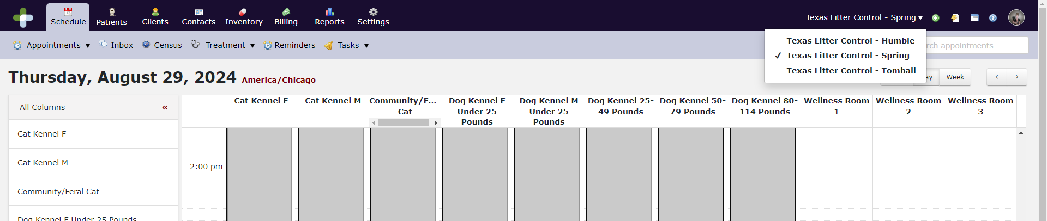
It is not necessary to change locations to access client or patient data. You only need to change when working with something specific to the location like the Schedule or Inventory. Billing is also specific to the location. Invoices must be paid in the specific location’s system.

Permissions
Each employee has permissions/access to only the modules and functions you need to perform your job duties. This manual’s screen shots are taken from the Administrator access. You may not be able to see some of the functions you see in this manual. If you see something you think pertains to your job, please let us know so we can update your access.

Schedule
The schedule columns are setup by Kennel Type/Size for surgery or a Wellness Room. The gray blocked out sections are times we do not take appointments for that particular service. You should only book appointments in sections of the calendar that are not blocked off. Each animal requires its own appointment slot. Times will vary on the surgery columns in order to limit the amounts of surgeries allowed per type, per day.

Appointments

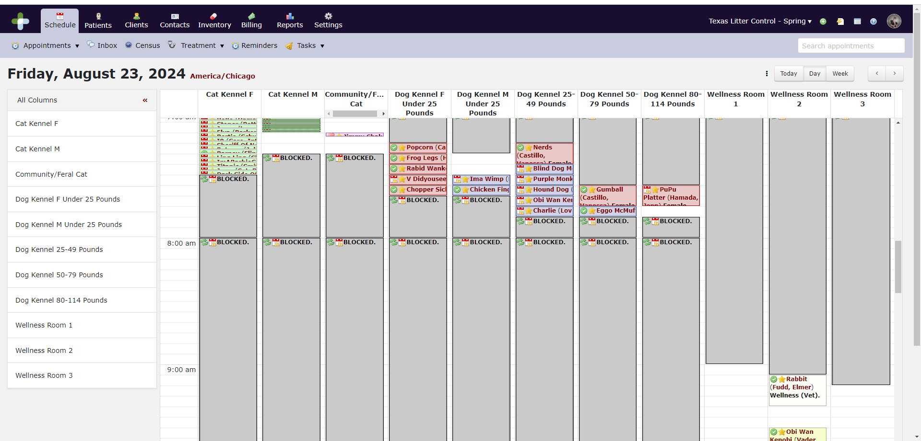

Columns = Kennels or Rooms
We have to schedule by cage size for surgery, so we have set up the following columns on the schedule:
Cat Kennel F1/Cat Kennel F2 = Female Cats
Cat Kennel M = Male Cats
Community/Feral Cats = Community Cats
Dog Kennel F Under 25lbs = Female Dogs Under 25lbs
Dog Kennel M Under 25lbs = Male Dogs Under 25lbs
Dog Kennel 25-49lbs, Dog Kennel 50-79lbs, and Dog Kennel 80-114lbs are either male or female appointments.
Wellness Rooms will be opened for either single, double or triple appointments.
You can either view All Columns or you can click on a single column on the left hand side of the screen if you just want to view one column.
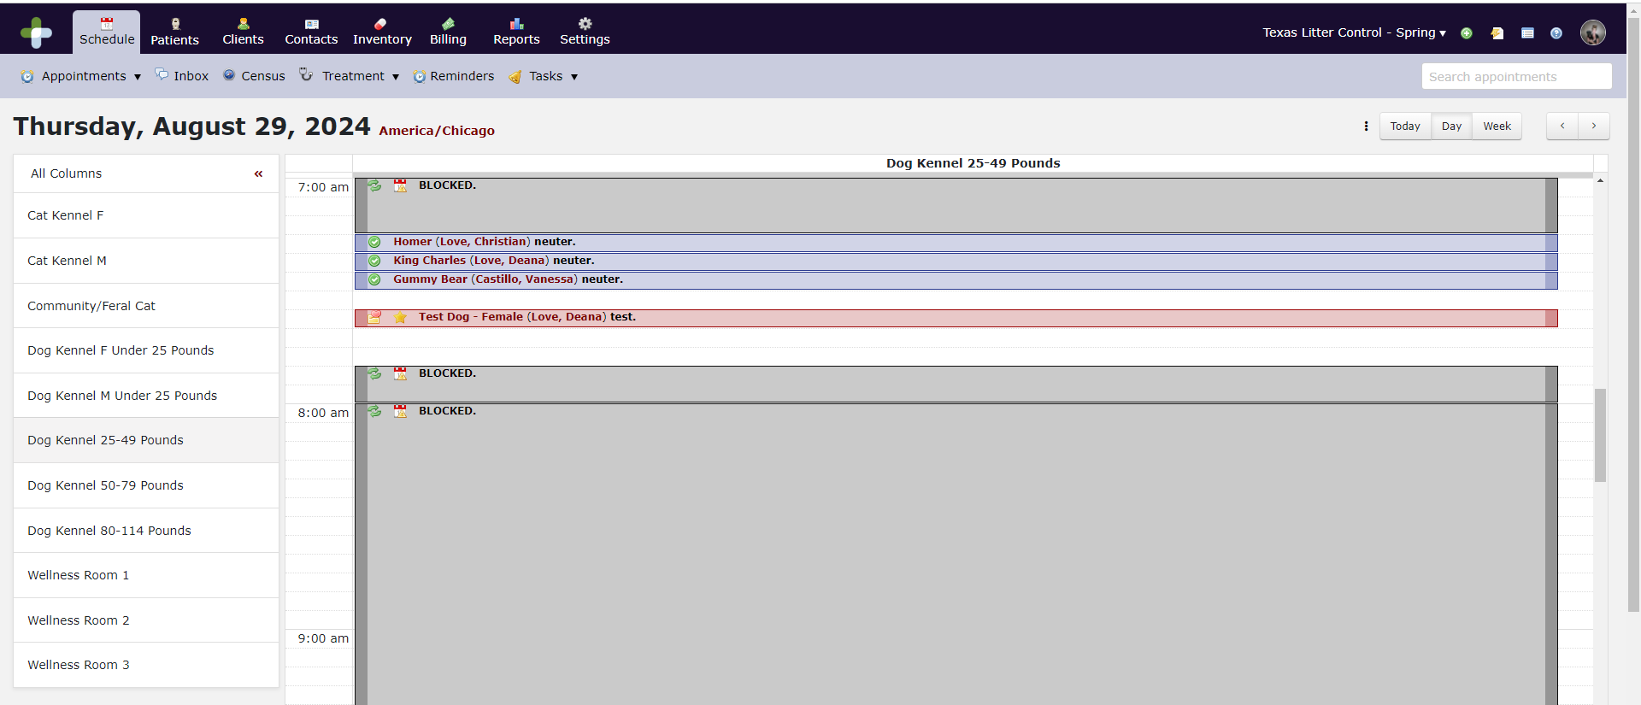
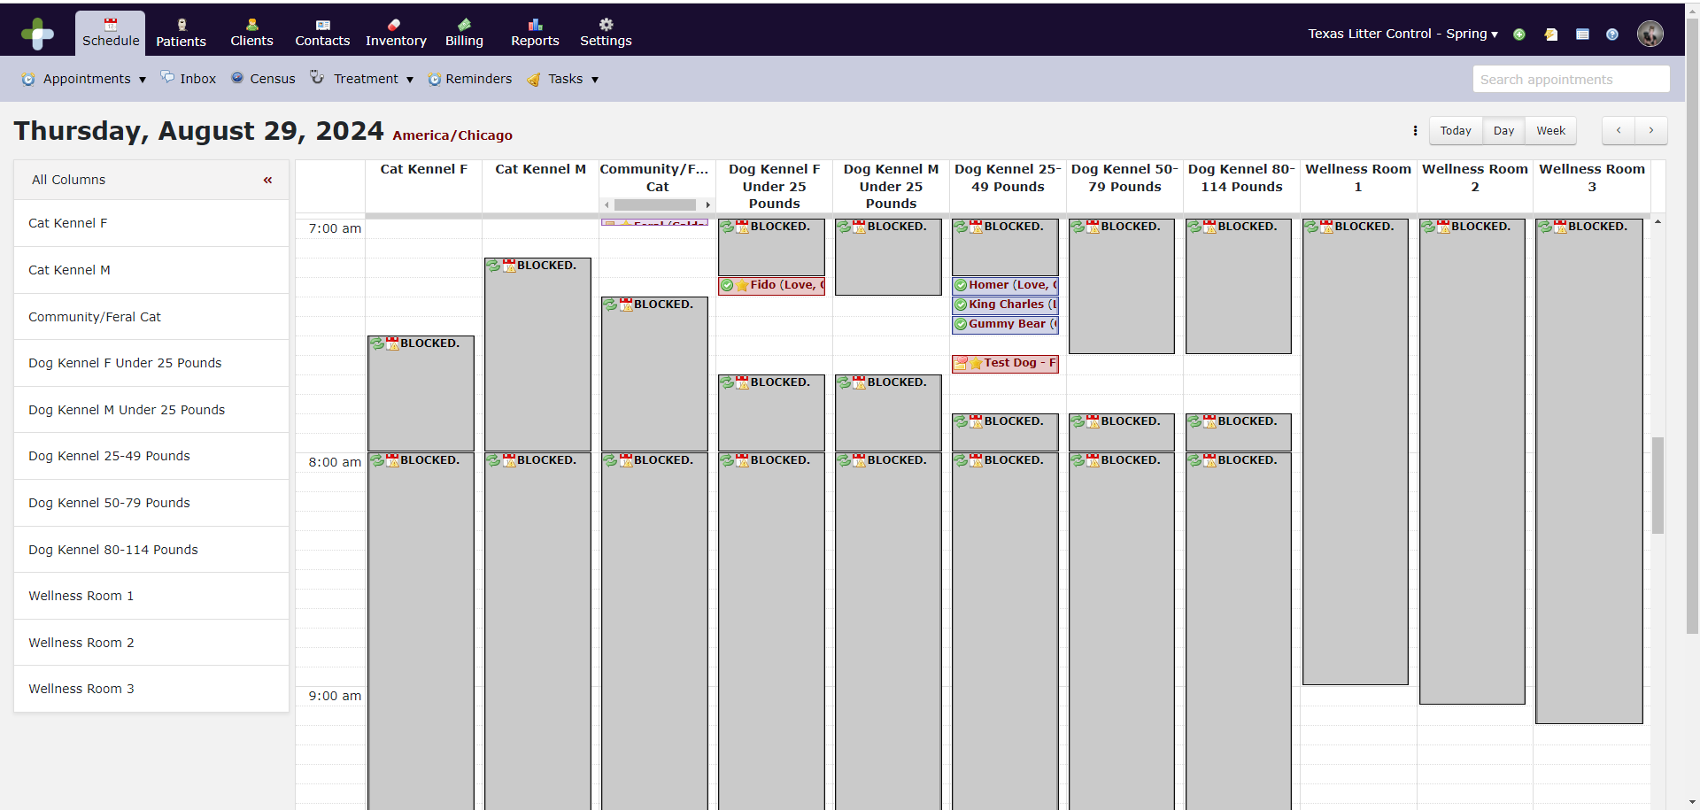

Appointment Types
Each appointment type triggers events within the system such as reminders and confirmations for the client that are specific to that appointment type. It also adds bundles and medical notes to some appointment types to help streamline workflows once the patient has been checked in.
These are the appointment types we have set up in our system:
Appointment Type | Duration (Minutes) | Schedule Column | Online Booking Allowed
Female Dog Spay Under 25 Pounds | 5 | Dog Kennel F Under 25 Pounds | ✓
Female Dog Spay 25-49 Pounds | 10 | Dog Kennel 25-49 Pounds | ✓
Female Dog Spay 50-79 Pounds | 10 | Dog Kennel 50-79 Pounds | ✓
Female Dog Spay 80-99 Pounds | 10 | Dog Kennel 80-114 Pounds | ✓
Female Dog Spay 100-114 Pounds | 10 | Dog Kennel 80-114 Pounds | ✓
Male Dog Neuter Under 25 Pounds | 5 | Dog Kennel M Under 25 Pounds | ✓
Male Dog Neuter 25-49 Pounds | 5 | Dog Kennel 25-49 Pounds | ✓
Male Dog Neuter 50-79 Pounds | 5 | Dog Kennel 50-79 Pounds | ✓
Male Dog Neuter 80-99 Pounds | 10 | Dog Kennel 80-114 Pounds | ✓
Male Dog Neuter 100-114 Pounds | 10 | Dog Kennel 80-114 Pounds | ✓
Female Cat Spay | 5 | Cat Kennel F | ✓
Male Cat Neuter | 5 | Cat Kennel M | ✓
Community/Feral Cat Spay/Neuter | 5 | Community/Feral Cat | ✓
Wellness Appointment (Vet) | 15 | Wellness Room 1  Wellness Room 2  Wellness Room 3 | ✓
Wellness Appointment (Tech) | 15 | Wellness Room 1  Wellness Room 2  Wellness Room 3 | Scheduled by Support Staff Only
Surgery Recheck | 15 | Wellness Room 1  Wellness Room 2  Wellness Room 3 | Scheduled by Support Staff Only
Expanded Services | 30 | Wellness Room 1  Wellness Room 2  Wellness Room 3 | Scheduled by Support Staff Only

Inbox
One of the many wonderful things about DaySmart is that when a client receives a text message reminder, they can respond, and it will appear in our DaySmart Inbox. A red light over the inbox indicates a new message has been received. This inbox will need to be checked often. To reply, just type your response in the box at the bottom and hit send. You can also initiate a message to a client. This feature can also be accessed through the Schedule Module. If you close the conversation, it will add the exchange to the customer communication log. You can also delete irrelevant conversations to keep the inbox clean and current.
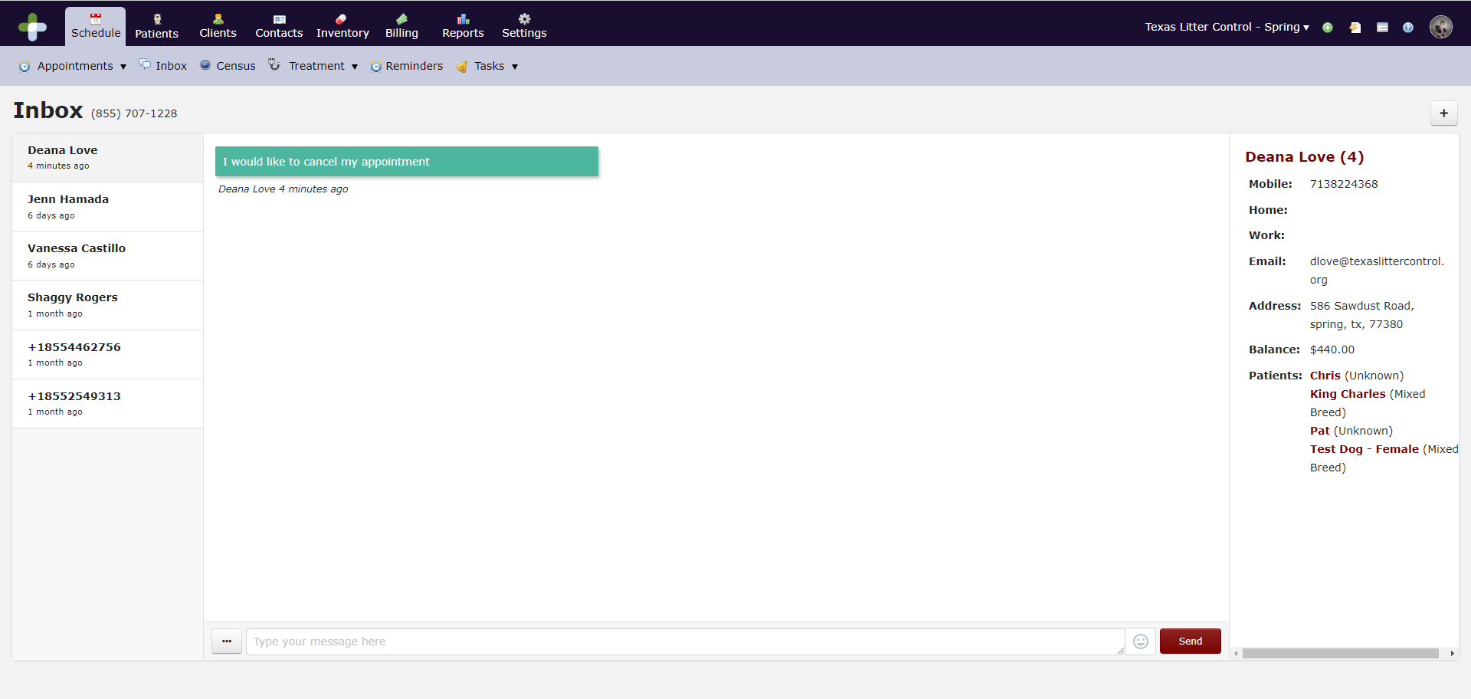
Tasks
Tasks are reminders for staff members. Tasks can be anything from cleaning reminders to follow-up phone calls to clients. Make sure you check your Tasks daily and check off once tasks have been completed.
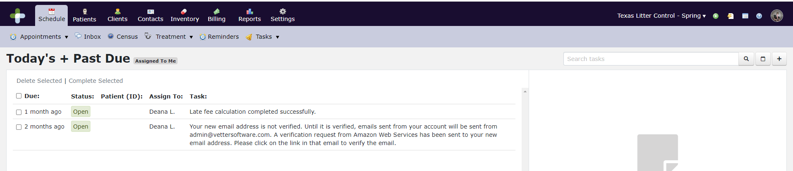

Patient Dashboard
The Patient Dashboard allows you to search for a patient by pet’s name, last name, rabies tag number, or micro-chip number. Just type your search criteria into the box at the top right corner of the screen.
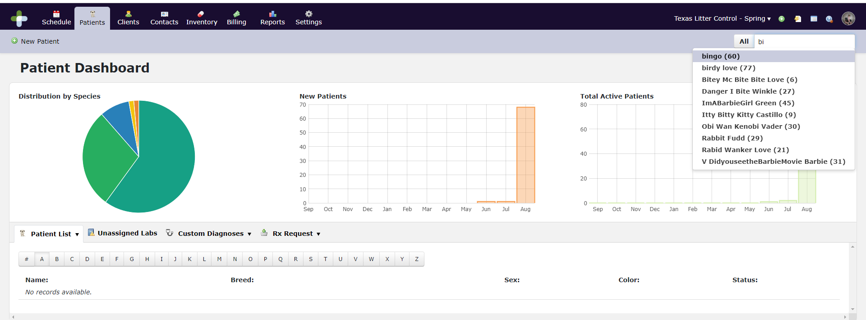
Select your patient and their full record will come up. You can access anything you need to about this patient from here. Any warnings or alerts will show up in a red pop up in the right-hand corner of the screen.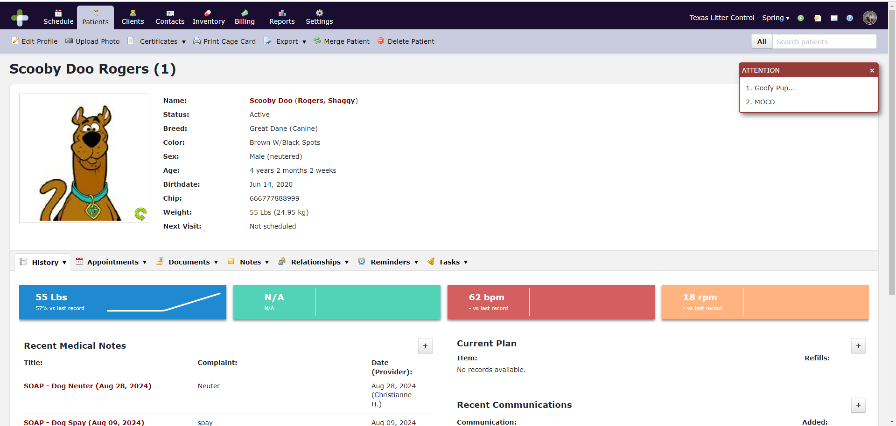

History
The history dropdown provides a full history of what has gone on with this patient at TLC. You can view Communications, Diagnoses, Diagnostics, Records and Vitals. You can also view refill requests and add new data to the record.
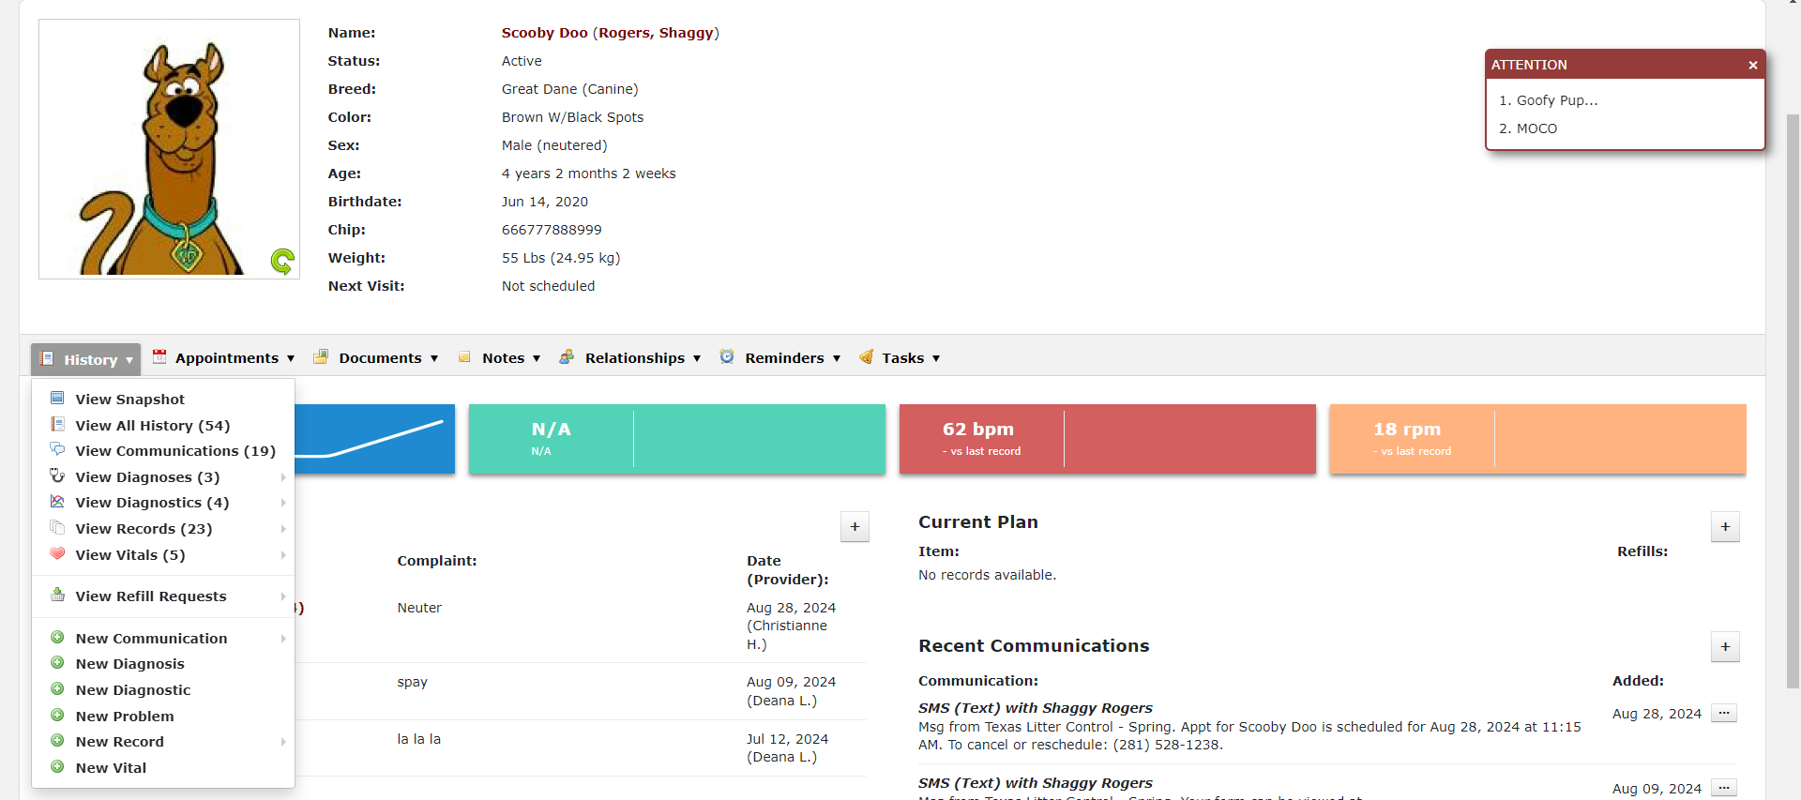

Appointments
You can view all appointments including future, past and cancelled appointments. You can add an appointment from here.
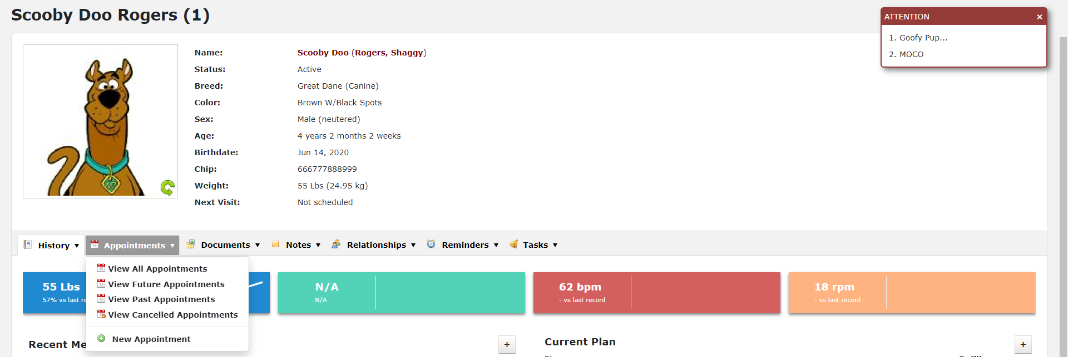

Documents
You can view a history of any letters, attachments, forms or certificates generated and/or sent to the client. You can also create new documents from here.
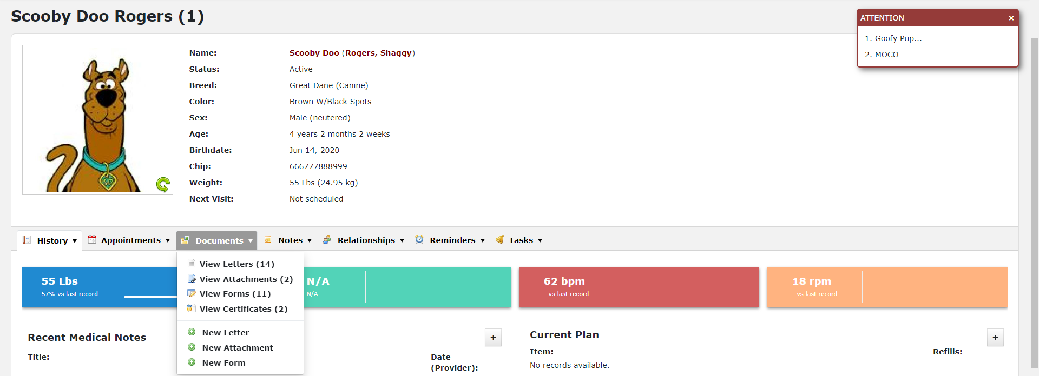

Notes
Any notes can be added or viewed. This is where you can add or change the pop-up screen when you first view the patient’s record. If you choose profile only, it will not show up on a pop up, only in the notes list.
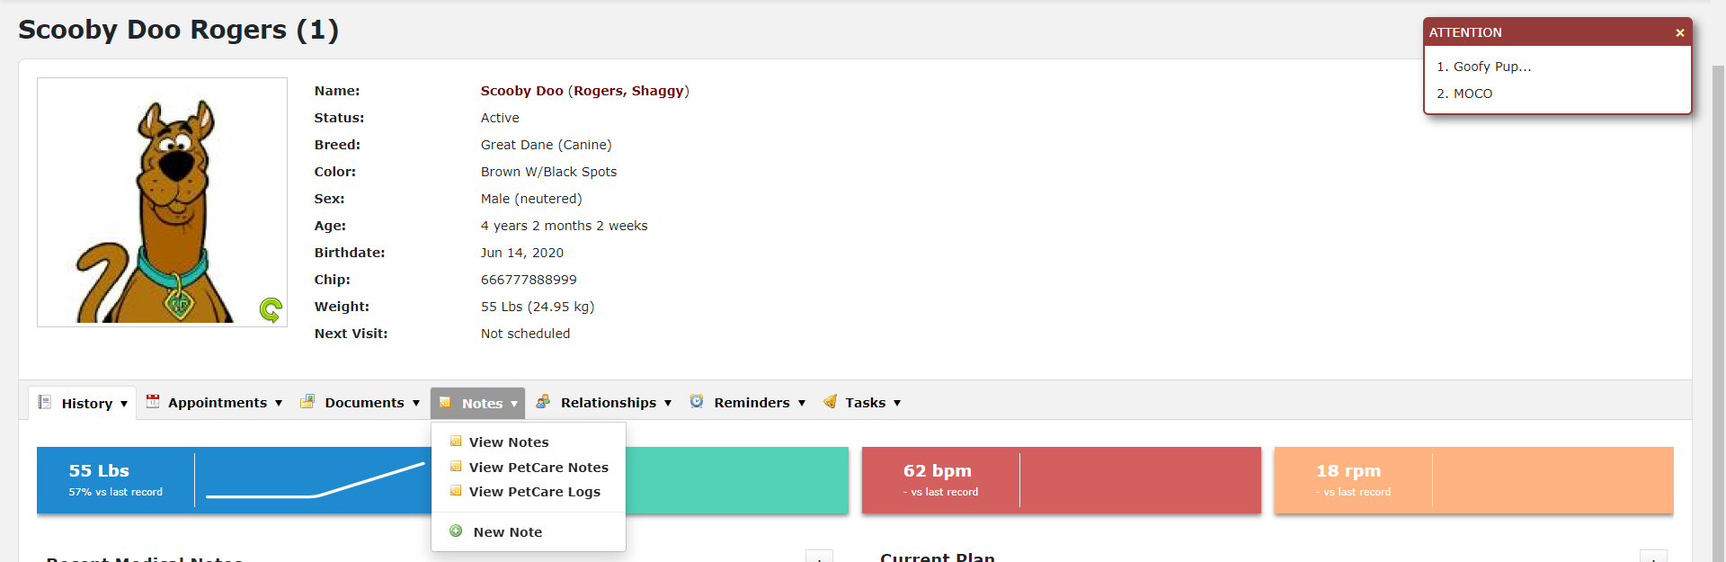

Relationships
Any type of relationship can be added to this section including additional owners, adopters, boarding facilities, etc. The primary owner will have a star by their name.
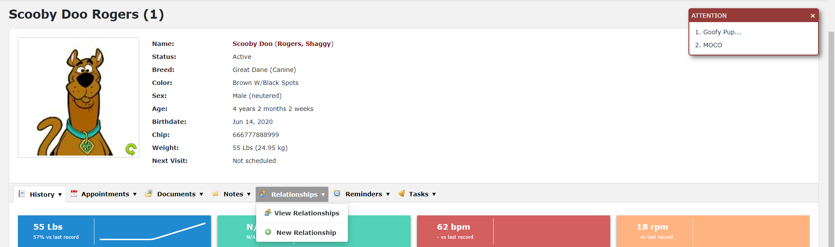

Reminders
You can view all reminders which have been sent to the client. You can also create new reminders for the client. Reminders will show up on the right side of the patient information. Any overdue reminders will be red, coming due in the next 30 days will be yellow, and up to date will show in green.
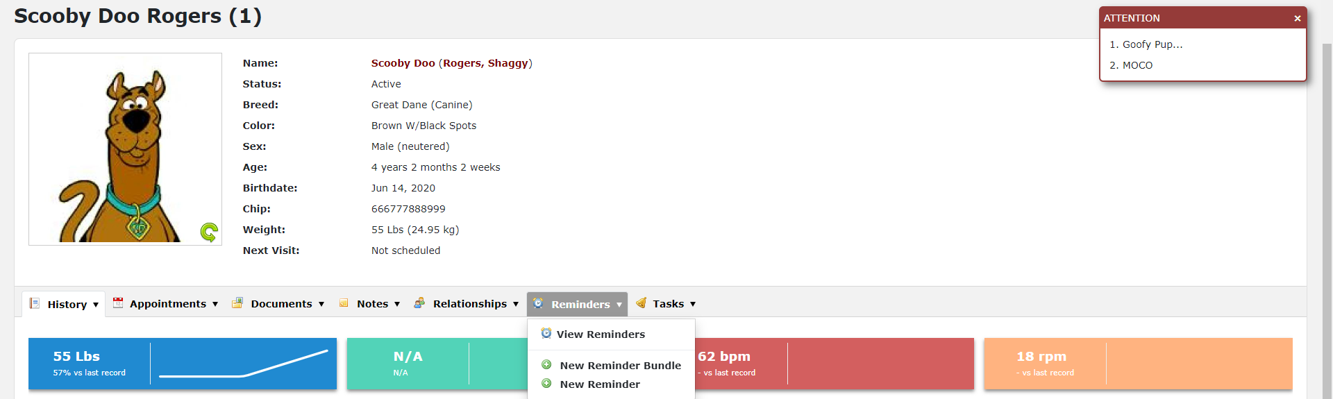

Tasks
You can view, update or add tasks that need to be followed up on for the patient such as follow up calls for bloodwork or to check on a patient.
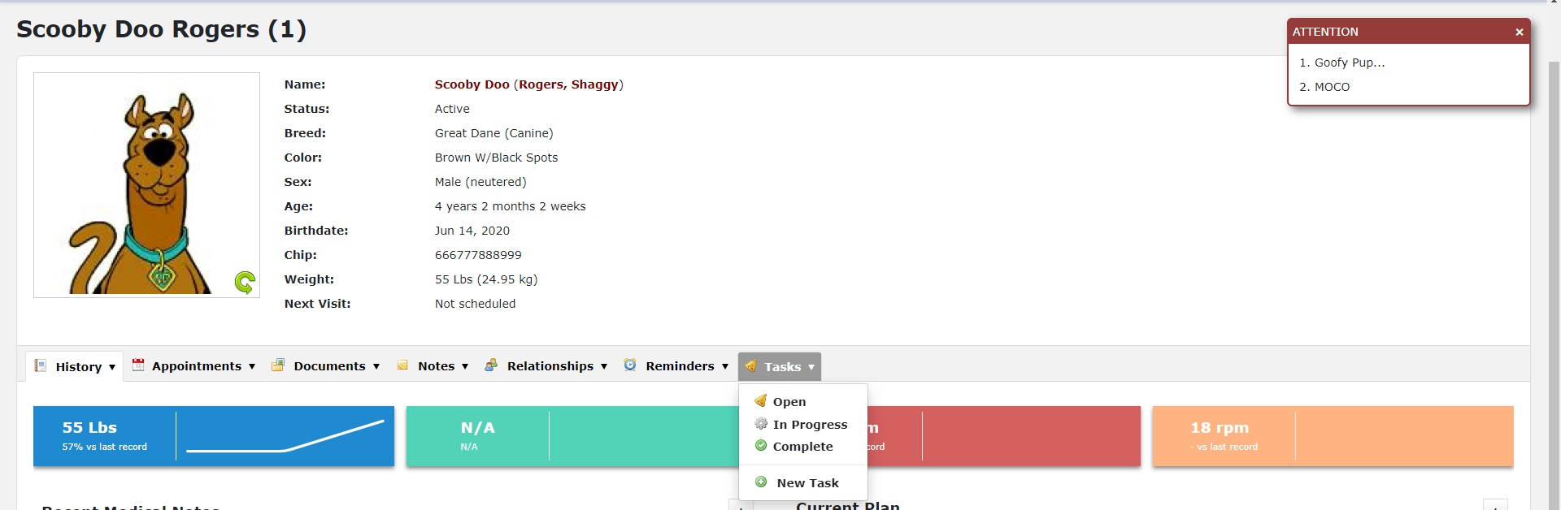

Client Dashboard
The Client Dashboard allows you to search for a client by first name, last name, email address, or phone number.
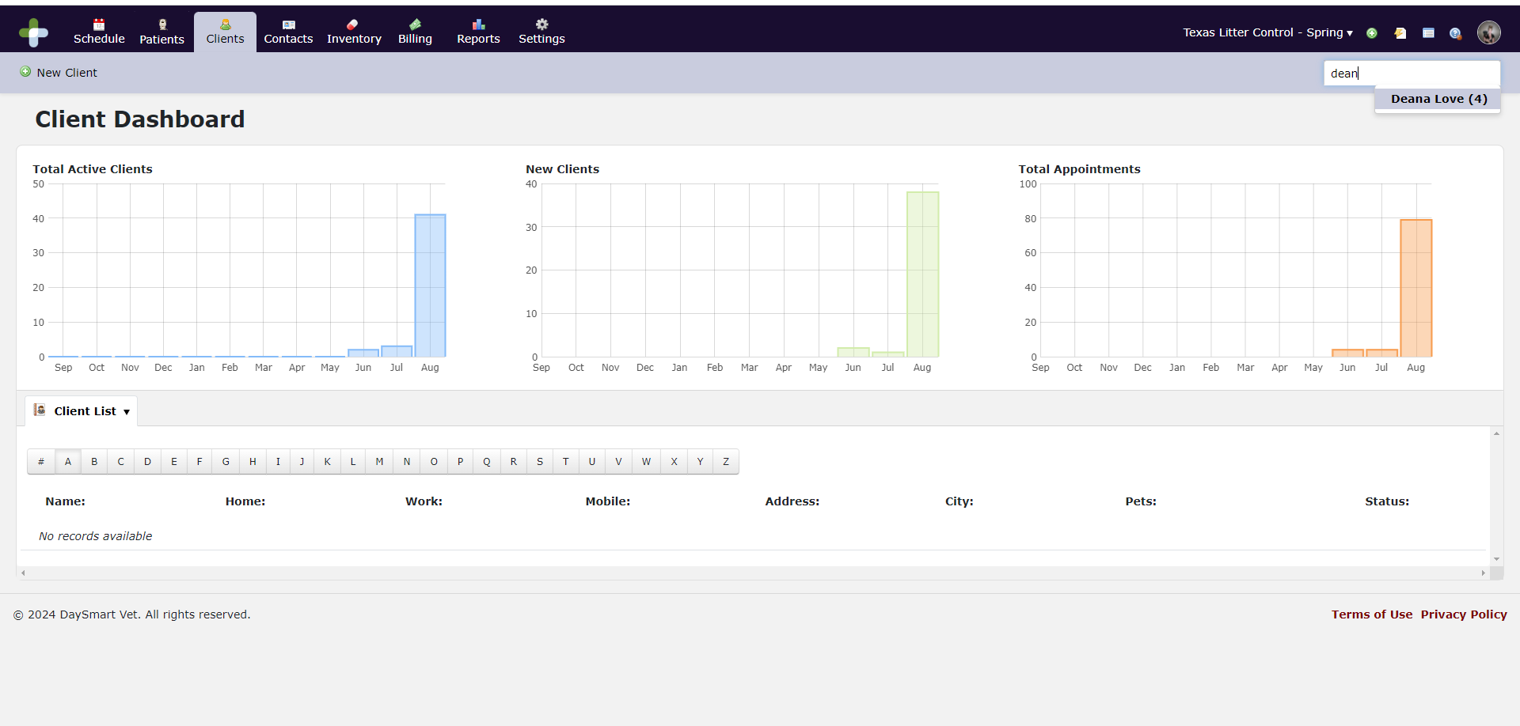
Once you select the client you are looking for, their profile will appear.
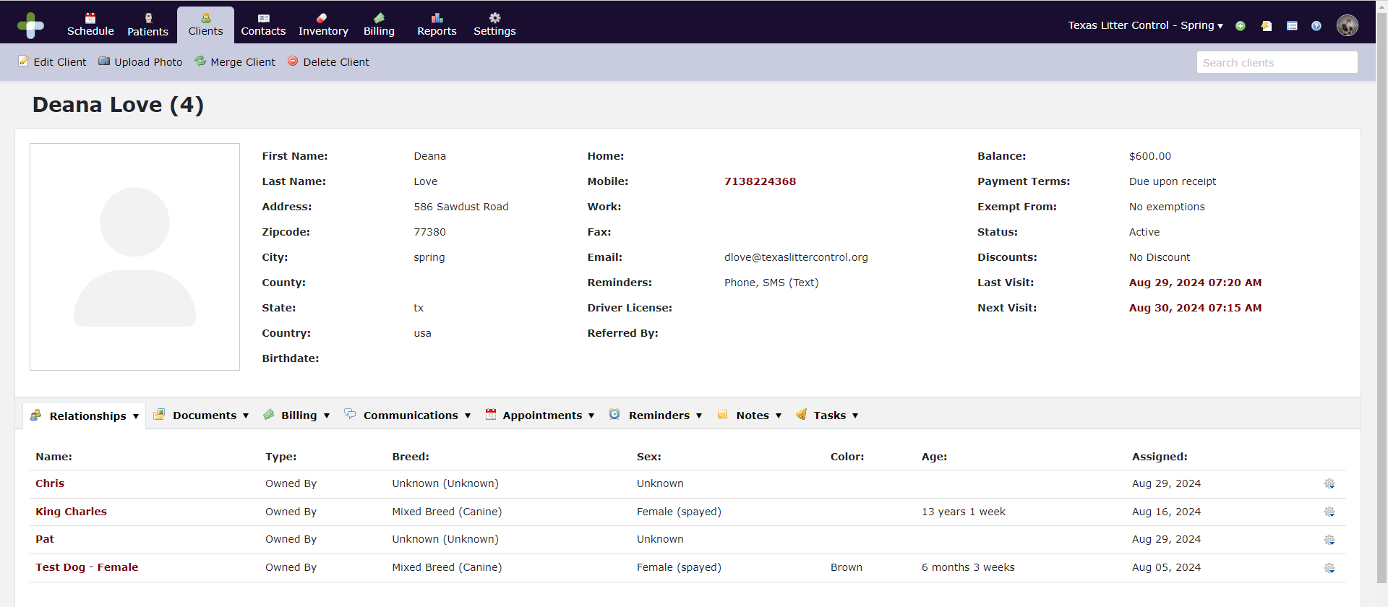

Relationships
You can view or add new relationships. Relationships include owned by, fostered by, adopted by, emergency contact for, prior owner, or related to.
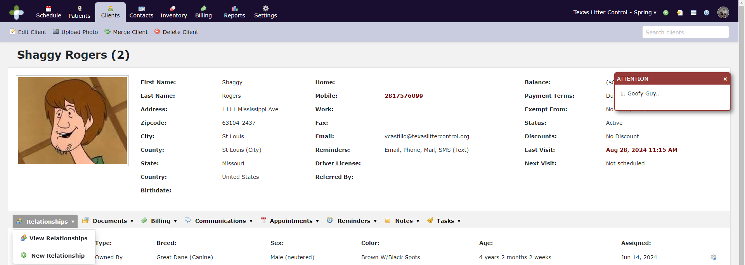

Documents
You can view a history of any letters, attachments, forms or certificates generated and/or sent to the client. You can also create new documents from here.
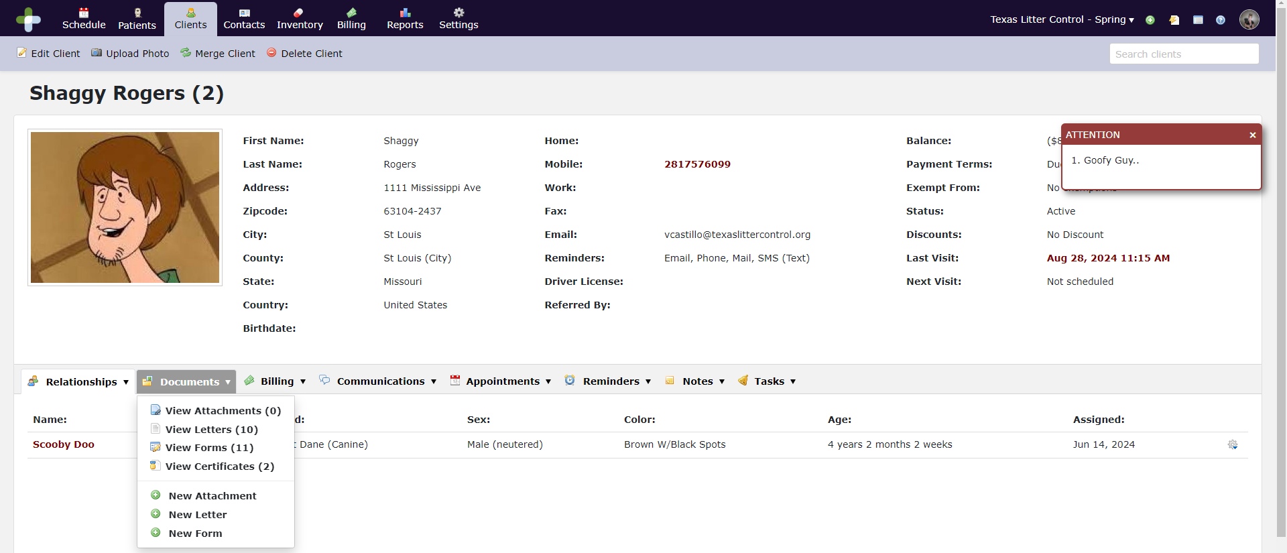

Billing
Here you can view all transactions associated with the client (Credits, Estimates, Invoices, Late Fees, Payments, Payment Methods, Refunds, Returns, Write Offs, and Declined Items. You can generate an account statement or add a new estimate, invoice or payment method.
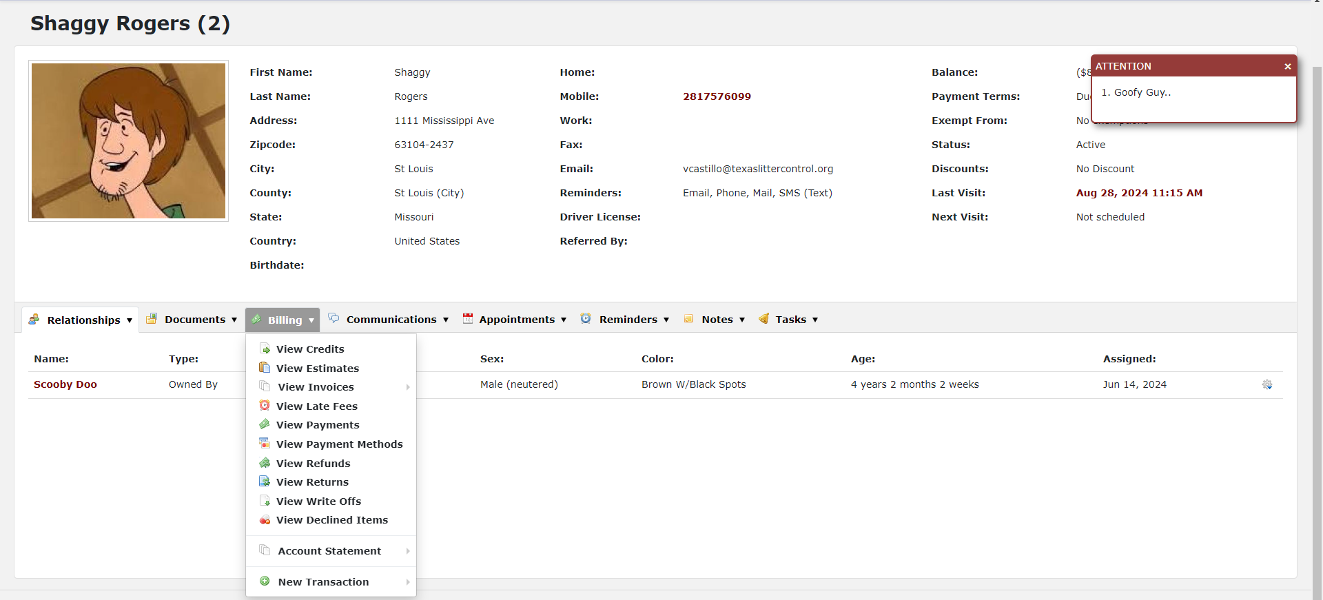

Communications
You can view all the communications with the client, log new communications that are not automated to the system (phone calls, emails, faxes, etc.)
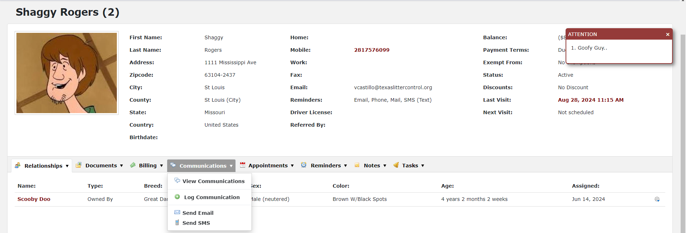

Appointments
You can view all appointments including future, past and cancelled appointments. You can add an appointment from here.
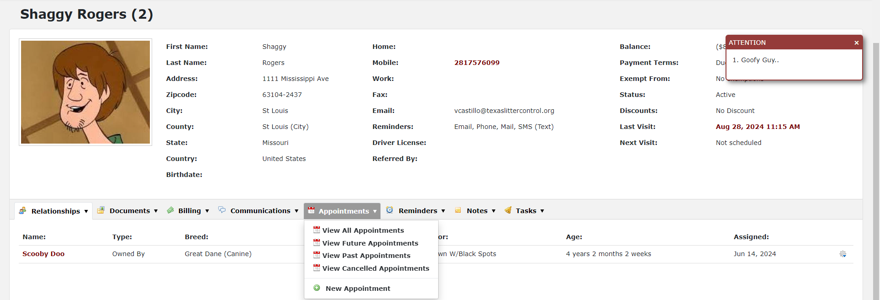

Reminders
You can view all reminders which have been sent to the client. You can also create new reminders for the client.
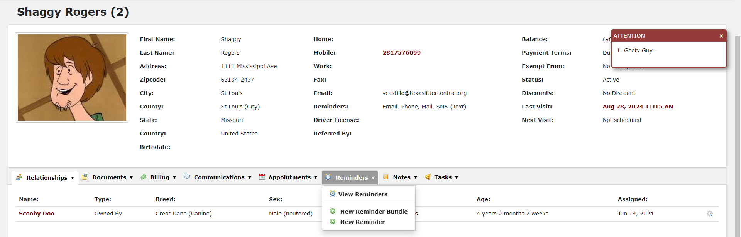

Notes
Any notes can be added or viewed. This is where you can add or change the pop-up screen when you first view the patient’s record. If you choose profile only, it will not show up on a pop up, only in the notes list.
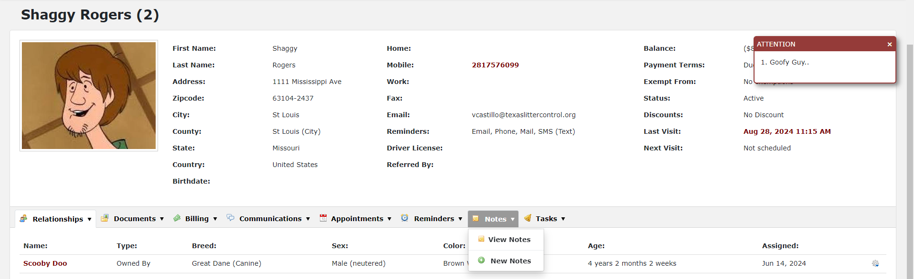

Tasks
You can view, update, or add tasks that need to be followed up on for the client such as follow up calls.
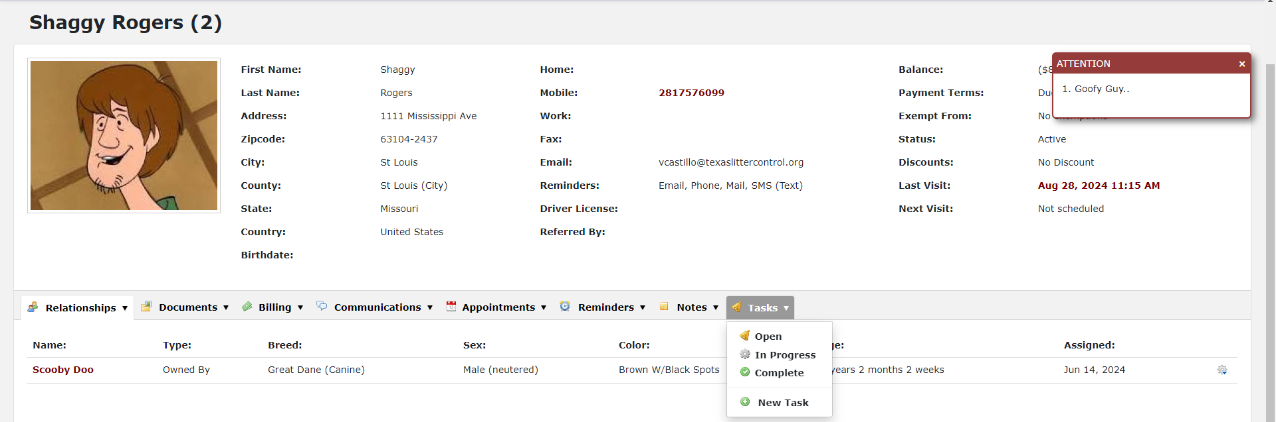

Contacts Dashboard
We have included some key contacts in our Contacts Dashboard such as management’s cell phone numbers, pharmaceutical vendors, landlords, and utility contacts.
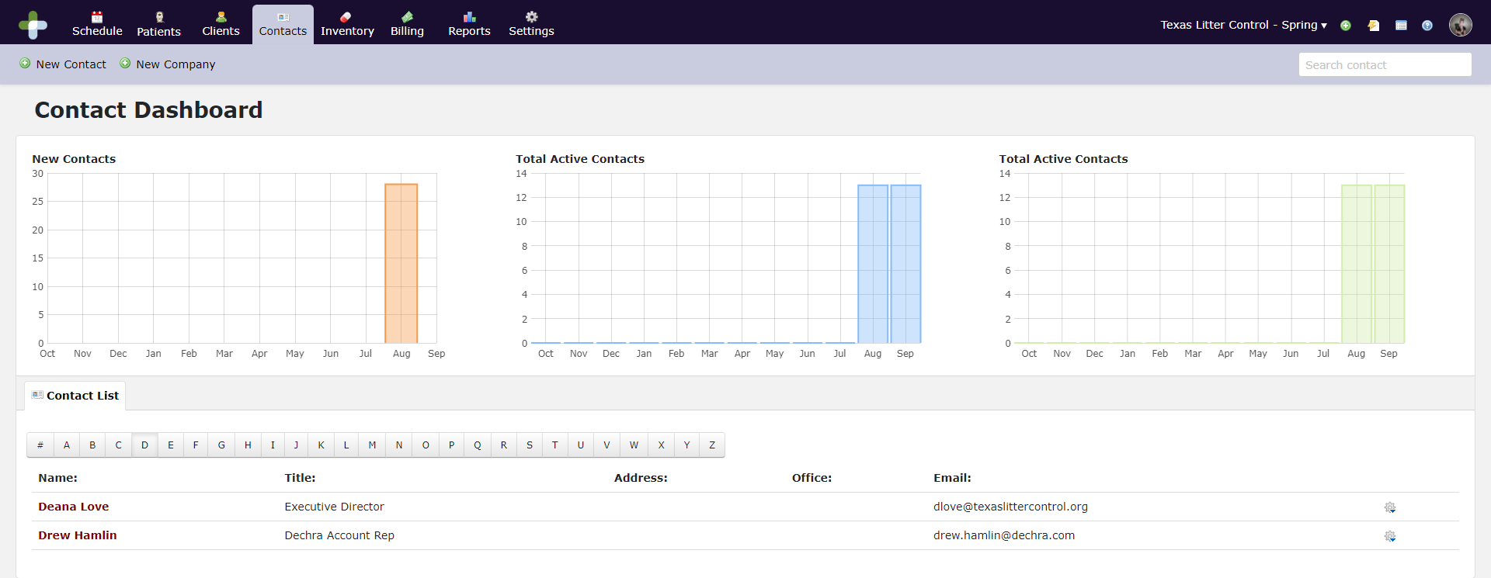

Inventory
Inventory is used to record orders, update pricing in the system and track restocking. Each inventory item is assigned to a Category and Sub Category. This allows us to assign price increases and discounts and apply sales tax to a full Sub Category. It also allows a more user-friendly search capability.
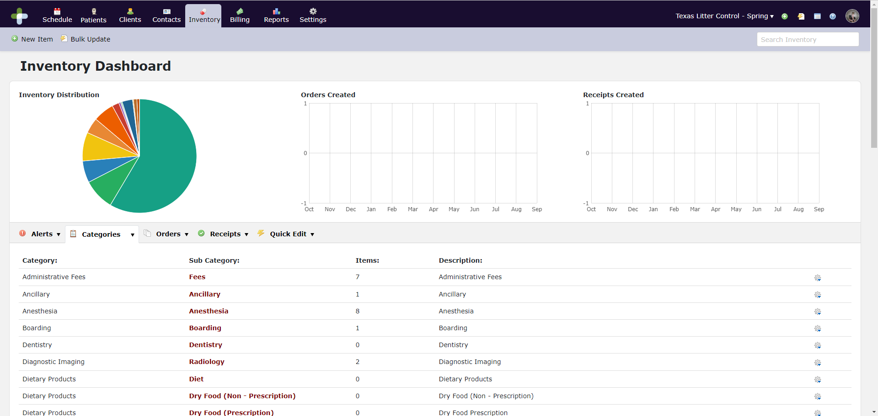

Workflow
Texas Litter Control has a unique workflow so we have tweaked the schedule, so we do not accidentally overbook. Please remember we are all new to this software and schedule. Staff and clients will make mistakes. We need to do everything we can to help make the transition easy for everyone. We need to work through any issues we have with onboarding. This will include clients thinking they have appointments. We all need to stay positive and just help the clients get the services they need.

Online Booking for Clients
Clients will be allowed to go through our website and link to an online calendar where they can request appointments. The appointment will be blocked on the schedule. A TLC staff member will review and approve the appointment and a confirmation will be sent to the client via email. Here is what the client will see when booking online.
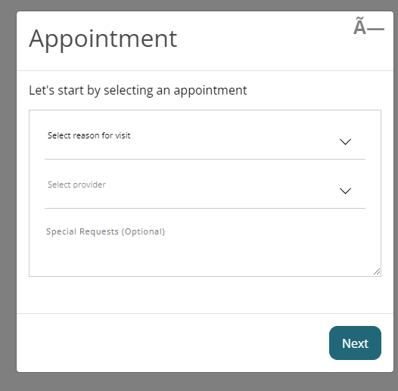
The client will choose a reason for their visit and then they will select a provider (which is a kennel size or wellness room).
Once these things have been selected, available timeslots will show up for selection. This process is noticeably different from our old scheduling software as DaySmart cannot book more than one appointment in a time slot. We made the different procedures different durations and then blocked off a certain amount of time for each kennel size. This should prevent overbooking. Our clients will be seeing an appointment time now instead of all cats at 7am and all dogs at 7:30am. Hopefully, this will help stagger arrivals a little better.
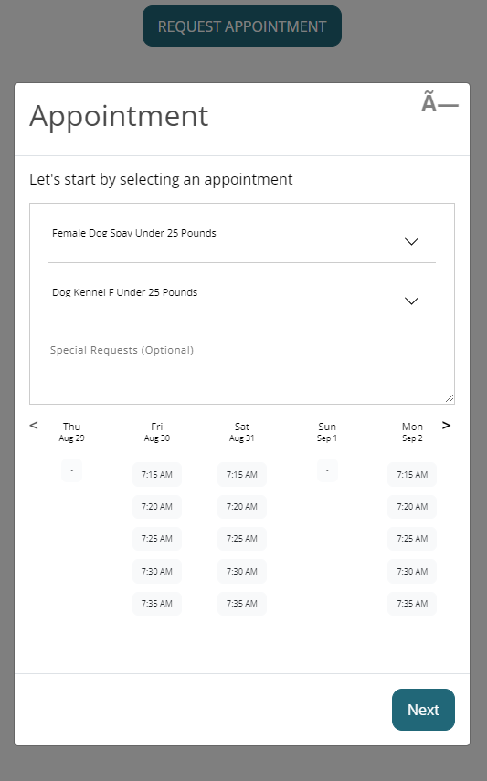
Once a time is selected, the client will enter information for the appointment. It is important to note here that some data may not carry over to DaySmart. An email will be sent to the Reggie@TexasLitterControl.org email account when an appointment is requested and the appointment request will also show up on the Pending Appointments report. Appointments can be worked by a TLC staff member from these emails or through a report in DaySmart. We will come back to this later.
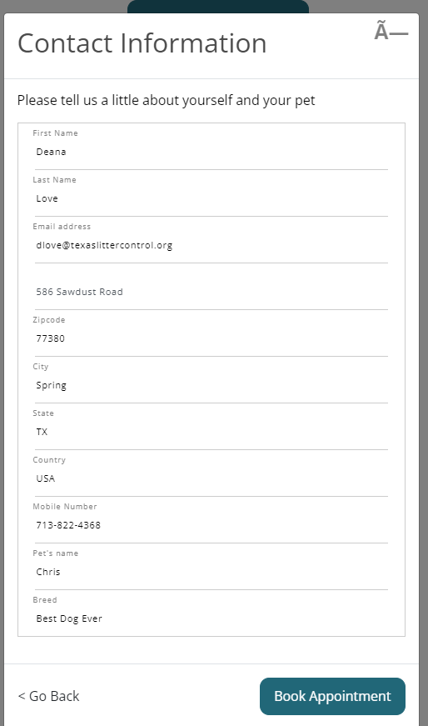
Once the client clicks “Book Appointment” they will see this screen. It is not a confirmation. It explains we will be reviewing the appointment.
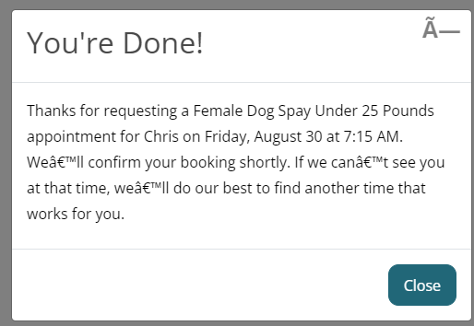

Approving Online Appointments

Working with the Pending Appointments Report
Go to Reports and under the Schedule tab, select Pending Appointments. This report will list all pending appointments in the order in which they were requested. You can click on the Appointment Date and it will take you to the schedule for that day.
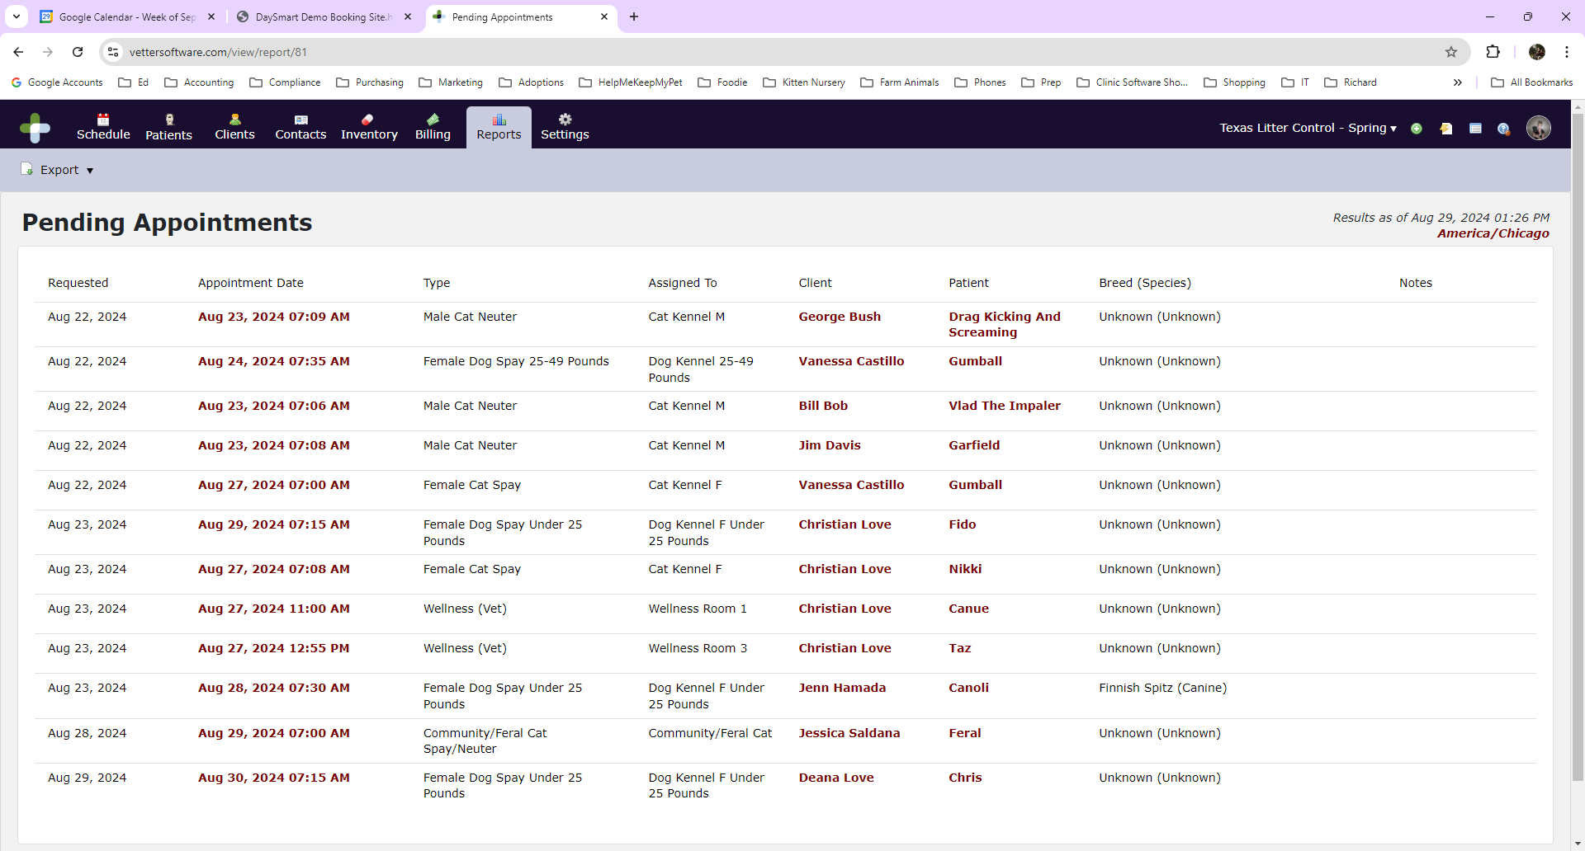

Approving/Declining/Rescheduling Appointments on the Calendar
Once on the schedule page, you can view the calendar showing all columns. Pending appointments will have a diagonal shaded line through them.
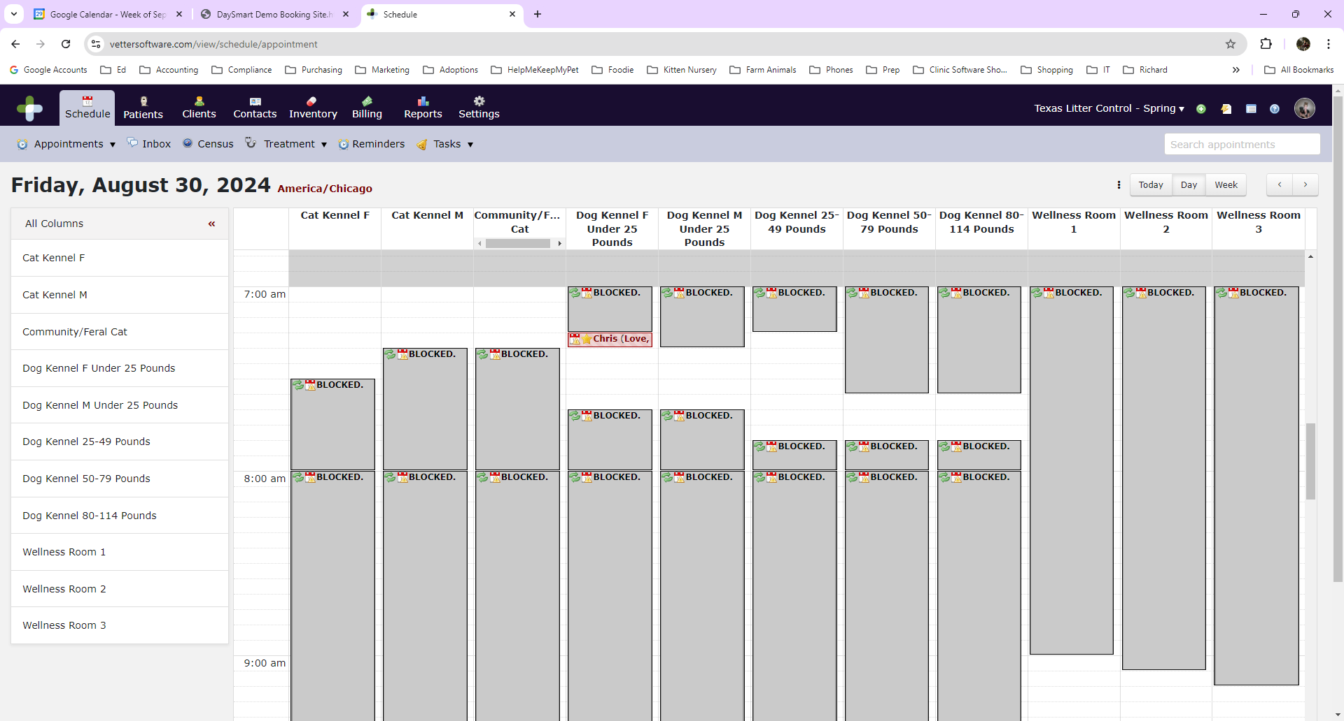
Or you can click on just the column you want to see.
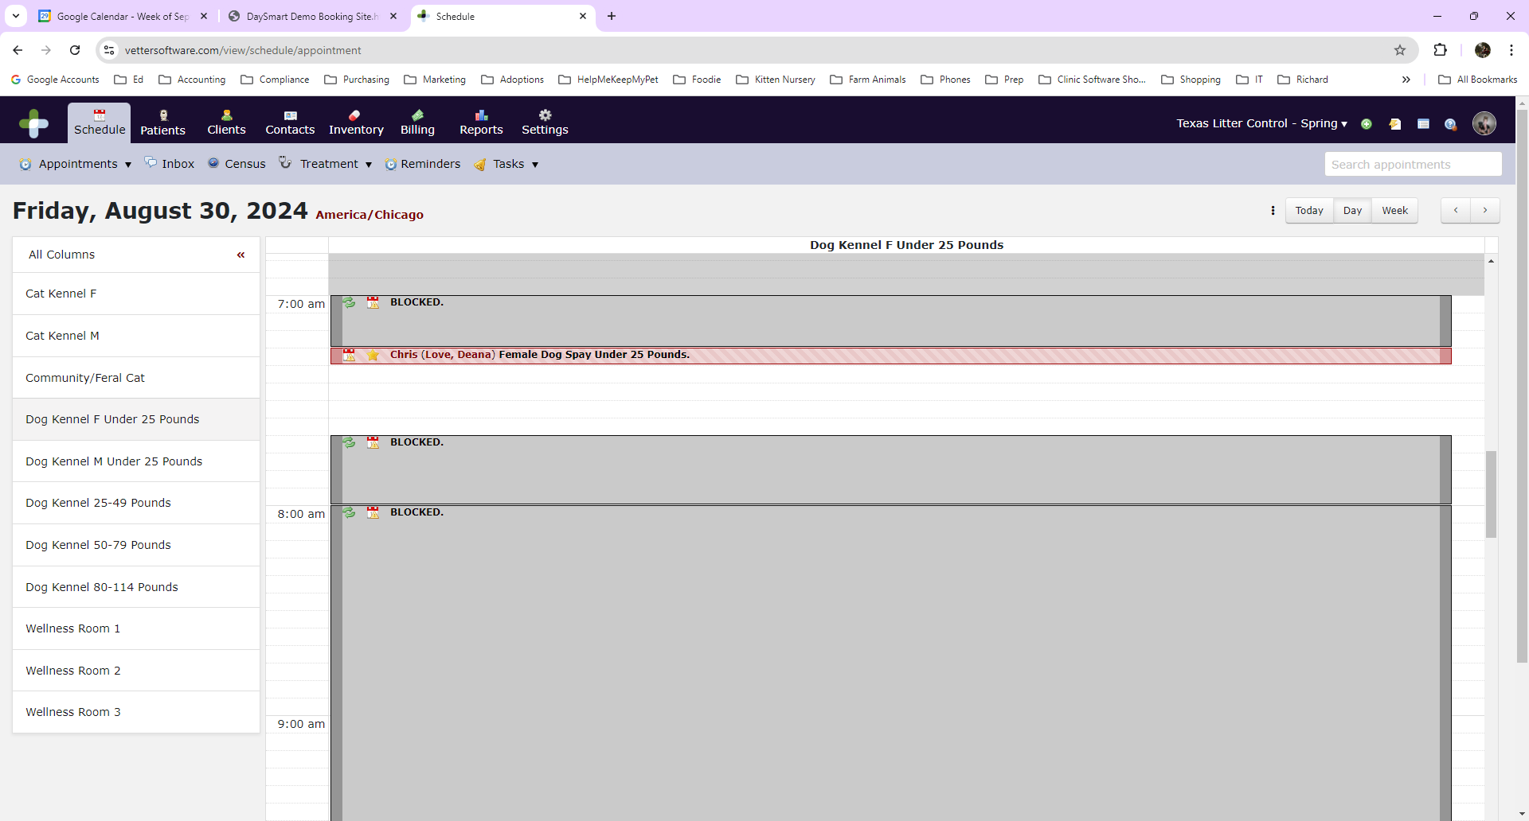
Click on the small calendar icon at the far-left side of the appointment. This will bring up the appointment and allow you to either approve, reschedule, or reject it.
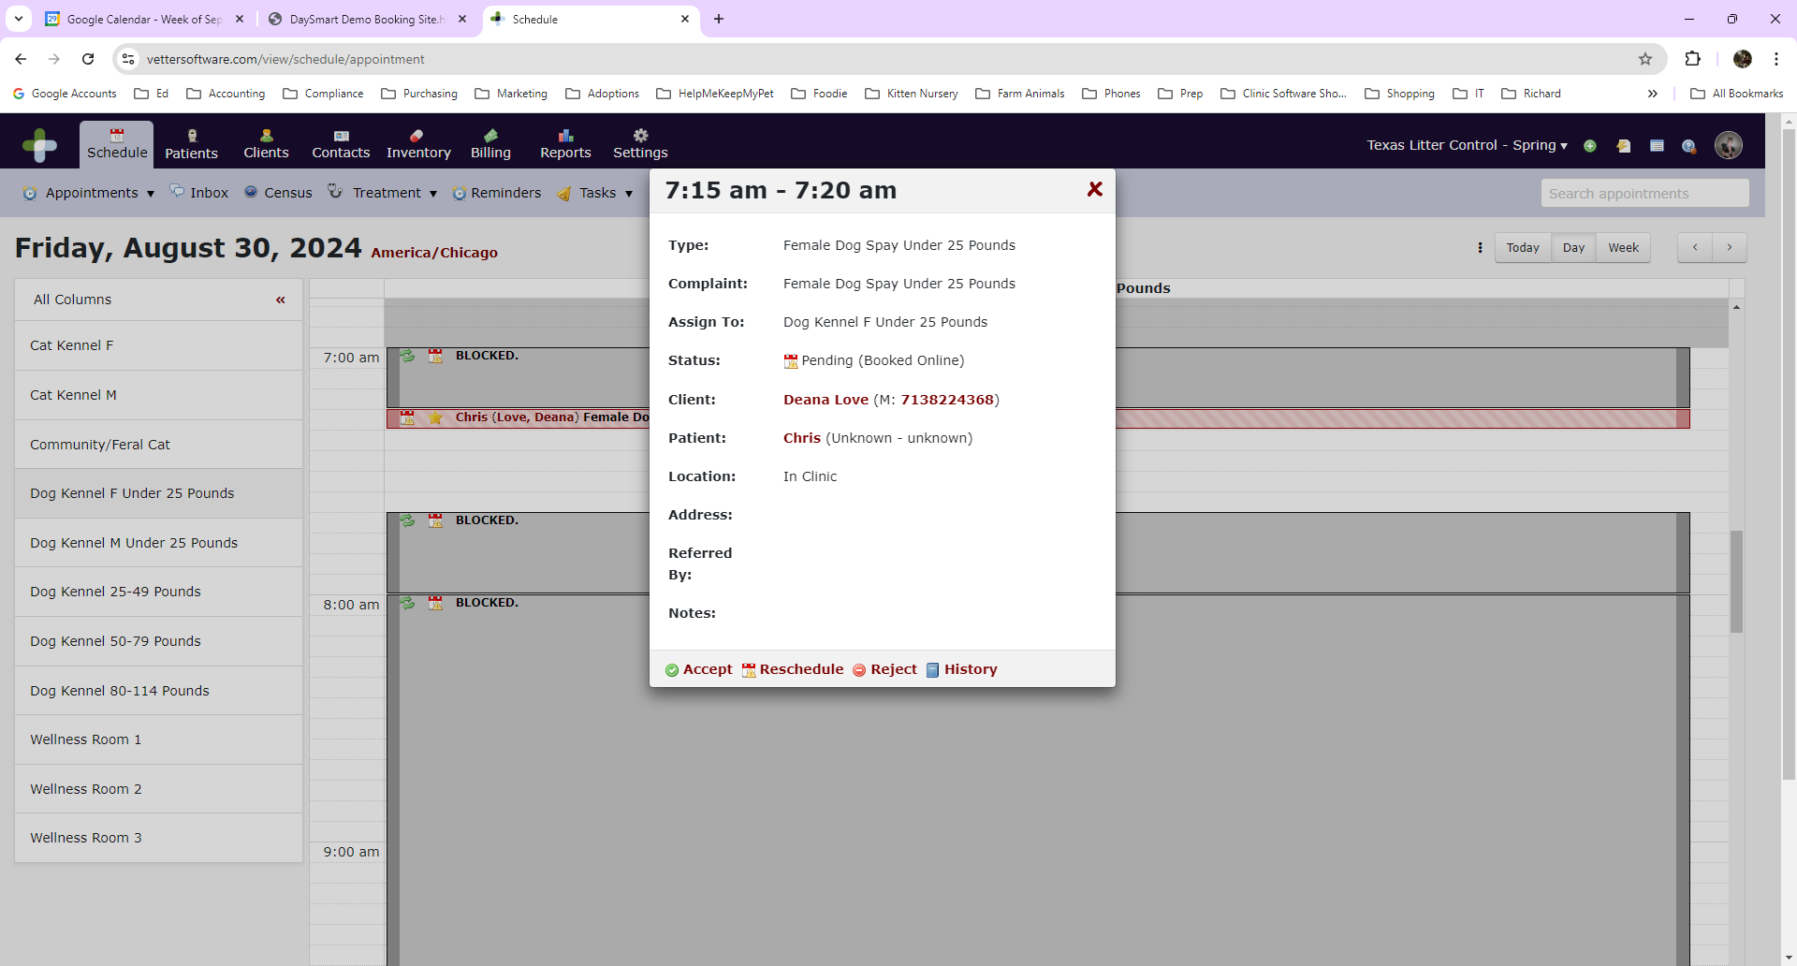
Click on Accept. The confirmation information will display. Click Accept again and the client will receive an email confirmation of their appointment.
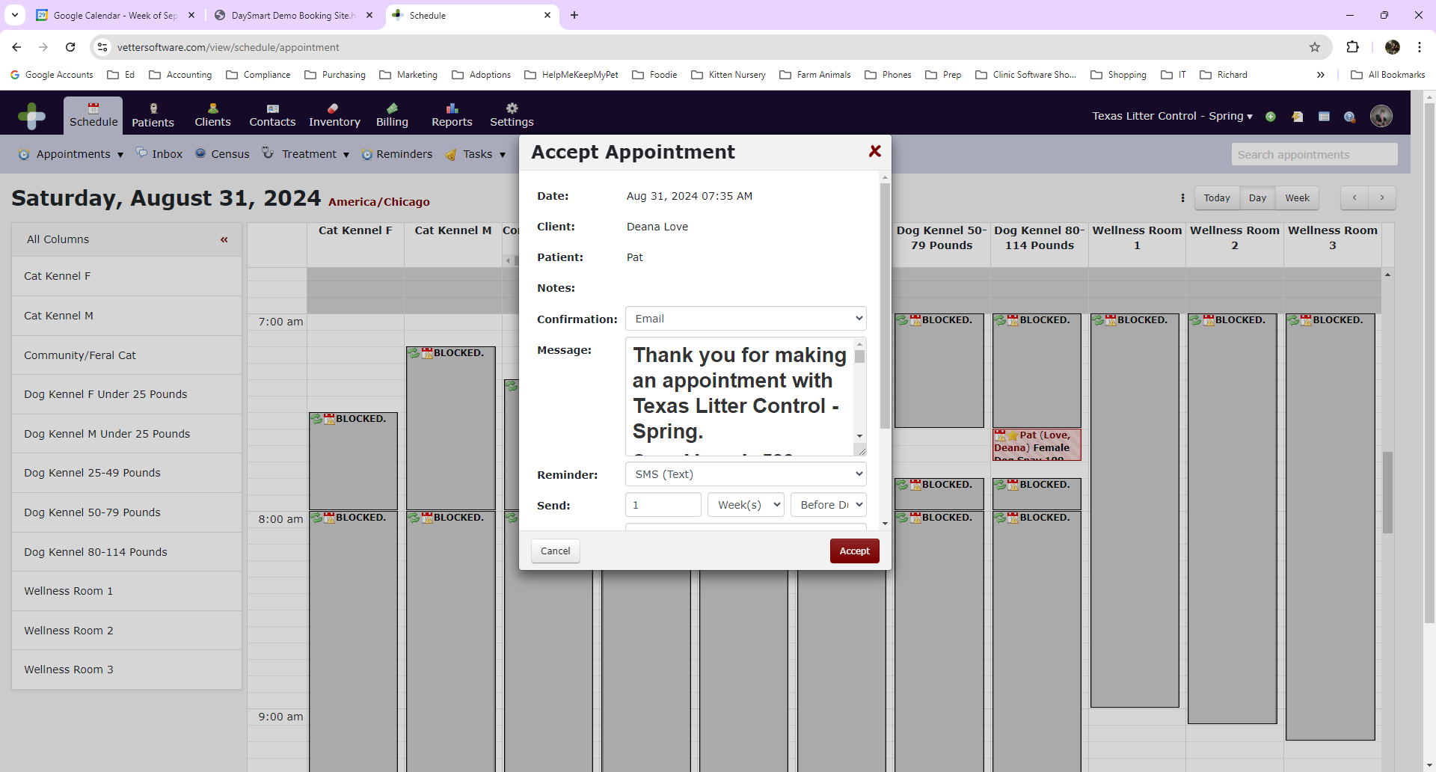

Analyzing the Calendar/Preventing Over booking & Under booking
Cat, small dog and XL dogs (80-114lbs) appointments are very straightforward. Simply look at the calendar and make sure everything looks ok and click Accept.
Dogs over 25 pounds are a little different. The 25-49lbs and 50-79lbs are a mix of males and females. We want to ensure we are not overbooking large female dogs. Clients can also book a male in the middle of our time slots, and it may prevent other clients from booking females.
Here is an example. Three clients booked male dogs in the middle of the slots. This will prevent any female dogs from being able to be booked because male dog slots are 5 minutes and female dogs are 10 minutes. This will probably not happen often, but we need to be aware of this so we can fill the schedule properly.
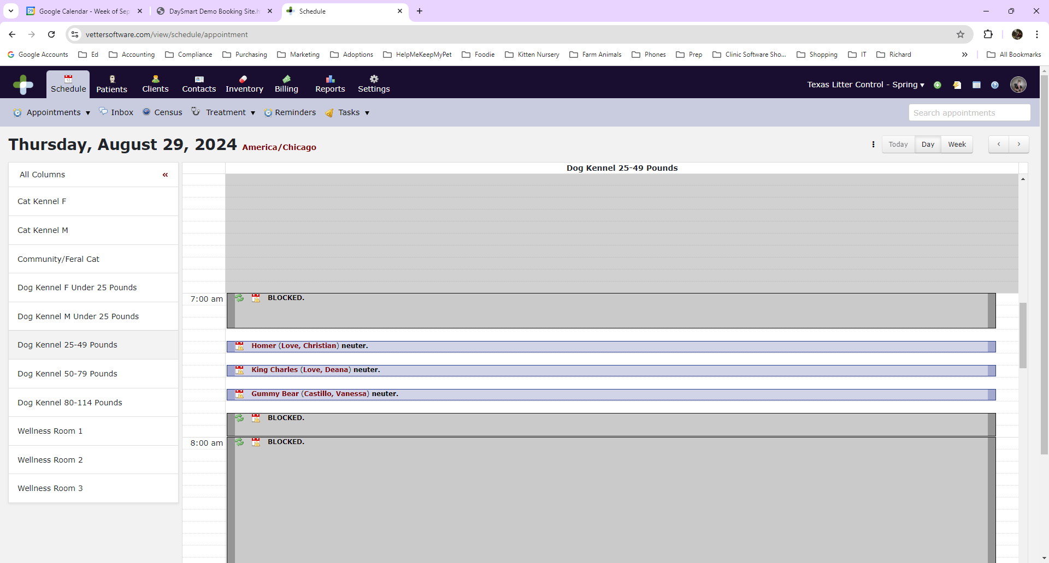

You will need to reschedule the appointments to the top or the bottom of the time slots. This will allow room for 2 female dogs on the schedule. Remember, you should only need to do this on the 2 columns: Dog Kennel 25-49lbs and Dog Kennel 50-79lbs.
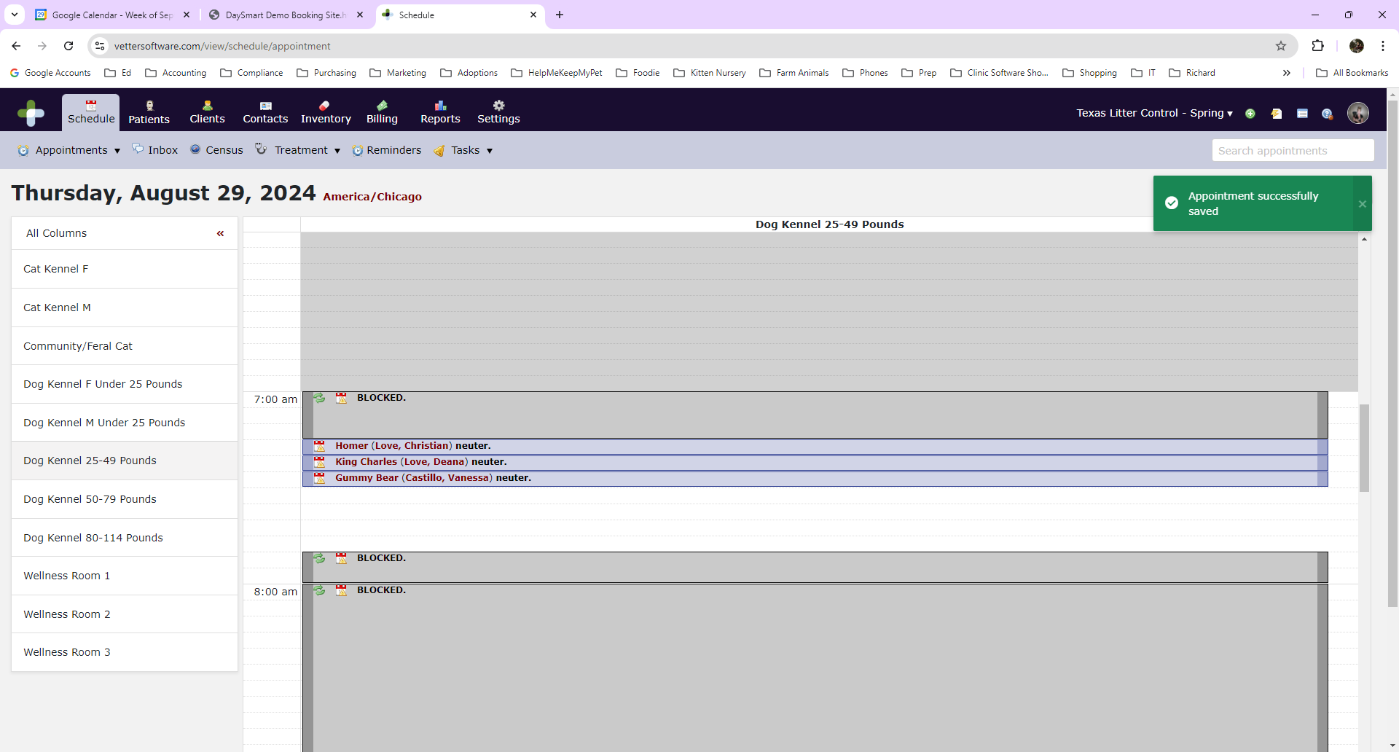

Booking an Appointment in House
Go to the Schedule tab. Search the calendar for an available timeslot. Select the appropriate Appointment Type. Click on the time and fill in all of the patient information. Click next.
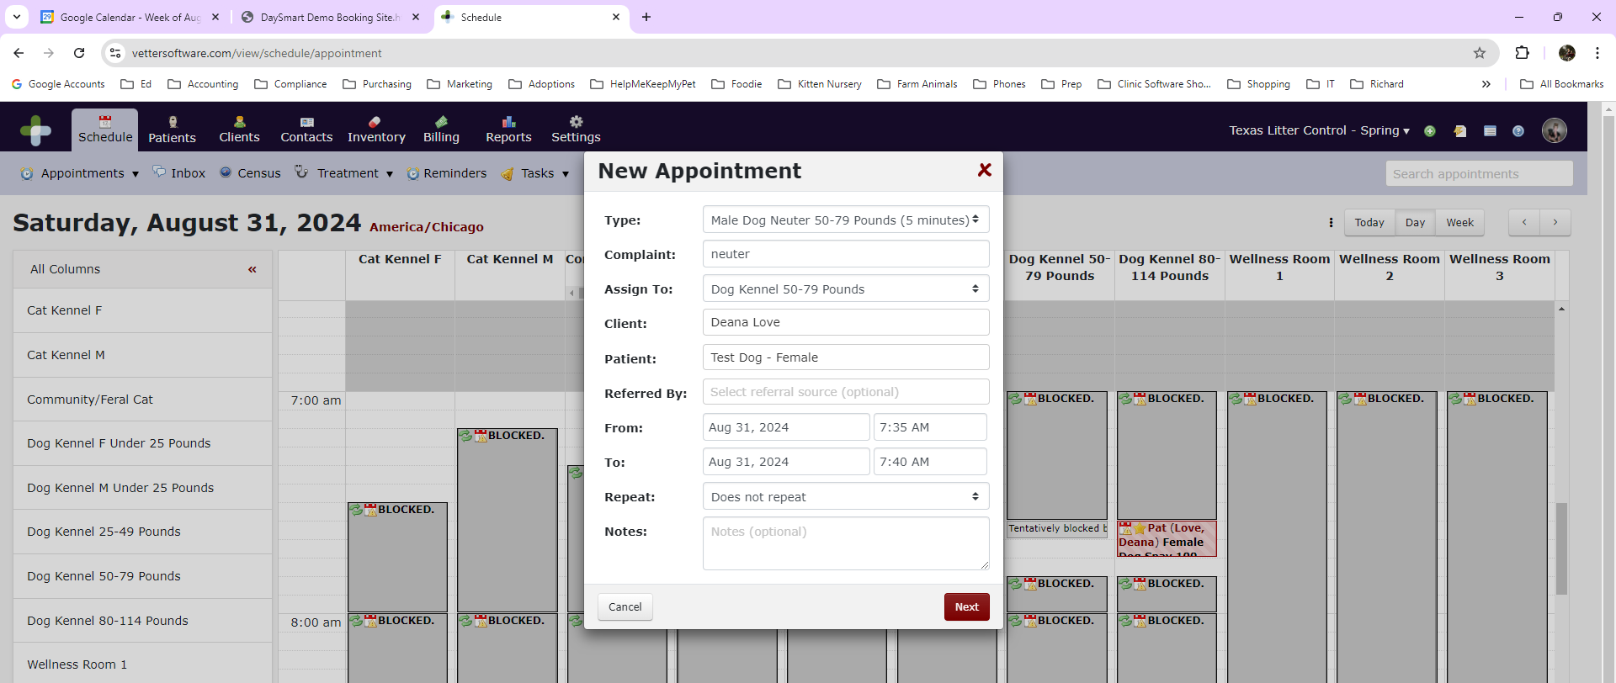
Fill in the client information and click save.
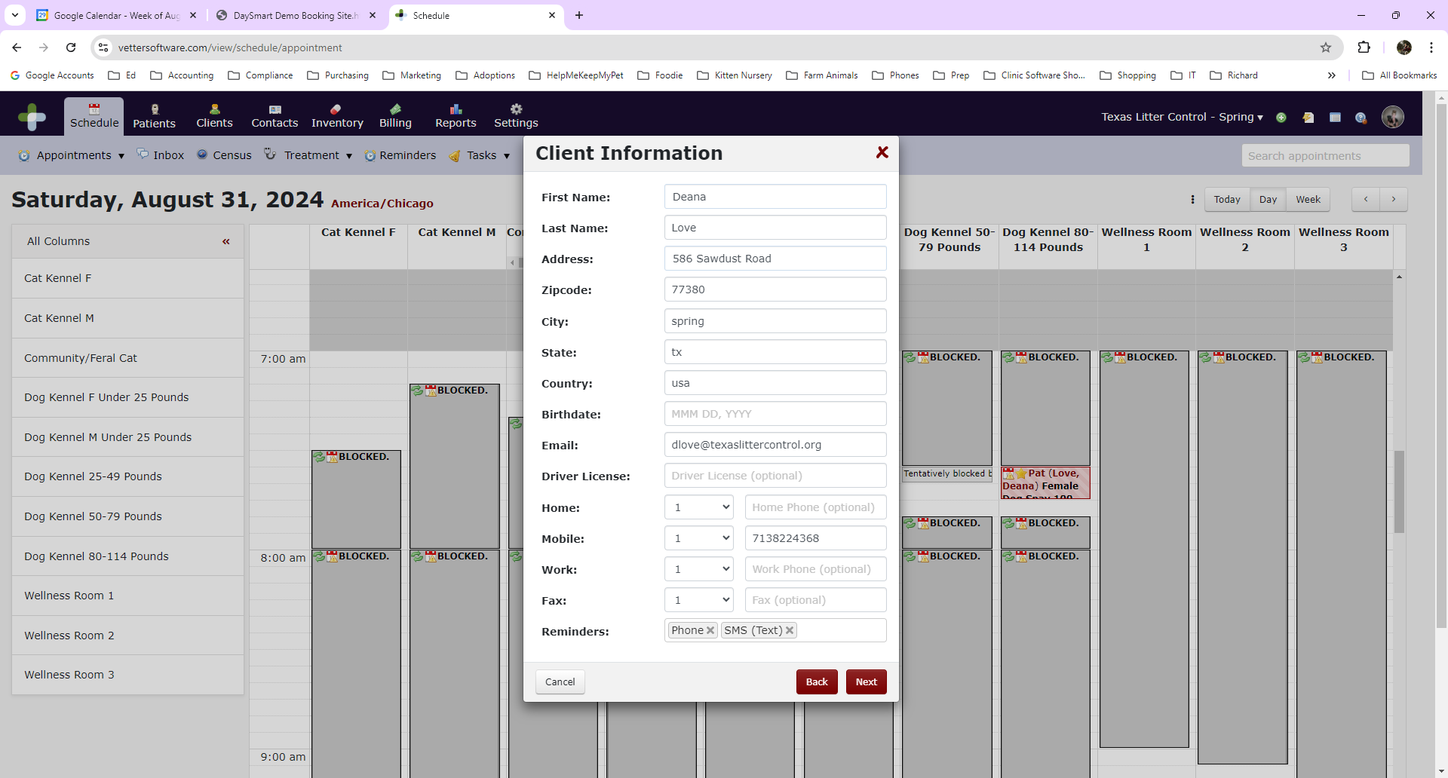

Verify the Confirmation information and click save.
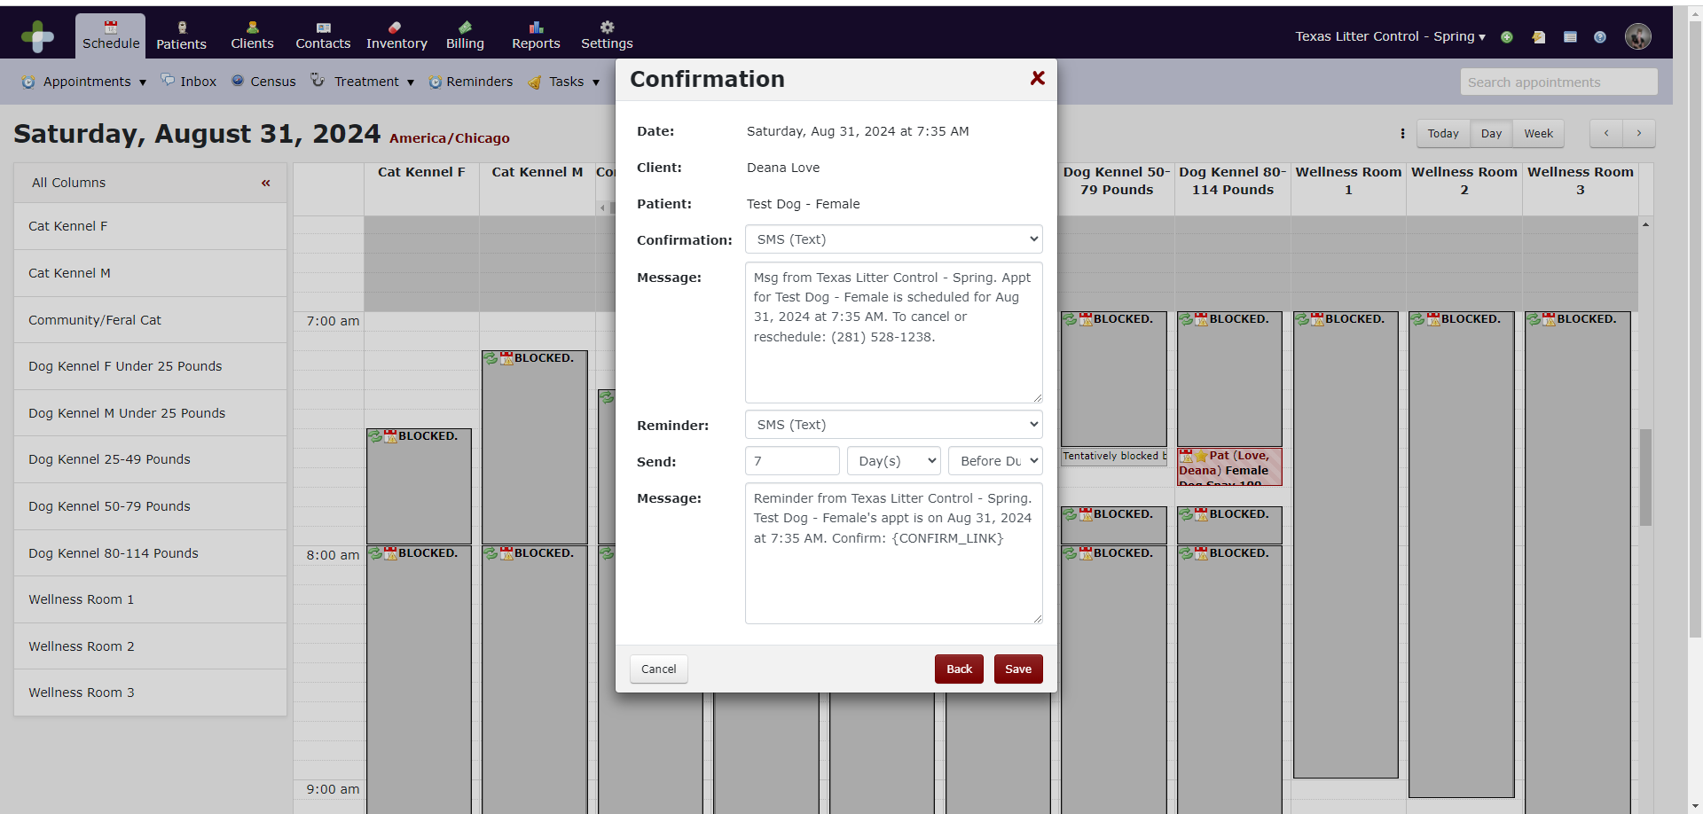

Appointment Triggers
Once an appointment is booked/approved, several automated things happen.

Reminders

Surgery Patients
- The client receives an email confirmation of the appointment.
- 5 days prior to the appointment, they will receive a text reminder.

Wellness Patients
- The client receives an email confirmation of the appointment.
- 3 days prior to the appointment, they will receive an email reminder.

Confirming Appointments
Confirmation calls are done 48 hours prior to the appointment. You do not need to call to confirm Community Cat appointments or our Volume Client rescues. Click on the appointment to view the status. If the status is not confirmed, you will need to call the client. If the status is confirmed, click on the History button at the bottom of the window to view the date the appointment was confirmed. If the appointment was confirmed more than 5 days ago, you will need to call with a reminder. Clients can confirm online at anytime. We do sometimes have instances where clients will schedule and confirm a month in advance, so a reminder is needed closer to the surgery date. The information you will confirm with the client is the appointment date, time, clinic location, verify female dogs have not been in heat in the past 30 days and verify they have received the reminder email with preop instructions and have reviewed that information.
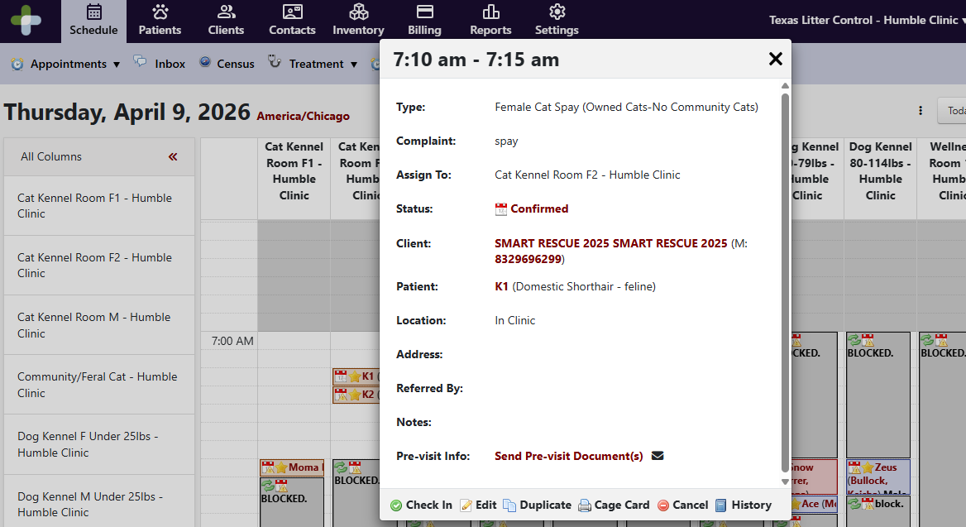

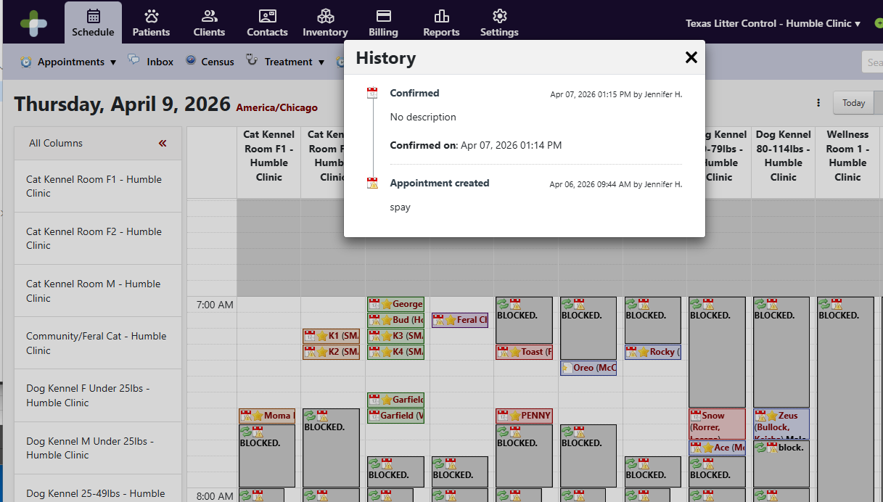

After you have called the client, you need to update the status. If you speak to them and confirm the appointment, change the status to confirmed and notate Confirmed with O and your initials. If you are unable to speak to them, leave the appointment as not confirmed and add notes of either LVM to Confirm or Unable to LVM to confirm with your initials.
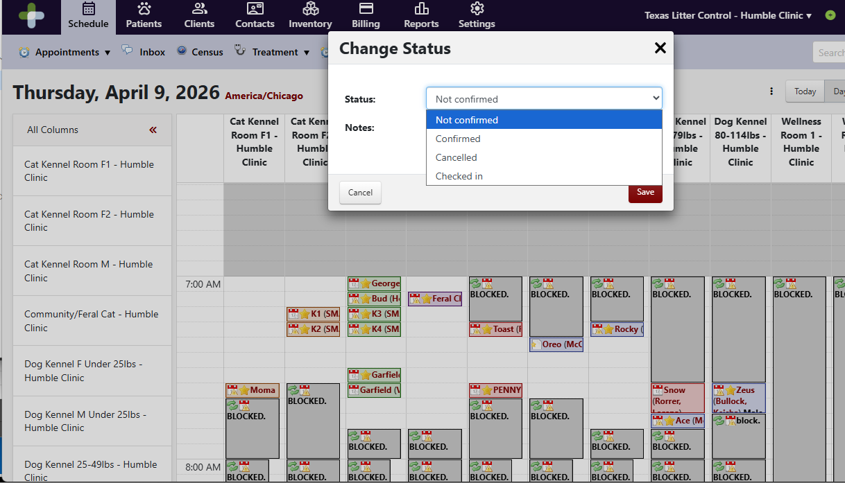
On the schedule, go to the day you are calling to confirm. It’s easier to go column by column to make sure you don’t miss click on something else.

Surgery Check-In
In the morning there will be 2-3 people scheduled. If there are 3 people, 2 will start outside and 1 will stay inside, when the line dies down a 2nd person can come inside to help with weighing pets and putting check-in sheets in sleeves along with a microchip if needed. If there are only 2 people, 1 person can stay inside while the other works the line. (To make things easier when there’s only 2 people the inside person can weigh the pets and put them in the kennel or back in their carrier so the outside person can move onto the next client).

From the appointment tab click on the schedule icon and then click “Check In”
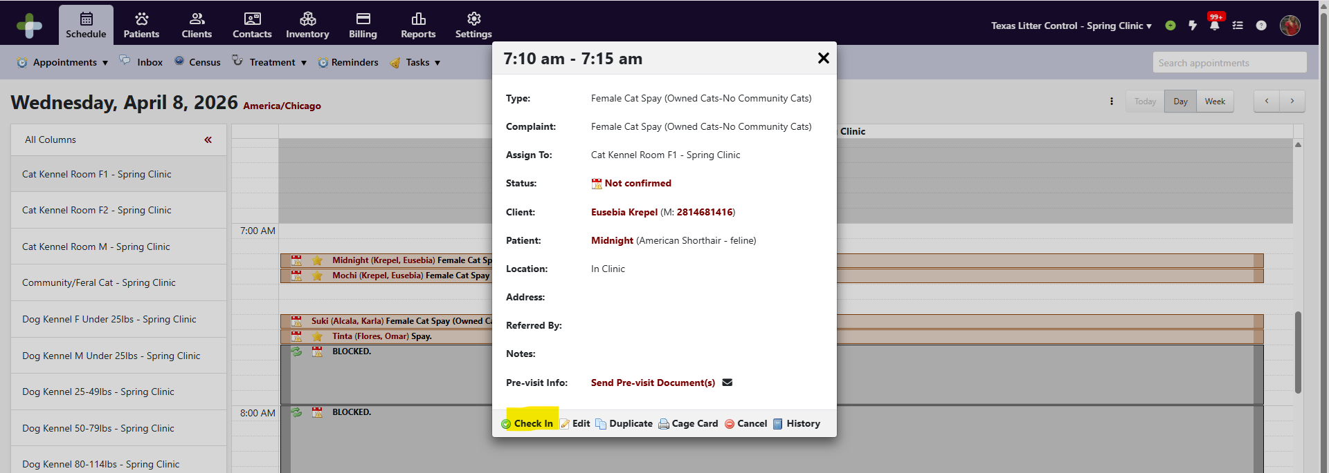
Select the Surgeon working.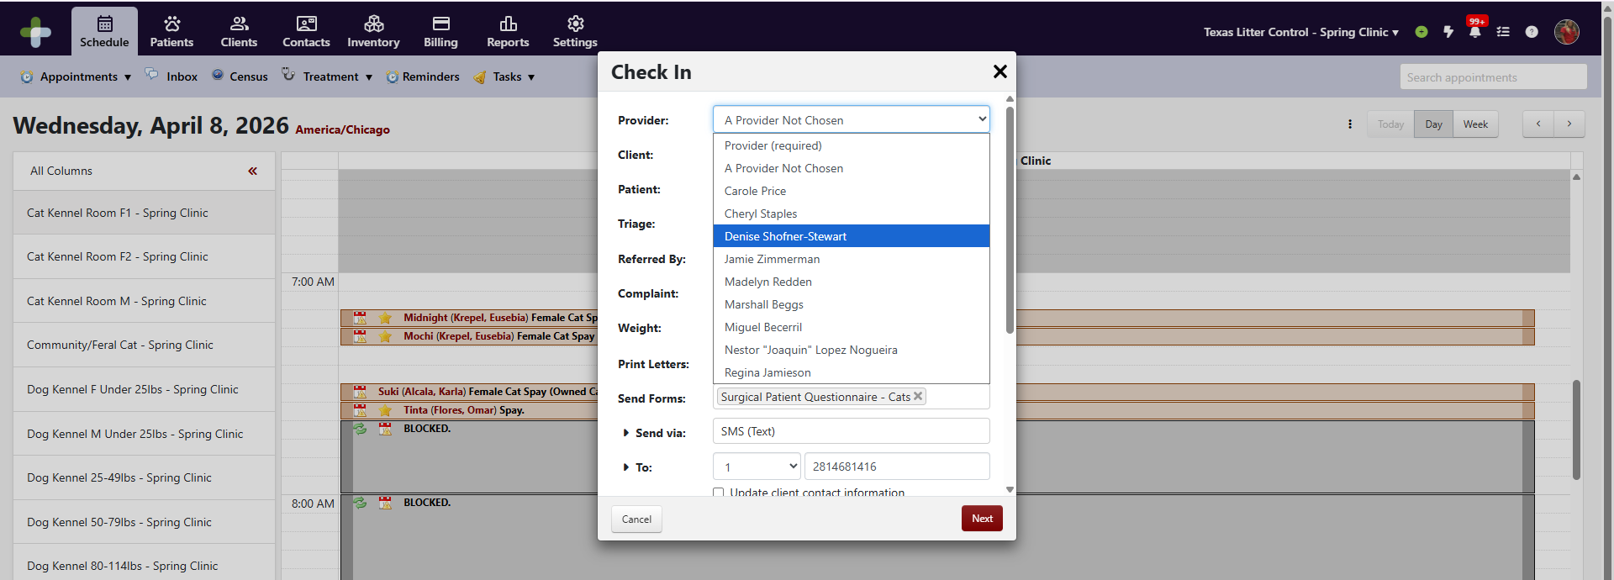

Enter the pet’s weight and uncheck any forms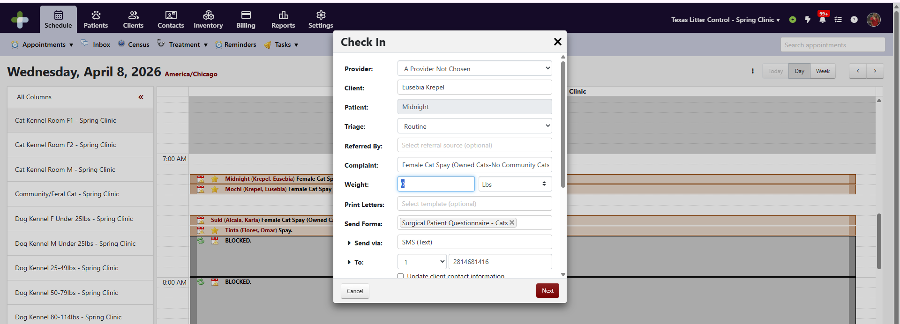

Select a new invoice or if the owner has multiple pets add each pet to the same invoice.
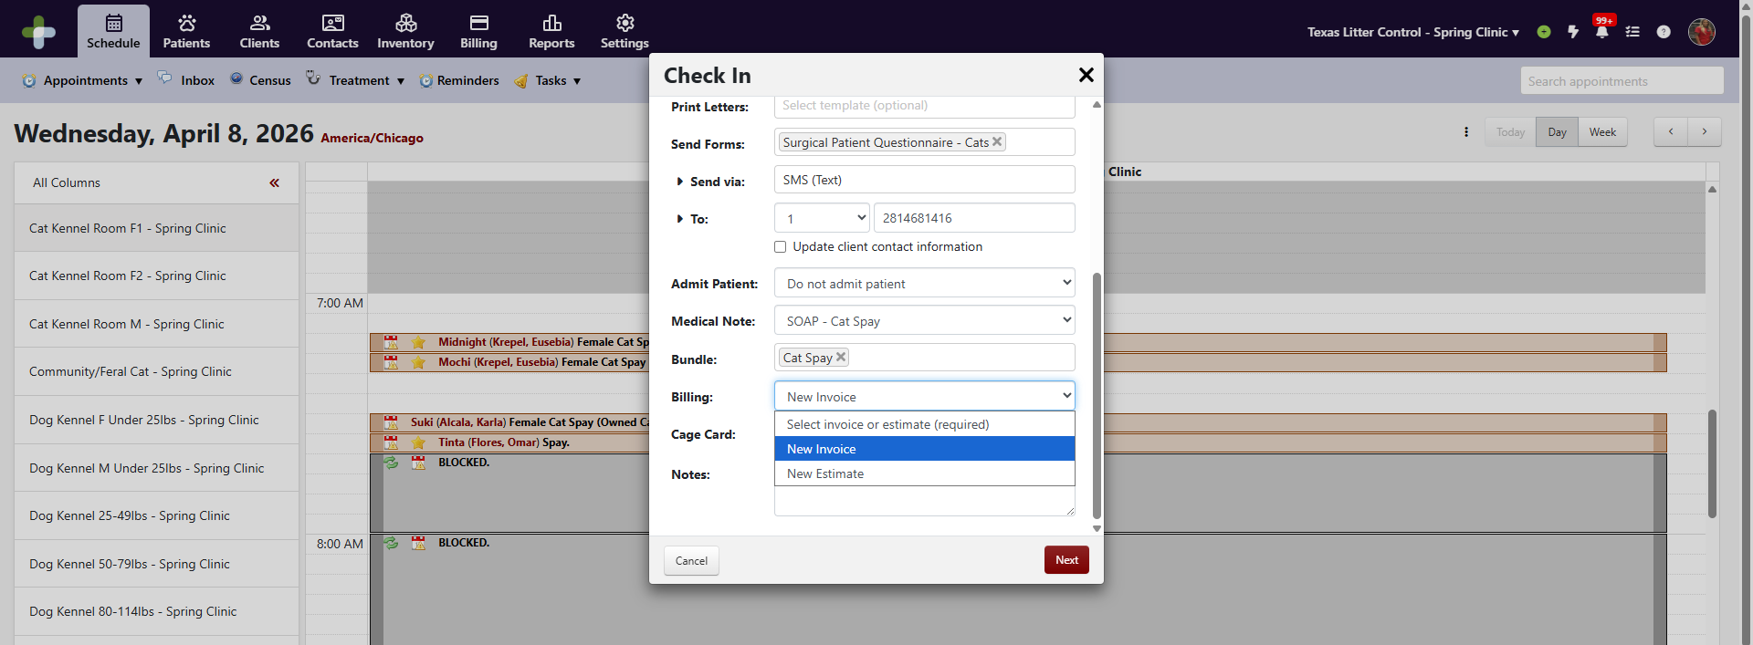

The bundles are defaulted based on information provided during the booking process. Make sure the Bundle matches the dog’s actual weight.
Click Next
Enter the KDB amount, Meloxicam amount and Antisedan amount for cats and the KDB amount and carprofen amount for dogs. Uncheck any items in the bundle not requested.
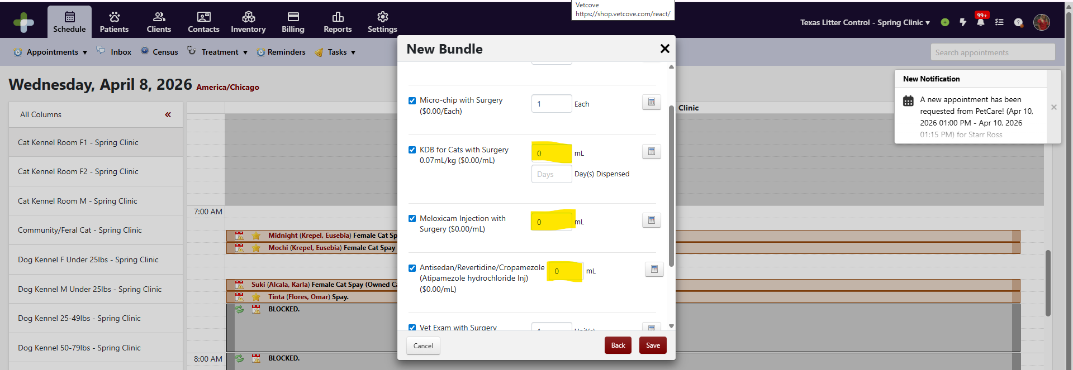
Click save
The patient is now checked in. The system will automatically add a Medical Note and a Bundle to the patient’s record. You will be logging most of the visit into the Medical Note.
The easiest way to access Medical Note is to click on the pet’s name from the schedule. From the pet’s profile a “SOAP” for the surgical procedure will have been created. Click on the SOAP to view & edit Medical Notes.
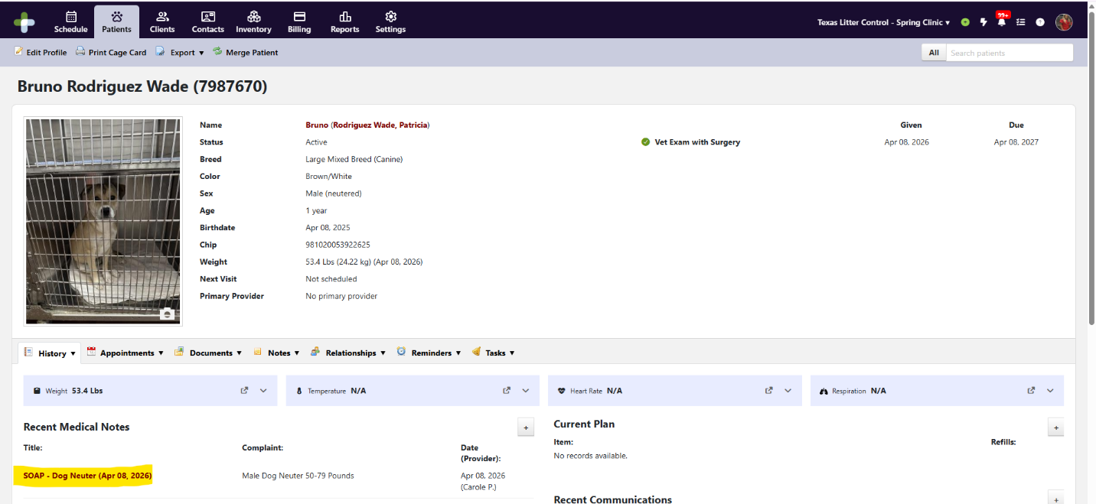

We have defaulted the medical notes to what is typically seen so you only have to update when something is out of the norm. We custom designed the Medical Notes for surgery to serve as a one stop shop for the surgery team.

Surgery Workflow Snapshot – Check-in through Check-out

Working the Line
The outside people should start as close to 6:45 as possible. Head outside with the clipboards that have the check-in forms on them and hand out the clipboards to the clients in line.
Label the cats’ pet taxis and give the dogs name tags. As the clients complete filling out the paperwork, check over the questions. Highlight anything that needs to be addressed by the veterinarian. Make sure have signed the Surgical Release Form and Payment Policy. THEY NEED TO SIGN THE PAYMENT POLICY EVEN IF THEY HAVE A VOUCHER.
If the client does not have rabies marked, ask for a copy of the pet’s current rabies certificate. If they do not have it and wish to email it, we MUST receive it before 9am or a rabies will be given to their pet and they will be charged for it.
Ask the client if they want an e collar and stress the importance of it.
If they don’t have anymore questions, take the pet inside. If it is a cat, tell the client that we will send them an invoice to pay online or they can pay at pick up, that they are free to go, and pick up is at 5. If it is a dog, ask them to wait while you take the dog inside so you can give them back their leash. Weigh the dog, put them in the kennel with a label, and return the leash to the client. Tell the client that we will send them an invoice to pay online or they can pay at pick up, that they are free to go, and pick up is at 5.

Dog Check-In
- Find the patient on the schedule. If you click on the kennel the patient should be in to expand the column it will make it easier to read/click on the correct spot.
- Click on the calendar next to the patient’s name, this will pull up the appointment screen. Select Check in.
- Select the Surgeon/Provider scheduled for today.
- Enter the dog’s weight.
- Uncheck any forms.
- Verify the correct Bundle is selected for the dog’s weight.
- Click Save.
- The bundle screen will pop up. Uncheck all items in the bundle that do not apply – The carprofen packages for the incorrect weight ranges and the E Collar if they decline it.
- Click save.
- To add on additional wellness services, click on the check mark next to the patient to open the appointment screen again.
- Select the soap note. In the middle of the screen click on Records then New Record and add any additional items the client wants with surgery.
- If the client has marked they uploaded the rabies, select the patient’s name to go to their profile
- Select Documents, View Forms, and if they filled it out, select the Surgical Patient Questionnaire
- Scroll through the form to make sure there is a picture of the rabies certificate
- Once done, turn the check in sheet over to the internal use and mark off what was verified and initial the first audit line

Cat Check-In
- Find the patient on the schedule. If you click on the kennel the patient should be in to expand the column it will make it easier to read/click on the correct spot.
- Click on the calendar next to the patient’s name, this will pull up the appointment screen. Select Check in.
- Select the Surgeon/Provider scheduled for today.
- Uncheck any forms.
- Verify the correct Bundle is selected.
- Click Save.
- The bundle screen will pop up. Uncheck any items in the bundle that do not apply.
- To add additional wellness services, click on the check mark next to the patient to open the appointment screen again.
- Select the soap note. In the middle of the screen click on Records, then New Record and add any additional items the client wants with surgery.
- If the client has marked they uploaded the rabies, select the patients name to go to their profile
- Select Documents, View Forms, and if they filled it out, select the Surgical Patient Questionnaire
- Scroll through the form to make sure there is a picture of the rabies certificate
- Once done, turn the check in sheet over to the internal use and mark off what was verified and initial the first audit line

No Shows
Once surgery is completed, you will need to mark no show. You do this by going to the schedule page. Click on Cancelled and then select No Show. For ferals, mark them as Cancelled by Client so that they do not count against our no show numbers.

Documenting the Procedure
We have created a customized Medical Note for each type of Surgery. This form is a one stop shop for you.
The Vitals Monitoring Form will follow the patient as a check and balance. Always be aware of the patient’s first & last name and the label on the patient. Many pets have the same name/similar names or may look alike. You should be checking constantly to ensure that each patient is being treated with the services requested.
Working from the Schedule, select the check mark next to the patient’s name to open the appointment screen and open the Medical Note for the patient.
Medical notes are live documents. You do not need to save at any time as it automatically saves your work. It also allows more than one person to work within the form.
Please note that the only notes or findings the pet parent will receive are what you enter at the bottom of the form under Client Communication. Everything else is internal notes which can only be seen by the staff.

Starting from the top:

Edit Patient Profile
Select Edit Profile - Input the microchip number. Use the barcode scanner to ensure data entry accuracy. Change the sex to Female (spayed) or Male (neutered) for ferals or if the pet was sexed incorrectly by the pet owner. Click Save+Done at the top to save.

Edit the Author of the Surgical discharge and sterilization certificate
Select Documents – Select View Letters, then the Surgical Discharge Instructions &Sterilization Certificate, Select Edit Letter and change the Doctor, Select Save+Done

Subjective
Internal Preop Medical Notes – Enter the vet’s exam notes here. These notes are internal notes. Remember to enter anything you wish to communicate to the client at the bottom of this form.
Reason for Visit – Make sure the appropriate procedure is selected.
All Other Fields – The other fields are defaulted to Within Normal Limits. You only need to change these if something is not within normal limits or if something was not assessed.

Objective
Weight – The dog weights should automatically fill in from check-in, however you will need to input the cats’ weights.
Respiration & Heartrate – Fill in if performed.
Mucous Membrane – All Fields are defaulted to normal standards. They only need to be changed if they are not. Notes in this section are internal.

Assessment
You will always add a Diagnosis. You will use either TLC Approved Surgical Candidate, TLC Rejected for Surgery, or TLC Already Altered. If rejected, please list the notes as to why the pet was rejected for surgery.

Plan
Records – Update any drugs given. Review all items on the list and ensure the patient received all services ordered. Go into any drugs that you need labels printed and print them. Make sure all drugs and vaccines have the correct lot numbers updated
Procedure Details – Use Snippets to enter the surgeon’s technique. The Hashtag sign “#” will bring up all of the snippets. Surgery snippets will start with sx.
All Other Fields – Use/change as needed. Include any special notes about the procedure here. The client will not see these notes.

Client Communication
This entire section will print out on the discharge paperwork. It is very important that it all be filled in correctly.
Surgical Outcome – You will select Spayed/Neutered/Spay not performed-already spayed/Neuter not performed-already neutered/Spay not performed-other reason/Neuter not performed-other reason.
Other Reason Details – If you chose other reason, select the reason the pet was not sterilized today. Make any comments you wish the client to see next to the reason.
Additional Spay Procedure Notes – This is where you communicate anything the client needs to know concerning the condition of the pet (Pregnant, Lactating, Friable, etc.)
Other Notable Conditions – This is where you select anything else you want the client to know about (Fleas, Weight Concerns, Ringworm, etc.)
Umbilical Hernia Repair – Select the appropriate option if applicable.
Cryptorchid Fields – Fill in these if applicable.
Heartworm Test Results – Input results here if applicable.
Applied Topical Flea Preventative – Use this field if applicable.
FeLV Test Results – Input results here if applicable.
FIV Test Results – Input results here if applicable.
Notes – These notes print on the discharge instructions.
Lastly, after recording test results and placing the stickers on the Check in sheet. Scroll back to the top, select Documents, add attachment, and upload a picture of every page.

Sending the Invoice
If the client has a voucher, once you have added in everything additional the owner wants, go to the top of the Medical Note and click on the Invoice Number.
- Apply any discounts by clicking on Apply Discount at the top of the invoice. Select the appropriate discount if applicable.
  - Help Me Keep My Pet
  - Community Cat Montgomery County
  - Community Cat FCAP
  - Employee Pricing
  - Volume Pricing
- To add in the voucher payment, select Payment, New Payment, Remove the invoice from the applied to field and select deposit, Change the amount collected to the voucher amount, Change the payment type to the correct voucher, and if there is a voucher number put it in the notes.
If you are still in the soap note, scroll to the top and click on the Invoice number in the middle of the screen. Select Export and Email Invoice. Make sure the box is checked to allow online payments.
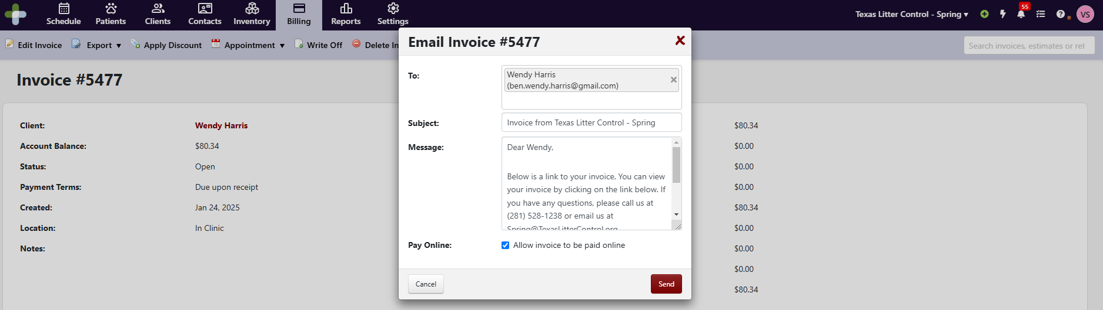

Preparing Paperwork
Once everything is in the Medical Note, the Vitals Monitoring Form will go to the person preparing the discharge paperwork.
This person will double check everything:
- All procedures performed
- All test results entered
- Micro-chip number entered
- Drug dosing input
- Any drugs have been dispensed and labeled properly.
- All lot numbers are correctly updated
- All pictures are uploaded

Printing Discharge Paperwork
Once you finish verifying all data has been entered accurately, you will need to navigate back to the Patient’s Profile and select Export at the top of the screen, then Print Patient File.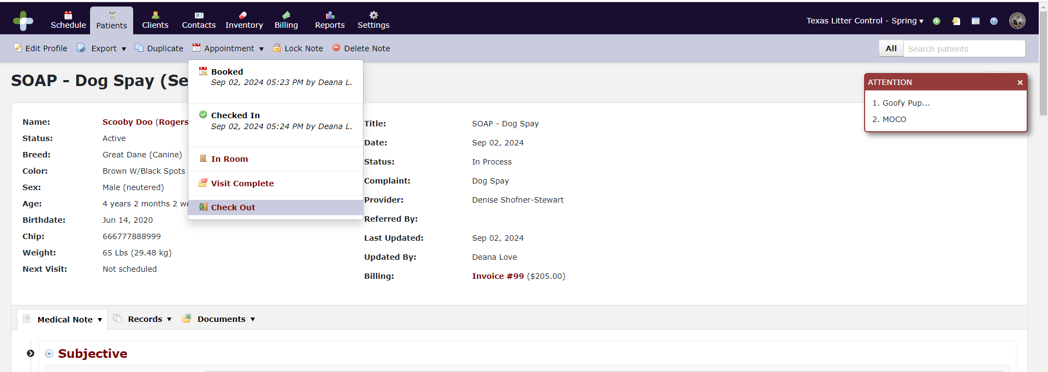

This action will bring up a box. Change the doctor and the date, then select Letters, Rabies Certificate (if applicable), and Medical Records, then Preview. A pdf file will pop up. Make sure there are no blank pages. Print only the pages with data.
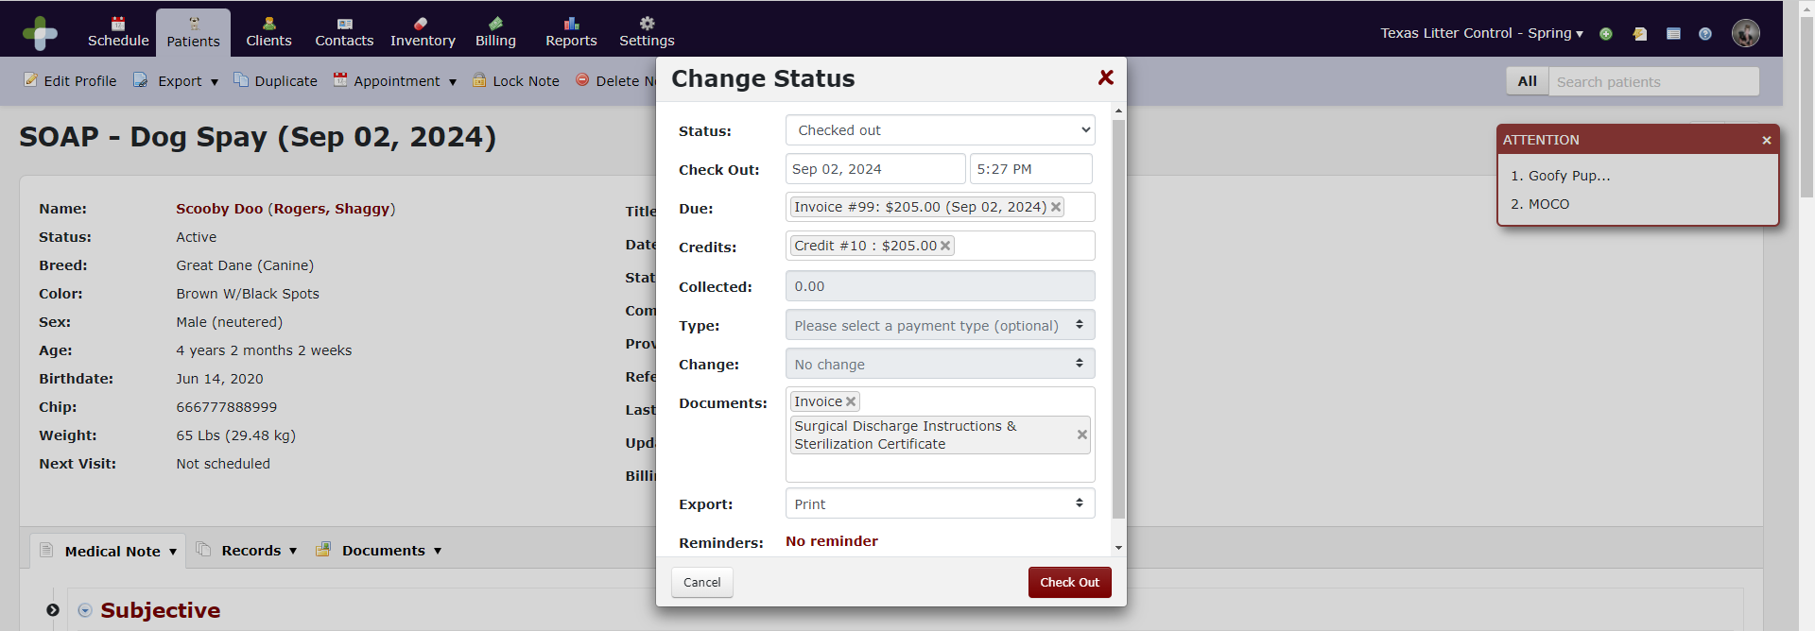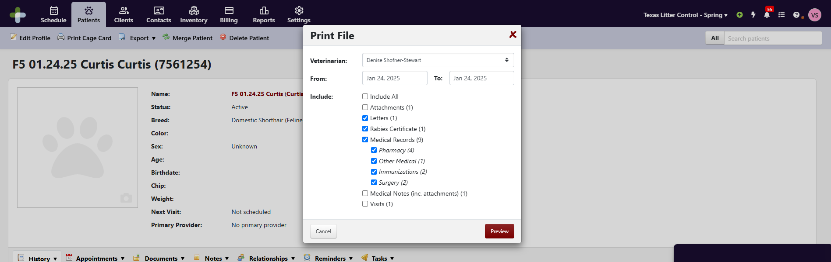
Paperwork should be stapled in the following order (from top to bottom):
- Medical Records
- Sterilization Certificate
- Surgical Discharge Instructions
- Rabies Certificate (if applicable)
- Pain Medication

Daily Audit for Surgery – Prior to Discharge
We want to ensure that all clients go home with accurate paperwork. We have put together an Audit Worksheet that is to be completed at the end of each day prior to discharging patients.
This form is called Daily Audit for Surgery and can be found in the DaySmart Place folder.

Microchip Error Report
Navigate to the Reports Tab in DaySmart. Select the Custom Tab. Select Micro-chip Error Report.
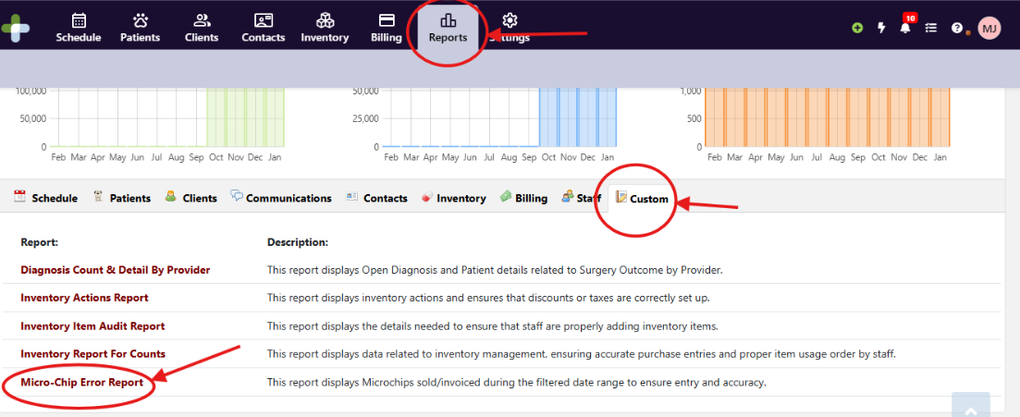
Select your date range and click Update.
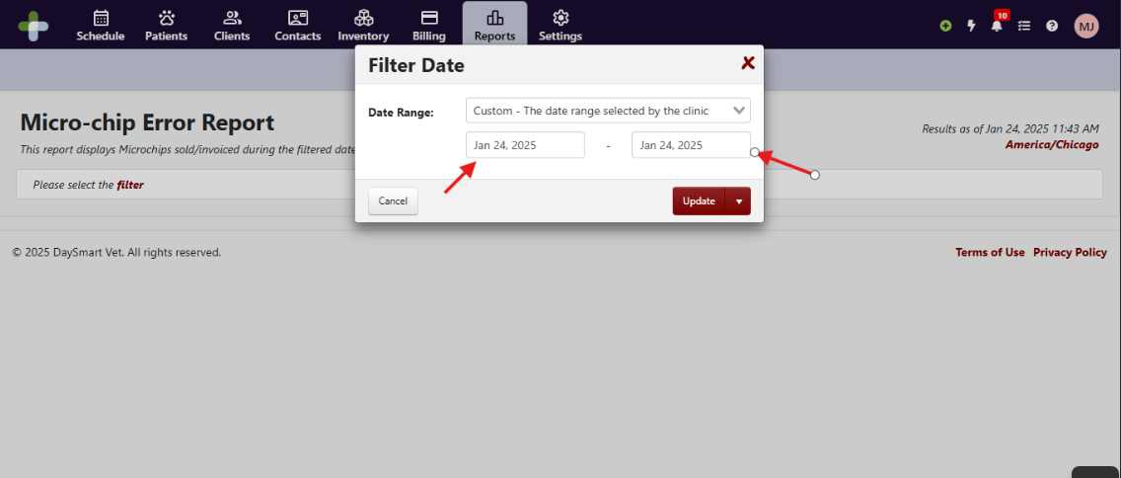
The report will show you all clients who have a microchip selected in products. You need to make sure that no Chip numbers are blank or look odd (too long, too short, or don’t match the Datamars number scheme). If you find an error, please correct it on the client’s record, and reprint the client’s record before discharging the patient.

Diagnosis Count & Detail by Provider Report

Vaccine Lot Number Audit

Wellness Workflow Snapshot – Check-in through Check-out
If the client has an appointment, you will find them on the Schedule. If they do not, you will need to make an appointment for them as either Recheck, Wellness Appointment (Vet) – Walk In, or Wellness Appointment (Tech) – Walk In. Please refer to the section “Booking An Appointment In House.”

Check-In
Once you find the patient on the Schedule, select the calendar next to the patient’s name.This will pull up the appointment screen. Select Check In.
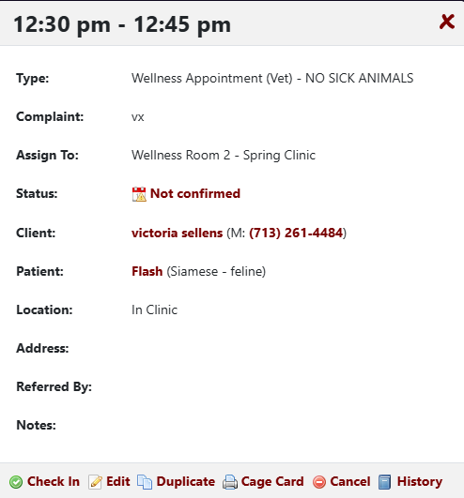
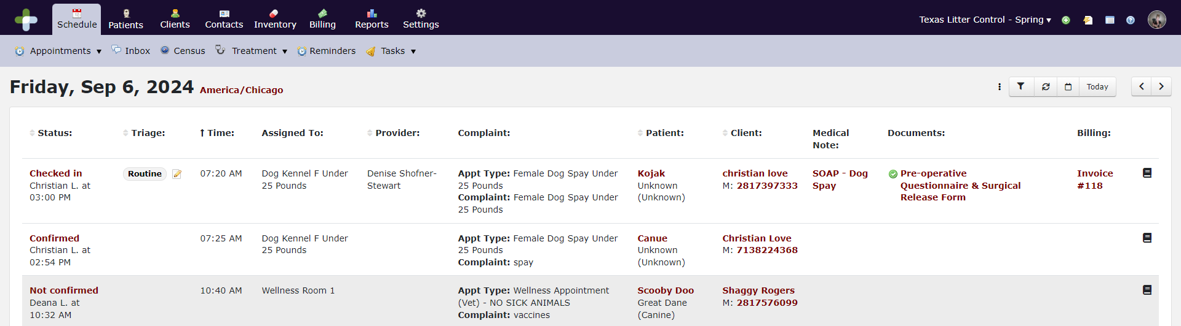
A new screen will pop up. Select the veterinarian’s name from the Provider dropdown. Fill in the dog’s weight. Cats will be weighed in the room, so leave the weight blank if it is a cat. Select Admit patient. (The Admit patient action will move the patient to the Treatment Board.) Ensure the correct Medical Note and Bundle are selected. Click Save. See chart below for more information.
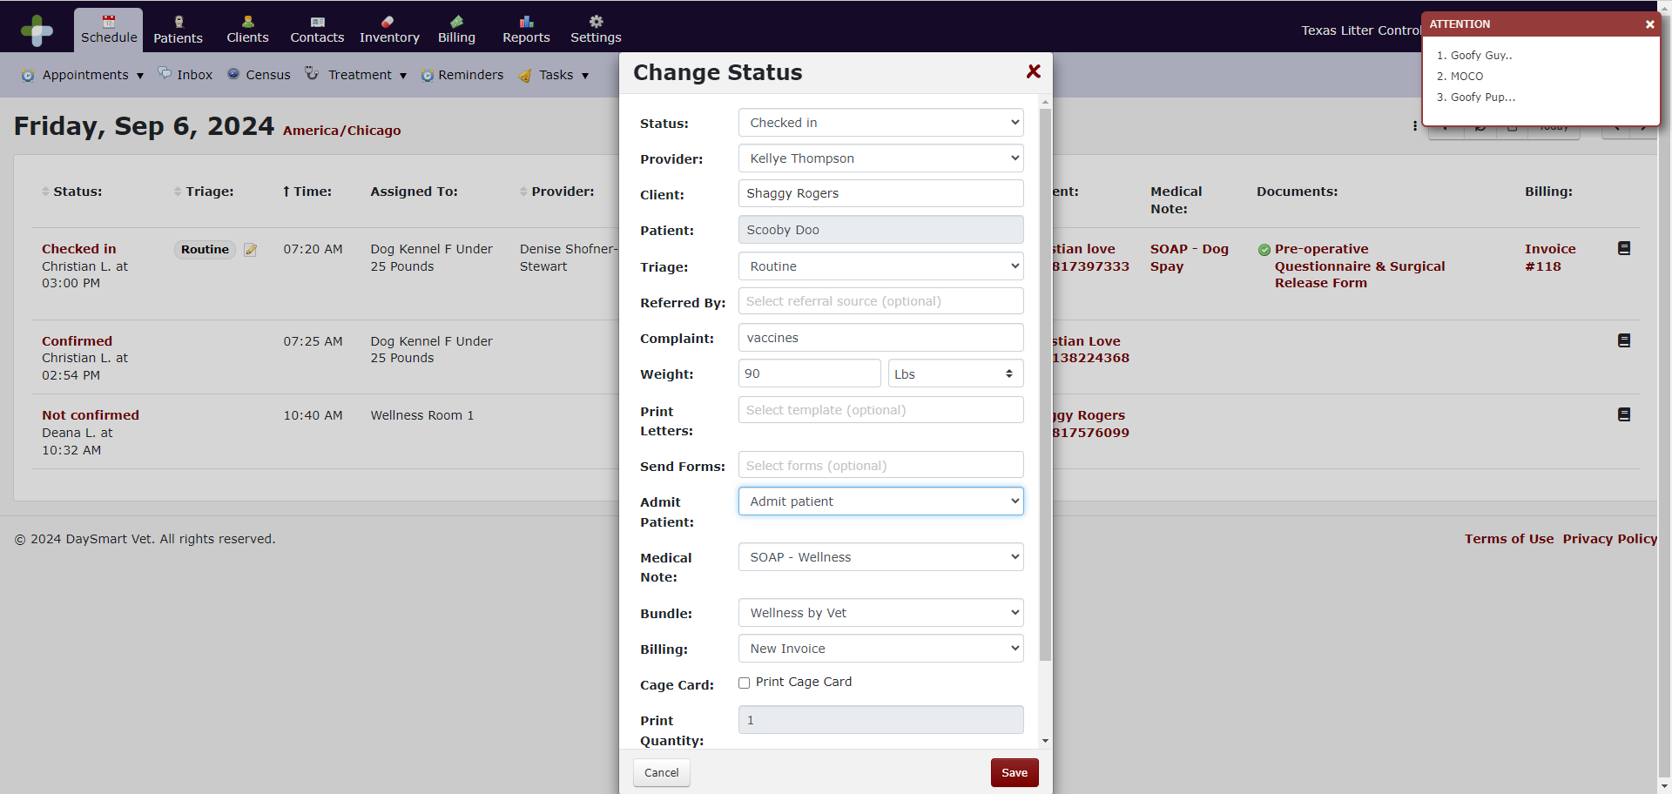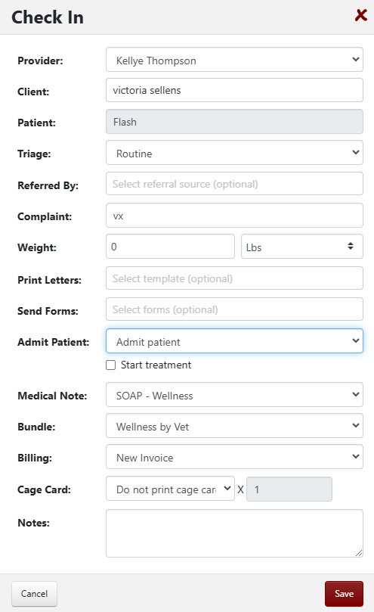Use the below chart to ensure you are selecting the correct data for checking in a wellness appointment.
Appointment Type | Triage | Bundle | Medical Note
Wellness Appointment (Vet) | Routine | Wellness by Vet | SOAP – Wellness
Wellness Appointment (Vet) - Walk In | Minor | Wellness by Vet Walk-In | SOAP – Wellness
Wellness Appointment (Tech) | Routine | Wellness by Tech | SOAP – Wellness
Wellness Appointment (Tech) - Walk In | Minor | Wellness by Tech Walk-In | SOAP – Wellness
Surgery Recheck | Urgent | Surgery Recheck | SOAP – Surgery Recheck
Expanded Services | Routine | Expanded Services | SOAP – Expanded Services

Retrieve a Wellness Check In Form (Dog or Cat) and write the Client’s Arrival Time at the top. Check the walk-in box if the client is a walk-in. Check the Recheck box if the client is a recheck. Fill out the form and ask the client the questions on the form and record their answers.Alert the tech on duty that the client has arrived.

Treatment Board
The support staff will go to the Treatment Board and select the room the client is waiting in by clicking on Admitted. If it is a tech visit, you will change the “Assigned to” to the tech’s name.
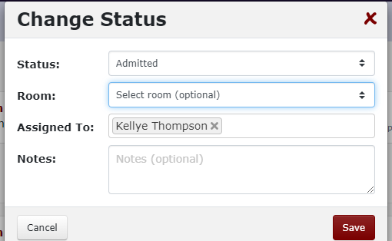

The tech will work from the Treatment Board. The Treatment Board is a living board. It shows you how long a patient has been here and checked in. In addition, you can quickly see rechecks versus scheduled appointments versus walk-ins.
The board should be worked in that order. First by Triage (Urgent-Rechecks, Routine-Scheduled Appointments, and then Minor-Walk-Ins) and next by arrival time. You can sort the Treatment Board by Triage status.
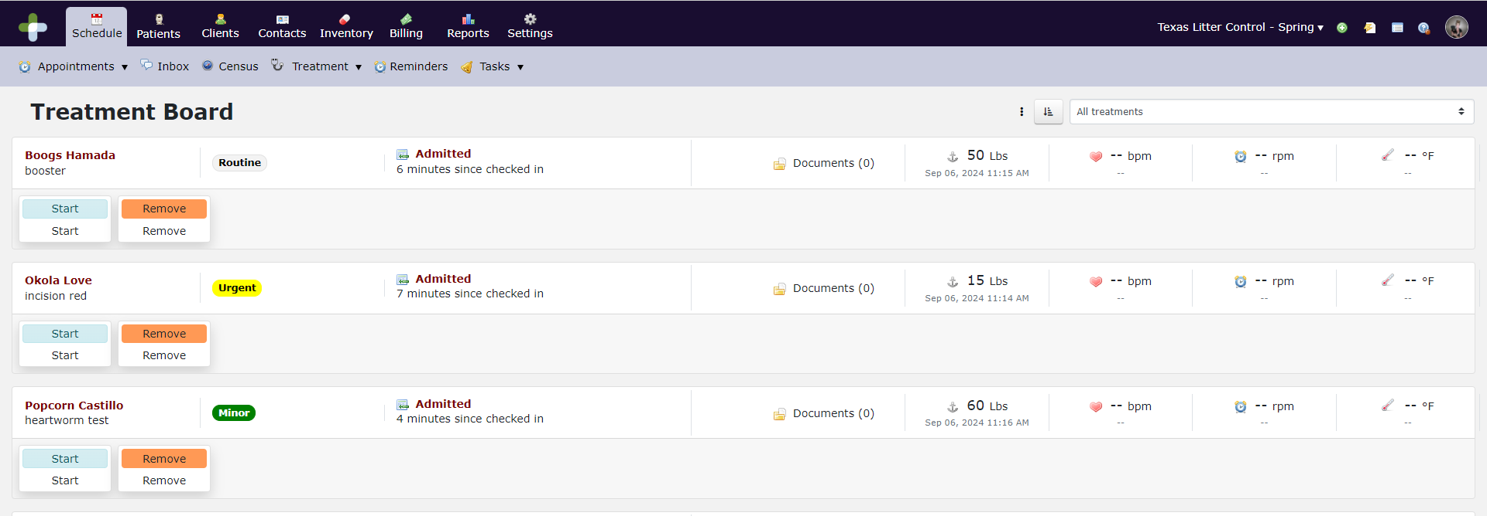
The tech will hit start when they enter the room to begin the appointment. A pop up will appear. Verify everything looks correct and click Next. A second pop up will appear. Make sure the correct bundle is checked and click Save.
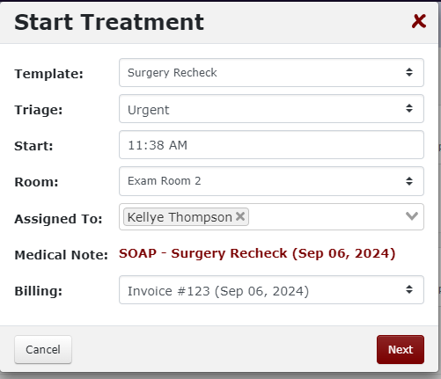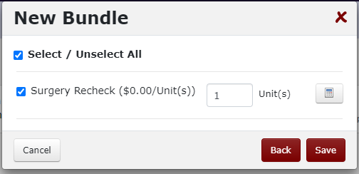

Documentation
From the Treatment Board, click on the Documents link for the patient.
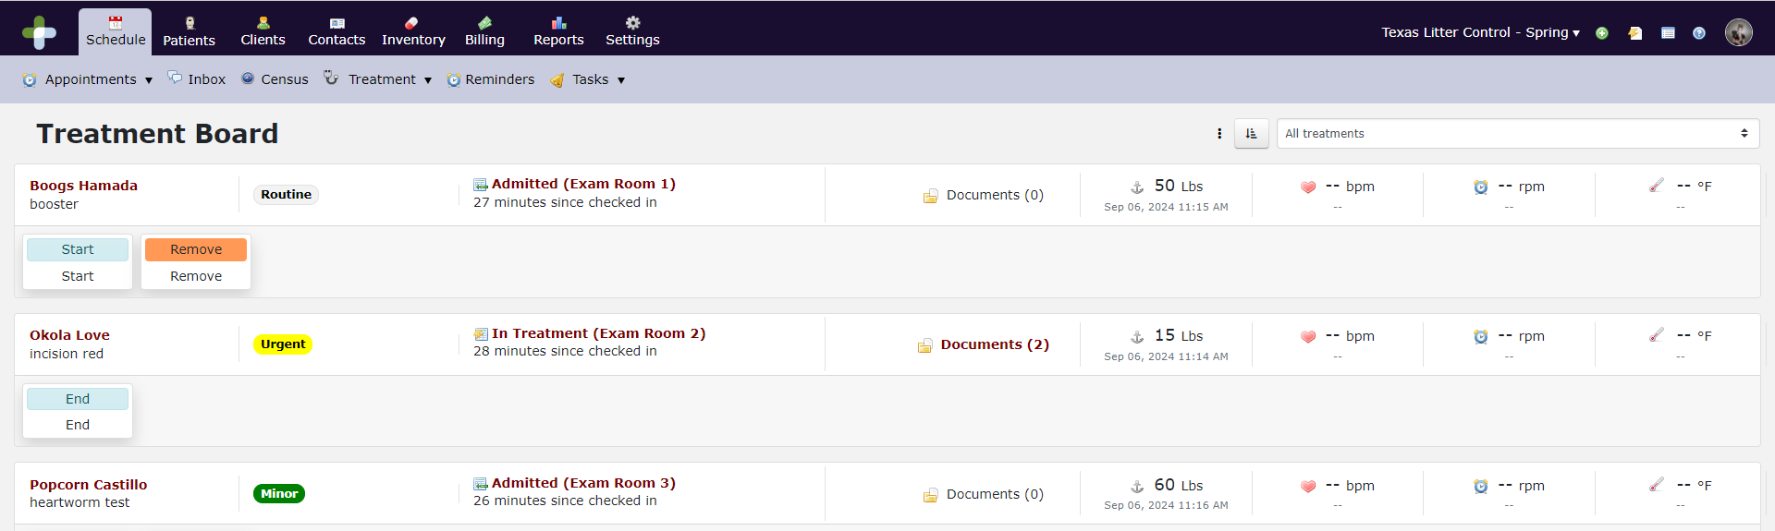
This will bring up a window which will allow you to select the SOAP you will be working from.
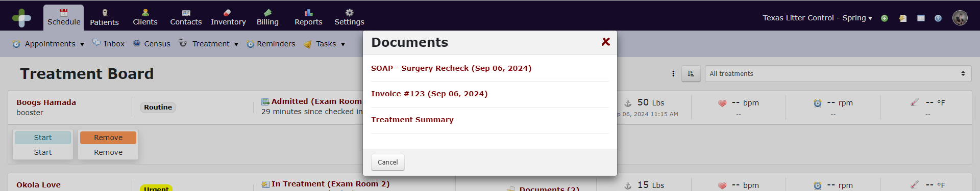
Work your way through the SOAP and notate your findings.
Add any additional items (prescriptions, services, etc.) under Plan by clicking New Record if it is one item or New Bundle if it is a preset bundle of items. Time saver – When you are adding multiple services and products, select New Record and instead of clicking Save + Done, use the arrow to change the button to Save + Add New. 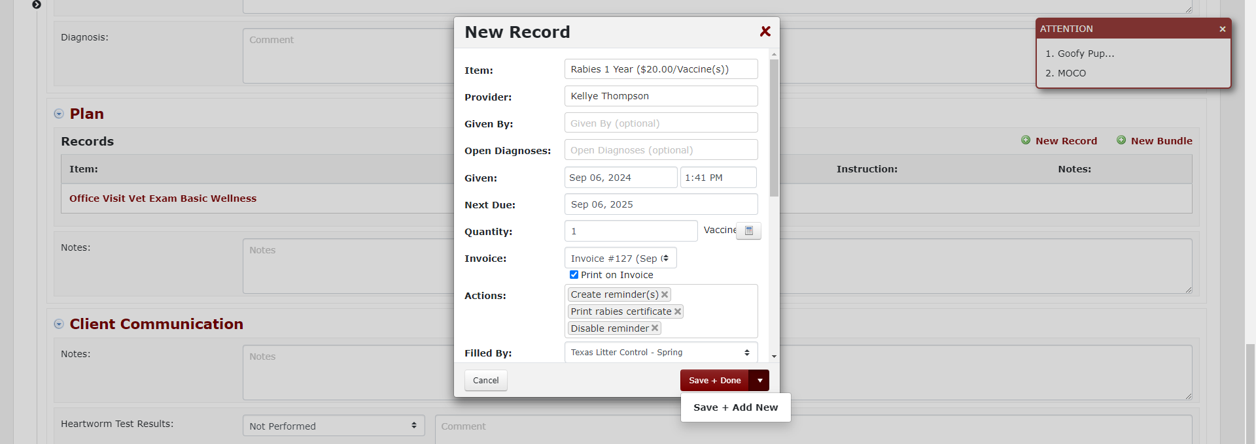
When adding vaccines and other medications, make sure you are picking the correct Lot Number.
Keep in mind that the only thing the client will receive printed on their discharge documentation will be the last section, Client Communication. Any notes you want the client to go home with should be input here. You will also add any test results here.
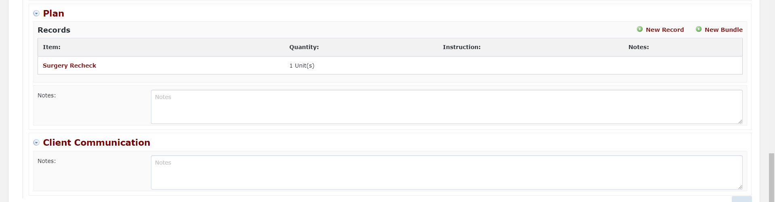
The system has snippets which are predefined segments of text. They can be started with the hashtag (#) symbol. Wellness snippets will begin with #GP, prescription snippets will begin with #RX, and surgery snippets will begin with #SX. If you find yourself typing the same information repeatedly, please send this to your supervisor so we can add them to the snippet template for you.
Once you have performed all services requested by the client, added any charges, and completed any notes, you will go back to the Treatment Board click End. This will allow the support staff to take payment and check the client out. Give the client the paper form and send them to the front desk for check out.

Check Out
The support staff will go to the Schedule, locate the patient and open the SOAP.
From the SOAP, Select New Attachment from the Documents dropdown. Take a photo of the Wellness Check In Form and attach it here as a new upload.

If the client has a voucher, you will attach a photo of the voucher in the Documents dropdown.
If the client needs any discounts applied, click on the invoice and apply any applicable discounts.
Ask the client whether they will be paying cash or card. If they select cash, apply the cash discount. Ask the client if they would like to make a donation to support animal welfare efforts in our community. If they wish to, add the line item “Donation” to their invoice and input the amount in Unit Price.
You will then select Check Out from the Appointment dropdown.
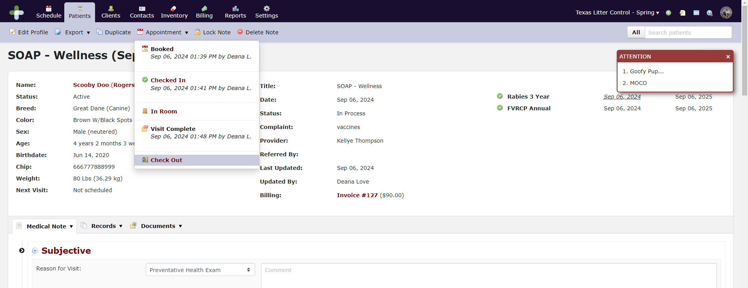

Change the Status to Checked Out. Input the payment fields. For more information about taking payments, refer to the “Taking Payments” section of this manual. Select Invoice, Discharge Instructions (Non Surgical), and the rabies certificate, if applicable. Key in the rabies tag number, if applicable. For Export, select whether you wish to print or email the documents.
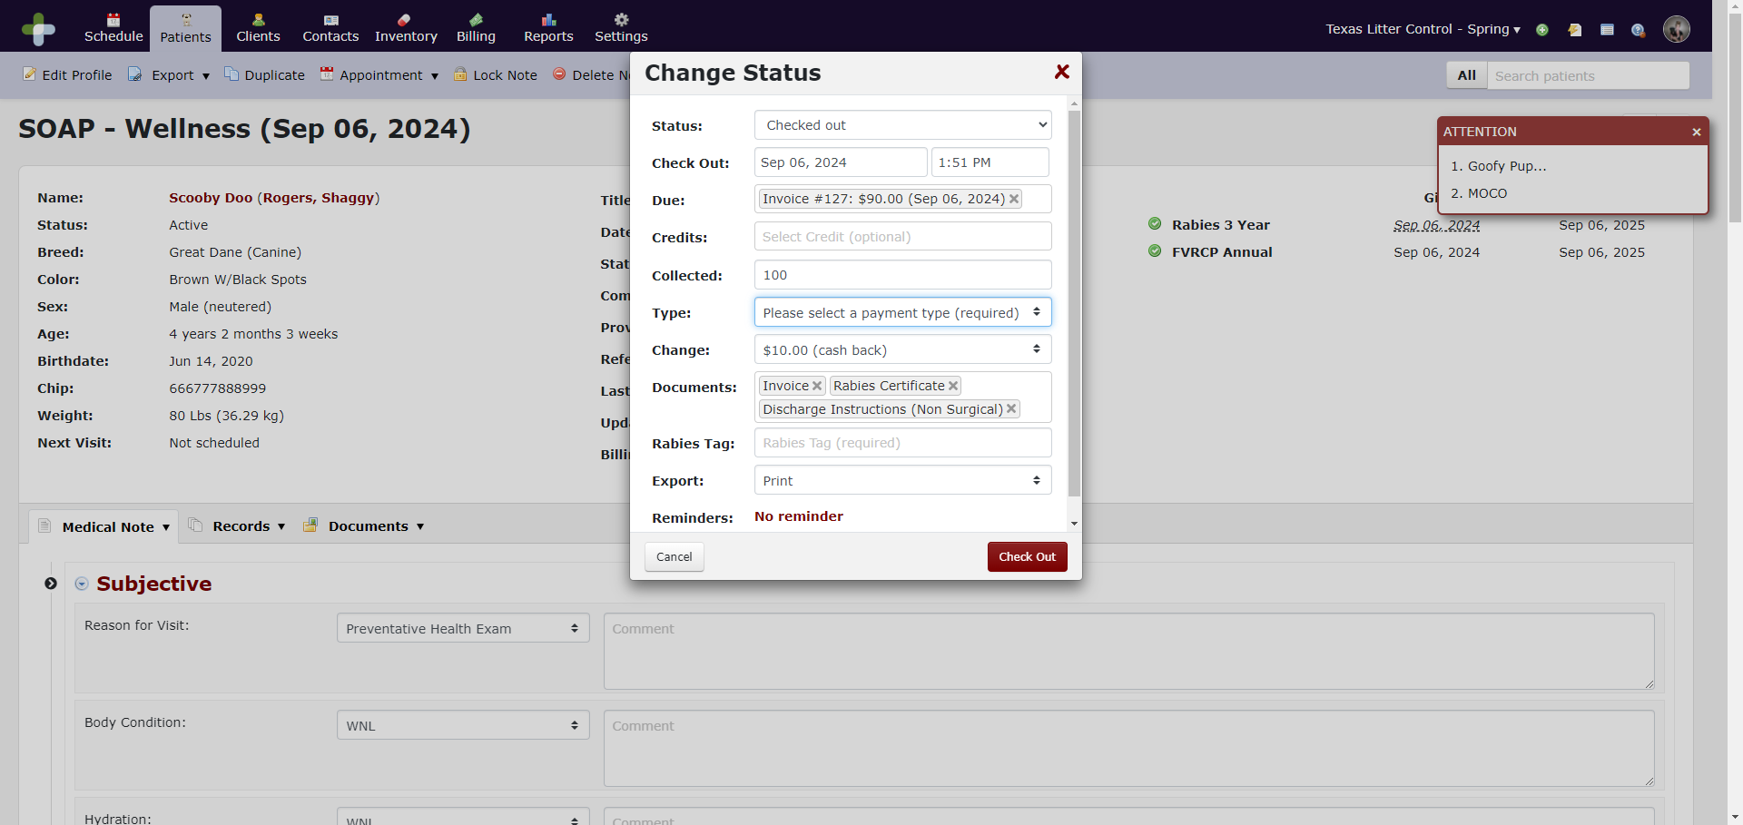

No Shows
You will need to mark no shows. You do this by going to the schedule page. Click on Cancelled and then select No Show.

Refilling Prescriptions

Refill Verification Process
- Verify the patient is a TLC patient and that they have been seen within the year.
- Determine what medications they need, do they prefer topical versus oral, and if the pet has had any adverse reactions to certain brands.
- Look at the age, breed and weight of the pet. You will never want to dispense 6 months’ worth of medications to a dog that is still growing. We cannot take prescription medications back so you do not want to oversell products to a client.
- Look at how many doses we are allowed to dispense. For example, if a client does not purchase heartworm prevention with a heartworm test today. If they come back in 2 months from now, they can only purchase 10 months of medication. If the patient is a My House Vet patient, Dr. Beth may have dispensed medication. This always needs to be taken into account.
- If a dog has missed more than 5 months doses of heartworm medication, they must bring the pet in for a heartworm test.
- If you are dispensing heartworm prevention, you must verify that the pet has been heartworm tested and a vet exam at TLC within the last 12 months. We can accept results from another clinic provided the results are printed on the paperwork.

Refill Process
- Navigate to the patient’s file.
- Under history, select New Record and Prescription Refill Medical Note.
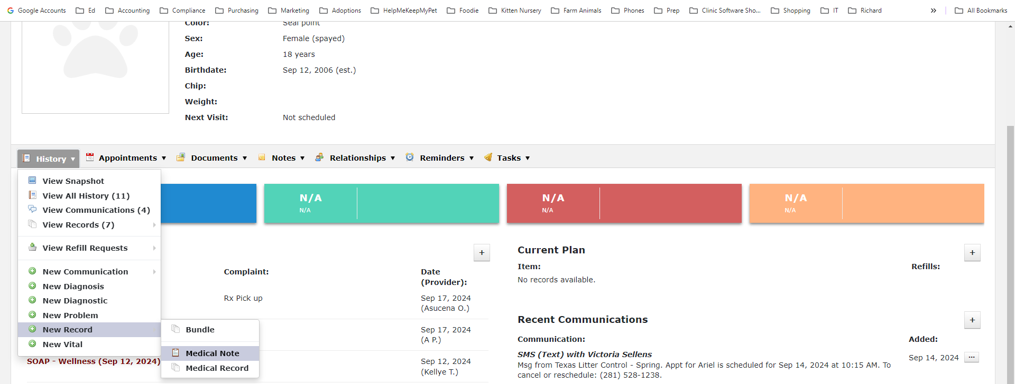

- Change the Template to Prescription Refill. Use the guide within to help you assess the client’s needs.
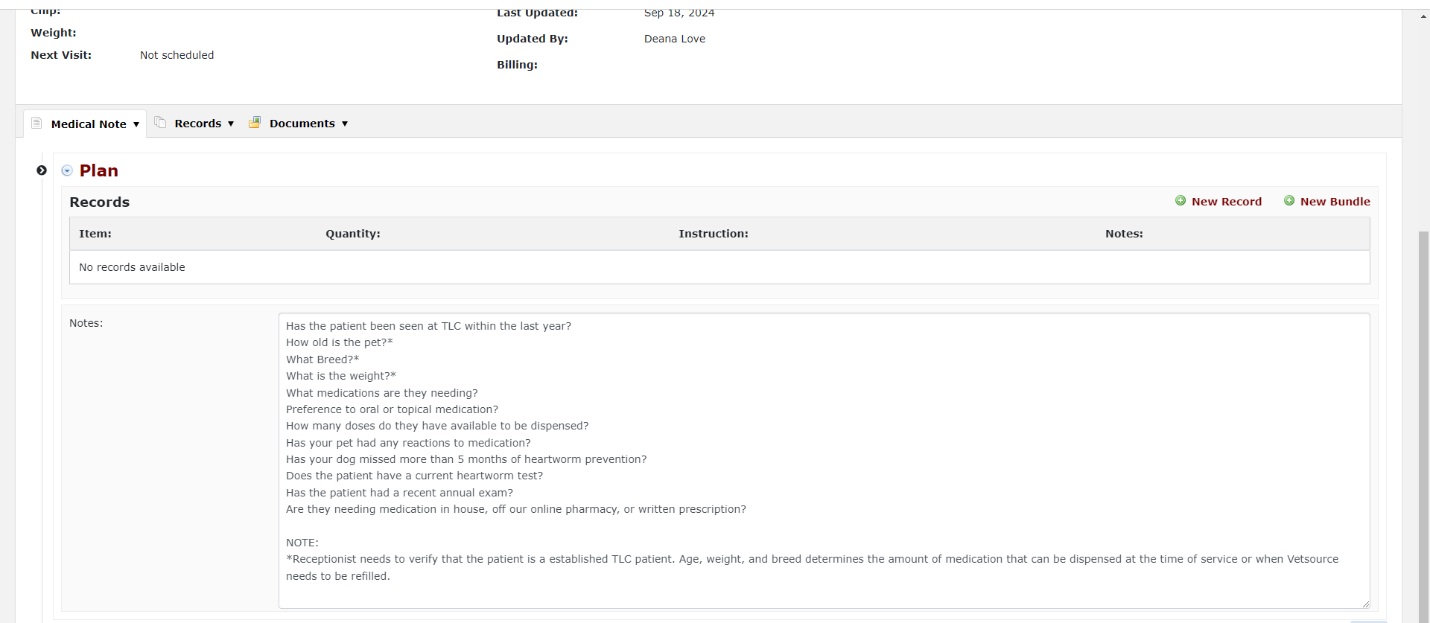
- Click on New Record and select the medication you wish to dispense and update the Provider. If dispensing for multiple patients, make sure they are under the same invoice.
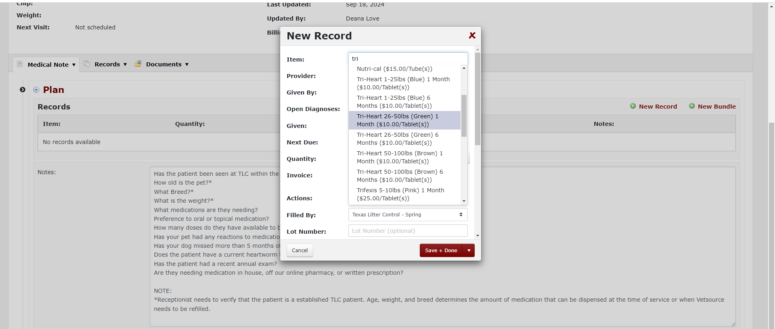

- Update any instructions and change the label to the correct dymo. Click Save + Done.
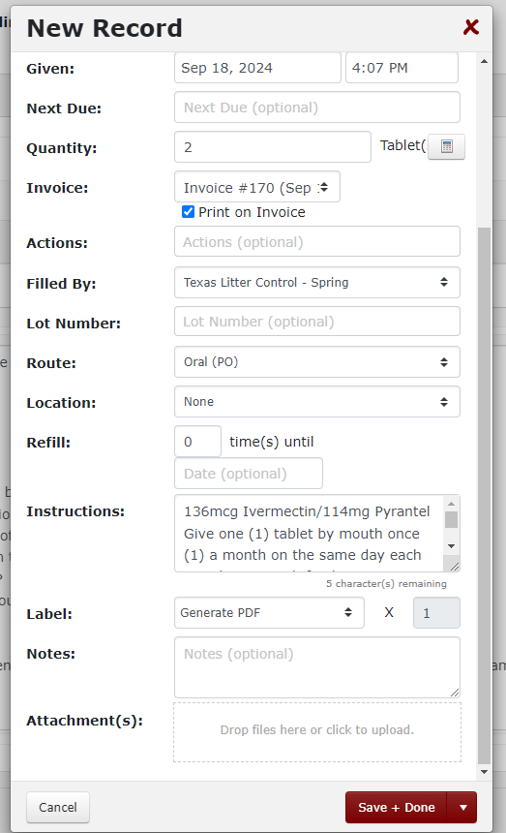
- Print the prescription label. Select the Invoice number and take payment.

Billing & Reconciliation
When checking clients out, make sure you have applied all discounts first. You will then apply any voucher information. Lastly, you will take the remaining payment from the client.

Discounts & Voucher Programs
Volume – We have partnerships with some groups who bring in a significant number of animals. They are rescue groups and municipalities. We do not offer every rescue organization discounts. Volume clients go through an approval process with management to receive this discount. This discount will be set up at the client level and unless something is set up wrong, you should never have to choose it, except when they have a HPPL voucher
Employee Pricing – Employees get deep discounts. Employees will be set up in DaySmart as a part of the hiring process and their discount will be added to their account. This discount will be set up at the client level and unless something is set up wrong, you should never have to choose it.
Help Me Keep My Pet (HMKMP) – TLC has a shelter intervention program. The shelter intervention staff will send clients to TLC for help. These clients have to fill out a form and be prequalified for this discount based upon income status. They will have a voucher when they get to the clinic. If they do not have a voucher, they will not receive a discount. To process these clients, you will apply their discount. READ THE VOUCHER CAREFULLY. Every situation is different. The client will be responsible for payment.
Montgomery County Community Cats – TLC has a partnership with Montgomery County. If a citizen cannot afford to fix an outdoor cat, the citizen can trap the cat and bring it to TLC for spay/neuter. You must check the photo ID and verify the person is a citizen of Montgomery County. We offer a small discount on the Community Cat Package and then we bill the county. You will need to apply the Montgomery County Discount and then chose Montgomery County CCP as the payment method.
HPPL – The Homeless Pet Placement League issues vouchers to people to be used at TLC. READ THE VOUCHER CAREFULLY. The voucher will only be good for part of the service. Apply the Volume client discount. Enter the client’s copay first. Then select HPPL Voucher as the payment method for the remainder.
FCAP Voucher – TLC has a partnership with the Feral Cat Assistance Program with Citizens for Animal Protection. We offer a small discount on the Community Cat Package and then we bill FCAP for the remainder. These clients will have a voucher. You will need to apply the FCAP Discount and then choose FCAP Voucher as the payment method.
Harris County Community Cats – TLC has a partnership with Harris County. These clients will have a voucher. You will need to choose Harris County CCP as the payment method.

Taking Deposits
We take deposits for a couple of reasons. We have situations where a third party wants to pay for someone else’s pet to be sterilized. For example, a college student’s mom might pay for the student’s cat to be fixed. Both require taking Deposits.
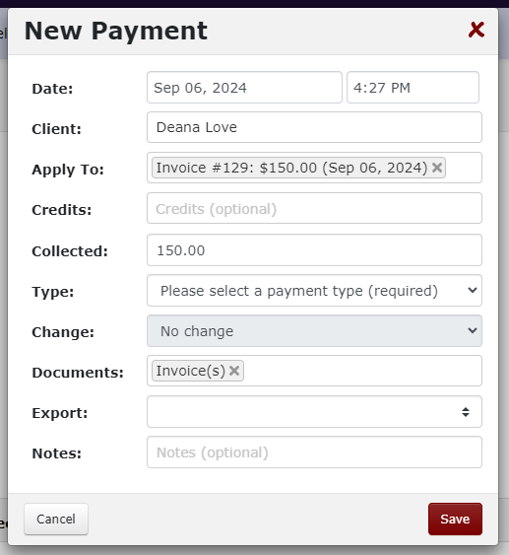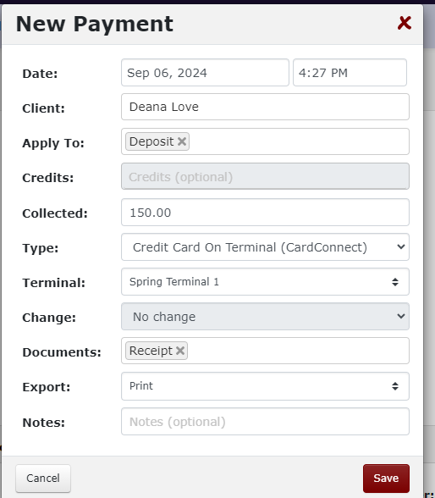

Pre-pay for Services Are we getting rid of Paypal still?
TLC will no longer be taking pre-payment though Paypal. The client will be required to call or email our Support Team. The support team will create an invoice for the services the person is willing to cover.
- Navigate to client
- Go to the billing tab
- View Open Invoices
- Go to Gear Icon
- Select Email or SMS
- Make sure the Paid Online Box is checked
- Send
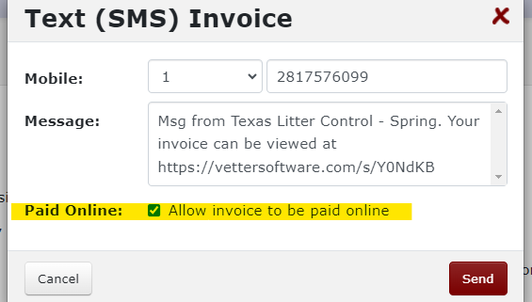
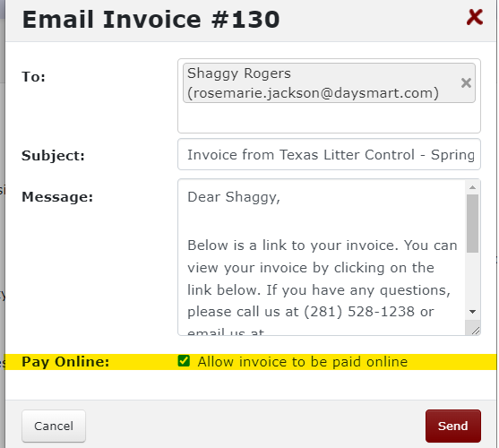

Taking Payments

Cash
Input the amount of cash you collect from the customer. The system will give you the amount of change due. Set the cash on the counter. Make change, if applicable. Count the change to the client BEFORE you put the cash into the drawer. This will prevent any argument over how much a client gave you.
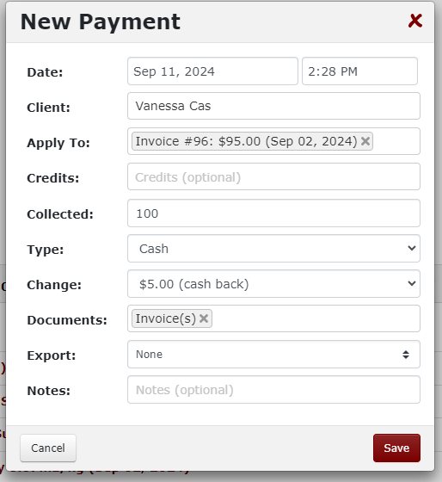

Credit Cards
Input the amount you wish to charge the card and select Credit Card on Terminal (CardConnect), Credit Card Keyed-In (CardConnect) or Card on File (CardConnect). Please note that you should ALWAYS try and swipe the card first.
Credit Card on Terminal (CardConnect) – Chose which Terminal you wish to send the payment to and click save. The transaction will be sent to the terminal so the client can tap, insert or swipe the card.
Credit Card Keyed-In (CardConnect) – Click Next and a screen will pop up and allow you to enter a card number.
Card on File (CardConnect) – We will be storing some cards going forward. We will be trying to use this function for some groups who typically pre-pay for services. We will be charging the card at check-in using the same steps described in the Check-In section. If the card declines, the person bringing the animal in will be responsible for payment or the patient will be rejected.

Vouchers
Voucher Type | Discounts to be Applied Prior to Payment | Documentation Needed
FCAP Voucher | FCAP Discount | Voucher will need to be shown at check-in
Harris County CCP | None | Voucher will need to be shown at check-in
HPPL – Owned Pets | Volume Discount | Voucher will need to be shown at check-in
HPPL – Community Cats | None | Voucher will need to be shown at check-in
Montgomery County CCP | Montgomery County CCP Discount | Valid ID with Montgomery County address must be shown at check-in

Refunding Deposits

Full Refund
To refund a deposit, go to the client’s record. Click View Credits under the Billing tab. Find the credit you wish to refund and click on the gear icon to the right. Select Convert Credit.
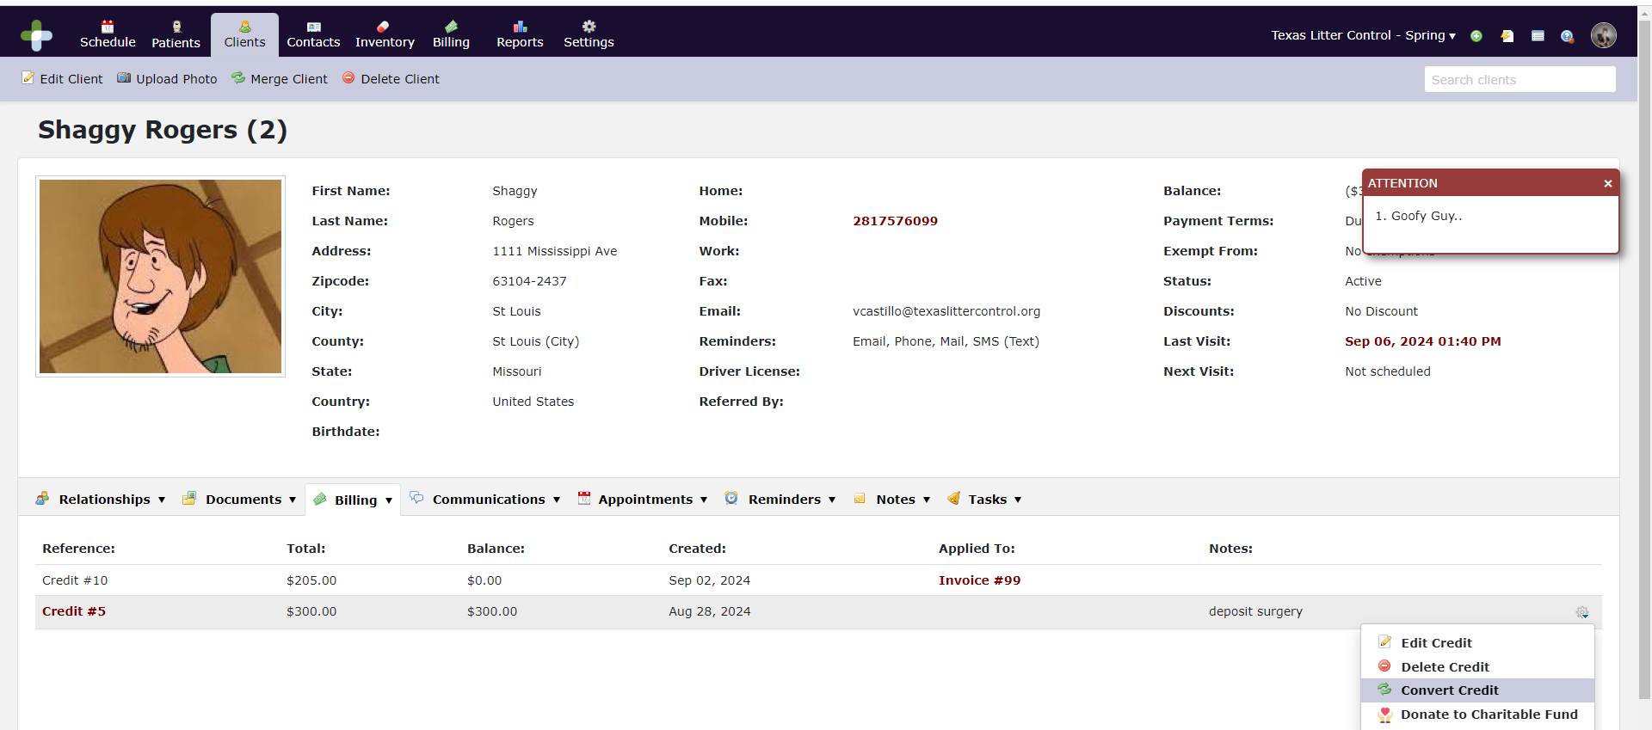

Select the payment method you need to refund the amount to.
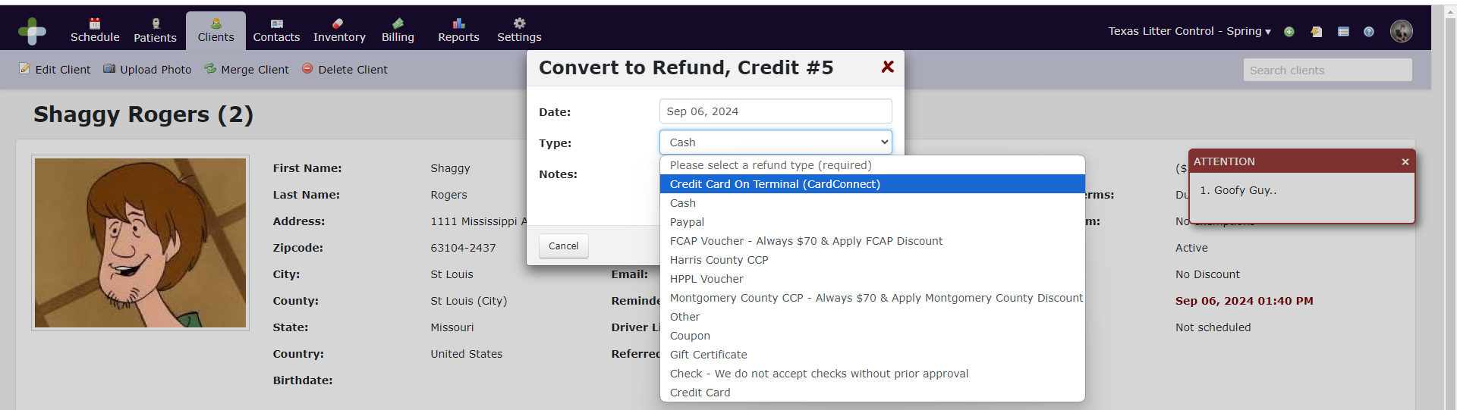

Partial Refund
To issue a partial refund, you will apply the full credit to the open invoice. It will cause the amount to be collected to be a negative number. Select the payment method you want to refund to.
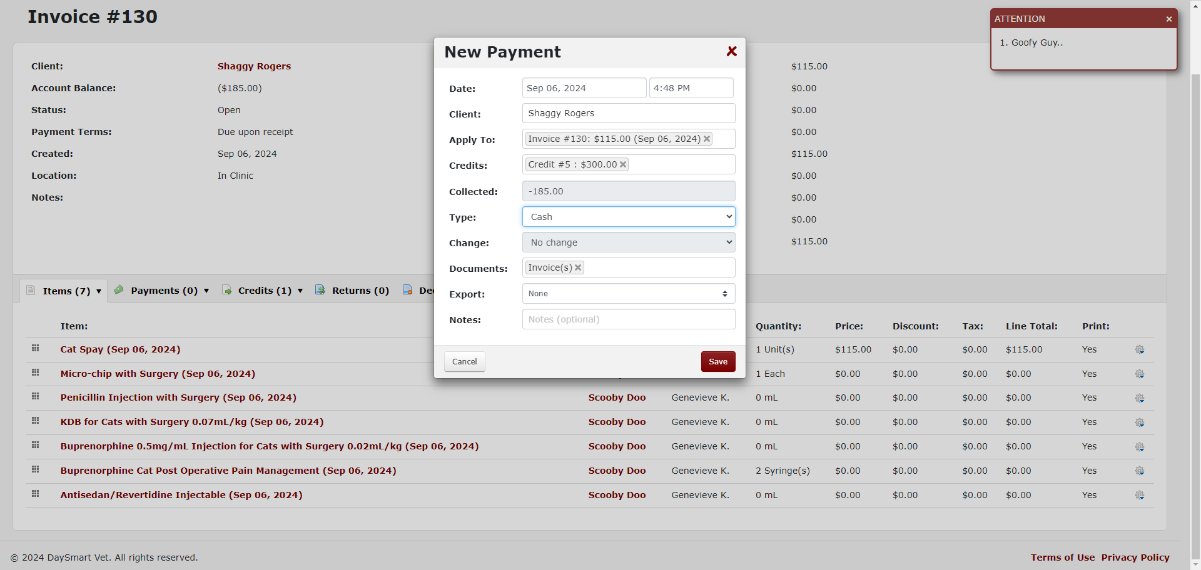

End of Day Reconciliation
Under Reports > Schedule > Appointments by status. Click on filter and change to today’s date. Click update. Look for any client that is not checked out or completed. All files need to be closed out or marked as no show. If they are not closed out, look for an open balance.
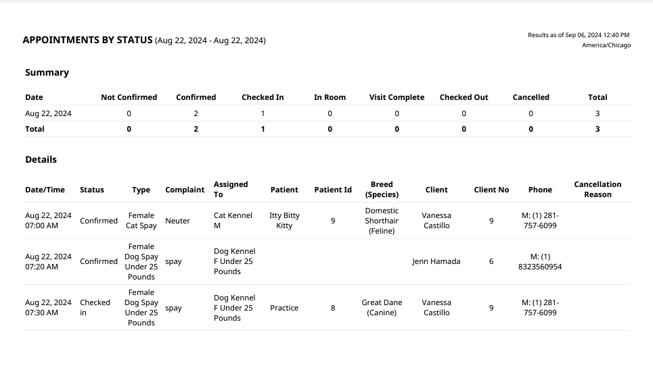
Once all clients are checked out/closed. You will go to reports > billing > end of day detail. Click filter and change it to start at 8:30pm yesterday and end at 8:30pm today. This will give you a detailed breakdown for all CC’s, cash, voucher payments etc. You can export this report to a .pdf.
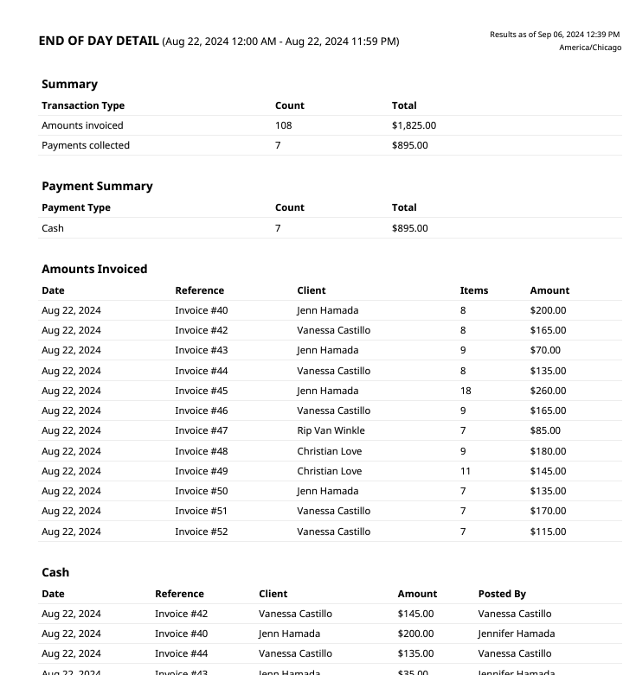

Inventory Management

Ordering
DaySmart can track orders from when you place the order through to receiving the order. We will be utilizing this functionality so everyone will know what was ordered and when.

VetCove
VetCove will be integrated with DaySmart. Once you place an order through our VetCove account, the order will transmit into DaySmart under the Receipts Tab. You can view all receipts here.
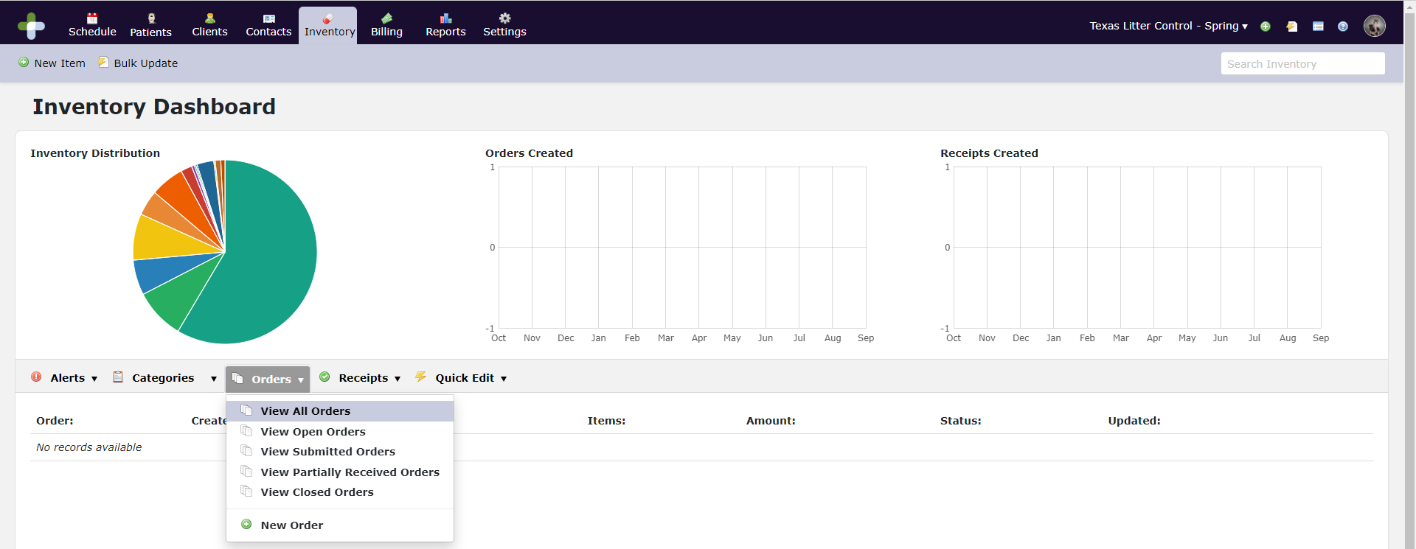

Orders Not Placed Through VetCove
For orders not placed through VetCove, a New Order must be created. Click on New Order.
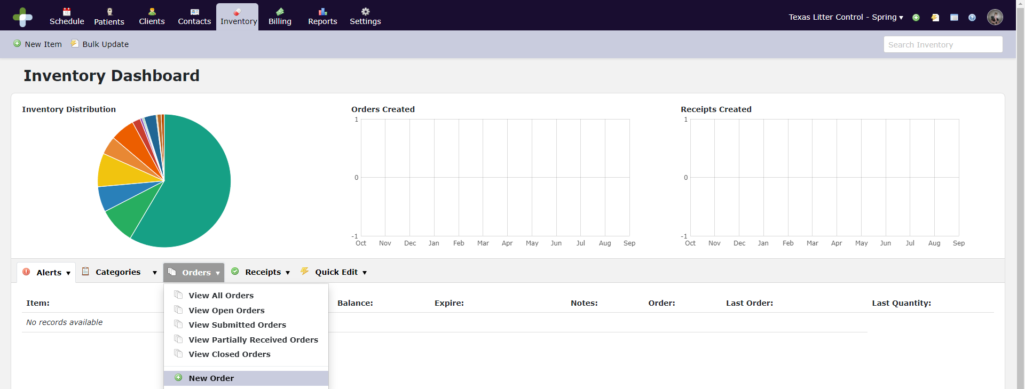
Enter the vendor details and hit save.
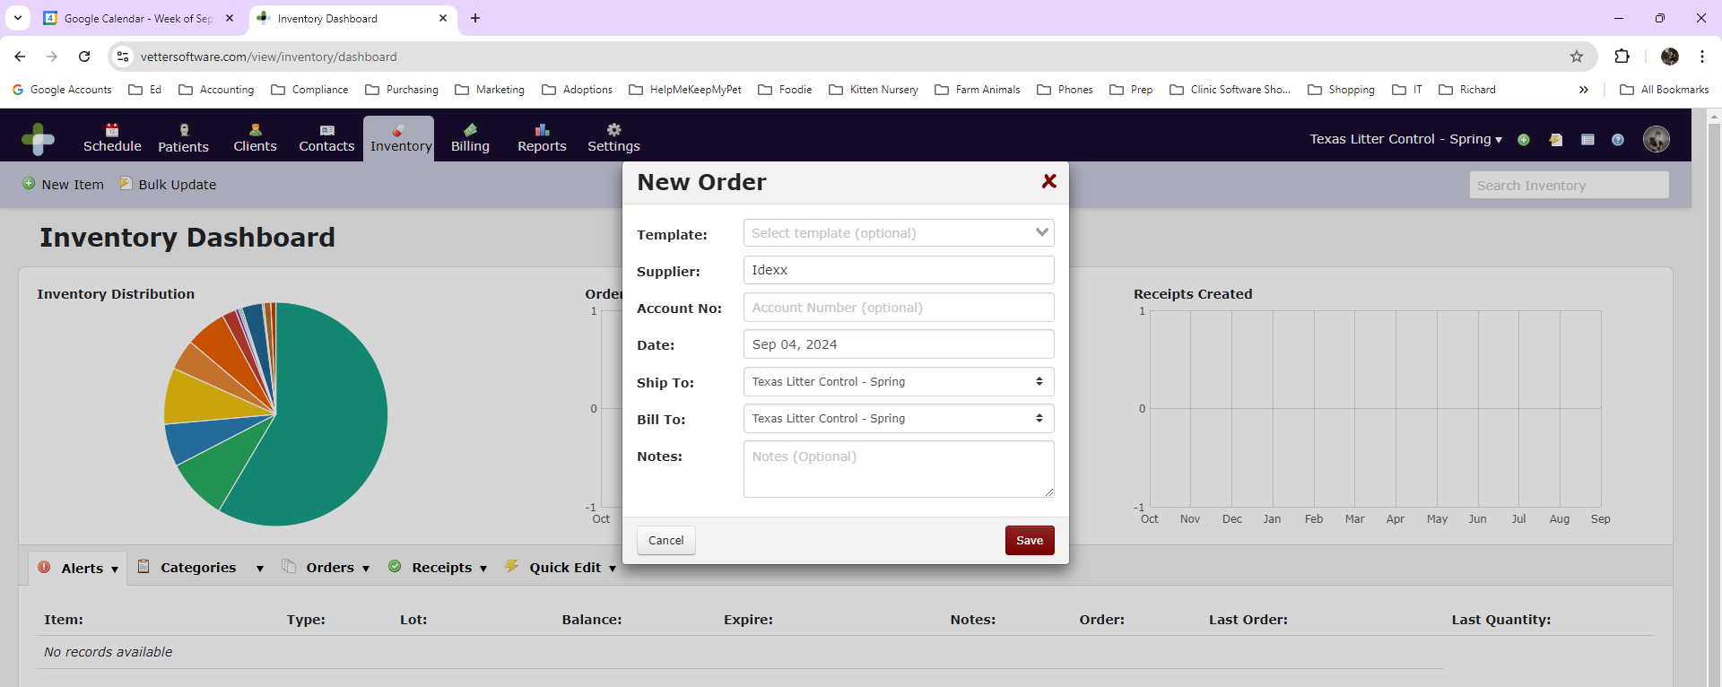
Click on Add Item under the Items tab and then select the items you ordered from this vendor.
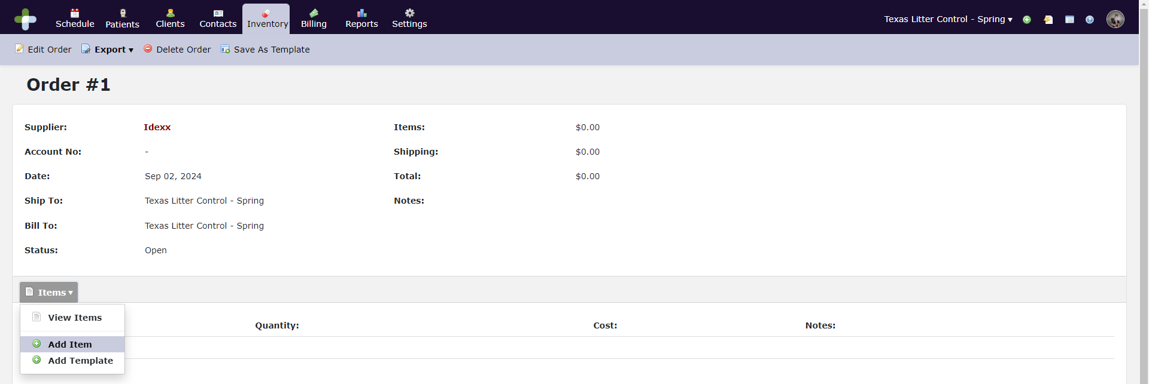
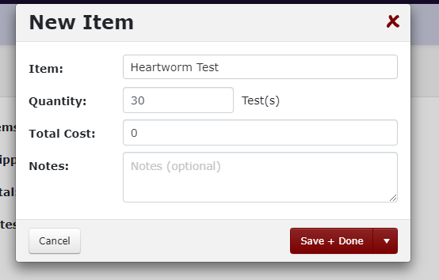

Once everything is in, click Submit Order. Once you submit the order, it cannot be changed so it is a good idea to enter the order into DaySmart after you have placed the order through whatever vendor you are purchasing from.
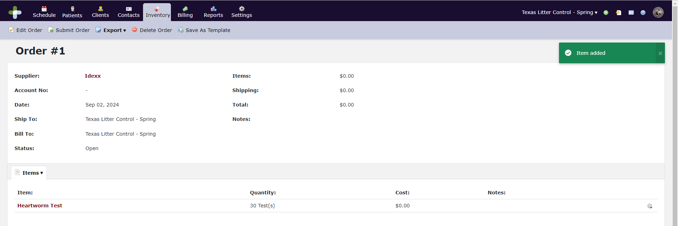

Receiving Inventory
When the order comes in, we will need to ensure the vendor sent us the correct quantity and nothing was left out of the order. Go back to the original order in the system and make sure we received everything on the order. You will then need to log this into the system. To receive the order, go to Receipts. Click New Receipt.
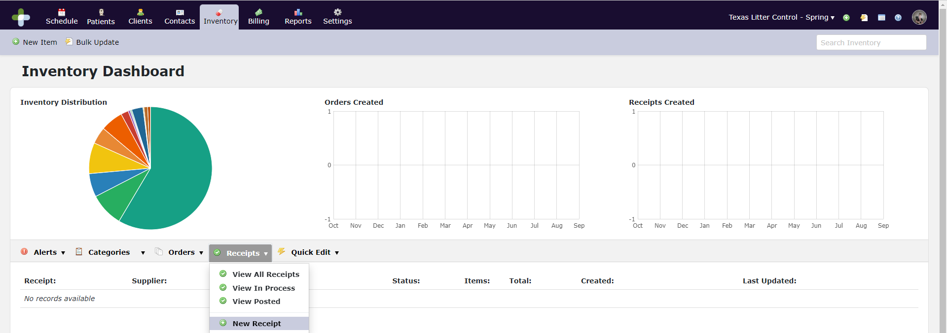
Input the Supplier and select the Order Number that corresponds to the shipment. Input the Invoice number, any taxes charged, and the shipping charges.
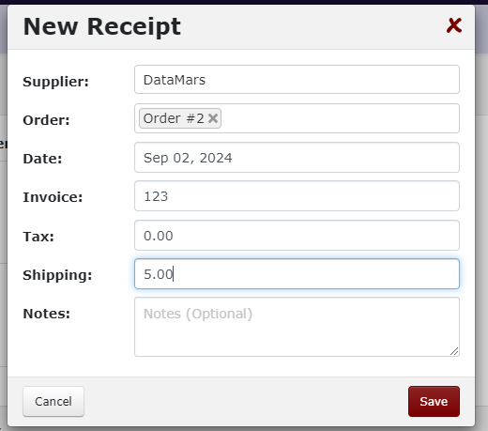
After you have saved the receipt, you need to go back into the Receipt and input any lot numbers and expiration dates. Click on the Gear Icon on the right to update this information. Edit each item with the correct information and click Save. Be especially careful when entering the information about the item because this data will be used to populate other information within the system. For example, the rabies lot numbers will not have to be manually entered. We will be able to select them and they will print on the patient’s rabies certificate.
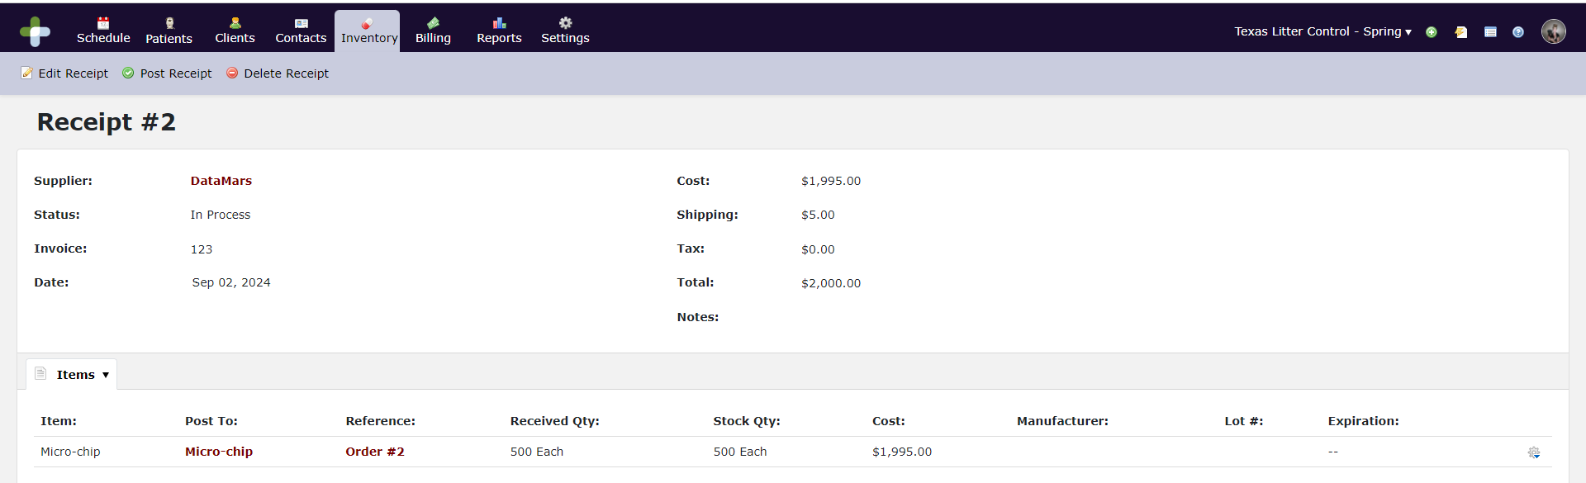

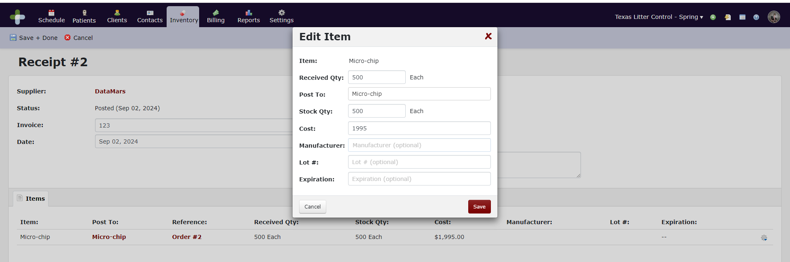

Inventory Adjustments
Occasionally, inventory must be adjusted. To perform this task, you must go into the inventory item you need to adjust. Under the Purchases tab you will select View Purchases. This will bring up all of the purchases by lot number.
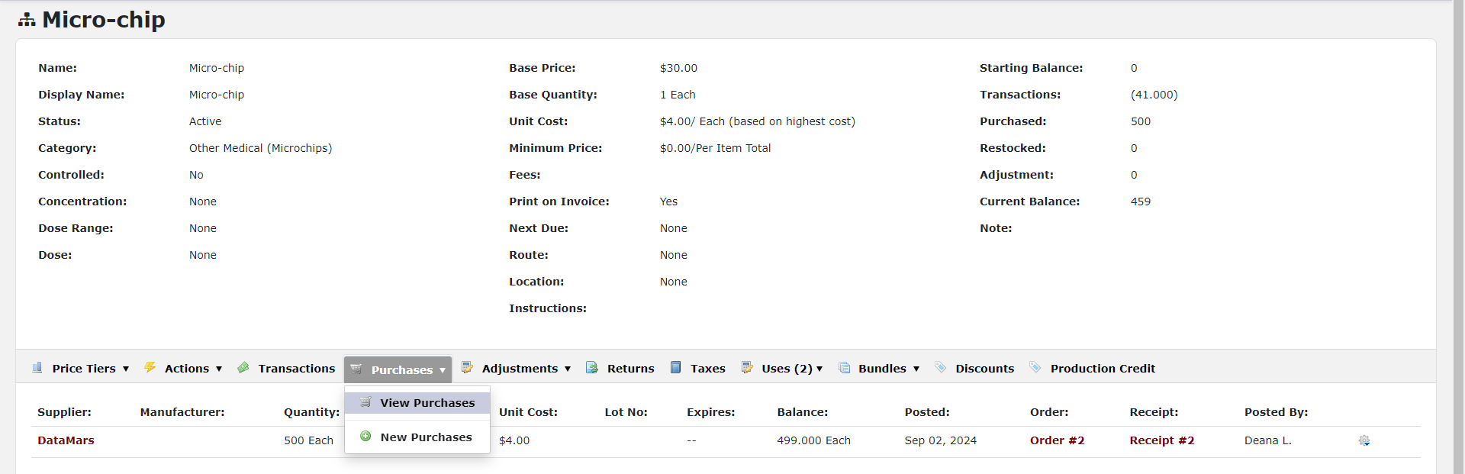
Click the Gear Icon on the right and select Adjust Balance.
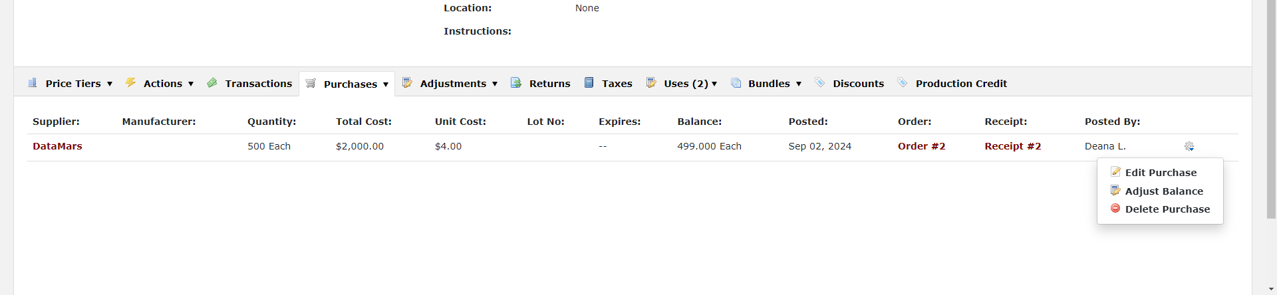

Key in the actual balance and the reason why we are adjusting inventory. Put in any notes you may want to include with this adjustment. Click save.
