
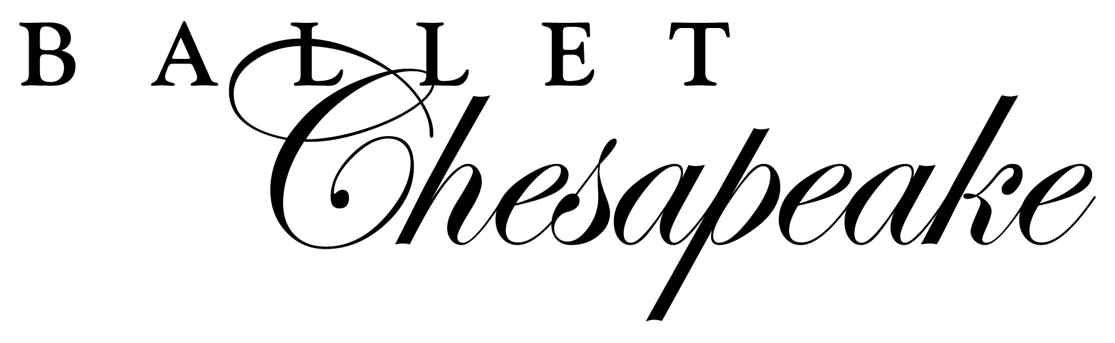

Ballet Chesapeake’s Annual Spring Production

The dates and times listed on the attached sheets are mandatory. If a student misses any of the scheduled dress rehearsals, Ballet Chesapeake will not allow them to perform in the concert. NO EXCEPTIONS.

Please find your child’s class(es) below to see when they are performing. Cast 1 & 2 are part of to Act 1 of the performance. Cast A & B are part of to Act 2 of the performance. Cast 1 & Cast A will be performing Saturday, 6/8, and Cast 2 & Cast B will be performing Sunday, 6/9.

***Concert Commitment form and payment due: Saturday, January 12***
Class | Class Day | Class Time | Teacher | Cast | Costume Rental/Cost | Performance Class Cost (per session)
PreBallet | Monday | 5:00pm | Diane Brown | A | $55 | N/A
PreBallet | Tuesday | 6:30pm | Diane Brown | B | $55 | N/A
Preballet | Thursday | 11:00am | Diane Brown | A | $55 | N/A
PreBallet | Saturday | 11:00am | Diane Brown | B | $55 | N/A
Ballet 1 | Monday | 7:00pm | Diane Brown | A | $60 | $75
Ballet 1 | Friday | 5:300pm | Gail Melfi | A | $60 | $75
Ballet 1 | Saturday | 1:15pm | Diane Brown | B | $60 | $75
Ballet 1 Intensive | Wednesday | 5:30pm | Holly Mora | B | $60 | $75
Ballet 2 | Wednesday | 7:15pm | Holly Mora | A | $60 | $75
Ballet 2 | Friday | 7:15pm | Gail Melfi | B | $60 | $75
Ballet 2 Intensive | Saturday | 1:15pm | Holly Mora | A | $60 | $75
Ballet 2X | Wednesday | 7:15pm | Holly Mora | B | $60 | $75
Ballet 2X | Saturday | 3:00pm | Holly Mora | B | $60 | $75
Ballet 2X Intensive | Tuesday | 6:00pm | Kait Weber | A | $60 | $75
Elem/Inter Ballet | Tuesday | 7:15pm | Ashley Spears | A | $45 | $75
Boys Class | Friday | 4:30pm | Algernon Campbell | B | $60 | N/A
Ballet 3/4 | Wednesday | 6:00-6:30 | Barclay Gibbs | A&B | $45 | $75
Ballet 5/6 | Thursday | 6:45pm | Jessica Treherne | A&B | $45 | $75
Inter/Adv Ballet | Monday | 8:45pm | Barclay Gibbs | A&B | $45 | $75
Elem & Int Modern | Friday | 5:30 & 6:30 | Algernon Campbell | 1 | $60 | N/A
Elem Modern | Thursday | 5:00pm | Alyson Jacques | 2 | $60 | N/A
Adv. Modern 1 & 2 | Tuesday and Wed | 6:00 & 6:30 | Shana O’Brien | 1&2 | $65 | N/A
Beg/Elem Hip Hop | Thursday | 5:00pm | Tyone Pompey | 2 | $60 | N/A
Inter/Adv Hip Hop | Thursday | 6:00pm | Tyone Pompey | 2 | $65 | N/A
Broadway Jazz | Tuesday | 7:30pm | Diane Brown | 2 | $60 | N/A
Int/Adv Jazz | Monday | 6:30pm | Shana O’Brien | 1 | $65 | N/A
Elem. Tap | Friday | 6:30pm | Anita Samek | 2 | $60 | N/A
Inter/Adv Tap | Friday | 4:30 & 5:30 | Anita Samek | 1 | $65 | N/A
NHSDA | Tuesday | 7:45 | Spears/O’Brien | 1&2 | $45 | N/A

