Download Android 3.4 Instructions:
- In our website https://sobersensellc.com/ go to the “More” tab at the top menu and select “Videos/Downloads”
- Scroll down all the way to DOWNLOADS
- Below Android 3.4 press blue link down (3 seconds approximately) until another window menu opens
- Select “Open in Incognito tab”
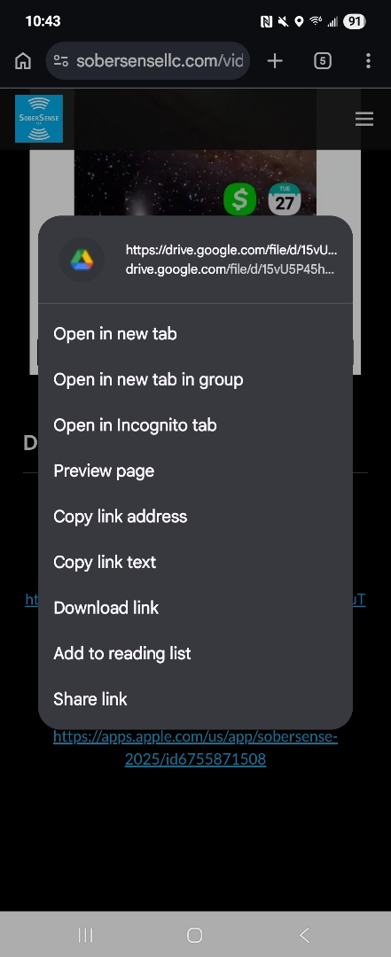

- Press on the blue “Download” button below “No preview available”
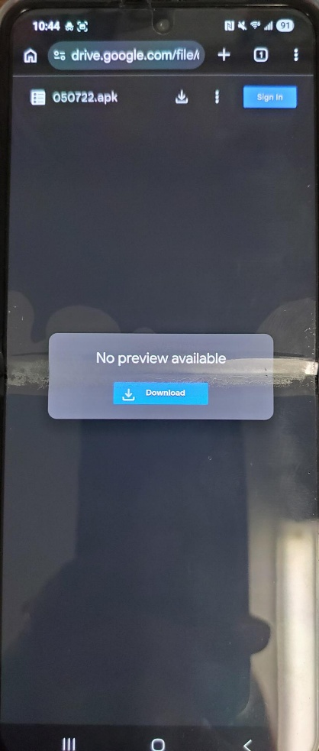

- Another window will open (it could take a couple of seconds; view might be small) click the “Download anyway” grey button
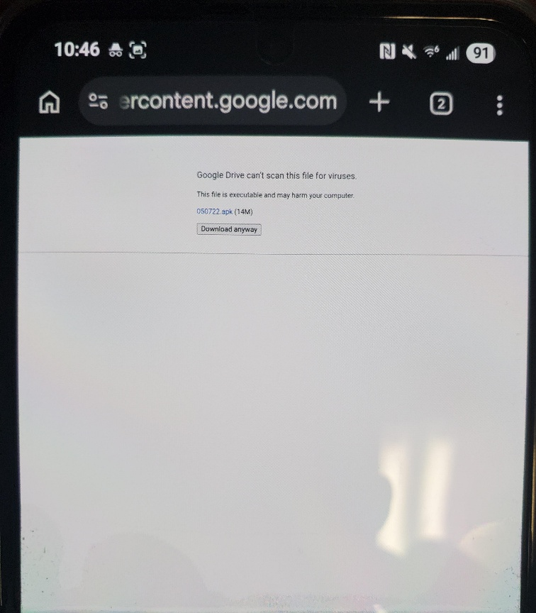

- A request window to download the file will popup (It may take a couple of seconds), please press “Download”
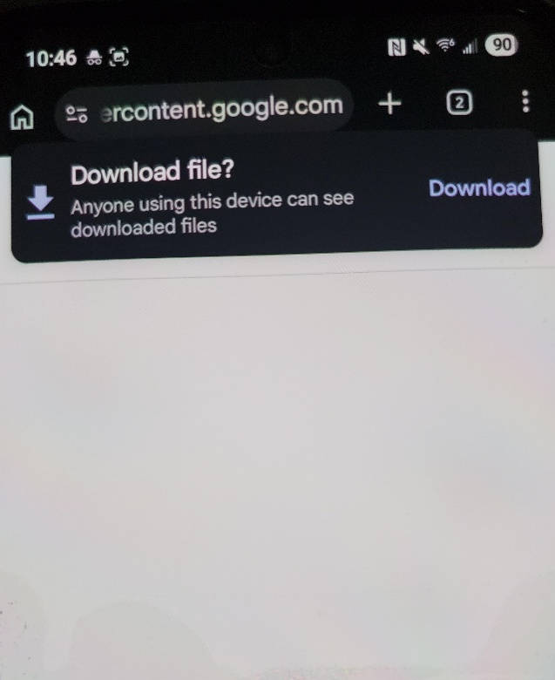

- It is possible a warning window will appear stating that the file might be harmful, this is only due to the security features set to not install anything in “Incognito mode” App is safe to install, please press “Download anyway”
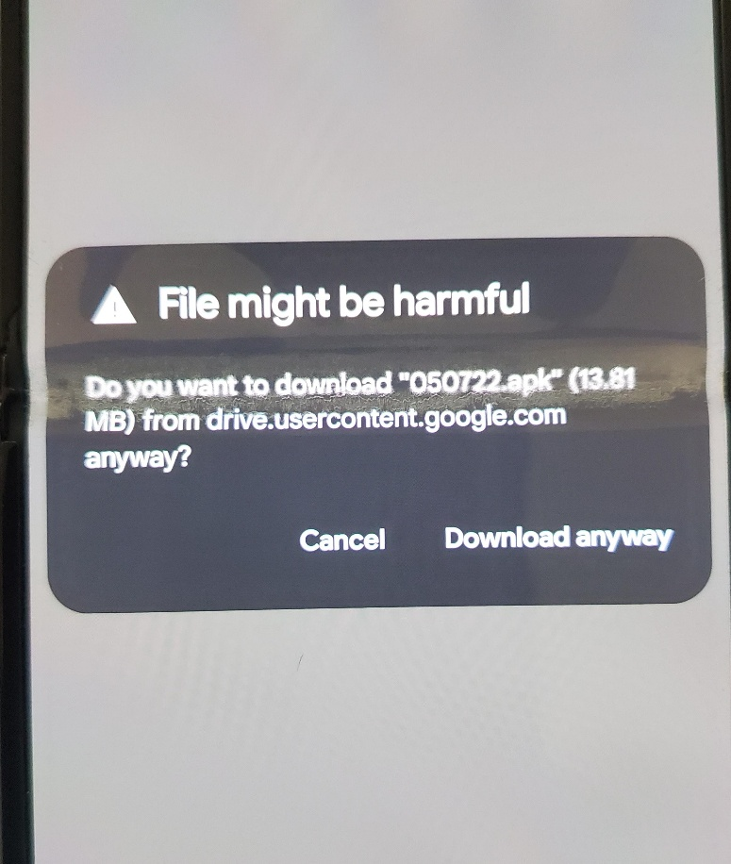

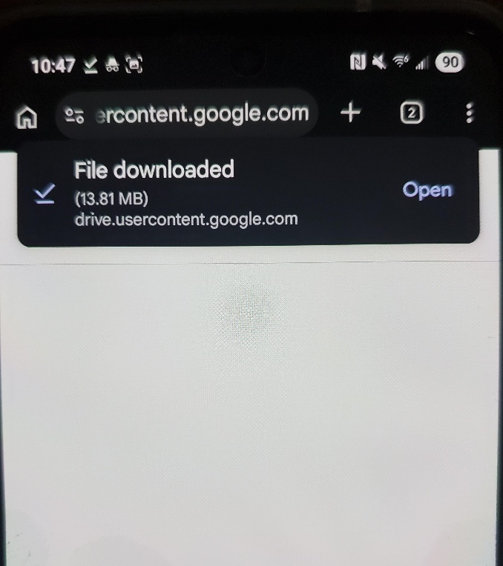
- Another window requesting to open file will popup, press “Open”

- At the bottom of your screen, a message will request permission to install the SoberSense app, press “Install”
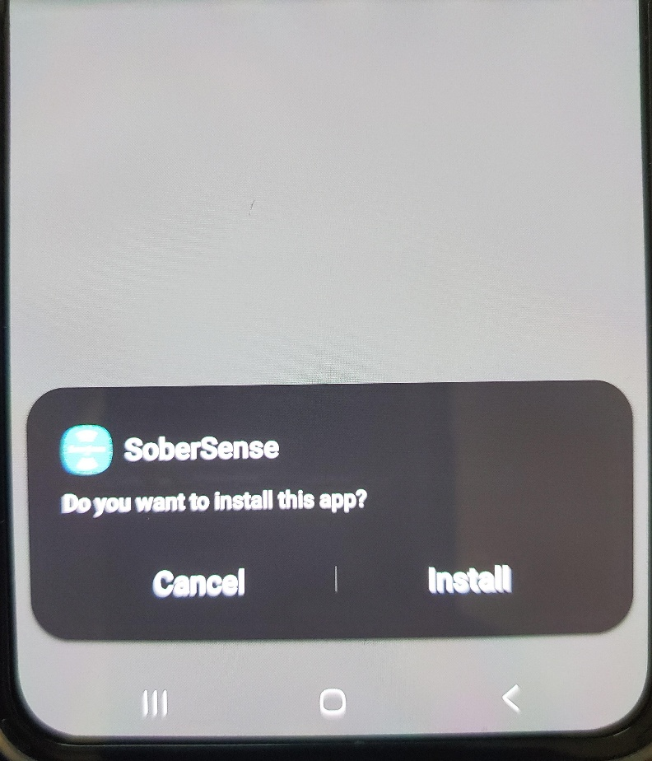

- A Google play protect window will appear stating it has blocked the app, it is very important you do not press on “GOT IT”. Next to where it says “More details” there is an arrow pointing down, please press on the arrow, the window message will expand, and another permission will appear as “Install anyway”
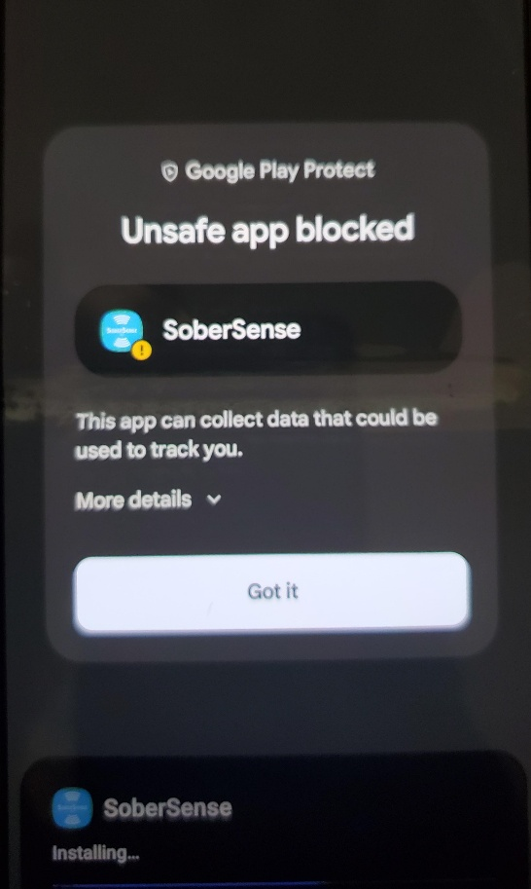
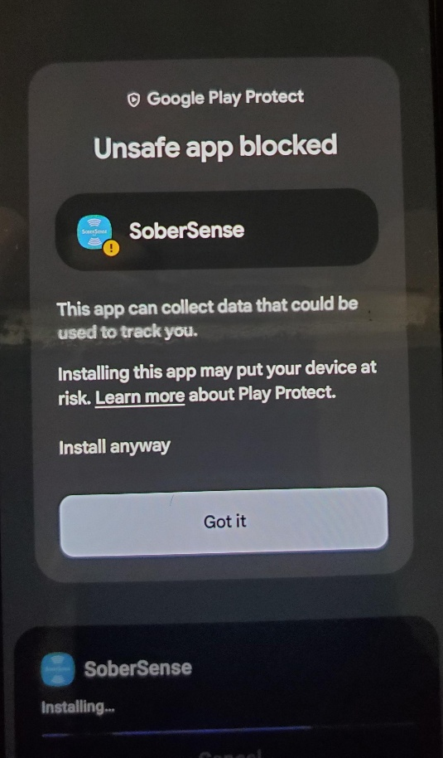

- Press on “Install anyway”
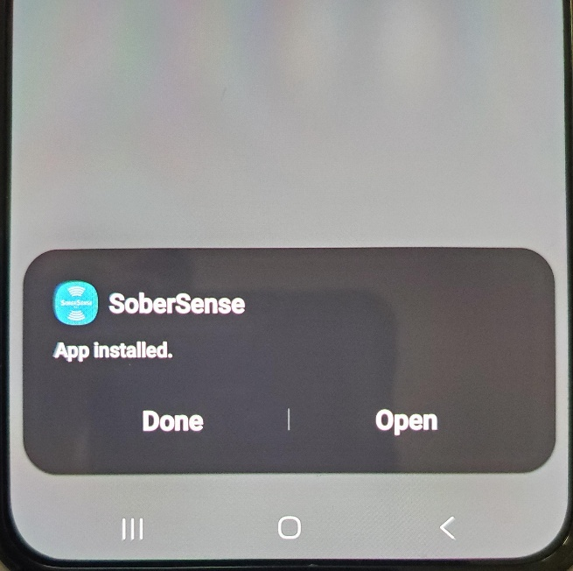
- A final Window will appear at the bottom of the screen stating app has been successfully installed and will allow you to Open the app. You can go ahead and press “Open”

