Sandhills Alternative Academy, LLC

Sliding Fee Discount Application
It is the policy of Sandhills Alternative Academy, LLC to provide essential services regardless of the patient’s ability to pay. Discounts are offered based on family size and annual income. Please complete the following information and return to the front desk to determine if you or members of your family are eligible for a discount.
The discount will apply to all services received at this agency, but not those services or equipment that are purchased from outside, including reference laboratory testing, drugs, contracted psychiatric services, and other such services. This form must be completed every 12 months or if your financial situation changes.

Sandhills Alternative Academy, LLC does not discriminate in the provision of services to an individual (i) because the individual is unable to pay; (ii) because payment for those services would be made under Medicare, Medicaid, or the Children's Health Insurance Program (CHIP); or (iii) based upon the individual's race, color, sex, national origin, disability, religion, age, sexual orientation, or gender identity.

Sliding Fee Discount Application
NAME OF HEAD OF HOUSEHOLD |  |  | PLACE OF EMPLOYMENT
STREET | CITY | STATE | ZIP | PHONE

Please list spouse and dependents under age 18.
Name | Date of Birth |  |  | Name | Date of Birth
SELF |  | DEPENDENT
SPOUSE |  | DEPENDENT
DEPENDENT |  | DEPENDENT
DEPENDENT |  | DEPENDENT

Annual Household Income
Source | Self | Spouse | Other | Total
Gross wages, salaries, tips, etc.
Income from business, self-employment, and dependents
Unemployment compensation, workers' compensation, Social Security, Supplemental Security Income, public assistance, veterans' payments, survivor benefits, pension or retirement income
Interest, dividends, rents, royalties, income from estates, trusts, educational assistance, alimony, child support, assistance from outside the household, and other miscellaneous sources
Total Income
NOTE: Copies of tax returns, pay stubs, or other information verifying income may be required before a discount is approved.
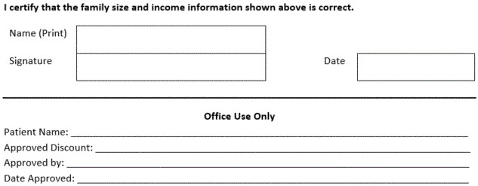

Verification Checklist | Yes | No
Identification/Address: Driver’s license, utility bill, employment ID, or other
Income: Prior year tax return, three most recent pay stubs, or other
Insurance: Insurance Cards

