Title Page

- Submission Title:

Enhanced Eye and Face Protection for Surgical Patients in Robotic Trendelenberg and Supine Positions: Evaluation of a Novel Shielding Device

- Full name of author:

Michael D. Sparkuhl, MD, FACS

- Affiliation:

Michael D. Sparkuhl, MD, FACS is a former Clinical Instructor, General Surgery Residency Program, Community Memorial Health System, Ventura, CA and currently works as a private consultant.

- Summary of submission:

Unrecognized and unrecorded eye and face near misses from dropped and moving objects in Robotic and supine surgery results in impact testing and a novel shield to enhance patient protection.

Enhanced Eye and Face Protection for Surgical Patients in Robotic Trendelenberg and Supine Positions: Evaluation of a Novel Shielding Device

Michael D. Sparkuhl, MD, FACS

A prior newsletter addressed malpractice claims associated with visual loss in prone positioning, face pressures and a protective device in response to eye injuries. ¹ Other than lip and tooth injuries and postoperative visual loss, the medical literature lacks investigation into unintentional patient eye and face injuries during supine and Trendelenberg general anesthesia.
Occupational Safety and Health Administration (OSHA) regulations ² (29 CFR 1910.133 and 1910.1030) require the use of eye and face protection for healthcare workers, but not for patients, within the operating room. In contrast to OSHA the Joint Commission for Accreditation of Hospital Healthcare Organizations (JCAHO) has no specific eye and face protection requirements for the patient ³. This is paradoxical given the vulnerability a patient’s face during surgical procedures.
Experience tells us that there are many unrecognized and unrecorded hazards or near misses around the patient’s eyes and face during surgery which are potential sentinel events. This is especially true in Robotic surgery with the face commonly hidden from view. Moreover, the impact forces of dropped objects and their potential for eye and face injuries have not been systematically studied. Prior investigations focused on complications associated with prone positioning. ⁴
Existing eye and face protective devices for supine and Trendelenberg positioning are limited, often bulky, cumbersome, obscure the face, and are not easily amenable to airway management. Eyelid taping may prevent corneal abrasions but does little to prevent traumatic injuries caused by dropped objects and instruments.
Using electronic sensors and slow-motion videography we evaluated the effectiveness of a novel transparent foam-padded eye and face shield developed by Dupaco, Inc. Blunt and pointed weights (50-500 gm.) mimicking common surgical instruments were each dropped ten times onto the supine shield from a height of 60 cm. The impact forces were recorded with high-speed electronic sensor technology (Xsensor Technology Corporation) as used in automobile crash testing. The average impact pressures ranged from 1032 mmHg. to 5410 mmHg (pointed end) and 348 mmHg. to 3139 mmHg (blunt end), signifying significant hazards if these weights were to strike the unprotected eyes and face.
The foam padding disperses the impact pressure, converting split-second high pressures (up to 5410 mmHg) uniformly to self-limited lower pressures (ranging from 79 to 138 mmHg) measured around the face at the chin and forehead. Unlike sustained pressure in the prone position, there was no sustained pressure in the supine position due to the compression and expansion properties of the foam. It acts like a shock absorber, immediately dissipating high shield impact pressures regardless of the weight dropped.
The findings suggest that a protective shield may mitigate eye and facial trauma in patients undergoing surgery in the supine and Trendelenberg positions.
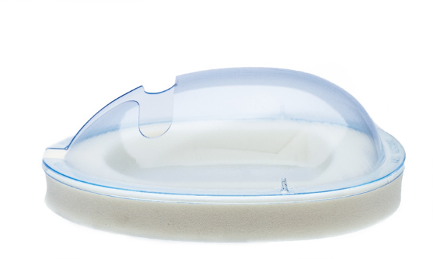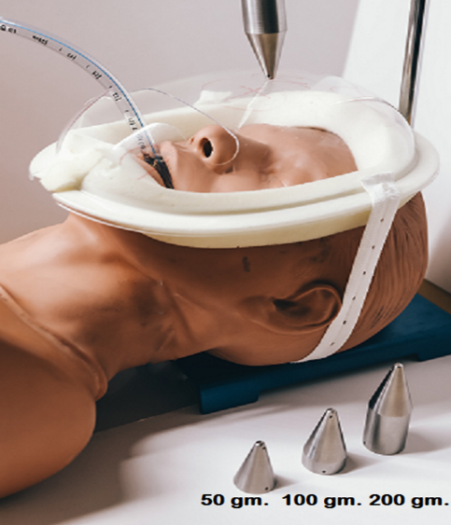

Michael D. Sparkuhl, MD, FACS
Michael D. Sparkuhl, MD, FACS participated in development.
1.) Mazzei, W.J., Benumof, J.L. Eye injury issue leads to new protective helmet device and research on face pressures from prone positioning on OR table. Anesthesia Patient Safety Foundation Newsletter, 2020:15(3, Fall).
2.Occupational Health and Safety Administration Code of Federal Regulations 29 CFR 1910.133 and 1910.1030.
3. The Joint Commision. National Patient Safety Goals Effective January 2024 For the Hospital Program pg.1-12 (online- https://www.jointcommission.org/-/media/tjc/documents/standards/national-patient-safety-goals/2024/npsg_chapter_hap_jan2024.pdf)
4. American Society of Anesthesiologists. Practice Advisory for Perioperative Visual Loss Associated with Spine Surgery 2019: An Updated Report by the American Society of Anesthesiologists Task Force on Perioperative Visual Loss, the North American Neuro-Ophthalmology Society, and the Society for Neuroscience in Anesthesiology and Critical Care* Anesthesiology January 2019, Vol. 130, 12–30.

