Kathy J. Owen
9th Degree Black Belt
Newark Kenpo Karate
P.O. Box 7065
Newark, DE 19714
(302) 836-1557
(302) 540-4151

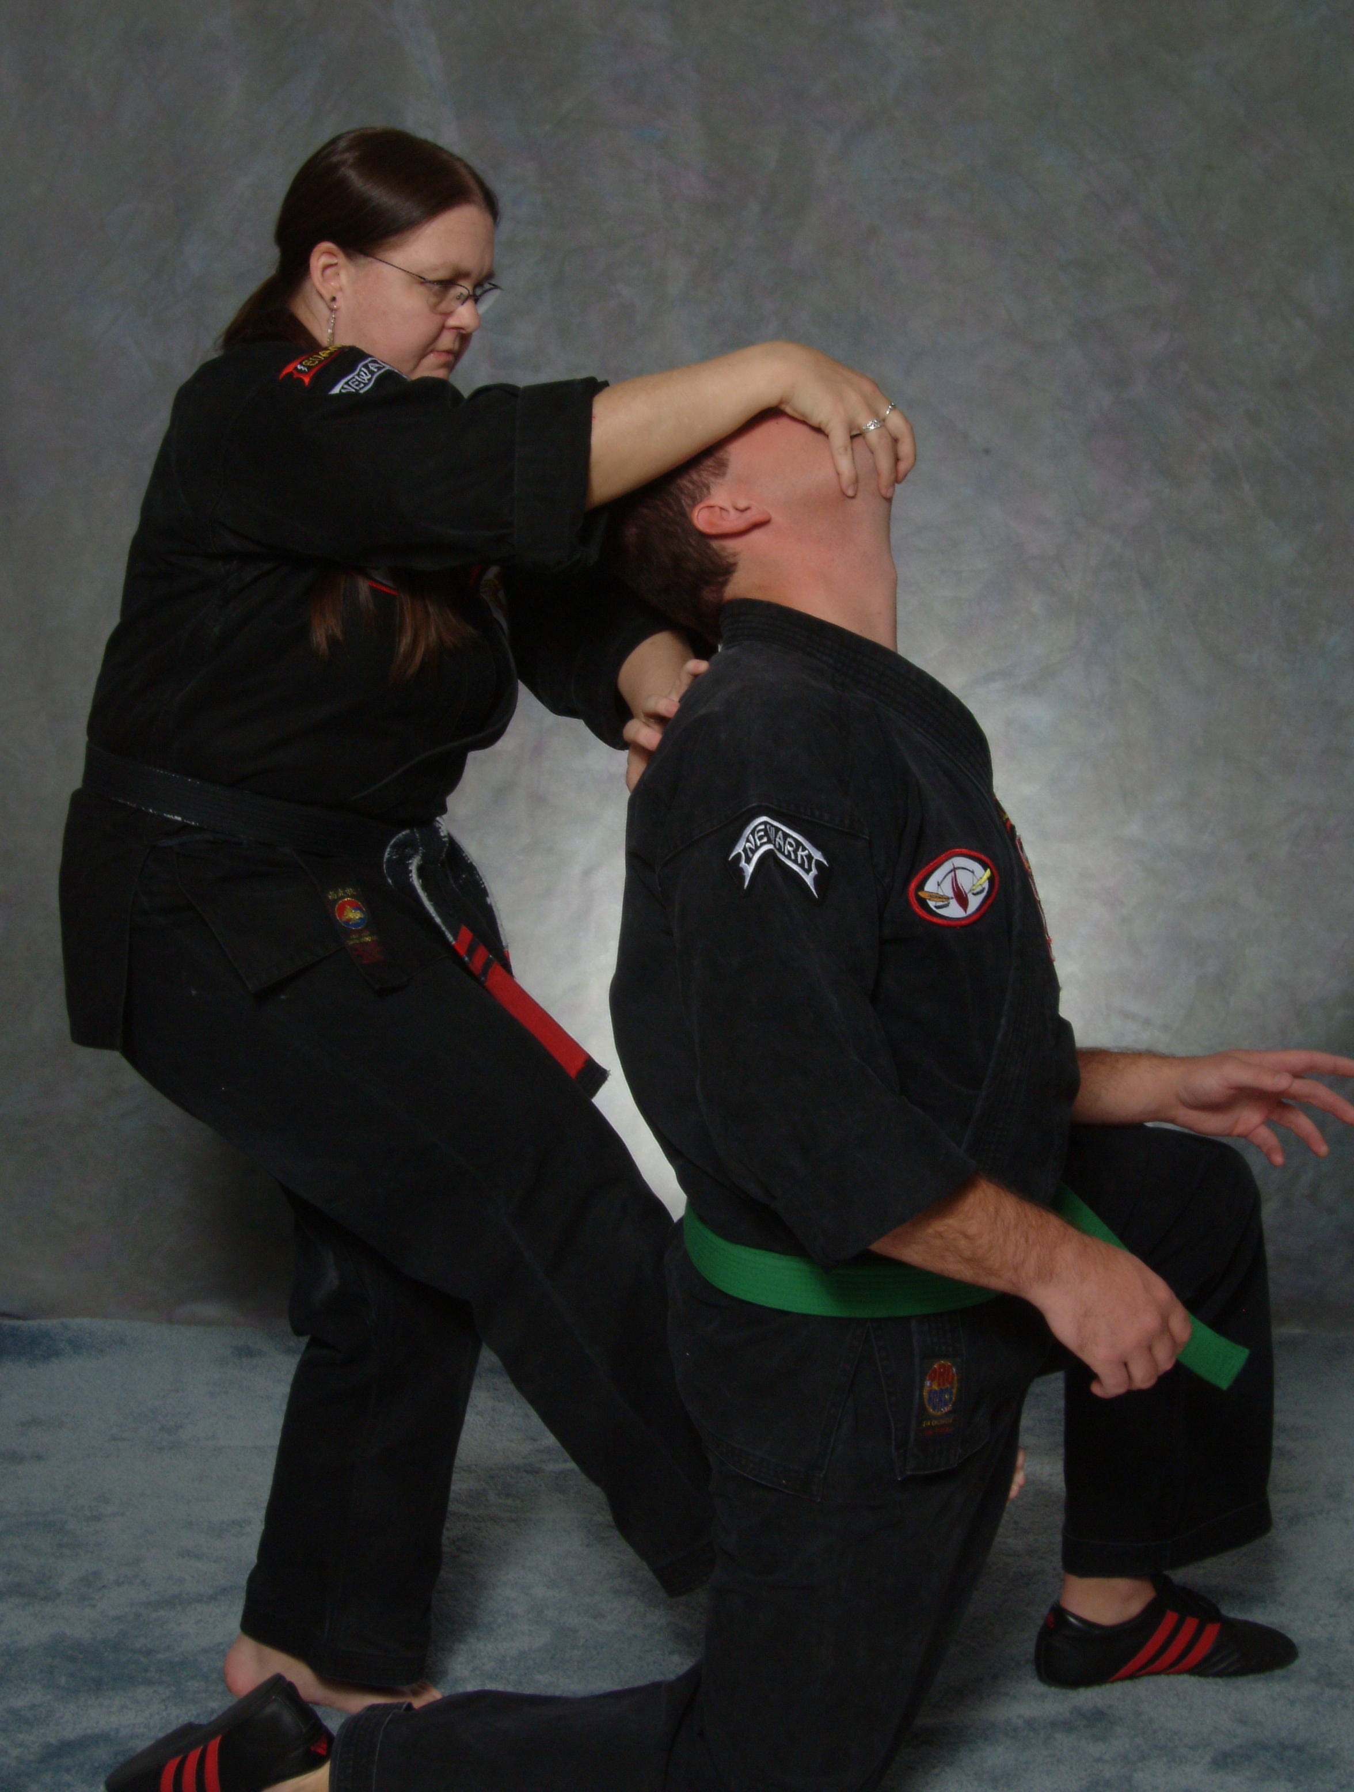

Kathy J. Owen began her Martial Arts training in 1977 while a student at the University of Delaware. She trained in several Martial Arts styles including Aikido, Judo, Bushidokan, Filipino Arnis, Shotokan and a variety of styles of Kenpo. Ms. Owen received her 1st Degree Black Belt in Kenpo in 1983. Ms. Owen currently holds a 9th Degree Black Belt in American Kenpo and has earned the title of Master of the Arts.

Since 1988, Ms. Owen has owned and operated Newark Kenpo Karate in Newark, Delaware, a Martial Arts studio with over 150 active students. Her students range in age from 3 years old through adults well into their 70’s. One unique aspect of her school is her long-term commitment and success working with mentally and physically challenged children and adults.

Ms. Owen has successfully competed in many tournaments, including National and International level competitions. She currently has numerous junior and senior students successfully competing at these same levels of competition. Her students are well-known for their creative, dynamic choreography as well as their explosive speed and power.

Ms. Owen has been a direct personal student of Grand Master Paul Mills and currently serves as Eastern Regional Representative and is a member of the Executive Board of Directors for the American Kenpo Karate International Association. She also hosts bi-annual International Training Camps in Newark, DE.

In addition to teaching at Newark Kenpo Karate 4 days a week, Ms. Owen conducts self-defense workshops at area corporations, local businesses and community groups, including: DuPont, University of Delaware, St. Francis Medical Center, Delmarva Power, Winterthur Museum, I.C.I. Americas, the YMCA and the Jewish Community Center. She also teaches Kenpo Karate seminars nationally and internationally, including at the prestigious International Karate Championships in Long Beach, California, at the AKKI International Training Camps in Las Vegas, Nevada, Evanston, Wyoming, Dublin, Ireland and on the Island of Jersey in the Channel Islands, UK. She is a certified Personal Fitness Trainer and often assists her students in developing multidimensional fitness programs.

She holds degrees in Anthropology, Sociology and Education and is a former public-school teacher. In her spare time, she enjoys gardening, playing guitar and Native American Flute.

