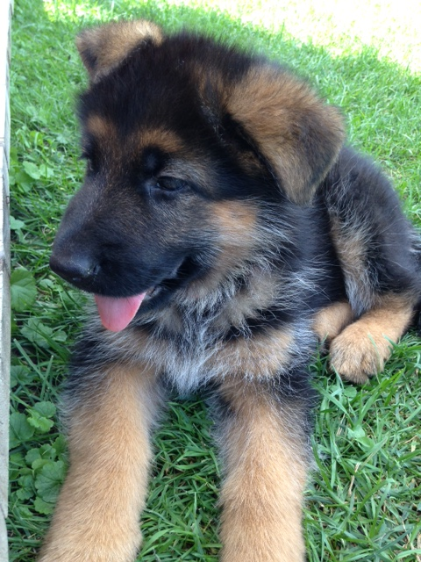
PFERDELAND KENNEL
RICHARD and JULIE LAGACE
Curran ON K0B 1C0
(613) 851-9592

German Shepherd Dog Application

Please complete each of the following questions as thoroughly and accurately as possible.

Today’s Date:

Applicant’s name:
Address:
E-mail: Home phone: Work/cell phone:

1. Please list your preferences in a dog (gender, size, personality, age):
2. Have you submitted an application with another organization for a dog at this time? Yes No
3. Have you ever had an application declined for adoption of an animal from an animal rescue/breeder group/animal control facility? Yes No
If yes, please explain:
4. Do you understand that changing a dog’s environment may cause the them to have accidents or exhibit unwanted behaviour? Yes No
5. Does any member of your family have any allergies to animals? Yes No
6. For whom are you adopting the dog? Self Gift Other
7. How many people live in your home?
8. Are there any children in your household? Yes No
If yes, what are their ages?
9. Will the dog live indoors?
10. Who will be responsible for feeding and taking the dog outside?
11. Who will take care of the dog in the absence of the primary caretaker?
12. Will you take the dog to obedience training?
13. Will you be willing to obtain an appropriately sized crate, if recommended? Yes No
14. Do you currently have any pets and tell me a little about them?

15. Have you had other dogs in the past? If so, tell me a little about them.

16. Have you considered the extra expenses that will come with having a dog, including vet care, food, supplies and equipment, toys, grooming, training and boarding? Yes No
17. What type of home do you live in? House Condo Apt Other:
18. Do you have a fenced yard? Yes No Partially fenced
19. If you do not have a fence, do you plan to install a fence or kennel?
Yes No
20. How many hours per day will the dog be left unattended (i.e., workday)?
21. When no one is home (i.e. at work, shopping), where will the dog stay (please be specific)?
22. How often do you travel?
23. What will you do with the dog when you travel?
24. Are all adult family members who reside in your home aware that you are considering adopting a pet? Yes No Do they approve? Yes No
25. Why did you choose this breed?

27. Tell me a little bit more about yourself (your lifestyle, your family, or anything else to help me make sure that one of my puppies would be a good fit for your family).

How did you hear about Pferdeland Kennel? (please choose one)
Google Facebook Word of mouth CKC Other:

Pferdeland Kennel reserves the right to refuse any applicant at any time for any reason that Pferdeland Kennel may feel in their opinion is not a good fit for one of our puppies whether a deposit has been given or not (deposit will be refunded) right up to and including the day of delivery.

By signing this document, you acknowledge that you have read and understand the above statement and that all information given is as accurate as possible.

Date

Printed Full Name

Signature

