2020 Richmond Little League Spirit Card Form

SPIRIT CARD FUNDRAISER: Sell a minimum of 6 spirit cards, $10 each
WHEN/WHERE TO TURN IN $60 AND PICK UP CARDS: FEBUARY 23rd 1:00-2:30pm @ Galaxy Bowling Center (Cash or Check (payable to RLL)

2020 Spirit Card Sponsors
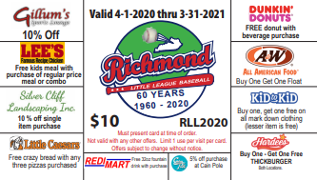

Player’s Name ___________________________________ Division: Wee Tee RCP CP Minor Major Senior

NAME | PHONE NO | QTY | TOTAL
 | TOTAL AMOUNT | ________ | ________
***Return this sheet with $60 on February 23rd to pick up cards***

