2023 Richmond Little League Spirit Card Form

SPIRIT CARD FUNDRAISER: Sell a minimum of 6 spirit cards, $10 each
WHEN/WHERE TO TURN IN $60 AND PICK UP CARDS: MARCH 12th 2:00-3:00pm @ Richmond Mall (enter doors next to Gillum’s) (Cash or Check (payable to RLL)

2023 Spirit Card Sponsors
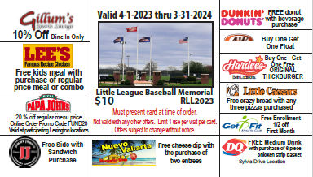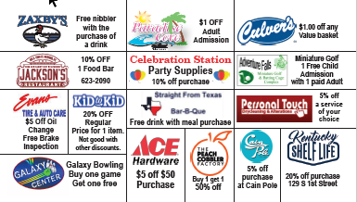

Player’s Name ___________________________________ Division: Wee Tee RCP CP Minor Major Senior

NAME | PHONE NO | QTY | TOTAL
 | TOTAL AMOUNT | ________ | ________
***Return this sheet with $60 on March 12th to pick up cards***

