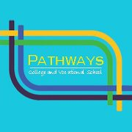
PATHWAYS MIDDLE AND HIGH SCHOOL
3110-1 Randall Parkway
Wilmington, NC 28403
910-343-3321
teresa.carroll@ymail.com

Parents: Please complete this form including the address of your child’s previous school. Return the completed form to Pathways with your child’s application.

Student’s Name: __________________________________________________
Last First Middle

Student’s Birth Date: ____________________ Grade Level: __________

School: _________________________________________________________

Mailing Address: __________________________________________________
Street/PO Box

__________________________________________________
City State Zip Code

I give my permission for the release of the following records concerning my child to Pathways.

Parent’s Signature: _________________________________ Date: _________

Attention Student Records Administrator:

The student listed above has enrolled in Pathways. Please send the following information as soon as possible.

- Official Transcript
- Withdrawal Grades (if necessary)
- Standardized Test Scores
- Immunization Records

Sincerely,

Teresa W. Carroll
Pathways Administrator

