My Utmost for His Highest – 10/14/25

The Key to the Missionary’s Work


Jesus came and spoke to them, saying, "All authority has been given to Me in heaven and on earth. Go therefore and make disciples of all the nations…" —Matthew 28:18-19
The key to the missionary’s work is the authority of Jesus Christ, not the needs of the lost. We are inclined to look on our Lord as one who assists us in our endeavors for God. Yet our Lord places Himself as the absolute sovereign and supreme Lord over His disciples. He does not say that the lost will never be saved if we don’t go— He simply says, “Go therefore and make disciples of all the nations….” He says, “Go on the basis of the revealed truth of My sovereignty, teaching and preaching out of your living experience of Me.”
“Then the eleven disciples went…to the mountain which Jesus had appointed for them” (Matthew 28:16). If I want to know the universal sovereignty of Christ, I must know Him myself. I must take time to worship the One whose name I bear. Jesus says, “Come to Me…”— that is the place to meet Jesus— “all you who labor and are heavy laden…” (Matthew 11:28)— and how many missionaries are! We completely dismiss these wonderful words of the universal Sovereign of the world, but they are the words of Jesus to His disciples meant for here and now.
“Go therefore….” To “go” simply means to live. Acts 1:8 is the description of how to go. Jesus did not say in this verse, “Go into Jerusalem, Judea, and Samaria,” but, “…you shall be witnesses to Me in [all these places].” He takes upon Himself the work of sending us.
“If you abide in Me, and My words abide in you…” (John 15:7)— that is the way to keep going. Where we are placed is then a matter of indifference to us, because God sovereignly engineers our goings.
“None of these things move me; nor do I count my life dear to myself, so that I may finish my race with joy, and the ministry which I received from the Lord Jesus…” (Acts 20:24). That is how to keep going until we are gone from this life.
Wisdom From Oswald Chambers
If a man cannot prove his religion in the valley, it is not worth anything. Shade of His Hand, 1200 L

CCEL – 10/14/25
Christ both died, and rose, and revived, that he might be Lord both of the dead and living.—ROM. 14:9.
It pleased the Lord to bruise him; he hath put him to grief: when thou shalt make his soul an offering for sin, he shall see his seed, he shall prolong his days, and the pleasure of the Lord shall prosper in his hand. He shall see of the travail of his soul, and shall be satisfied: by his knowledge shall my righteous servant justify many; for he shall bear their iniquities.—Ought not Christ to have suffered these things, and to enter into his glory?—We thus judge, that if one died for all, then were all dead: and that he died for all, that they which live should not henceforth live unto themselves, but unto him which died for them, and rose again.
Let all the house of Israel know assuredly, that God hath made that same Jesus, whom ye have crucified, both Lord and Christ.—Who verily was foreordained before the foundation of the world, but was manifest in these last times for you, who by him do believe in God.
Isa. 53:10,11. -Luke. 24:26. -II Cor. 5:14,15.Acts. 2:36. -I Pet. 1:20,21.
“I count all things but loss for the excellency of the knowledge of Christ Jesus my Lord.” Philippians 3:8
Spiritual knowledge of Christ will be a personal knowledge. I cannot know Jesus through another person’s acquaintance with him. No, I must know him myself; I must know him on my own account. It will be an intelligent knowledge—I must know him, not as the visionary dreams of him, but as the Word reveals him. I must know his natures, divine and human. I must know his offices—his attributes—his works—his shame—his glory. I must meditate upon him until I “comprehend with all saints what is the breadth, and length, and depth, and height; and know the love of Christ, which passeth knowledge.” It will be an affectionate knowledge of him; indeed, if I know him at all, I must love him. An ounce of heart knowledge is worth a ton of head learning. Our knowledge of him will be a satisfying knowledge. When I know my Saviour, my mind will be full to the brim—I shall feel that I have that which my spirit panted after. “This is that bread whereof if a man eat he shall never hunger.” At the same time it will be an exciting knowledge; the more I know of my Beloved, the more I shall want to know. The higher I climb the loftier will be the summits which invite my eager footsteps. I shall want the more as I get the more. Like the miser’s treasure, my gold will make me covet more. To conclude; this knowledge of Christ Jesus will be a most happy one; in fact, so elevating, that sometimes it will completely bear me up above all trials, and doubts, and sorrows; and it will, while I enjoy it, make me something more than “Man that is born of woman, who is of few days, and full of trouble”; for it will fling about me the immortality of the ever living Saviour, and gird me with the golden girdle of his eternal joy. Come, my soul, sit at Jesus’s feet and learn of him all this day.

Word Live – 10/14/25

https://content.scriptureunion.org.uk/wordlive/

Scripture Union – 10/14/25
https://scriptureunion.org/encounters/

Today in the Word – 10/14/25

The Presence of the Future


Read Zechariah 8:1–23

The Lord Promises to Bless Jerusalem
8 The word of the Lord Almighty came to me.
² This is what the Lord Almighty says: “I am very jealous for Zion; I am burning with jealousy for her.”
³ This is what the Lord says: “I will return to Zion and dwell in Jerusalem. Then Jerusalem will be called the Faithful City, and the mountain of the Lord Almighty will be called the Holy Mountain.”
⁴ This is what the Lord Almighty says: “Once again men and women of ripe old age will sit in the streets of Jerusalem, each of them with cane in hand because of their age. ⁵ The city streets will be filled with boys and girls playing there.”
⁶ This is what the Lord Almighty says: “It may seem marvelous to the remnant of this people at that time, but will it seem marvelous to me?” declares the Lord Almighty.
⁷ This is what the Lord Almighty says: “I will save my people from the countries of the east and the west. ⁸ I will bring them back to live in Jerusalem; they will be my people, and I will be faithful and righteous to them as their God.”
⁹ This is what the Lord Almighty says: “Now hear these words, ‘Let your hands be strong so that the temple may be built.’ This is also what the prophets said who were present when the foundation was laid for the house of the Lord Almighty. ¹⁰ Before that time there were no wages for people or hire for animals. No one could go about their business safely because of their enemies, since I had turned everyone against their neighbor. ¹¹ But now I will not deal with the remnant of this people as I did in the past,” declares the Lord Almighty.
¹² “The seed will grow well, the vine will yield its fruit, the ground will produce its crops, and the heavens will drop their dew. I will give all these things as an inheritance to the remnant of this people. ¹³ Just as you, Judah and Israel, have been a curse^{[a]} among the nations, so I will save you, and you will be a blessing.^{[b]} Do not be afraid, but let your hands be strong.”
¹⁴ This is what the Lord Almighty says: “Just as I had determined to bring disaster on you and showed no pity when your ancestors angered me,” says the Lord Almighty, ¹⁵ “so now I have determined to do good again to Jerusalem and Judah. Do not be afraid. ¹⁶ These are the things you are to do: Speak the truth to each other, and render true and sound judgment in your courts; ¹⁷ do not plot evil against each other, and do not love to swear falsely. I hate all this,” declares the Lord.
¹⁸ The word of the Lord Almighty came to me.
¹⁹ This is what the Lord Almighty says: “The fasts of the fourth, fifth, seventh and tenth months will become joyful and glad occasions and happy festivals for Judah. Therefore love truth and peace.”
²⁰ This is what the Lord Almighty says: “Many peoples and the inhabitants of many cities will yet come, ²¹ and the inhabitants of one city will go to another and say, ‘Let us go at once to entreat the Lord and seek the Lord Almighty. I myself am going.’ ²² And many peoples and powerful nations will come to Jerusalem to seek the Lord Almighty and to entreat him.”
²³ This is what the Lord Almighty says: “In those days ten people from all languages and nations will take firm hold of one Jew by the hem of his robe and say, ‘Let us go with you, because we have heard that God is with you.’”

Footnotes
- Zechariah 8:13 That is, your name has been used in cursing (see Jer. 29:22); or, you have been regarded as under a curse.
- Zechariah 8:13 Or and your name will be used in blessings (see Gen. 48:20); or and you will be seen as blessed
This is what the LORD Almighty says: “I will save my people from the countries of the east and the west. I will bring them back to live in Jerusalem; they will be my people.” Zechariah 8:7–8
Warren Wiersbe once said, “God’s people don’t live on explanations; they live on promises.” The life of faith is not simply mastering content or puzzling out the meaning of obscure passages of the Bible, as important as those things may be. Rather, it is learning to believe and trust in God’s promises.
Zechariah 8 continues the Lord’s answer to the delegation of Jewish leaders (7:2–3). In a series of seven messages, the Lord weaves back and forth between describing the hope of Israel fulfilled in the millennial kingdom and the current life of the community. Realizing the hope of a fully restored Israel promised by God should impact the way God’s people lived in the present. Even more than that, the current remnant of exiles should serve as a signpost of the future kingdom.
Zechariah paints a beautiful picture of that future kingdom. Children and the elderly—the most vulnerable—will be in the streets without fear of harm or violence (vv. 4–5). Crops will produce bountifully (v. 12). Most significantly, people from all nations will come together to worship and seek the Lord (vv. 20–23). God’s promise to Abram, “all peoples on earth will be blessed through you” would be fulfilled (Gen. 12:3).
Because of this future hope, Israel should be compelled to act differently. They should, “Speak the truth to each other, and render true and sound judgment in your courts” (v. 16). In hope of a time when perfect justice would be administered, they should act justly now. We also live in hope of a promised future. The Lord Jesus has promised that He will “go and prepare a place” for us (John 14:2). The fact that He will come again and establish true justice and peace compels us to live in faithful obedience.
Go Deeper
What part of Zechariah’s prophecy in chapter 8 is especially encouraging to you? How does living and trusting in God’s promises change your life today?
Pray with Us
In the chaos of our world, we look forward to the promise of a home with You. Thank You, Lord, for the hope that You will bring peace. Help us live as lights that point to You.

Our Daily Bread – 10/14/25

New International Version



Read: Ecclesiastes 4:8-10
⁸ There was a man all alone;
he had neither son nor brother.
There was no end to his toil,
yet his eyes were not content with his wealth.
“For whom am I toiling,” he asked,
“and why am I depriving myself of enjoyment?”
This too is meaningless—
a miserable business!
⁹ Two are better than one,
because they have a good return for their labor:
¹⁰ If either of them falls down,
one can help the other up.
But pity anyone who falls
and has no one to help them up.
Two people are better off than one, for they can help each other succeed. Ecclesiastes 4:9 nlt

Today's Devotional
Climbing Jamaica’s Dunn’s River Falls is an exhilarating experience. Water cascades over the smooth rocks of the falls on its way to the Caribbean. It’s a challenge as climbers battle the water’s flow to make their way to the top. For a teenager named JW, it’s a near impossibility. He’s sight-impaired, with only a pinhole view of the world.
But JW was determined to climb, and his friend Josiah was willing to team up with him. Josiah was JW’s eyes—telling him which slippery rocks to avoid and where to put his hands and feet. And JW was Josiah’s heart—showing him what courage looks like.
So much of life is like that daunting climb: We shouldn’t walk alone. King Solomon points us to that truth. “Two people are better than one, for they can help each other succeed” (Ecclesiastes 4:9 nlt). Both Josiah and JW were attempting something special—and they could do it only in tandem. The passage continues: “If either [person] falls down, one can help the other up” (v. 10). But neither fell and neither failed. Together, they reached their goals.
God’s design for people, presented clearly by Solomon and demonstrated vividly by these two teenagers, is that we work together. The tasks God calls us to do are best done with others—each using what skills and emotions God has given to bring an outcome that points to Him.

Reflect & Pray
Why is it important to serve with others? How does it feel when you team up to point people to God?
Dear God, please help me team up with You and others to accomplish Your mission on earth.
For further study, read The Absurdity of Chasing Dreams.

Today's Insights
The book of Ecclesiastes—written from the perspective of “under the sun” (1:14) or the human experience on earth—seems to be one long lament. What’s it all about? Does anything ultimately matter? Why even try? That forlorn theme continues here, as the writer (called “the Teacher” in 1:1) observes “a man all alone” (4:8). Eventually this solitary figure asks himself, “For whom am I toiling?” The Teacher observes, “This too is meaningless—a miserable business!” (v. 8). Yet Ecclesiastes also recognizes that there is a life worth living. The wise man declares, “Two are better than one” (v. 9) and points to a specific reason why doing life together is preferred: “If either of them falls down, one can help the other up” (v. 10). God lovingly equips us to help each other and in turn to accept help. Our necessary interdependence reminds us of our complete reliance on God and His goodness.
Examine the original Hebrew meaning of key words in Ecclesiastes 1.

God Calling – 10/14/25

The Sacrifice
Behold the Lamb of God, which taketh away the sins of the world. -- John 1:29
"Christ our Passover is sacrificed for us." I am the Lamb of God. Lay upon Me your sins, your failures, your shortcomings. My sacrifice has atoned for all. I am the mediator between God and Man, the man Christ Jesus.
Do not dwell upon the past. You make My Sacrifice of no effect.
No! realize that in Me you have all, complete forgiveness, complete companionship, complete healing.
Surely he hath borne our griefs, and carried our sorrows: ... But he was wounded for our transgressions, he was bruised for our iniquities ... and with his stripes we are healed. Isaiah 53:4,5

My Utmost for His Highest – 10/15/25

The Key to the Missionary’s Message


He Himself is the propitiation for our sins, and not for ours only but also for the whole world. —1 John 2:2
The key to the missionary’s message is the propitiation of Christ Jesus— His sacrifice for us that completely satisfied the wrath of God. Look at any other aspect of Christ’s work, whether it is healing, saving, or sanctifying, and you will see that there is nothing limitless about those. But— “The Lamb of God who takes away the sin of the world!”— that is limitless (John 1:29). The missionary’s message is the limitless importance of Jesus Christ as the propitiation for our sins, and a missionary is someone who is immersed in the truth of that revelation.
The real key to the missionary’s message is the “remissionary” aspect of Christ’s life, not His kindness, His goodness, or even His revealing of the fatherhood of God to us. “…repentance and remission of sins should be preached…to all nations…” (Luke 24:47). The greatest message of limitless importance is that “He Himself is the propitiation for our sins….” The missionary’s message is not nationalistic, favoring nations or individuals; it is “for the whole world.” When the Holy Spirit comes into me, He does not consider my partialities or preferences; He simply brings me into oneness with the Lord Jesus.
A missionary is someone who is bound by marriage to the stated mission and purpose of his Lord and Master. He is not to proclaim his own point of view, but is only to proclaim “the Lamb of God.” It is easier to belong to a faction that simply tells what Jesus Christ has done for me, and easier to become a devotee of divine healing, or of a special type of sanctification, or of the baptism of the Holy Spirit. But Paul did not say, “Woe is me if I do not preach what Christ has done for me,” but, “…woe is me if I do not preach the gospel!” (1 Corinthians 9:16). And this is the gospel— “the Lamb of God who takes away the sin of the world!”
Wisdom From Oswald Chambers
“I have chosen you” (John 15:16). Keep that note of greatness in your creed. It is not that you have got God, but that He has got you. My Utmost for His Highest, October 25, 837 R

CCEL – 10/15/25
God is my defence.—PSA. 59:9.
The Lord is my rock, and my fortress, and my deliverer; the God of my rock; in him will I trust: he is my shield, and the horn of my salvation, my high tower, and my refuge, my saviour.—The Lord is my strength and my shield; my heart trusted in him, and I am helped: therefore my heart greatly rejoiceth; and with my song will I praise him.
When the enemy shall come in like a flood, the Spirit of the Lord shall lift up a standard against him.—We may boldly say, The Lord is my helper, and I will not fear what man shall do unto me.
The Lord is my light and my salvation; whom shall I fear? the Lord is the strength of my life; of whom shall I be afraid?
As the mountains are round about Jerusalem, so the Lord is round about his people from henceforth even for ever.—Because thou hast been my help, therefore in the shadow of thy wings will I rejoice.
For thy name's sake lead me, and guide me.
II Sam. 22:2,3. -Psa. 28:7.Isa. 59:19. -Heb. 13:6.Psa. 27:1.Psa. 125:2. -Psa. 63:7.Psa. 31:3.
“But who may abide the day of his coming?” Malachi 3:2
His first coming was without external pomp or show of power, and yet in truth there were few who could abide its testing might. Herod and all Jerusalem with him were stirred at the news of the wondrous birth. Those who supposed themselves to be waiting for him, showed the fallacy of their professions by rejecting him when he came. His life on earth was a winnowing fan, which tried the great heap of religious profession, and few enough could abide the process. But what will his second advent be? What sinner can endure to think of it? “He shall smite the earth with the rod of his mouth, and with the breath of his lips shall he slay the wicked.” When in his humiliation he did but say to the soldiers, “I am he,” they fell backward; what will be the terror of his enemies when he shall more fully reveal himself as the “I am?” His death shook earth and darkened heaven, what shall be the dreadful splendour of that day in which as the living Saviour, he shall summon the quick and dead before him? O that the terrors of the Lord would persuade men to forsake their sins and kiss the Son lest he be angry! Though a lamb, he is yet the lion of the tribe of Judah, rending the prey in pieces; and though he breaks not the bruised reed, yet will he break his enemies with a rod of iron, and dash them in pieces like a potter’s vessel. None of his foes shall bear up before the tempest of his wrath, or hide themselves from the sweeping hail of his indignation; but his beloved blood washed people look for his appearing with joy, and hope to abide it without fear: to them he sits as a refiner even now, and when he has tried them they shall come forth as gold. Let us search ourselves this morning and make our calling and election sure, so that the coming of the Lord may cause no dark forebodings in our mind. O for grace to cast away all hypocrisy, and to be found of him sincere and without rebuke in the day of his appearing.

Word Live – 10/15/25

https://content.scriptureunion.org.uk/wordlive/

Scripture Union – 10/15/25
https://scriptureunion.org/encounters/

Today in the Word – 10/15/25

God Keeps Watch
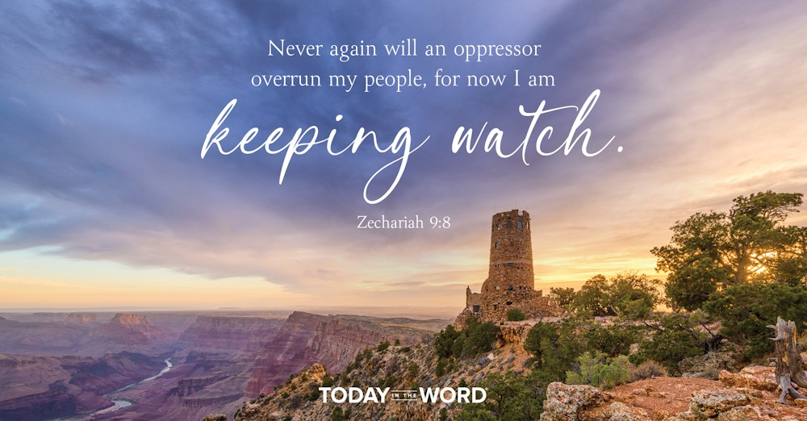

Read Zechariah 9:1–8

Judgment on Israel’s Enemies
9 A prophecy:
The word of the Lord is against the land of Hadrak
and will come to rest on Damascus—
for the eyes of all people and all the tribes of Israel
are on the Lord—^{[a]}
² and on Hamath too, which borders on it,
and on Tyre and Sidon, though they are very skillful.
³ Tyre has built herself a stronghold;
she has heaped up silver like dust,
and gold like the dirt of the streets.
⁴ But the Lord will take away her possessions
and destroy her power on the sea,
and she will be consumed by fire.
⁵ Ashkelon will see it and fear;
Gaza will writhe in agony,
and Ekron too, for her hope will wither.
Gaza will lose her king
and Ashkelon will be deserted.
⁶ A mongrel people will occupy Ashdod,
and I will put an end to the pride of the Philistines.
⁷ I will take the blood from their mouths,
the forbidden food from between their teeth.
Those who are left will belong to our God
and become a clan in Judah,
and Ekron will be like the Jebusites.
⁸ But I will encamp at my temple
to guard it against marauding forces.
Never again will an oppressor overrun my people,
for now I am keeping watch.

Footnotes
- Zechariah 9:1 Or Damascus. / For the eye of the Lord is on all people, / as well as on the tribes of Israel,
Never again will an oppressor overrun my people, for now I am keeping watch.Zechariah 9:8
The author of The Lord of the Rings, J.R.R. Tolkien, coined the term “eucatastrophe” to describe a story in which what looks like evil will be victorious. In this situation things might seem bleak and hopeless. But at the last moment, evil is defeated and good triumphs, usually through an act of grace rather than by the efforts or strength of the heroes in the story.
Beginning in chapter 9, we enter a new section of Zechariah. It is more visionary and cryptic than chapters 1–8. But the overall message of the second half of the book is clear: God’s kingdom will come through His Messiah. But there will be suffering and conflict. Things will look bleak before they get better.
In Zechariah 9, God confronts Israel’s enemies. He denounces them for their pride and greed (vv. 3, 6). But even in their judgment, some of them will turn to the Lord and be incorporated into the people of God (v. 7). There is hope even for God’s enemies. God promises that He will keep watch over His people and the Temple (v. 8). This whole section likely refers to the conquest of Alexander the Great, who famously conquered Tyre, Sidon, and the Philistines but did not attack Jerusalem or its Temple. Alexander’s conquest provided a unified language and culture for the whole region, paving the way for the coming of the Lord Jesus. Alexander also serves as a contrast to another king we will read about tomorrow.
We are in a spiritual battle too. Our hope is in the Second Coming of Jesus, not in any temporary political solution. Even when things look bleak, God has promised that He will make all things new. We are called to be faithful, “while we wait for the blessed hope—the appearing of the glory of our great God and Savior, Jesus Christ” (Titus 2:13).
Go Deeper
What encouragement have you found in the overall message of the first half of the book of Zechariah? Why does the anticipation of Jesus’ Second Coming bring us comfort today?
Pray with Us
Holy God, sometimes we lose sight of Your goodness when difficult situations surround us. Remind us that You have a greater plan for us than we could ever imagine and help us keep our eyes fixed on the hope You bring.

Our Daily Bread – 10/15/25

Walking in Christ’s Light



Read: 1 John 1:5-10

Light and Darkness, Sin and Forgiveness
⁵ This is the message we have heard from him and declare to you: God is light; in him there is no darkness at all. ⁶ If we claim to have fellowship with him and yet walk in the darkness, we lie and do not live out the truth. ⁷ But if we walk in the light, as he is in the light, we have fellowship with one another, and the blood of Jesus, his Son, purifies us from all^{[a]} sin.
⁸ If we claim to be without sin, we deceive ourselves and the truth is not in us. ⁹ If we confess our sins, he is faithful and just and will forgive us our sins and purify us from all unrighteousness. ¹⁰ If we claim we have not sinned, we make him out to be a liar and his word is not in us.

Footnotes
- 1 John 1:7 Or every
If we claim to have fellowship with him and yet walk in the darkness, we lie and do not live out the truth. 1 John 1:6

Today's Devotional
When my two nieces were younger, they’d coax me into a game after dinner. They’d turn off all the lights in the house, and we’d shuffle through the darkness, clutching each other and laughing. They enjoyed scaring themselves by choosing to walk in the dark, knowing they could turn on the light anytime.
In his letter to the early believers in Jesus, the apostle John talked about choosing to walk in a different kind of darkness. First John 1:6 refers to sin as “darkness.” Walking in darkness isn’t a momentary lapse but a choice to keep engaging in wrongdoing. John reminds us that our holy God “is light” and “in him there is no darkness” (v. 5). So when we claim a relationship with Him yet willfully continue sinning, “we lie and do not live out the truth” (v. 6). Jesus, the light of the world, came so that “whoever follows [Him] will never walk in darkness, but will have the light of life” (John 8:12).
By God’s grace, after we’ve wandered in spiritual darkness and we turn to Him in repentance, we can walk in His light again—in His ways and purposes. He will “forgive us our sins and purify us from all unrighteousness” (1 John 1:9). Only when we live in obedience to God can we enjoy the full blessing of relationship with Him and with other believers (v. 7).

Reflect & Pray
When have you chosen to “walk in the darkness”? How did this choice impact your relationship with God and with other believers?
Thank You, God, for Your forgiveness and help. Please enable me to walk in Your light.
For further study, watch The Scenery of Forgiveness.

Today's Insights
The prologue to the letter of 1 John (1:1-4) echoes the introduction to the gospel he’d written earlier (John 1:1-18). In the gospel of John, the apostle says, “In the beginning was the Word, and the Word was with God, and the Word was God” (1:1). The letter of 1 John begins, “That which was from the beginning . . .” (1:1). John’s gospel says of Jesus, “In him was life, and that life was the light of all mankind” (1:4). His letter says, “The life [Jesus] appeared” (1:2). The parallels continue as the gospel of John calls Christ “the true light” (1:9) and 1 John says, “God is light” (1:5). John then encourages us to “walk in the light, as he is in the light” (v. 7). Bringing our sin to the light of confession brings us forgiveness through the blood of Jesus (vv. 7, 9).

God Calling – 10/15/25

Feel Plenty
Live in My Secret Place and there the feeling is one of full satisfaction. You are to feel plenty. The storehouses of God are full to overflowing, but you must see this in your mind.
Be sure of this before you can realize it in material form.
Think thoughts of plenty. See yourselves as Daughters of a King. I have told you this. Wish plenty for yourselves, and all you care for and long to help.
For every beast of the forest is mine, and the cattle upon a thousand hills ... If I were hungry, I would not tell thee: for the world is mine, and the fullness thereof. Psalm 50:10,12

My Utmost for His Highest – 10/16/25

The Key to the Master’s Orders


Pray the Lord of the harvest to send out laborers into His harvest. —Matthew 9:38
The key to the missionary’s difficult task is in the hand of God, and that key is prayer, not work— that is, not work as the word is commonly used today, which often results in the shifting of our focus away from God. The key to the missionary’s difficult task is also not the key of common sense, nor is it the key of medicine, civilization, education, or even evangelization. The key is in following the Master’s orders— the key is prayer. “Pray the Lord of the harvest….” In the natural realm, prayer is not practical but absurd. We have to realize that prayer is foolish from the commonsense point of view.
From Jesus Christ’s perspective, there are no nations, but only the world. How many of us pray without regard to the persons, but with regard to only one Person— Jesus Christ? He owns the harvest that is produced through distress and through conviction of sin. This is the harvest for which we have to pray that laborers be sent out to reap. We stay busy at work, while people all around us are ripe and ready to be harvested; we do not reap even one of them, but simply waste our Lord’s time in over-energized activities and programs. Suppose a crisis were to come into your father’s or your brother’s life— are you there as a laborer to reap the harvest for Jesus Christ? Is your response, “Oh, but I have a special work to do!” No Christian has a special work to do. A Christian is called to be Jesus Christ’s own, “a servant [who] is not greater than his master” (John 13:16), and someone who does not dictate to Jesus Christ what he intends to do. Our Lord calls us to no special work— He calls us to Himself. “Pray the Lord of the harvest,” and He will engineer your circumstances to send you out as His laborer.
Wisdom From Oswald Chambers
Am I learning how to use my Bible? The way to become complete for the Master’s service is to be well soaked in the Bible; some of us only exploit certain passages. Our Lord wants to give us continuous instruction out of His word; continuous instruction turns hearers into disciples. Approved Unto God, 11 L

CCEL – 10/16/25
Not slothful in business; fervent in spirit; serving the Lord.—ROM. 12:11.
Whatsoever thy hand findeth to do, do it with thy might; for there is no work, nor device, nor knowledge, nor wisdom, in the grave, whither thou goest.—Whatsoever ye do, do it heartily, as to the Lord, and not unto men; knowing that of the Lord ye shall receive the reward of the inheritance: for ye serve the Lord Christ.—Whatsoever good thing any man doeth, the same shall he receive of the Lord.
I must work the works of him that sent me, while it is day: the night cometh, when no man can work.—Wist ye not that I must be about my Father's business?—The zeal of thine house hath eaten me up.
Brethren, give diligence to make your calling and election sure: for if ye do these things, ye shall never fall.—We desire that every one of you do shew the same diligence to the full assurance of hope unto the end; that ye be not slothful, but followers of them who through faith and perseverence inherit the promises.—So run, that ye may obtain.
Eccl. 9:10. -Col. 3:23,24. -Eph. 6:8.John 9:4. -Luke 2:49. -John 2:17.II Pet. 1:10. -Heb. 6:11,12. -I Cor. 9:24.
“Jesus saith unto them, Come and dine.” John 21:12
In these words the believer is invited to a holy nearness to Jesus. “Come and dine,” implies the same table, the same meat; aye, and sometimes it means to sit side by side, and lean our head upon the Saviour’s bosom. It is being brought into the banqueting-house, where waves the banner of redeeming love. “Come and dine,” gives us a vision of union with Jesus, because the only food that we can feast upon when we dine with Jesus is himself. Oh, what union is this! It is a depth which reason cannot fathom, that we thus feed upon Jesus. “He that eateth my flesh, and drinketh my blood, dwelleth in me, and I in him.” It is also an invitation to enjoy fellowship with the saints. Christians may differ on a variety of points, but they have all one spiritual appetite; and if we cannot all feel alike, we can all feed alike on the bread of life sent down from heaven. At the table of fellowship with Jesus we are one bread and one cup. As the loving cup goes round we pledge one another heartily therein. Get nearer to Jesus, and you will find yourself linked more and more in spirit to all who are like yourself, supported by the same heavenly manna. If we were more near to Jesus we should be more near to one another. We likewise see in these words the source of strength for every Christian. To look at Christ is to live, but for strength to serve him you must “come and dine.” We labour under much unnecessary weakness on account of neglecting this precept of the Master. We none of us need to put ourselves on low diet; on the contrary, we should fatten on the marrow and fatness of the gospel that we may accumulate strength therein, and urge every power to its full tension in the Master’s service. Thus, then, if you would realize nearness to Jesus, union with Jesus, love to his people and strength from Jesus, “come and dine” with him by faith.

Word Live – 10/16/25

https://content.scriptureunion.org.uk/wordlive/

Scripture Union – 10/16/25
https://scriptureunion.org/encounters/

Today in the Word – 10/16/25

A Humble King
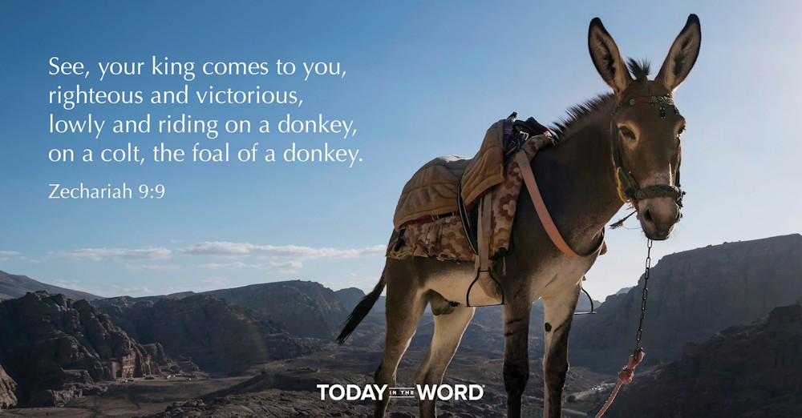

Read Zechariah 9:9–17

The Coming of Zion’s King
⁹ Rejoice greatly, Daughter Zion!
Shout, Daughter Jerusalem!
See, your king comes to you,
righteous and victorious,
lowly and riding on a donkey,
on a colt, the foal of a donkey.
¹⁰ I will take away the chariots from Ephraim
and the warhorses from Jerusalem,
and the battle bow will be broken.
He will proclaim peace to the nations.
His rule will extend from sea to sea
and from the River^{[a]} to the ends of the earth.
¹¹ As for you, because of the blood of my covenant with you,
I will free your prisoners from the waterless pit.
¹² Return to your fortress, you prisoners of hope;
even now I announce that I will restore twice as much to you.
¹³ I will bend Judah as I bend my bow
and fill it with Ephraim.
I will rouse your sons, Zion,
against your sons, Greece,
and make you like a warrior’s sword.

The Lord Will Appear
¹⁴ Then the Lord will appear over them;
his arrow will flash like lightning.
The Sovereign Lord will sound the trumpet;
he will march in the storms of the south,
¹⁵ and the Lord Almighty will shield them.
They will destroy
and overcome with slingstones.
They will drink and roar as with wine;
they will be full like a bowl
used for sprinkling^{[b]} the corners of the altar.
¹⁶ The Lord their God will save his people on that day
as a shepherd saves his flock.
They will sparkle in his land
like jewels in a crown.
¹⁷ How attractive and beautiful they will be!
Grain will make the young men thrive,
and new wine the young women.

Footnotes
- Zechariah 9:10 That is, the Euphrates
- Zechariah 9:15 Or bowl, / like
See, your king comes to you, righteous and victorious, lowly and riding on a donkey, on a colt, the foal of a donkey.
Ancient rabbis noticed that there are two very different pictures of the Messiah in the Old Testament. Some passages speak of a conquering military hero to bring in an everlasting kingdom (e.g., Dan. 7:13–14). Others depict a humble and suffering Messiah (e.g., Isa. 53:3–5; Zech. 9:9). To explain this seeming contradiction, some rabbis taught that if Israel was worthy, the Messiah would come with the clouds in heaven victoriously. But if Israel was unworthy, He would come lowly and riding upon a donkey.
Both pictures of the Messiah are true. In His first coming, Jesus came humbly as a suffering servant. In His second coming, the Lord Jesus will arrive victoriously to set up His eternal kingdom. Zechariah’s prophecy includes elements of both Jesus’ first and second coming.
Many world rulers in history have been known as oppressive tyrants. But Zechariah describes the Messiah in quite different terms. He is described as “lowly and riding on a donkey” (9:9). This prophecy was fulfilled on Palm Sunday (Matt. 21:5). This humble Messiah would usher in true peace among the nations and rule over all the earth (v. 10). “Peace” refers not just to the absence of conflict, but to a state of well-being and wholeness. The Messiah would bring in the kind of world that God originally intended for humanity. At this time, all of God’s promises to Israel would be fulfilled (vv. 14–17).
Zechariah’s words remind us that our ultimate hope is secure in the coming of the Lord Jesus. This has already been partially fulfilled by His first coming, so we can be confident that He will keep His promise to return (Rev. 22:12).
Go Deeper
What can we learn from the humble arrival of Jesus? How can we follow His example of humility? “For even the Son of Man did not come to be served, but to serve, and to give his life as a ransom for so many” (Mark 10:45).
Pray with Us
Thank You, Lord, for sending Your Son to bring restoration. We anticipate Your future coming when You will bring us peace. Thank You for your enduring promises!

Our Daily Bread – 10/16/25

Pursued by God


Read: Psalms 119:169-176

ת Taw
¹⁶⁹ May my cry come before you, Lord;
give me understanding according to your word.
¹⁷⁰ May my supplication come before you;
deliver me according to your promise.
¹⁷¹ May my lips overflow with praise,
for you teach me your decrees.
¹⁷² May my tongue sing of your word,
for all your commands are righteous.
¹⁷³ May your hand be ready to help me,
for I have chosen your precepts.
¹⁷⁴ I long for your salvation, Lord,
and your law gives me delight.
¹⁷⁵ Let me live that I may praise you,
and may your laws sustain me.
¹⁷⁶ I have strayed like a lost sheep.
Seek your servant,
for I have not forgotten your commands.
I have strayed like a lost sheep. Seek your servant, for I have not forgotten your commands. Psalm 119:176

Today's Devotional
David Uttal is a cognitive scientist who studies navigation but has problems navigating his way around geographic locations. This isn’t a new problem for him—one that goes back to when he was thirteen years old and got lost for two and a half days on a hike. Uttal admits he’s still terrible with simple directions in life. But some people are natural navigators—knowing exactly where they are and how to get where they desire to go. Others, like Uttal, struggle even with clear directions and often get lost.
The psalmist also felt the disorientation of lostness: “I have strayed like a lost sheep. Seek your servant, for I have not forgotten your commands” (Psalm 119:176). He compared himself to a wandering sheep. Although sheep can be valuable creatures, they’re also notoriously rebellious and will sometimes drift away from their shepherd—putting them in need of rescue. The psalmist’s spiritual navigation skills had deteriorated, and his spiritual sense of direction had faded, so he needed God to pursue him and give him a “discerning mind” (v. 169 nlt).
When we wander away from God’s care, He loves us enough to seek us and lead us back to Himself. As He helps us understand the Scriptures and follow “all [His] commands” (v. 172), we can avoid getting spiritually lost.

Reflect & Pray
In what ways have you drifted away from God and His wisdom? In what ways will you remember His instruction today?
Gracious God, I recognize that I’m often like a lost sheep—easily distracted and led astray. Please bring me back to Your side.
For further study, read Learning the Rhythms of Freedom.

Today's Insights
The Bible is God’s gift to enable us to live a life that honors Him (Deuteronomy 4:1-8; 2 Timothy 3:14-17). Psalm 119 is the psalmist’s unwavering commitment to live out its truths. The psalm begins with a declaration that “those who keep his statutes and seek him with all their heart” are blessed (v. 2). Throughout the psalm, the psalmist spells out these blessings. Its 176 verses (arranged in 22 stanzas of 8 verses each) affirm the authority, supremacy, sufficiency, and transformative power of the words of Scripture. They provide assurance, hope, peace, joy, and delight (vv. 14, 16, 24, 97, 103, 111, 114, 165). Scripture provides wisdom and guidance to navigate life’s challenges (vv. 32, 98-100, 105) and comforts us in times of trouble (vv. 28, 50, 52, 92). It empowers us to live a life that honors God, keeping us from sin and correcting us when we go astray (vv. 9-11, 29, 133). Our loving God uses the Scriptures to draw us to Himself.

God Calling – 10/16/25

The Imprisoned God
Our Lord, we praise Thee and bless Thy Name forever.
Yes! Praise. That moment, in the most difficult place, your sorrow is turned to Joy, your fret to praise, the outward circumstances change from those of disorder to order, of chaos to calm.
The beginning of all reform must be in yourselves. However restricted your circumstances, however little you may be able to remedy financial affairs, you can always turn to yourselves, and seeing something not in order there, seek to right that.
As all reform is from within out, you will always find the outward has improved too. To do this is to release the imprisoned God-Power within you.
That Power, once operative, will immediately perform miracles. Then indeed shall your mourning be turned into Joy.
Fret not thyself because of evildoers ... Trust in the Lord, and do good ... Delight thyself also in the Lord; and he shall give thee the desires of thine heart. Psalm 37:1-4

My Utmost for His Highest – 10/17/25

The Key of the Greater Work


…I say to you, he who believes in Me,…greater works than these he will do, because I go to My Father. —John 14:12
Prayer does not equip us for greater works— prayer is the greater work. Yet we think of prayer as some commonsense exercise of our higher powers that simply prepares us for God’s work. In the teachings of Jesus Christ, prayer is the working of the miracle of redemption in me, which produces the miracle of redemption in others, through the power of God. The way fruit remains firm is through prayer, but remember that it is prayer based on the agony of Christ in redemption, not on my own agony. We must go to God as His child, because only a child gets his prayers answered; a “wise” man does not (see Matthew 11:25).
Prayer is the battle, and it makes no difference where you are. However God may engineer your circumstances, your duty is to pray. Never allow yourself this thought, “I am of no use where I am,” because you certainly cannot be used where you have not yet been placed. Wherever God has placed you and whatever your circumstances, you should pray, continually offering up prayers to Him. And He promises, “Whatever you ask in My name, that I will do…” (John 14:13). Yet we refuse to pray unless it thrills or excites us, which is the most intense form of spiritual selfishness. We must learn to work according to God’s direction, and He says to pray. “Pray the Lord of the harvest to send out laborers into His harvest” (Matthew 9:38).
There is nothing thrilling about a laboring person’s work, but it is the laboring person who makes the ideas of the genius possible. And it is the laboring saint who makes the ideas of his Master possible. When you labor at prayer, from God’s perspective there are always results. What an astonishment it will be to see, once the veil is finally lifted, all the souls that have been reaped by you, simply because you have been in the habit of taking your orders from Jesus Christ.
Wisdom From Oswald Chambers
When we no longer seek God for His blessings, we have time to seek Him for Himself. The Moral Foundations of Life, 728 L

CCEL – 10/17/25
In thy name shall they rejoice all the day; and in thy righteousness shall they be exalted.—PSA. 89:16.
In the Lord have I righteousness and strength: even to him shall men come; and all that are incensed against him shall be ashamed. In the Lord shall all the seed of Israel be justified, and shall glory.—Be glad in the Lord, and rejoice, ye righteous: and shout for joy, all ye that are upright in heart.
The righteousness of God without the law is manifested, being witnessed by the law and the prophets; even the righteousness of God which is by faith of Jesus Christ unto all and upon all them that believe. To declare . . . at this time his righteousness: that he might be just, and the justifier of him which believeth in Jesus.
Rejoice in the Lord alway: and again I say, Rejoice.—Whom having not seen, ye love; in whom, though now ye see him not, yet believing, ye rejoice with joy unspeakable and full of glory.
Isa. 45:24,25. -Psa. 32:11.Rom. 3:21,22,26.Phi. 4:4. -I Pet. 1:8.
“And David said in his heart, I shall now perish one day by the hand of Saul.” 1 Samuel 27:1
The thought of David’s heart at this time was a false thought, because he certainly had no ground for thinking that God’s anointing him by Samuel was intended to be left as an empty unmeaning act. On no one occasion had the Lord deserted his servant; he had been placed in perilous positions very often, but not one instance had occurred in which divine interposition had not delivered him. The trials to which he had been exposed had been varied; they had not assumed one form only, but many—yet in every case he who sent the trial had also graciously ordained a way of escape. David could not put his finger upon any entry in his diary, and say of it, “Here is evidence that the Lord will forsake me,” for the entire tenor of his past life proved the very reverse. He should have argued from what God had done for him, that God would be his defender still. But is it not just in the same way that we doubt God’s help? Is it not mistrust without a cause? Have we ever had the shadow of a reason to doubt our Father’s goodness? Have not his lovingkindnesses been marvellous? Has he once failed to justify our trust? Ah, no! our God has not left us at any time. We have had dark nights, but the star of love has shone forth amid the blackness; we have been in stern conflicts, but over our head he has held aloft the shield of our defence. We have gone through many trials, but never to our detriment, always to our advantage; and the conclusion from our past experience is, that he who has been with us in six troubles, will not forsake us in the seventh. What we have known of our faithful God, proves that he will keep us to the end. Let us not, then, reason contrary to evidence. How can we ever be so ungenerous as to doubt our God? Lord, throw down the Jezebel of our unbelief, and let the dogs devour it.

Word Live – 10/17/25

https://content.scriptureunion.org.uk/wordlive/

Scripture Union – 10/17/25
https://scriptureunion.org/encounters/

Today in the Word – 10/17/25

The Good Shepherd
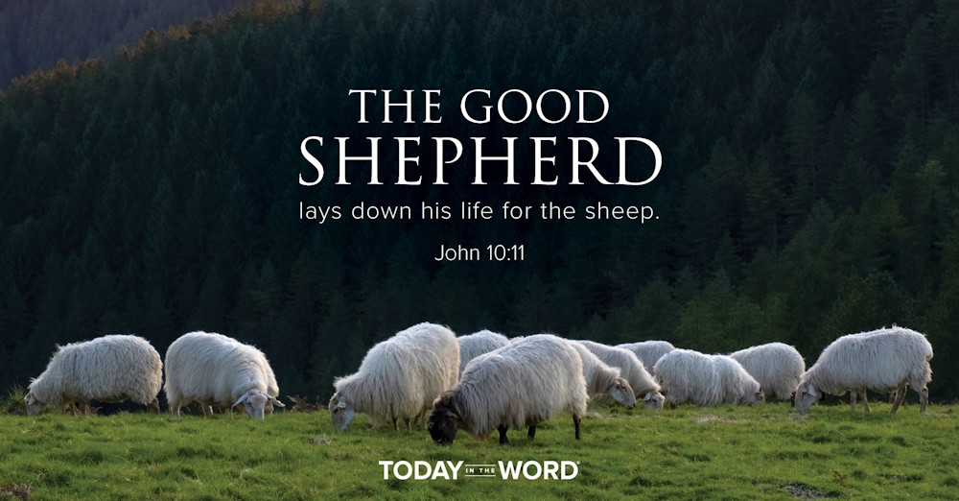

Read Zechariah 10:1–11:3

The Lord Will Care for Judah
10 Ask the Lord for rain in the springtime;
it is the Lord who sends the thunderstorms.
He gives showers of rain to all people,
and plants of the field to everyone.
² The idols speak deceitfully,
diviners see visions that lie;
they tell dreams that are false,
they give comfort in vain.
Therefore the people wander like sheep
oppressed for lack of a shepherd.
³ “My anger burns against the shepherds,
and I will punish the leaders;
for the Lord Almighty will care
for his flock, the people of Judah,
and make them like a proud horse in battle.
⁴ From Judah will come the cornerstone,
from him the tent peg,
from him the battle bow,
from him every ruler.
⁵ Together they^{[a]} will be like warriors in battle
trampling their enemy into the mud of the streets.
They will fight because the Lord is with them,
and they will put the enemy horsemen to shame.
⁶ “I will strengthen Judah
and save the tribes of Joseph.
I will restore them
because I have compassion on them.
They will be as though
I had not rejected them,
for I am the Lord their God
and I will answer them.
⁷ The Ephraimites will become like warriors,
and their hearts will be glad as with wine.
Their children will see it and be joyful;
their hearts will rejoice in the Lord.
⁸ I will signal for them
and gather them in.
Surely I will redeem them;
they will be as numerous as before.
⁹ Though I scatter them among the peoples,
yet in distant lands they will remember me.
They and their children will survive,
and they will return.
¹⁰ I will bring them back from Egypt
and gather them from Assyria.
I will bring them to Gilead and Lebanon,
and there will not be room enough for them.
¹¹ They will pass through the sea of trouble;
the surging sea will be subdued
and all the depths of the Nile will dry up.
Assyria’s pride will be brought down
and Egypt’s scepter will pass away.
¹² I will strengthen them in the Lord
and in his name they will live securely,”
declares the Lord.
11 Open your doors, Lebanon,
so that fire may devour your cedars!
² Wail, you juniper, for the cedar has fallen;
the stately trees are ruined!
Wail, oaks of Bashan;
the dense forest has been cut down!
³ Listen to the wail of the shepherds;
their rich pastures are destroyed!
Listen to the roar of the lions;
the lush thicket of the Jordan is ruined!

Footnotes
- Zechariah 10:5 Or ruler, all of them together. / ⁵ They
The good shepherd lays down his life for the sheep.John 10:11
Our experiences in life are deeply shaped by the leaders under whom we serve. Jesus was concerned about the type of leaders His disciples would become. “You know that the rulers of the Gentiles lord it over them, and their high officials exercise authority over them. Not so with you. Instead, whoever wants to become great among you must be your servant” (Matt. 20:25–26).
For much of Israel’s history, they had experienced poor leadership. They were led by kings who went along with the people in their desire to worship other gods (v. 2). The Lord had choice words for them: “My anger burns against the shepherds, and I will punish the leaders” (v. 3). This is part of the reason why Israel ended up in exile.
In Zechariah 10, the prophet points to a wonderful future promised for His people. Looking forward to the millennial kingdom, God describes how He will call Israel from all corners of the earth, bring them back to the land, and dwell among them (vv. 6–12). Even more encouraging, He will be their shepherd, “For the LORD Almighty will care for his flock, the people of Judah” (v. 3). He will rule through his chosen king from the tribe of Judah (v. 4).
In Israel’s restoration to the land, it will be as if their sin and rebellion never happened. We can give thanks that we worship a God who redeems and restores sinners! “God made him who had no sin to be sin for us, so that in him we might become the righteousness of God” (2 Cor. 5:21). Not only has God made it possible for us to be redeemed from our sin, but He has provided for us a true and perfect leader to trust and follow (John 10:11).
Go Deeper
Think of individuals who had led in your life? Which qualities did you admire? What qualities diminished their leadership? What type of leader is God calling you to be?
Pray with Us
Loving Father, we praise You for caring for us as Your children. You are the Good Shepherd and our ultimate example of leadership. Help us follow in Your steps.

Our Daily Bread – 10/17/25

God’s Way Is Love



Read: Romans 12:9-16

Love in Action
⁹ Love must be sincere. Hate what is evil; cling to what is good. ¹⁰ Be devoted to one another in love. Honor one another above yourselves. ¹¹ Never be lacking in zeal, but keep your spiritual fervor, serving the Lord. ¹² Be joyful in hope, patient in affliction, faithful in prayer. ¹³ Share with the Lord’s people who are in need. Practice hospitality.
¹⁴ Bless those who persecute you; bless and do not curse. ¹⁵ Rejoice with those who rejoice; mourn with those who mourn. ¹⁶ Live in harmony with one another. Do not be proud, but be willing to associate with people of low position.^{[a]} Do not be conceited.

Footnotes
- Romans 12:16 Or willing to do menial work
Share with the Lord’s people who are in need. Romans 12:13

Today's Devotional
With extra time on my hands, my plan for the coming months centered on serving people as much as I could. But while helping a new friend, I tripped and fell and broke my arm in three places. Suddenly I was the one in need. God’s people cared for me with visits, gift cards, flowers, phone calls, texts, prayers, meals (and even a box of chocolates), and by running errands. I couldn’t believe how kind my family, friends, and fellow church members were! It was as if God were saying, “Sit down. You need help. You’ll see what caring looks like.” Because of them, I know more about serving from the heart and feeling grateful to God for others.
Fellow believers eagerly helped me in the ways Paul instructed the church members living in Rome to follow (Romans 12). He encouraged them in many ways, including to love sincerely, to be devoted to one another in love, to honor others, and to share with those in need (vv. 9-13). Paul taught them doctrine throughout his letter. But he also shared that life in Christ isn’t abstract theology—it’s shown in our practical daily living (chs. 12-16). God’s way is love. Receiving and then pouring out His love on others is one of many ways to express His love for us.
As we look for and find everyday ways to serve people in our churches or communities, they’ll be encouraged, we’ll be blessed, and God will be praised.

Reflect & Pray
Who needs your help this week? What will you do?
You’re kind beyond measure, God. Please help me to receive and give Your love to those around me.
For further study, read A Family Dedicated to Serving.

Today's Insights
A pattern found in several of Paul’s church letters (see Ephesians and Colossians) is that he teaches a section of doctrine followed by a section of practical application and response. In Romans, the doctrinal teaching is found in chapters 1-11, with practical response dominating chapters 12-16. The key transition point is the word therefore in 12:1: “Therefore, I urge you, brothers and sisters, in view of God’s mercy, to offer your bodies as a living sacrifice, holy and pleasing to God—this is your true and proper worship.” Paul is saying that because of the love and grace God has demonstrated for us as described in chapters 1-11, we can have the heart response described in chapters 12-16. As one pastor said, “What we believe must influence and impact how we behave as God’s ambassadors.” God’s love for us enables us to pour out His love on others.

God Calling – 10/17/25

Faith-Vision
Turn your eyes to behold Me. Look away from sordid surroundings, from lack of beauty, from the imperfections in yourselves and those around you. Then you who have the Faith-Vision will see all you could and do desire in Me.
In your unrest behold My calm, My rest. In your impatience, My unfailing patience. In your lack and limitations, My Perfection.
Looking at Me you will grow like Me, until men say to you, too, that you have been with Jesus.
As you grow like Me you will be enabled to do the things I do, and greater works than these shall ye do because I go unto My Father.
From that place of abiding, limited by none of humanity's limitations, I can endue you with the all-conquering, all miracle working Power of your Divine Brother and Ally.
Looking unto Jesus ... who for the joy that was set before him endured the cross ... and is set down at the right hand of the throne of God. Hebrews 12:2

My Utmost for His Highest – 10/18/25

The Key to the Missionary’s Devotion


…they went forth for His name’s sake… —3 John 7
Our Lord told us how our love for Him is to exhibit itself when He asked, “Do you love Me?” (John 21:17). And then He said, “Feed My sheep.” In effect, He said, “Identify yourself with My interests in other people,” not, “Identify Me with your interests in other people.” 1 Corinthians 13:4-8 shows us the characteristics of this love— it is actually the love of God expressing itself. The true test of my love for Jesus is a very practical one, and all the rest is sentimental talk.
Faithfulness to Jesus Christ is the supernatural work of redemption that has been performed in me by the Holy Spirit— “the love of God has been poured out in our hearts by the Holy Spirit…” (Romans 5:5). And it is that love in me that effectively works through me and comes in contact with everyone I meet. I remain faithful to His name, even though the commonsense view of my life may seemingly deny that, and may appear to be declaring that He has no more power than the morning mist.
The key to the missionary’s devotion is that he is attached to nothing and to no one except our Lord Himself. It does not mean simply being detached from the external things surrounding us. Our Lord was amazingly in touch with the ordinary things of life, but He had an inner detachment except toward God. External detachment is often an actual indication of a secret, growing, inner attachment to the things we stay away from externally.
The duty of a faithful missionary is to concentrate on keeping his soul completely and continually open to the nature of the Lord Jesus Christ. The men and women our Lord sends out on His endeavors are ordinary human people, but people who are controlled by their devotion to Him, which has been brought about through the work of the Holy Spirit.
Wisdom From Oswald Chambers
Much of the misery in our Christian life comes not because the devil tackles us, but because we have never understood the simple laws of our make-up. We have to treat the body as the servant of Jesus Christ: when the body says “Sit,” and He says “Go,” go! When the body says “Eat,” and He says “Fast,” fast! When the body says “Yawn,” and He says “Pray,” pray! Biblical Ethics, 107 R

CCEL – 10/18/25
One of the soldiers with a spear pierced his side, and forthwith came there out blood and water.—JOHN 19:34.
Behold the blood of the covenant, which the Lord hath made with you.—The life of the flesh is in the blood: and I have given it to you upon the altar to make an atonement for your souls.—It is not possible that the blood of bulls and of goats should take away sins.
Jesus said unto them, This is my blood of the new testament, which is shed for many.—By his own blood he entered in once into the holy place, having obtained eternal redemption for us.—Peace through the blood of his cross.
Ye know that ye were not redeemed with corruptible things, as silver and gold, . . . but with the precious blood of Christ, as of a lamb without blemish and without spot, . . . manifest in these last times for you.
Then will I sprinkle clean water upon you and ye shall be clean: . . . from all your idols, will I cleanse you.—Let us draw near with a true heart in full assurance of faith, having our hearts sprinkled from an evil conscience.
Exo. 24:8. -Lev. 17:11. -Heb. 10:4.Mark 14:24. -Heb. 9:12. -Col. 1:20.I Pet. 1:18-20.Ezek. 36:25. -Heb. 10:22.
“Thy paths drop fatness.” Psalm 65:11
Many are “the paths of the Lord” which “drop fatness,” but an especial one is the path of prayer. No believer, who is much in the closet, will have need to cry, “My leanness, my leanness; woe unto me.” Starving souls live at a distance from the mercy- seat, and become like the parched fields in times of drought. Prevalence with God in wrestling prayer is sure to make the believer strong—if not happy. The nearest place to the gate of heaven is the throne of the heavenly grace. Much alone, and you will have much assurance; little alone with Jesus, your religion will be shallow, polluted with many doubts and fears, and not sparkling with the joy of the Lord. Since the soul-enriching path of prayer is open to the very weakest saint; since no high attainments are required; since you are not bidden to come because you are an advanced saint, but freely invited if you be a saint at all; see to it, dear reader, that you are often in the way of private devotion. Be much on your knees, for so Elijah drew the rain upon famished Israel’s fields.
There is another especial path dropping with fatness to those who walk therein, it is the secret walk of communion. Oh! the delights of fellowship with Jesus! Earth hath no words which can set forth the holy calm of a soul leaning on Jesus’ bosom. Few Christians understand it, they live in the lowlands and seldom climb to the top of Nebo: they live in the outer court, they enter not the holy place, they take not up the privilege of priesthood. At a distance they see the sacrifice, but they sit not down with the priest to eat thereof, and to enjoy the fat of the burnt offering. But, reader, sit thou ever under the shadow of Jesus; come up to that palm tree, and take hold of the branches thereof; let thy beloved be unto thee as the apple-tree among the trees of the wood, and thou shalt be satisfied as with marrow and fatness. O Jesus, visit us with thy salvation!

Word Live – 10/18/25

https://content.scriptureunion.org.uk/wordlive/

Scripture Union – 10/18/25
https://scriptureunion.org/encounters/

Today in the Word – 10/18/25

Two Shepherds
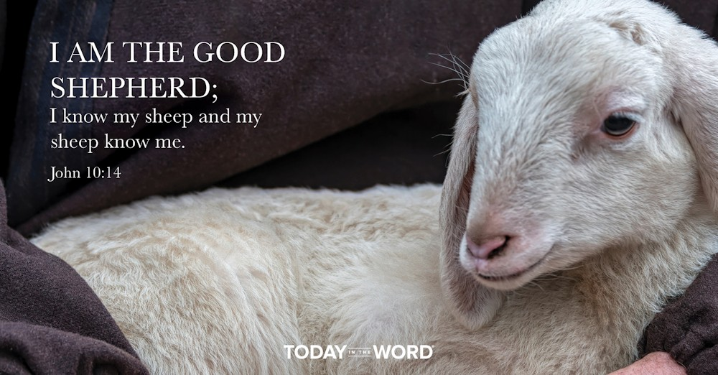

Read Zechariah 11:4–17

Two Shepherds
⁴ This is what the Lord my God says: “Shepherd the flock marked for slaughter. ⁵ Their buyers slaughter them and go unpunished. Those who sell them say, ‘Praise the Lord, I am rich!’ Their own shepherds do not spare them. ⁶ For I will no longer have pity on the people of the land,” declares the Lord. “I will give everyone into the hands of their neighbors and their king. They will devastate the land, and I will not rescue anyone from their hands.”
⁷ So I shepherded the flock marked for slaughter, particularly the oppressed of the flock. Then I took two staffs and called one Favor and the other Union, and I shepherded the flock. ⁸ In one month I got rid of the three shepherds.
The flock detested me, and I grew weary of them ⁹ and said, “I will not be your shepherd. Let the dying die, and the perishing perish. Let those who are left eat one another’s flesh.”
¹⁰ Then I took my staff called Favor and broke it, revoking the covenant I had made with all the nations. ¹¹ It was revoked on that day, and so the oppressed of the flock who were watching me knew it was the word of the Lord.
¹² I told them, “If you think it best, give me my pay; but if not, keep it.” So they paid me thirty pieces of silver.
¹³ And the Lord said to me, “Throw it to the potter”—the handsome price at which they valued me! So I took the thirty pieces of silver and threw them to the potter at the house of the Lord.
¹⁴ Then I broke my second staff called Union, breaking the family bond between Judah and Israel.
¹⁵ Then the Lord said to me, “Take again the equipment of a foolish shepherd. ¹⁶ For I am going to raise up a shepherd over the land who will not care for the lost, or seek the young, or heal the injured, or feed the healthy, but will eat the meat of the choice sheep, tearing off their hooves.
¹⁷ “Woe to the worthless shepherd,
who deserts the flock!
May the sword strike his arm and his right eye!
May his arm be completely withered,
his right eye totally blinded!”
Jesus said, “I am the good shepherd; I know my sheep and my sheep know me.” John 10:14
It is not enough to simply have a good leader. We must also accept and follow that leadership. It is a two-way relationship. Even the best leader can be ineffective if people refuse to trust and embrace their direction.
In Zechariah 11, the Lord calls His prophet to role-play as two different shepherds. First, Zechariah acts as the good shepherd. In this role, he was to look after the oppressed and protect the flock (v. 7). The good shepherd role prophesies about Israel’s rejection of Jesus in His first coming. Zechariah vividly describes this rejection: “The flock detested me, and I grew weary of them and said, ‘I will not be your shepherd’” (vv. 8–9).
After rejecting the good shepherd, the people gave back pay to the shepherd of thirty pieces of silver. The Lord directed Zechariah to throw this silver to the potter, a symbolic act that points to Judas’s betrayal (Matt. 27:3–5). The rejection of Jesus would lead Israel to follow false leaders, contributing to its destruction by the Romans in AD 70.
Zechariah was then called to role play a “foolish shepherd” (v. 15). While it is debated who this shepherd can be, he could refer to a future “man of lawlessness” (2 Thess. 2:3) or an end-times anti-Messiah figure (Rev. 13:1–10). This leader will “not care for the lost, or seek the young, or heal the injured” (v. 16). This evil leader will be judged and destroyed by the Lord (v. 17).
As believers, we are called to follow the Lord’s leadership. Jesus said, “I am the good shepherd; I know my sheep and my sheep know me” (John 10:14). As we grow in our knowledge of Jesus, we will clearly recognize His voice and follow His leading.
Go Deeper
How would you rate yourself as a follower? Do you listen to your Shepherd’s voice? What are some ways you can improve your “following”?
Pray with Us
God, Your rule is perfect, and we desire to follow Your leading. Guide us into Your truth, helping us to trust in Your compassion and goodness. Incline our ears to hear Your voice.

Our Daily Bread – 10/18/25

A Prayerful Posture



Read: 2 Chronicles 20:5-12
⁵ Then Jehoshaphat stood up in the assembly of Judah and Jerusalem at the temple of the Lord in the front of the new courtyard ⁶ and said:
“Lord, the God of our ancestors, are you not the God who is in heaven? You rule over all the kingdoms of the nations. Power and might are in your hand, and no one can withstand you. ⁷ Our God, did you not drive out the inhabitants of this land before your people Israel and give it forever to the descendants of Abraham your friend? ⁸ They have lived in it and have built in it a sanctuary for your Name, saying, ⁹ ‘If calamity comes upon us, whether the sword of judgment, or plague or famine, we will stand in your presence before this temple that bears your Name and will cry out to you in our distress, and you will hear us and save us.’
¹⁰ “But now here are men from Ammon, Moab and Mount Seir, whose territory you would not allow Israel to invade when they came from Egypt; so they turned away from them and did not destroy them. ¹¹ See how they are repaying us by coming to drive us out of the possession you gave us as an inheritance. ¹² Our God, will you not judge them? For we have no power to face this vast army that is attacking us. We do not know what to do, but our eyes are on you.”
Jehoshaphat bowed down with his face to the ground . . . in worship before the Lord. 2 Chronicles 20:18

Today's Devotional
A lengthy battle with a chronic illness had taken its toll on Jimmy. Though he desired to spend time with God each morning, praying to Him and meditating on the Scriptures, he couldn’t find a way to position his body in his chair that wasn’t painful. He shifted from side to side, but there was no relief. Finally, in desperation, he fell to his knees. As he did, that prayerful posture proved to lessen the agonizing ache. In the mornings that followed, Jimmy spent time with God on his knees—experiencing comfort even as he called out to Him in prayer.
Jehoshaphat, king of Judah, also faced a battle—not with pain but with threatening enemies (2 Chronicles 20:1-2). The king was “terrified by this news and begged the Lord for guidance” (v. 3 nlt). All the people of Judah sought “help from the Lord” as well (v. 4). God heard their prayers, and His Spirit came upon a Levite named Jahaziel, who delivered this comforting message to the king: “Do not be afraid or discouraged . . . . The Lord will be with you” (vv. 15, 17). Jehoshaphat “bowed down with his face to the ground,” and everyone “fell down in worship before the Lord” (v. 18).
In painful and challenging times, we can often experience God’s nearness in a powerful way. As He helps us submit to His will and live out a prayerful posture in our hearts, we can find comfort and peace in Him.

Reflect & Pray
How has God comforted you as you prayed to Him? What painful thing will you bring to Him today?
Loving God, thank You for meeting and comforting me as I pray to You.
For further study, read Compassion: Learning to Love Like Jesus.

Today's Insights
Jehoshaphat is one of Judah’s more intriguing kings. The kingdoms of Judah and Israel had parted ways barely six decades earlier, yet Jehoshaphat foolishly agreed to go into battle allied with Israel’s idol-worshiping King Ahab (2 Chronicles 18:3). Their combined forces were routed, and Ahab was killed (vv. 33-34). Despite that episode, Jehoshaphat followed God throughout most of his reign. As a large foe amassed against the people of Judah (20:1-3), Jehoshaphat instinctively sought God. Praying before all the people, he recalled God’s promise to their father Abraham (vv. 5-9). Desperate though he was, Jehoshaphat knew God could be trusted. In our trials, we too can find comfort when we seek God in prayer.

God Calling – 10/18/25

Loneliness
And they all forsook him, and fled. -- Mark 14:50.
Down through the ages all the simple acts of steadfast devotion, of obedience in difficulty, of loving service, have been taken by Me as an atonement for the loneliness My humanity suffered by that desertion.
Yet I, who had realized to the full the longing of the Father to save, and His rejection by men, the misunderstanding of His mind and purpose, how could I think that I should not know that desertion too?
Learn, My children, from these words two lessons. Learn first that I know what loneliness, desertion, and solitude mean. Learn that every act of yours of faithfulness is a comfort to My Heart. Learn too that it was to those deserters I gave the task of bringing My Message to mankind. To those deserters, those fearful ones, I gave My Power to heal, to raise to life.
Earth's successes are not the ones I use for the great work of My Kingdom. "They all forsook Him and fled." Learn My tender understanding and pardon of human frailty. Not until man has failed has he learnt true humility. And it is only the humble who can inherit the earth.
Then said Jesus, "Father, forgive them; for they know not what they do." Luke 23:34h

My Utmost for His Highest – 10/19/25

The Unheeded Secret

Jesus answered, "My kingdom is not of this world." —John 18:36
The great enemy of the Lord Jesus Christ today is the idea of practical work that has no basis in the New Testament but comes from the systems of the world. This work insists upon endless energy and activities, but no private life with God. The emphasis is put on the wrong thing. Jesus said, “The kingdom of God does not come with observation….For indeed, the kingdom of God is within you” (Luke 17:20-21). It is a hidden, obscure thing. An active Christian worker too often lives to be seen by others, while it is the innermost, personal area that reveals the power of a person’s life.
We must get rid of the plague of the spirit of this religious age in which we live. In our Lord’s life there was none of the pressure and the rushing of tremendous activity that we regard so highly today, and a disciple is to be like His Master. The central point of the kingdom of Jesus Christ is a personal relationship with Him, not public usefulness to others.
It is not the practical activities that are the strength of this Bible Training College— its entire strength lies in the fact that here you are immersed in the truths of God to soak in them before Him. You have no idea of where or how God is going to engineer your future circumstances, and no knowledge of what stress and strain is going to be placed on you either at home or abroad. And if you waste your time in overactivity, instead of being immersed in the great fundamental truths of God’s redemption, then you will snap when the stress and strain do come. But if this time of soaking before God is being spent in getting rooted and grounded in Him, which may appear to be impractical, then you will remain true to Him whatever happens.
Wisdom From Oswald Chambers
An intellectual conception of God may be found in a bad vicious character. The knowledge and vision of God is dependent entirely on a pure heart. Character determines the revelation of God to the individual. The pure in heart see God. Biblical Ethics, 125 R

CCEL – 10/19/25
The Lord shall be thy confidence, and shall keep thy foot from being taken.—PROV. 3:26.
Surely the wrath of man shall praise thee: the remainder of wrath shalt thou restrain.—The king's heart is in the hand of the Lord, as the rivers of water: he turneth it whithersoever he will.—When a man's ways please the Lord, he maketh even his enemies to be at peace with him.
I wait for the Lord, my soul doth wait, and in his word do I hope. My soul waiteth for the Lord more than they that wait for the morning: I say, more than they that watch for the morning.—I sought the Lord, and he heard me, and delivered me from all my fears.
The eternal God is thy refuge, and underneath are the everlasting arms: and he shall thrust out the enemy from before thee; and shall say, Destroy them.—Blessed is the man that trusteth in the Lord, and whose hope the Lord is.
What shall we then say to these things? If God be for us, who can be against us?
Psa. 76:10. -Prov. 21:1. -Prov. 16:7.Psa. 130:5,6. -Psa. 34:4.Deut. 33:27. -Jer. 17:7.Rom. 8:31.
“Babes in Christ.” 1 Corinthians 3:1
Are you mourning, believer, because you are so weak in the divine life: because your faith is so little, your love so feeble? Cheer up, for you have cause for gratitude. Remember that in some things you are equal to the greatest and most full-grown Christian. You are as much bought with blood as he is. You are as much an adopted child of God as any other believer. An infant is as truly a child of its parents as is the full-grown man. You are as completely justified, for your justification is not a thing of degrees: your little faith has made you clean every whit. You have as much right to the precious things of the covenant as the most advanced believers, for your right to covenant mercies lies not in your growth, but in the covenant itself; and your faith in Jesus is not the measure, but the token of your inheritance in him. You are as rich as the richest, if not in enjoyment, yet in real possession. The smallest star that gleams is set in heaven; the faintest ray of light has affinity with the great orb of day. In the family register of glory the small and the great are written with the same pen. You are as dear to your Father’s heart as the greatest in the family. Jesus is very tender over you. You are like the smoking flax; a rougher spirit would say, “put out that smoking flax, it fills the room with an offensive odour!” but the smoking flax he will not quench. You are like a bruised reed; and any less tender hand than that of the Chief Musician would tread upon you or throw you away, but he will never break the bruised reed. Instead of being downcast by reason of what you are, you should triumph in Christ. Am I but little in Israel? Yet in Christ I am made to sit in heavenly places. Am I poor in faith? Still in Jesus I am heir of all things. Though “less than nothing I can boast, and vanity confess.” Yet, if the root of the matter be in me I will rejoice in the Lord, and glory in the God of my salvation.

Word Live – 10/19/25

https://content.scriptureunion.org.uk/wordlive/

Scripture Union – 10/19/25
https://scriptureunion.org/encounters/

Today in the Word – 10/19/25

Looking to Jesus
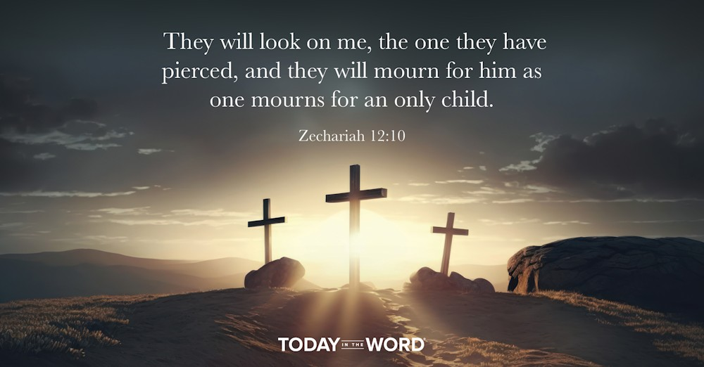

Read Zechariah 12:1–14

Jerusalem’s Enemies to Be Destroyed
12 A prophecy: The word of the Lord concerning Israel.
The Lord, who stretches out the heavens, who lays the foundation of the earth, and who forms the human spirit within a person, declares: ² “I am going to make Jerusalem a cup that sends all the surrounding peoples reeling. Judah will be besieged as well as Jerusalem. ³ On that day, when all the nations of the earth are gathered against her, I will make Jerusalem an immovable rock for all the nations. All who try to move it will injure themselves. ⁴ On that day I will strike every horse with panic and its rider with madness,” declares the Lord. “I will keep a watchful eye over Judah, but I will blind all the horses of the nations. ⁵ Then the clans of Judah will say in their hearts, ‘The people of Jerusalem are strong, because the Lord Almighty is their God.’
⁶ “On that day I will make the clans of Judah like a firepot in a woodpile, like a flaming torch among sheaves. They will consume all the surrounding peoples right and left, but Jerusalem will remain intact in her place.
⁷ “The Lord will save the dwellings of Judah first, so that the honor of the house of David and of Jerusalem’s inhabitants may not be greater than that of Judah. ⁸ On that day the Lord will shield those who live in Jerusalem, so that the feeblest among them will be like David, and the house of David will be like God, like the angel of the Lord going before them. ⁹ On that day I will set out to destroy all the nations that attack Jerusalem.

Mourning for the One They Pierced
¹⁰ “And I will pour out on the house of David and the inhabitants of Jerusalem a spirit^{[a]} of grace and supplication. They will look on^{[b]} me, the one they have pierced, and they will mourn for him as one mourns for an only child, and grieve bitterly for him as one grieves for a firstborn son. ¹¹ On that day the weeping in Jerusalem will be as great as the weeping of Hadad Rimmon in the plain of Megiddo. ¹² The land will mourn, each clan by itself, with their wives by themselves: the clan of the house of David and their wives, the clan of the house of Nathan and their wives, ¹³ the clan of the house of Levi and their wives, the clan of Shimei and their wives, ¹⁴ and all the rest of the clans and their wives.

Footnotes
- Zechariah 12:10 Or the Spirit
- Zechariah 12:10 Or to
They will look on me, the one they have pierced, and they will mourn for him as one mourns for an only child.Zechariah 12:10
Have you ever had your perspective on someone completely shift? In seminary, I had a teacher who seemed to enjoy finding fault. Nothing we did as his students was quite good enough. Yet looking back, I realize he was simply trying to bring out the best in us.
Zechariah 12 takes us to future Tribulation at the battle of Armageddon (Rev. 16:12–16). All the nations will fight against the Lord and Israel. The Lord promises that He will protect Israel (v. 4). As He did with the Egyptians at the Red Sea, the attacking armies will be thrown into panic and defeated. This victory will cause Israel to look to the Lord in a new way, “Then the clans of Judah will say in their hearts, ‘The people of Jerusalem are strong, because the LORD Almighty is their God’” (v. 5).
It will be as if their eyes are opened to the Lord for the first time. In this passage we are treading on holy ground: “And I will pour out on the house of David…a spirit of grace and supplication. They will look on me, the one they have pierced, and they will mourn for him as one mourns for an only child” (v. 10). In some way, the victory and repentance of Israel will require that God Himself be pierced by His own people. The New Testament clarifies that this was fulfilled when Jesus was crucified (John 19:34, 37). One day, there will be widespread repentance among Israel and recognition that Jesus is the Messiah, and they will turn to Him.
No one needs to wait until these end times to turn to Jesus. Right now, “If you declare with your mouth, ‘Jesus is Lord,’ and believe in your heart that God raised him from the dead, you will be saved” (Rom. 10:9).
Go Deeper
When were your eyes opened to the truth of the gospel? Whom do you know who needs to hear the message of salvation?
Pray with Us
Jesus, thank You for suffering in our place. May this truth pierce our hearts and compel us to follow You. We pray that those who hear the message of salvation will give their lives to You.

Our Daily Bread – 10/19/25

Casting Cares



Read: 1 Peter 5:6-9
⁶ Humble yourselves, therefore, under God’s mighty hand, that he may lift you up in due time. ⁷ Cast all your anxiety on him because he cares for you.
⁸ Be alert and of sober mind. Your enemy the devil prowls around like a roaring lion looking for someone to devour. ⁹ Resist him, standing firm in the faith, because you know that the family of believers throughout the world is undergoing the same kind of sufferings.
Cast all your anxiety on him because he cares for you. 1 Peter 5:7

Today's Devotional
I walked to the airline kiosk to check in using the confirmation number stored in my cell phone. But my phone was missing! I’d left it behind in the car that had dropped me off. So how could I contact the ride-hailing driver who’d dropped me off?
As I scrambled to connect my laptop to the airport’s Wi-Fi, I worried it was too late. Utilizing an app, my husband noticed my phone wasn’t with me at the airport and had already sent me an email—waiting for me as soon as I connected to the Wi-Fi. His email said, “Send me the car service’s number and I’ll take care of it.” My husband had jumped in to take care of things—giving me an immediate sense of peace.
This is part of the peace I believe God wants us to enjoy in the relationship we can experience with Him through Christ. First Peter 5:7 reminds us to “cast all [our] anxiety on him because he cares for [us].” This verse says that God wants to take on our worries and concerns. Why? Because He cares that much for us. We can give our cares to God rather than allowing them to swim around in our heads as we try to figure things out.
Casting our anxiety on God is a form of humility that acknowledges that He’s much more capable of handling our concerns than we are (v. 6). Although something may pop up to cause us to suffer (v. 10), we can rest in His care and provision.

Reflect & Pray
What do you need to cast on God? How does it encourage you to know He cares for you?
Gracious God, thank You for allowing me to place my worries and concerns in Your faithful hands.
For further study, check out Experiencing God's Peace by Reclaim Today.

Today's Insights
Giving our worries to God acknowledges His sovereign and loving care for us (1 Peter 5:7). Jesus devoted a portion of His Sermon on the Mount (Matthew 5-7) to the topic of worry (6:25-34). He specifically told His listeners not to worry about their life—including food and clothing—but instead to observe birds and flowers and see how lovingly God provides for them. Noting His care for them, we better understand His love and care for us, for we are much more valuable than birds (v. 26)! Christ said, “Can any one of you by worrying add a single hour to your life?” (v. 27). Instead, we’re invited to focus on God—who’s so much bigger and greater than we are—and entrust our concerns to His loving care (vv. 33-34; 1 Peter 5:7).

God Calling – 10/19/25

Hear My Answer
Lord, hear our prayer, and let our cry come unto Thee.
The cry of the human soul is never unheard. It is never that God does not hear the cry, but that man fails to hear the response.
Like parts of a machine, made to fit each into the other, and to work in perfect harmony, so is the human cry and the God-response.
But man treats this cry as if it were a thing alone, to be heard, or not, as it pleased God, not realizing that the response was there in all eternity, awaiting the cry, and only man's failing to heed, or to listen, kept him unaware of the response, and unsaved, unhelped by it.
If we ask any thing according to his will, he heareth us: And if we know that he hear us,
whatsoever we ask, we know that we have the petitions that we desired of him. 1 John 5:14,15

My Utmost for His Highest – 10/20/25

Is God’s Will My Will?


This is the will of God, your sanctification… —1 Thessalonians 4:3
Sanctification is not a question of whether God is willing to sanctify me— is it my will? Am I willing to let God do in me everything that has been made possible through the atonement of the Cross of Christ? Am I willing to let Jesus become sanctification to me, and to let His life be exhibited in my human flesh? (see 1 Corinthians 1:30). Beware of saying, “Oh, I am longing to be sanctified.” No, you are not. Recognize your need, but stop longing and make it a matter of action. Receive Jesus Christ to become sanctification for you by absolute, unquestioning faith, and the great miracle of the atonement of Jesus will become real in you.
All that Jesus made possible becomes mine through the free and loving gift of God on the basis of what Christ accomplished on the cross. And my attitude as a saved and sanctified soul is that of profound, humble holiness (there is no such thing as proud holiness). It is a holiness based on agonizing repentance, a sense of inexpressible shame and degradation, and also on the amazing realization that the love of God demonstrated itself to me while I cared nothing about Him (see Romans 5:8). He completed everything for my salvation and sanctification. No wonder Paul said that nothing “shall be able to separate us from the love of God which is in Christ Jesus our Lord” (Romans 8:39).
Sanctification makes me one with Jesus Christ, and in Him one with God, and it is accomplished only through the magnificent atonement of Christ. Never confuse the effect with the cause. The effect in me is obedience, service, and prayer, and is the outcome of inexpressible thanks and adoration for the miraculous sanctification that has been brought about in me because of the atonement through the Cross of Christ.
Wisdom From Oswald Chambers
The fiery furnaces are there by God’s direct permission. It is misleading to imagine that we are developed in spite of our circumstances; we are developed because of them. It is mastery in circumstances that is needed, not mastery over them. The Love of God—The Message of Invincible Consolation, 674 R

CCEL – 10/20/25
I delight in the law of God after the inward man.—ROM. 7:22.
O how love I thy law! it is my meditation all the day.—Thy words were found, and I did eat them; and thy word was unto me the joy and rejoicing of mine heart.—I sat down under his shadow with great delight, and his fruit was sweet to my taste.—I have esteemed the words of his mouth more than my necessary food.

I delight to do thy will, O my God: yea, thy law is within my heart.—My meat is to do the will of him that sent me, and to finish his work.

The statutes of the Lord are right, rejoicing the heart: the commandment of the Lord is pure enlightening the eyes. More to be desired are they than gold, yea, than much fine gold: sweeter also than honey and the honeycomb.—Be ye doers of the word, and not hearers only, deceiving your own selves. For if any be a hearer of the word, and not a doer, he is like unto a man beholding his natural face in a glass.

Psa. 119:97. -Jer. 15:16. -Song 2:3. -Job 23:12.Psa. 40:8. -John 4:34.Psa. 19:8,10. -Jas. 1:22,23.
“Grow up into him in all things.” Ephesians 4:15
Many Christians remain stunted and dwarfed in spiritual things, so as to present the same appearance year after year. No up-springing of advanced and refined feeling is manifest in them. They exist but do not “grow up into him in all things.” But should we rest content with being in the “green blade,” when we might advance to “the ear,” and eventually ripen into the “full corn in the ear?” Should we be satisfied to believe in Christ, and to say, “I am safe,” without wishing to know in our own experience more of the fulness which is to be found in him. It should not be so; we should, as good traders in heaven’s market, covet to be enriched in the knowledge of Jesus. It is all very well to keep other men’s vineyards, but we must not neglect our own spiritual growth and ripening. Why should it always be winter time in our hearts? We must have our seed time, it is true, but O for a spring time—yea, a summer season, which shall give promise of an early harvest. If we would ripen in grace, we must live near to Jesus—in his presence—ripened by the sunshine of his smiles. We must hold sweet communion with him. We must leave the distant view of his face and come near, as John did, and pillow our head on his breast; then shall we find ourselves advancing in holiness, in love, in faith, in hope—yea, in every precious gift. As the sun rises first on mountain-tops and gilds them with his light, and presents one of the most charming sights to the eye of the traveller; so is it one of the most delightful contemplations in the world to mark the glow of the Spirit’s light on the head of some saint, who has risen up in spiritual stature, like Saul, above his fellows, till, like a mighty Alp, snow-capped, he reflects first among the chosen, the beams of the Sun of Righteousness, and bears the sheen of his effulgence high aloft for all to see, and seeing it, to glorify his Father which is in heaven.

Word Live – 10/20/25

https://content.scriptureunion.org.uk/wordlive/

Scripture Union – 10/20/25
https://scriptureunion.org/encounters/

Today in the Word – 10/20/25

A Cleansing Fountain
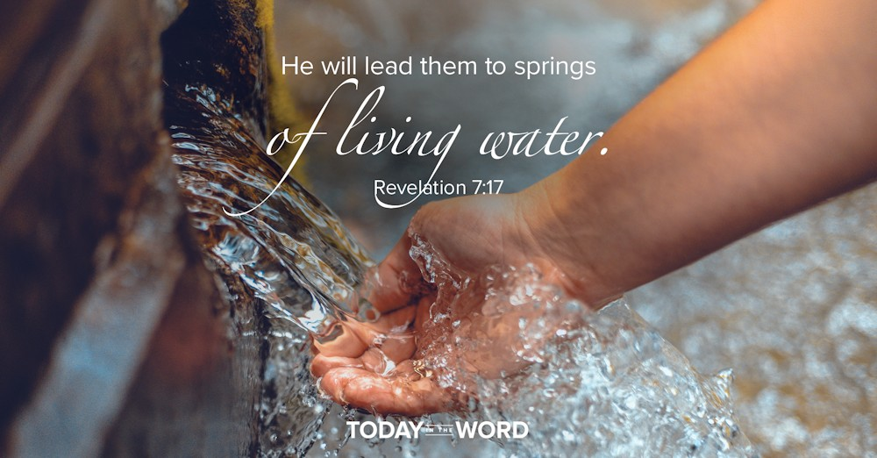

Read Zechariah 13:1–6

Cleansing From Sin
13 “On that day a fountain will be opened to the house of David and the inhabitants of Jerusalem, to cleanse them from sin and impurity.
² “On that day, I will banish the names of the idols from the land, and they will be remembered no more,” declares the Lord Almighty. “I will remove both the prophets and the spirit of impurity from the land. ³ And if anyone still prophesies, their father and mother, to whom they were born, will say to them, ‘You must die, because you have told lies in the Lord’s name.’ Then their own parents will stab the one who prophesies.
⁴ “On that day every prophet will be ashamed of their prophetic vision. They will not put on a prophet’s garment of hair in order to deceive. ⁵ Each will say, ‘I am not a prophet. I am a farmer; the land has been my livelihood since my youth.^{[a]}’ ⁶ If someone asks, ‘What are these wounds on your body^{[b]}?’ they will answer, ‘The wounds I was given at the house of my friends.’

Footnotes
- Zechariah 13:5 Or farmer; a man sold me in my youth
- Zechariah 13:6 Or wounds between your hands
He will lead them to springs of living water. Revelation 7:17
You know it’s summer in Chicago when the Buckingham Memorial Fountain in Grant Park turns on. One of the largest fountains in the world, it shoots water to a height of 150 feet. A fountain is often used as a metaphor for an unfailing or inexhaustible supply. In Zechariah 12, we saw how in the last days Israel would turn to the Lord in repentance. They would realize they had pierced God and mourn over their sin (v. 10). Those tears of mourning would be replaced by a cleansing fountain.
In a remarkable act of grace, God will provide them a cleansing from sin they could not achieve on their own. Earlier, God had told the High Priest Joshua that He would, “remove the sin of this land in a single day” (3:9). That promise is fulfilled in chapter 13. No sin is too great, no impurity too defiling for this fountain.
Specifically, God promises that on that day He would banish three things: idols, false prophets, and impurity (v. 2). Idols and false prophets often go together in Scripture (10:2). We are often tempted to worship other gods. In ancient Israel, it was the gods of the Canaanites and their prophets. Today false gods go under different names, but they have compelling spokespersons. They tell us that the most important things in life are pleasure, wealth, or personal happiness—or any other number of idols. One of the blessings of the millennial kingdom is that these false prophets will be silenced.
True cleansing from sin is possible because of the work of Jesus in His death and resurrection. As Jesus proclaimed, “Let anyone who is thirsty come to me and drink. Whoever believes in me…rivers of living water will flow from within them” (John 7:37–38).
Go Deeper
Why is a fountain such a good metaphor for God? Do some word searches in Scripture, using “fountain,” “water,” or “streams.” What can we learn about God from these images?
Pray with Us
Dear Lord, thank You for washing our sins away! Grant us Your abundant mercy to repent of our idolatry and live reflecting the work You have done in us.

Our Daily Bread – 10/20/25

Great Enough to Care



Read: Jonah 4:5-11
⁵ Jonah had gone out and sat down at a place east of the city. There he made himself a shelter, sat in its shade and waited to see what would happen to the city. ⁶ Then the Lord God provided a leafy plant^{[a]} and made it grow up over Jonah to give shade for his head to ease his discomfort, and Jonah was very happy about the plant. ⁷ But at dawn the next day God provided a worm, which chewed the plant so that it withered. ⁸ When the sun rose, God provided a scorching east wind, and the sun blazed on Jonah’s head so that he grew faint. He wanted to die, and said, “It would be better for me to die than to live.”
⁹ But God said to Jonah, “Is it right for you to be angry about the plant?”
“It is,” he said. “And I’m so angry I wish I were dead.”
¹⁰ But the Lord said, “You have been concerned about this plant, though you did not tend it or make it grow. It sprang up overnight and died overnight. ¹¹ And should I not have concern for the great city of Nineveh, in which there are more than a hundred and twenty thousand people who cannot tell their right hand from their left—and also many animals?”

Footnotes
- Jonah 4:6 The precise identification of this plant is uncertain; also in verses 7, 9 and 10.
The Lord said, . . . “Should I not have concern for the great city of Nineveh?” Jonah 4:10-11

Today's Devotional
How could God possibly care about all these people? The thought hit me as I stepped off a busy train platform in a crowded city, thousands of miles from home. I was a teenager traveling abroad for the first time, and I was overwhelmed by the size of the world around me. I felt small by comparison and wondered how God could love so many people.
I had yet to understand the broad reach of God’s perfect love. In Scripture, the prophet Jonah couldn’t fathom this either. When Jonah finally obeyed God’s call to preach repentance to the city of Nineveh, the capital of the brutal Assyrian Empire that had oppressed his native Israel, he didn’t want God to forgive them. But the city did repent, and when God didn’t destroy them, Jonah was angry. God provided shelter for Jonah through a fast-growing plant but then took his shade away, which angered him all the more. Jonah complained, but God responded, “You have been concerned about this plant . . . . And should I not have concern for the great city of Nineveh, in which there are more than a hundred and twenty thousand people?” (Jonah 4:10-11).
God’s so great that He’s able to care deeply for those who are far from Him. His love goes to the lengths of the cross and empty tomb of Jesus to meet our ultimate need. His greatness manifests itself in goodness, and He longs to draw us near.

Reflect & Pray
How does it comfort you to know God cares for you? How will you respond to His love?
Loving God, thank You for coming to save me. Please help me to love others like You do.
For further study, read The Pouting Prophet.

Today's Insights
Jonah 4 shows just how hardened the prophet’s heart had become. While it’s true that the people of Nineveh were far from the God of Abraham, Isaac, and Jacob, we see that Jonah himself was also very far from God’s heart. Having been God’s instrument to bring about a national revival in Nineveh (3:5-10), Jonah was angry at Him for rescuing his enemies. God’s love for Nineveh could’ve been a learning opportunity for him, but his heart was so filled with hate that all he could feel was his own rage. Still God loved and cared for the prophet (4:6), just as He loves and cares for us in spite of our hardened hearts.

God Calling – 10/20/25

No Burden Irks
Our Lord and our God. Be it done unto us according to Thy Word.
Simple acceptance of My Will is the Key to Divine Revelation. It will result in both Holiness and Happiness. The way to the Cross may be a way of sorrow, but at its foot the burdens of sin and earth-desire are rolled away.
The yoke of My acceptance of My Father's Will in all things is adjusted to My servants' shoulders, and from that moment on no burden irks or presses.
But not only in the great decisions of life accept and welcome My Will. Try to see in each interruption, each task, however small, the same fulfillment of Divine intent.
Accept it, say your thanks for it. Do so until this becomes a habit, and the resulting Joy will transfigure and transform your lives.
Walk as children of light: (For the fruit of the Spirit is in all goodness and righteousness
and truth;) Proving what is acceptable unto the Lord. Ephesians 5:8-10

