My Utmost for His Highest – 9/30/25

The Assigning of the Call

I now rejoice in my sufferings for you, and fill up in my flesh what is lacking in the afflictions of Christ, for the sake of His body, which is the church… —Colossians 1:24
We take our own spiritual consecration and try to make it into a call of God, but when we get right with Him He brushes all this aside. Then He gives us a tremendous, riveting pain to fasten our attention on something that we never even dreamed could be His call for us. And for one radiant, flashing moment we see His purpose, and we say, “Here am I! Send me” (Isaiah 6:8).

This call has nothing to do with personal sanctification, but with being made broken bread and poured-out wine. Yet God can never make us into wine if we object to the fingers He chooses to use to crush us. We say, “If God would only use His own fingers, and make me broken bread and poured-out wine in a special way, then I wouldn’t object!” But when He uses someone we dislike, or some set of circumstances to which we said we would never submit, to crush us, then we object. Yet we must never try to choose the place of our own martyrdom. If we are ever going to be made into wine, we will have to be crushed—you cannot drink grapes. Grapes become wine only when they have been squeezed.

I wonder what finger and thumb God has been using to squeeze you? Have you been as hard as a marble and escaped? If you are not ripe yet, and if God had squeezed you anyway, the wine produced would have been remarkably bitter. To be a holy person means that the elements of our natural life experience the very presence of God as they are providentially broken in His service. We have to be placed into God and brought into agreement with Him before we can be broken bread in His hands. Stay right with God and let Him do as He likes, and you will find that He is producing the kind of bread and wine that will benefit His other children.
WISDOM FROM OSWALD CHAMBERS
The truth is we have nothing to fear and nothing to overcome because He is all in all and we are more than conquerors through Him. The recognition of this truth is not flattering to the worker’s sense of heroics, but it is amazingly glorifying to the work of Christ. Approved Unto God, 4 R

CCEL – 9/30/25
He knoweth the way that I take: when he hath tried me, I shall come forth as gold.—JOB 23:10.

He knoweth our frame.—He doth not afflict willingly nor grieve the children of men.

The foundation of God standeth sure, having this seal, The Lord knoweth them that are his. And, Let every one that nameth the name of Christ depart from iniquity. But in a great house there are not only vessels of gold and of silver, but also of wood and of earth; and some to honour, and some to dishonour. If a man therefore purge himself from these, he shall be a vessel unto honour, sanctified, and meet for the master's use, and prepared unto every good work.

He shall sit as a refiner and purifier of silver: and he shall purify the sons of Levi, and purge them as gold and silver, that they may offer unto the Lord an offering in righteousness.—I . . . will refine them as silver is refined, . . . they shall call on my name, and I will hear them: I will say, It is my people: and they shall say, the Lord is my God
.
Psa. 103:14. -Lam. 3:33.II Tim. 2:19-21.Mal. 3:3. -Zech. 13:9.

“Sing forth the honour of his name, make his praise glorious.” Psalm 66:2

It is not left to our own option whether we shall praise God or not. Praise is God’s most righteous due, and every Christian, as the recipient of his grace, is bound to praise God from day to day. It is true we have no authoritative rubric for daily praise; we have no commandment prescribing certain hours of song and thanksgiving: but the law written upon the heart teaches us that it is right to praise God; and the unwritten mandate comes to us with as much force as if it had been recorded on the tables of stone, or handed to us from the top of thundering Sinai. Yes, it is the Christian’s duty to praise God. It is not only a pleasurable exercise, but it is the absolute obligation of his life. Think not ye who are always mourning, that ye are guiltless in this respect, or imagine that ye can discharge your duty to your God without songs of praise. You are bound by the bonds of his love to bless his name so long as you live, and his praise should continually be in your mouth, for you are blessed, in order that you may bless him; “this people have I formed for myself, they shall show forth my praise”; and if you do not praise God, you are not bringing forth the fruit which he, as the Divine Husbandman, has a right to expect at your hands. Let not your harp then hang upon the willows, but take it down, and strive, with a grateful heart, to bring forth its loudest music. Arise and chant his praise. With every morning’s dawn, lift up your notes of thanksgiving, and let every setting sun be followed with your song. Girdle the earth with your praises; surround it with an atmosphere of melody, and God himself will hearken from heaven and accept your music.

“E'en so I love thee, and will love,
And in thy praise will sing,
Because thou art my loving God,
And my redeeming King.”

Word Live – 9/30/25

https://content.scriptureunion.org.uk/wordlive/

Scripture Union – 9/30/25

https://scriptureunion.org/encounters/

Today in the Word – 9/30/25

A Doxology
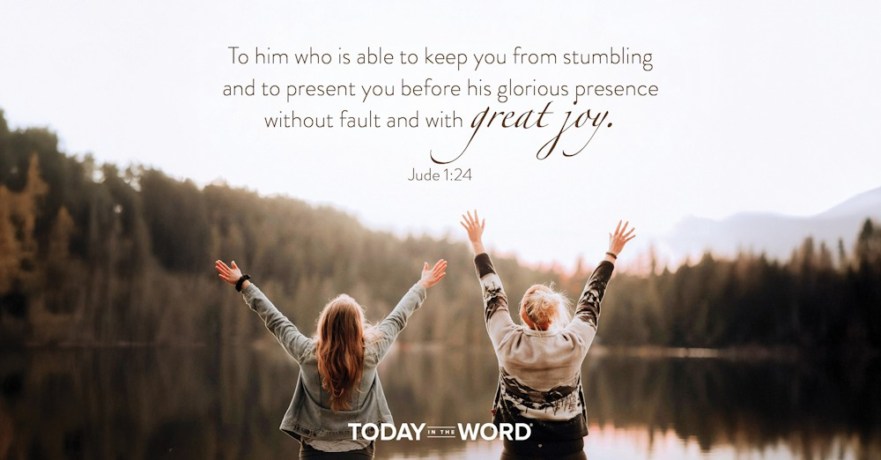

Read Jude 1:24–25

Doxology
²⁴ To him who is able to keep you from stumbling and to present you before his glorious presence without fault and with great joy— ²⁵ to the only God our Savior be glory, majesty, power and authority, through Jesus Christ our Lord, before all ages, now and forevermore! Amen.
To him who is able to keep you from stumbling and to present you before his glorious presence without fault and with great joy.Jude 1:24
As many letters of the New Testament, Jude’s letter ends with a doxology, an expression of praise to God. Jude’s doxology begins by addressing God directly: “To him” (v. 24). He praises “the only God our Savior” (v. 25). God is the focus, the center, and the purpose in this doxology, and in our lives. After warning of the many threats that had grown up within the church and would increase in the last days, Jude ends by reminding us that God can keep us from “stumbling” (v. 24)!
Jude’s words remind us of Hebrews 12:1,“Let us throw off everything that hinders and the sin that so easily entangles. And let us run with perseverance the race marked out for us.” As believers, we can run with the end as our focus, assured that God will keep our feet steady and enable us to reach the finish line. We can finish “without fault” based not on our own effort but on the perfection bought by Christ’s sacrifice.
Verse 25 shifts our focus to the greatness of our God, His “glory, majesty, power and authority.” We serve a God who was “before all ages” and will exist “forevermore.” When we read the book of Revelation, we are amazed by the majesty of God and the Lamb (Jesus). Revelation 4 states that the four living creatures day and night never stop saying: “‘Holy, holy, holy is the Lord God Almighty,’ who was, and is, and is to come” (Rev. 4:8). Later, 24 elders fall down before Him and say, “You are worthy, our Lord and God, to receive glory and honor and power, for you created all things, and by your will they were created and have their being” (Rev. 4:11). What an awe-inspiring God we serve!
Go Deeper
As we conclude our study of Jude, why not pause to praise God? He is able to keep us from “stumbling” and gives us “great joy”!
Pray with Us
As we finish our study, we praise you today, Jesus Christ our Lord! God our Savior, all glory, majesty, power, and authority are Yours forever and ever. Amen.

Our Daily Bread – 9/30/25

A Leap of Faith


Read: Ephesians 2:1-10

Made Alive in Christ
2 As for you, you were dead in your transgressions and sins, ² in which you used to live when you followed the ways of this world and of the ruler of the kingdom of the air, the spirit who is now at work in those who are disobedient. ³ All of us also lived among them at one time, gratifying the cravings of our flesh^{[a]} and following its desires and thoughts. Like the rest, we were by nature deserving of wrath. ⁴ But because of his great love for us, God, who is rich in mercy, ⁵ made us alive with Christ even when we were dead in transgressions—it is by grace you have been saved. ⁶ And God raised us up with Christ and seated us with him in the heavenly realms in Christ Jesus, ⁷ in order that in the coming ages he might show the incomparable riches of his grace, expressed in his kindness to us in Christ Jesus. ⁸ For it is by grace you have been saved, through faith—and this is not from yourselves, it is the gift of God— ⁹ not by works, so that no one can boast. ¹⁰ For we are God’s handiwork, created in Christ Jesus to do good works, which God prepared in advance for us to do.

Footnotes
- Ephesians 2:3 In contexts like this, the Greek word for flesh (sarx) refers to the sinful state of human beings, often presented as a power in opposition to the Spirit.
It is by grace you have been saved, through faith. Ephesians 2:8

Today's Devotional
A French sailor, along with his cat, was sailing from Dutch Harbor—located on an island south of Alaska—to San Diego, California, when his yacht was capsized by a huge wave. The vessel righted itself, but the mariner lost his rudder and rigging to the violent swells. He reported his dire situation to the Coast Guard, saying he was stranded, had no control, and his boat was “pretty much dead in the water.” Eventually the Coast Guard contacted an oil drilling ship nearby, and they came to the sailor’s rescue. However, he still had to make a literal leap of faith—with his cat tucked under his jacket—from his boat to the rescue vessel.
In Ephesians 2, Paul described the sinful and hopeless condition of humanity—dead in the water spiritually and separated from God (v. 1). Moreover, we were disobedient to all that He desires (v. 2) and depraved—unable to do anything to merit salvation (v. 3). But “by grace,” Jesus made it possible for us to be “saved, through faith,” and this salvation is a “gift of God” (v. 8).
We were all stranded in the raging seas of sin and death, but praise God that we have a Savior who made it possible for us to leap into His saving arms by faith. Christ alone can rescue us and carry us to safety.

Reflect & Pray
What is the means of the rescue Jesus has made possible? How are faith in Him and the salvation He’s made possible linked?
Dear Jesus, Your mercy and grace led me to—by faith—leap into Your saving arms.
For further study, read What’s Wrong with the Sinner’s Prayer.

Today's Insights
Our need of Christ’s rescue is undeniable, given Paul’s clear teaching in Ephesians 2. Apart from Jesus we “were dead” (v. 1), and the dead can do absolutely nothing on their own behalf. How grateful we should be that God, out “of his great love for us” and His rich mercy (v. 4) has given us life through Christ’s death and resurrection on our behalf. In addition to giving us life, He’s given us a place “in the heavenly realms” (v. 6). All this was done to express God’s “kindness to us” (v. 7). Apart from Jesus (vv. 8-9), we’d be both lost and helpless, but He came and took our place. He’s rescued and brought to safety those who’ve believed in Him!

God Calling – 9/30/25

Wisdom
As thy days so shall thy strength be.
I have promised that for every day you live, the strength shall be given you. Do not fear.
Face each difficulty sure that the wisdom and strength will be given you for it. Claim it.
Rely on Me to keep My Promise about this. In My Universe, for every task I give one of My children, there is set aside all that is necessary for its performance. So why fear? So why doubt?
So teach us to number our days, that we may apply our hearts into wisdom. Psalm 90:12

My Utmost for His Highest – 10/1/25

The Place of Exaltation

…Jesus took…them up on a high mountain apart by themselves… —Mark 9:2
We have all experienced times of exaltation on the mountain, when we have seen things from God’s perspective and have wanted to stay there. But God will never allow us to stay there. The true test of our spiritual life is in exhibiting the power to descend from the mountain. If we only have the power to go up, something is wrong. It is a wonderful thing to be on the mountain with God, but a person only gets there so that he may later go down and lift up the demon-possessed people in the valley (see Mark 9:14-18). We are not made for the mountains, for sunrises, or for the other beautiful attractions in life— those are simply intended to be moments of inspiration. We are made for the valley and the ordinary things of life, and that is where we have to prove our stamina and strength. Yet our spiritual selfishness always wants repeated moments on the mountain. We feel that we could talk and live like perfect angels, if we could only stay on the mountaintop. Those times of exaltation are exceptional and they have their meaning in our life with God, but we must beware to prevent our spiritual selfishness from wanting to make them the only time.
We are inclined to think that everything that happens is to be turned into useful teaching. In actual fact, it is to be turned into something even better than teaching, namely, character. The mountaintop is not meant to teach us anything, it is meant to make us something. There is a terrible trap in always asking, “What’s the use of this experience?” We can never measure spiritual matters in that way. The moments on the mountaintop are rare moments, and they are meant for something in God’s purpose.
Wisdom From Oswald Chambers
Jesus Christ is always unyielding to my claim to my right to myself. The one essential element in all our Lord’s teaching about discipleship is abandon, no calculation, no trace of self-interest. Disciples Indeed, 395 L

CCEL – 10/1/25
The fruit of the Spirit is temperance.—GAL. 5:22.
Every man that striveth for the mastery is temperate in all things. Now they do it to obtain a corruptible crown; but we an incorruptible. I therefore so run, not as uncertainly; so fight I, not as one that beateth the air: but I keep under my body, and bring it into subjection: lest that by any means, when I have preached to others, I myself should be a castaway.
Be not drunk with wine, wherein is excess: but be filled with the Spirit.
If any man will come after me let him deny himself, and take up his cross, and follow me.
Let us not sleep, as do others: but let us watch and be sober. For they that sleep sleep in the night; and they that be drunken are drunken in the night. But let us, who are of the day, be sober.—Denying ungodliness and worldly lusts, we should live soberly, righteously, and godly, in this present world: looking for that blessed hope, and the glorious appearing of the great God and our Saviour Jesus Christ.
I Cor. 9:25-27.Eph. 5:18.Matt. 16:24.I Thes. 5:6-8. -Tit. 2:12,13,.
“Pleasant fruits, new and old, which I have laid up for thee, O my beloved.” Song of Solomon 7:13
The spouse desires to give to Jesus all that she produces. Our heart has “all manner of pleasant fruits,” both “old and new,” and they are laid up for our Beloved. At this rich autumnal season of fruit, let us survey our stores. We have new fruits. We desire to feel new life, new joy, new gratitude; we wish to make new resolves and carry them out by new labours; our heart blossoms with new prayers, and our soul is pledging herself to new efforts. But we have some old fruits too. There is our first love: a choice fruit that! and Jesus delights in it. There is our first faith: that simple faith by which, having nothing, we became possessors of all things. There is our joy when first we knew the Lord: let us revive it. We have our old remembrances of the promises. How faithful has God been! In sickness, how softly did he make our bed! In deep waters, how placidly did he buoy us up! In the flaming furnace, how graciously did he deliver us. Old fruits, indeed! We have many of them, for his mercies have been more than the hairs of our head. Old sins we must regret, but then we have had repentances which he has given us, by which we have wept our way to the cross, and learned the merit of his blood. We have fruits, this morning, both new and old; but here is the point—they are all laid up for Jesus. Truly, those are the best and most acceptable services in which Jesus is the solitary aim of the soul, and his glory, without any admixture whatever, the end of all our efforts. Let our many fruits be laid up only for our Beloved; let us display them when he is with us, and not hold them up before the gaze of men. Jesus, we will turn the key in our garden door, and none shall enter to rob thee of one good fruit from the soil which thou hast watered with thy bloody sweat. Our all shall be thine, thine only, O Jesus, our Beloved!

Word Live – 10/1/25

https://content.scriptureunion.org.uk/wordlive/

Scripture Union – 10/1/25

https://scriptureunion.org/encounters/

Today in the Word – 10/1/25
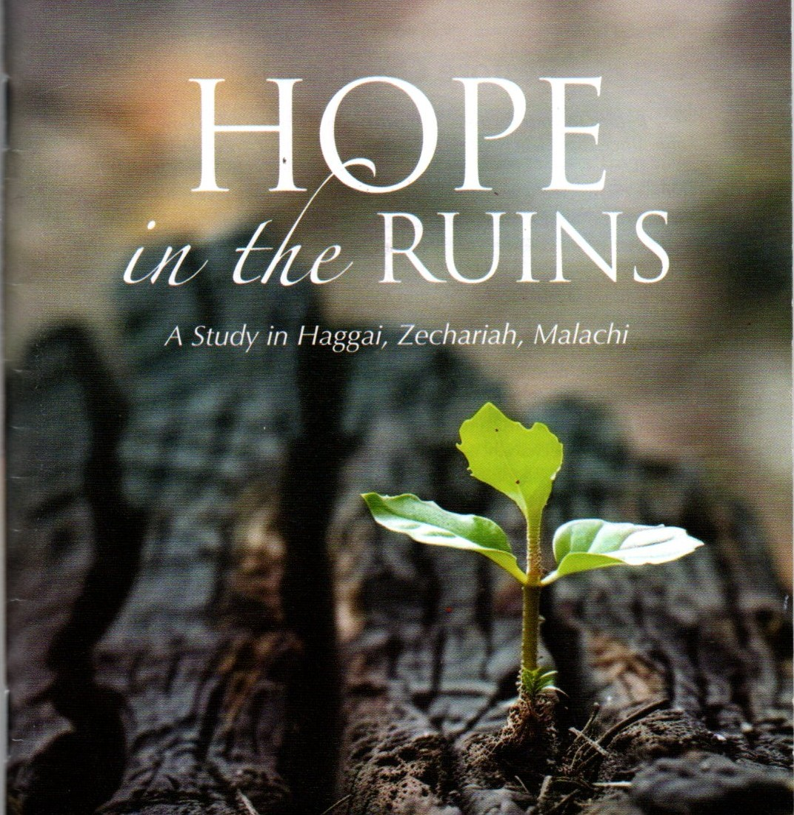 Fight Complacency!
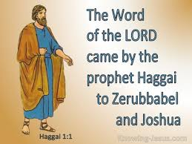

Read Haggai 1:1-11

A Call to Build the House of the Lord
1 In the second year of King Darius, on the first day of the sixth month, the word of the Lord came through the prophet Haggai to Zerubbabel son of Shealtiel, governor of Judah, and to Joshua son of Jozadak,^{[a]} the high priest:
² This is what the Lord Almighty says: “These people say, ‘The time has not yet come to rebuild the Lord’s house.’”
³ Then the word of the Lord came through the prophet Haggai: ⁴ “Is it a time for you yourselves to be living in your paneled houses, while this house remains a ruin?”
⁵ Now this is what the Lord Almighty says: “Give careful thought to your ways. ⁶ You have planted much, but harvested little. You eat, but never have enough. You drink, but never have your fill. You put on clothes, but are not warm. You earn wages, only to put them in a purse with holes in it.”
⁷ This is what the Lord Almighty says: “Give careful thought to your ways. ⁸ Go up into the mountains and bring down timber and build my house, so that I may take pleasure in it and be honored,” says the Lord. ⁹ “You expected much, but see, it turned out to be little. What you brought home, I blew away. Why?” declares the Lord Almighty. “Because of my house, which remains a ruin, while each of you is busy with your own house. ¹⁰ Therefore, because of you the heavens have withheld their dew and the earth its crops. ¹¹ I called for a drought on the fields and the mountains, on the grain, the new wine, the olive oil and everything else the ground produces, on people and livestock, and on all the labor of your hands.”

Footnotes
- Haggai 1:1 Hebrew Jehozadak, a variant of Jozadak; also in verses 12 and 14

Is it a time for you yourselves to be living in your paneled houses, while this house remains a ruin?— Haggai 1:4

Have you ever had a difficult job to do, but it was hard to get started? Maybe the project seemed so daunting you weren't even sure where to start. It is easy to come up with reasons to delay. But as evangelist Billy Sunday once quipped, an excuse is “the skin of a reason stuffed with a lie.”

The book of Haggai records four messages the Lord gave between August and December of 520 BC. Twenty years earlier, the Lord had worked a miracle. The Jewish people had been allowed to return from their exile in Babylon and were commissioned to rebuild the Temple (Ezra 1:1-4). Shortly after, they faced vigorous opposition from their neighbors, the Samaritans (Ezra 4:1-24). The work of rebuilding the Temple was put on hold.

Twenty years later the Temple mount was still in ruins. The work had never been restarted. The book of Haggai opens with a word from the Lord, “These people say, ‘The time has not yet come to rebuild the Lord’s house” (v. 2). God gets right to the heart of the issue. The people were making excuses. From their perspective, it was not the right time to rebuild the Temple. The economy was struggling. People had their own worries.

The Lord saw their apathy as a sign of their spiritual condition. They have found time to make lovely paneled houses for themselves (v.4). So why was the house of God in ruins? It was ultimately an issue of the heart. It is not just ancient Israel that struggled with these issues. The
apostle Paul lamented, “For everyone looks out for their own interests, not those of Jesus Christ” (Phil. 2:21). God does not want our leftovers. He wants all of us. Our relationship with Him should be our first priority.

Go Deeper

Why did the Israelites delay rebuilding the Temple? What excuses are you making to avoid following God’s call in your life?

Pray with Us

Lord, forgive us for pursuing our selfish desires above the work You have for us. Help us to trust You, for Your plans are greater than ours. Give us passionate hearts to put You first. All we have is Yours!

Our Daily Bread – 10/1/25

Out from the Dark



Read: Isaiah 9:2-7
² The people walking in darkness
have seen a great light;
on those living in the land of deep darkness
a light has dawned.
³ You have enlarged the nation
and increased their joy;
they rejoice before you
as people rejoice at the harvest,
as warriors rejoice
when dividing the plunder.
⁴ For as in the day of Midian’s defeat,
you have shattered
the yoke that burdens them,
the bar across their shoulders,
the rod of their oppressor.
⁵ Every warrior’s boot used in battle
and every garment rolled in blood
will be destined for burning,
will be fuel for the fire.
⁶ For to us a child is born,
to us a son is given,
and the government will be on his shoulders.
And he will be called
Wonderful Counselor, Mighty God,
Everlasting Father, Prince of Peace.
⁷ Of the greatness of his government and peace
there will be no end.
He will reign on David’s throne
and over his kingdom,
establishing and upholding it
with justice and righteousness
from that time on and forever.
The zeal of the Lord Almighty
will accomplish this.
The people walking in darkness have seen a great light. Isaiah 9:2

Today's Devotional
The tugboat sank twenty miles off the coast of Nigeria, turning upside down as it fell to the sea floor. Eleven crew members drowned, but the ship’s cook, Harrison Odjegba Okene, found an air pocket and waited. He only had one bottle of Coke for provisions, and both of his flashlights died within the first twenty-four hours. For three terrifying days, Okene was trapped alone in darkness at the bottom of the ocean. He’d begun to give up hope when divers on a mission to recover dead bodies found him hunkered and shivering deep in the hull.
The image of Okene alone in the dark for sixty hours is unnerving. He told reporters he still suffers nightmares from the horrifying ordeal. But can you imagine what he felt when he saw the diver’s powerful lamp piercing the darkness? What joy and elation, what hope. The prophet Isaiah foretold how, when the Messiah came, all “the people walking in darkness” would see “a great light” (9:2). Left to our own devices, we live “in the land of deep darkness,” but in Jesus, “a light has dawned” (v. 2).
Christ is “the light of the world,” and in Him we need never again fear the darkness for we “have the light of life” (John 8:12). We may feel trapped or hopeless, alone or in despair, but God illuminates good news. Jesus carries us out of the dark and into His marvelous light.

Reflect & Pray
What darkness are you facing? How do you need Jesus to be your light and bring you out of it?
Dear God, I need Your light in my life. Please bring me out of my dark place.
For further study, read Deceived by Disappointment.

Today's Insights
Oppressed by an Aram-Israel alliance, King Ahaz of Judah turned to Assyria for help (2 Kings 16:7-9; Isaiah 7:1-6). God told Ahaz He’d use Assyria to defeat Israel and Aram (Isaiah 7:7-9; 8:4-7), and because of Ahaz’s unfaithfulness, Judah too would be punished (7:13-25; 8:8). The punishment would be so severe the Israelites would “be thrust into utter darkness” (8:22). But God promised deliverance and restoration, starting with Zebulun and Naphtali (9:1), lands in Israel’s far north that had been ravaged by the Assyrians. Isaiah prophesied that with the birth of the Messiah, “the people walking in darkness [would see] a great light” (v. 2).
Seven hundred years later, Jesus fulfilled this prophecy as He began His ministry in that region (Matthew 4:12-17). Christ, that “great light,” calls us to follow Him: “I am the light of the world. Whoever follows me will never walk in darkness, but will have the light of life” (John 8:12).

God Calling – 10/1/25

Secret of Prosperity
Look unto me, and be saved, all the ends of the earth. -- Isaiah 45:22.
Look to no other source of Salvation. Only look unto Me. See no other supply. Look unto Me, and you shall be saved. Regard Me as your only supply. That is the secret of prosperity for you, and you in your turn shall save many from poverty and distress.
Whatever danger threatens look unto Me.... Whatever you desire or need, or desire or need for others, look to Me. Claim all from My Storehouse. Claim, claim, claim.
Remember that I fed the Children of Israel with Heaven-sent manna. I made a way through the Red Sea for them. I led them through the wilderness of privation, difficulty, discipline. I led them into a land flowing with milk and honey. So trust. So be led.
Rejoice. These are your wilderness days. But surely and safely, you are being led to your Canaan of Plenty.
The Lord shall command the blessing upon thee in thy storehouses ... in all that thou settest thine hand unto ... in the land which the Lord thy God giveth thee. Deuteronomy 23:8

My Utmost for His Highest – 10/2/25

The Place of Humiliation

If You can do anything, have compassion on us and help us. —Mark 9:22
After every time of exaltation, we are brought down with a sudden rush into things as they really are, where it is neither beautiful, poetic, nor thrilling. The height of the mountaintop is measured by the dismal drudgery of the valley, but it is in the valley that we have to live for the glory of God. We see His glory on the mountain, but we never live for His glory there. It is in the place of humiliation that we find our true worth to God— that is where our faithfulness is revealed. Most of us can do things if we are always at some heroic level of intensity, simply because of the natural selfishness of our own hearts. But God wants us to be at the drab everyday level, where we live in the valley according to our personal relationship with Him. Peter thought it would be a wonderful thing for them to remain on the mountain, but Jesus Christ took the disciples down from the mountain and into the valley, where the true meaning of the vision was explained (see Mark 9:5-6, Mark 9:14-23).
“If you can do anything….” It takes the valley of humiliation to remove the skepticism from us. Look back at your own experience and you will find that until you learned who Jesus really was, you were a skillful skeptic about His power. When you were on the mountaintop you could believe anything, but what about when you were faced with the facts of the valley? You may be able to give a testimony regarding your sanctification, but what about the thing that is a humiliation to you right now? The last time you were on the mountain with God, you saw that all the power in heaven and on earth belonged to Jesus— will you be skeptical now, simply because you are in the valley of humiliation?
Wisdom From Oswald Chambers
If a man cannot prove his religion in the valley, it is not worth anything. Shade of His Hand, 1200 L

CCEL – 10/2/25
The goat shall bear upon him all their iniquities unto a land not inhabited: and he shall let go the goat in the wilderness.—LEV. 16:22.
As far as the east is from the west, so far hath he removed our transgressions from us.—In those days, and in that time, saith the Lord, the iniquity of Israel shall be sought for, and there shall be none; and the sins of Judah, and they shall not be found: for I will pardon them whom I reserve.—Thou wilt cast all their sins into the depths of the sea.—Who is a God like unto thee, that pardoneth iniquity?
All we like sheep have gone astray; we have turned every one to his own way; and the Lord hath laid on him the iniquity of us all.—He shall bear their iniquities. Therefore will I divide him a portion with the great, and he shall divide the spoil with the strong, because he hath poured out his soul unto death; and he was numbered with the transgressors; and he bare the sin of many, and made intercession for the transgressors.—The Lamb of God, which taketh away the sin of the world.
Psa. 103:12. -Jer. 50:20. -Mic. 7:19. -Mic. 7:18.Isa. 53:6. -Isa. 53:11,12. -John 1:29.
“The hope which is laid up for you in heaven.” Colossians 1:5
Our hope in Christ for the future is the mainspring and the mainstay of our joy here. It will animate our hearts to think often of heaven, for all that we can desire is promised there. Here we are weary and toilworn, but yonder is the land of rest where the sweat of labour shall no more bedew the worker’s brow, and fatigue shall be forever banished. To those who are weary and spent, the word “rest” is full of heaven. We are always in the field of battle; we are so tempted within, and so molested by foes without, that we have little or no peace; but in heaven we shall enjoy the victory, when the banner shall be waved aloft in triumph, and the sword shall be sheathed, and we shall hear our Captain say, “Well done, good and faithful servant.” We have suffered bereavement after bereavement, but we are going to the land of the immortal where graves are unknown things. Here sin is a constant grief to us, but there we shall be perfectly holy, for there shall by no means enter into that kingdom anything which defileth. Hemlock springs not up in the furrows of celestial fields. Oh! is it not joy, that you are not to be in banishment forever, that you are not to dwell eternally in this wilderness, but shall soon inherit Canaan? Nevertheless let it never be said of us, that we are dreaming about the future and forgetting the present, let the future sanctify the present to highest uses. Through the Spirit of God the hope of heaven is the most potent force for the product of virtue; it is a fountain of joyous effort, it is the corner stone of cheerful holiness. The man who has this hope in him goes about his work with vigour, for the joy of the Lord is his strength. He fights against temptation with ardour, for the hope of the next world repels the fiery darts of the adversary. He can labour without present reward, for he looks for a reward in the world to come.

Word Live – 10/2/25

https://content.scriptureunion.org.uk/wordlive/

Scripture Union – 10/2/25

https://scriptureunion.org/encounters/

Today in the Word – 10/2/25

The Lord Is with You
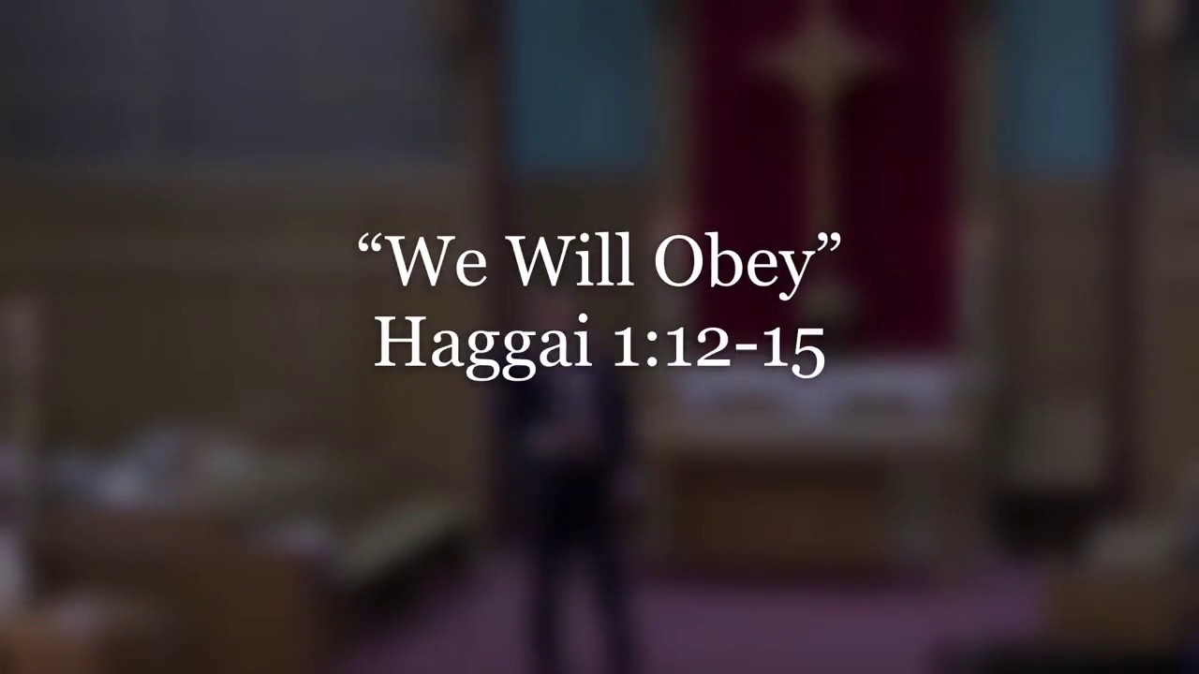

Read Haggai 1:12-15
¹² Then Zerubbabel son of Shealtiel, Joshua son of Jozadak, the high priest, and the whole remnant of the people obeyed the voice of the Lord their God and the message of the prophet Haggai, because the Lord their God had sent him. And the people feared the Lord.
¹³ Then Haggai, the Lord’s messenger, gave this message of the Lord to the people: “I am with you,” declares the Lord. ¹⁴ So the Lord stirred up the spirit of Zerubbabel son of Shealtiel, governor of Judah, and the spirit of Joshua son of Jozadak, the high priest, and the spirit of the whole remnant of the people. They came and began to work on the house of the Lord Almighty, their God, ¹⁵ on the twenty-fourth day of the sixth month.
“I am with you,” declares the Lorp.— Haggai 1:13

When I was a young pastor, an older member of our congregation took me aside to give me some advice on preaching. My initial response was to feel defensive. But by God's grace, I held my tongue and listened. He helped me to notice that I had some habits that needed to change. He said, “You always walk to the left and look at that side of the sanctuary. We feel a bit left out on the other side.” I had no idea. I probably walked to the left because I’m left-handed. I put in my notes to walk both ways until it became a habit.

In the first chapter of Haggai, the Lord had brought some significant criticism upon Israel and its leadership. He charged Israel with selfishness. They had been prioritizing their own needs and neglecting the house of the Lord. How would Israel respond? It might have been tempting to be defensive.

Thankfully, Israel responded in just the right way, “the whole remnant of the people obeyed the voice of the Logd their God and the message of the prophet Haggai” (v. 12). They
were able to look honestly at their past behavior and repent. They had a heart that feared the Lord (v. 12). In response, God promised that He would help them complete the difficult and demanding work He had called them to (v. 13). God would empower the people to obey His commands. Work on the Temple was restarted (v. 14).

The Lord has given the church a job that often seems difficult and demanding—to make disciples of all nations (Matt. 28:19). Yet, God has not left us to our own efforts. The Lord Jesus promised, “And surely I am with you always, to the very end of the age” (Matt. 28:20). God is with you today as you seek to live for Him.

Go Deeper

What stops us from reaching the lost with the gospel? What encouragement today’s devotional give us as we face that challenge?

Pray with Us

Father, we desire to obey You. May we have an attitude of repentance, relying on You for the tasks You have given us. Grant us opportunities to share Your light and strengthen us to reach the world with Your gospel.

Our Daily Bread – 10/2/25

Remaining Teachable in God



Proverbs 9:1-6

Invitations of Wisdom and Folly
9 Wisdom has built her house;
she has set up^{[a]} its seven pillars.
² She has prepared her meat and mixed her wine;
she has also set her table.
³ She has sent out her servants, and she calls
from the highest point of the city,
⁴ “Let all who are simple come to my house!”
To those who have no sense she says,
⁵ “Come, eat my food
and drink the wine I have mixed.
⁶ Leave your simple ways and you will live;
walk in the way of insight.”

Footnotes
- Proverbs 9:1 Septuagint, Syriac and Targum; Hebrew has hewn out

Proverbs 9:13-18
¹³ Folly is an unruly woman;
she is simple and knows nothing.
¹⁴ She sits at the door of her house,
on a seat at the highest point of the city,
¹⁵ calling out to those who pass by,
who go straight on their way,
¹⁶ “Let all who are simple come to my house!”
To those who have no sense she says,
¹⁷ “Stolen water is sweet;
food eaten in secret is delicious!”
¹⁸ But little do they know that the dead are there,
that her guests are deep in the realm of the dead.
Instruct the wise and they will be wiser still. Proverbs 9:9

Today's Devotional
After Kat learned she was pregnant, she dropped out of high school to care for her daughter. Fifteen years later, Kat was a working mother of three who dreamed of becoming a licensed beautician. With humility and tenacity, she became a student again in a free GED support program. It was humbling to go back to school after so long. “This program changed my life!” Kat said. “My teacher was amazing and offered so much encouragement.”
Remaining teachable may be one of the most difficult things we can do. The Bible speaks of having a teachable heart that’s open to God’s wisdom. The poetry of Proverbs paints a picture of two women calling out to passersby—Wisdom and Folly (Proverbs 9:1-6; 13-18). Those who listen to Wisdom receive correction with grace. They “add to their learning” and become even wiser (v. 9). They habitually “walk in the way of insight” (v. 6) and seat themselves at Wisdom’s table for instruction. Their obedience leads to a full life (v. 11). In contrast, those who listen to Folly hate being corrected or criticized. They insult anyone who tries to instruct them (vv. 7-8). Humility comes from fearing God—acknowledging that He’s “the Holy One” and we are not (v. 10). It’s not easy to stay teachable, but it also brings freedom to admit we don’t know it all and we still need help. Wisdom calls to us. How will we respond?

Reflect & Pray
What’s your default reaction to criticism? How could a humble response lead to growth and victory?
Receiving instruction doesn’t always come naturally to me, wise Father, but I trust Your ways.
For further study, read An Invitation to Wisdom.
Today's Insights
“I have set before you life and death, blessings and curses,” Moses told Israel shortly before his death. Then he exhorted them: “Choose life . . . . love the Lord your God, listen to his voice, and hold fast to him” (Deuteronomy 30:19-20). Proverbs reinforces this prudent counsel to forsake deadly ways and choose life. Chapter 9 is the last of three chapters that contrast folly and wisdom by personifying these concepts as female characters. In chapter 7, a father urges his son, “Say to wisdom, ‘You are my sister’ ” (v. 4) but warns against the adulterous woman: “Do not let your heart turn to her ways” (v. 25). Chapters 7, 8, and 9 all conclude with warnings about the deadly end awaiting those who neglect wisdom (7:26-27; 8:35-36; 9:18). Instead, “Leave your simple ways and you will live” (9:6). By cultivating a teachable heart, fools grow wiser and draw closer to God.

God Calling – 10/2/25

True Meekness
How easy it is to lead and guide when you are responsive to My wish! The hurts of life come only when you, or those about whom you care, endeavor to go your, or their, own way and resist the pressure of My Hand.
But in willing My Will there must be a gladness. Delight to do that Will.
"The meek shall inherit the earth," I said. That is, control others, and the material forces of the earth.
But this exultant state of possession is the result of a yielded will. That was My meaning of the word meek.
So live. So yield. So conquer.
I can of mine own self do nothing: as I hear, I judge: and my judgment is just; because I seek not mine own will, but the will of the Father which hath sent me. John 5:30

My Utmost for His Highest – 10/3/25

The Place of Ministry


He said to them, "This kind [of unclean spirit] can come out by nothing but prayer and fasting." —Mark 9:29
“His disciples asked Him privately, ‘Why could we not cast it out?’ ” (Mark 9:28). The answer lies in a personal relationship with Jesus Christ. “This kind can come out by nothing but” concentrating on Him, and then doubling and redoubling that concentration on Him. We can remain powerless forever, as the disciples were in this situation, by trying to do God’s work without concentrating on His power, and by following instead the ideas that we draw from our own nature. We actually slander and dishonor God by our very eagerness to serve Him without knowing Him.
When you are brought face to face with a difficult situation and nothing happens externally, you can still know that freedom and release will be given because of your continued concentration on Jesus Christ. Your duty in service and ministry is to see that there is nothing between Jesus and yourself. Is there anything between you and Jesus even now? If there is, you must get through it, not by ignoring it as an irritation, or by going up and over it, but by facing it and getting through it into the presence of Jesus Christ. Then that very problem itself, and all that you have been through in connection with it, will glorify Jesus Christ in a way that you will never know until you see Him face to face.
We must be able to “mount up with wings like eagles” (Isaiah 40:31), but we must also know how to come down. The power of the saint lies in the coming down and in the living that is done in the valley. Paul said, “I can do all things through Christ who strengthens me” (Philippians 4:13) and what he was referring to were mostly humiliating things. And yet it is in our power to refuse to be humiliated and to say, “No, thank you, I much prefer to be on the mountaintop with God.” Can I face things as they actually are in the light of the reality of Jesus Christ, or do things as they really are destroy my faith in Him, and put me into a panic?
Wisdom From Oswald Chambers
The root of faith is the knowledge of a Person, and one of the biggest snares is the idea that God is sure to lead us to success. My Utmost for His Highest, March 19, 761 L

CCEL – 10/3/25
Unto him that loved us, and washed us from our sins in his own blood.—REV. 1:5.
Many waters cannot quench love, neither can the floods drown it. Love is strong as death.—Greater love hath no man than this, that a man lay down his life for his friends.
Who his own self bare our sins in his own body on the tree, that we, being dead to sins, should live unto righteousness: by whose stripes ye were healed.—In whom we have redemption through his blood, the forgiveness of sins, according to the riches of his grace.
Ye are washed, . . . ye are sanctified, . . . ye are justified in the name of the Lord Jesus, and by the Spirit of our God.—Ye are a chosen generation, a royal priesthood, a holy nation, a peculiar people; that ye should shew forth the praises of him who hath called you out of darkness into his marvellous light.—I beseech you . . . brethren, by the mercies of God, that ye present your bodies a living sacrifice, holy, acceptable unto God, which is your reasonable service.
Song 8:7,6. -John 15:13.I Pet. 2:24. -Eph. 1:7.I Cor. 6:11. -I Pet. 2:9. -Rom. 12:1.
“Are they not all ministering spirits, sent forth to minister for them who shall be heirs of salvation?” Hebrews 1:14
Angels are the unseen attendants of the saints of God; they bear us up in their hands, lest we dash our foot against a stone. Loyalty to their Lord leads them to take a deep interest in the children of his love; they rejoice over the return of the prodigal to his father’s house below, and they welcome the advent of the believer to the King’s palace above. In olden times the sons of God were favoured with their visible appearance, and at this day, although unseen by us, heaven is still opened, and the angels of God ascend and descend upon the Son of man, that they may visit the heirs of salvation. Seraphim still fly with live coals from off the altar to touch the lips of men greatly beloved. If our eyes could be opened, we should see horses of fire and chariots of fire about the servants of the Lord; for we have come to an innumerable company of angels, who are all watchers and protectors of the seed-royal. Spenser’s line is no poetic fiction, where he sings—
“How oft do they with golden pinions cleave
The flitting skies, like flying pursuivant
Against foul fiends to aid us militant!”
To what dignity are the chosen elevated when the brilliant courtiers of heaven become their willing servitors! Into what communion are we raised since we have intercourse with spotless celestials! How well are we defended since all the twenty- thousand chariots of God are armed for our deliverance! To whom do we owe all this? Let the Lord Jesus Christ be forever endeared to us, for through him we are made to sit in heavenly places far above principalities and powers. He it is whose camp is round about them that fear him; he is the true Michael whose foot is upon the dragon. All hail, Jesus! thou Angel of Jehovah’s presence, to thee this family offers its morning vows.

Word Live – 10/3/25

https://content.scriptureunion.org.uk/wordlive/

Scripture Union – 10/3/25

https://scriptureunion.org/encounters/

Today in the Word – 10/3/25

Don’t Be Discouraged


Read Haggai 2:1-9
¹ on the twenty-first day of the seventh month, the word of the Lord came through the prophet Haggai: ² “Speak to Zerubbabel son of Shealtiel, governor of Judah, to Joshua son of Jozadak,^{[a]} the high priest, and to the remnant of the people. Ask them, ³ ‘Who of you is left who saw this house in its former glory? How does it look to you now? Does it not seem to you like nothing? ⁴ But now be strong, Zerubbabel,’ declares the Lord. ‘Be strong, Joshua son of Jozadak, the high priest. Be strong, all you people of the land,’ declares the Lord, ‘and work. For I am with you,’ declares the Lord Almighty. ⁵ ‘This is what I covenanted with you when you came out of Egypt. And my Spirit remains among you. Do not fear.’
⁶ “This is what the Lord Almighty says: ‘In a little while I will once more shake the heavens and the earth, the sea and the dry land. ⁷ I will shake all nations, and what is desired by all nations will come, and I will fill this house with glory,’ says the Lord Almighty. ⁸ ‘The silver is mine and the gold is mine,’ declares the Lord Almighty. ⁹ ‘The glory of this present house will be greater than the glory of the former house,’ says the Lord Almighty. ‘And in this place I will grant peace,’ declares the Lord Almighty.”

Footnotes
- Haggai 2:2 Hebrew Jehozadak, a variant of Jozadak; also in verse 4

“The glory of this present house will be greater than the glory of the former house,” says the Lorp Almighty. — Haggai 2:9

At a church I once pastored, people often talked about the glory days. A decade earlier, the church had been bursting at the seams. There were multiple services, a variety of programs, and lots of energy. But then the church split, not just once, but twice. The church was now a quarter of the size it had been. Some members had trouble not comparing everything the church was currently doing with the glory days of their past.

It had been a month since Haggai’s last message. Work on the Temple had begun. Volunteers were clearing the rubble and laying the foundation. Haggai 2 begins on the last full day of the Feast of Booths. Perhaps some older members of the community had been comparing the current Temple with the glory of Solomon’s Temple (v. 3). Solomon had paid skilled workers from other countries and paneled the inside of the building in gold. This new work might have looked small and pathetic in comparison.

The problem with nostalgia is that it can make you miss what God is doing in the present. When we remember the glory days, our memories tend to make them out as better than they actually were. Idolatry at the former Temple was part of the reason Israel ended up in exile. The Lord wanted to direct the people’s attention to the opportunity before them. The Lord promised, “I will shake all nations, and what is desired by all nations will come, and I will fill this house with glory” (v. 7). The Lord will be with his people. The Temple will be a place that all nations will stream to. It will be a place of true peace (v. 9).

Go Deeper

While we should be grateful for the blessings of the past, why might too much reminiscing about the past decrease our focus on God’s calling for us in the present? How do we combat that tendency?

Pray with Us

Lord, we are often discouraged when we take our focus off of You. Remind us that You are working in every season of our lives, while we anticipate the wonders You will accomplish.

Our Daily Bread – 10/3/25

Representing Jesus

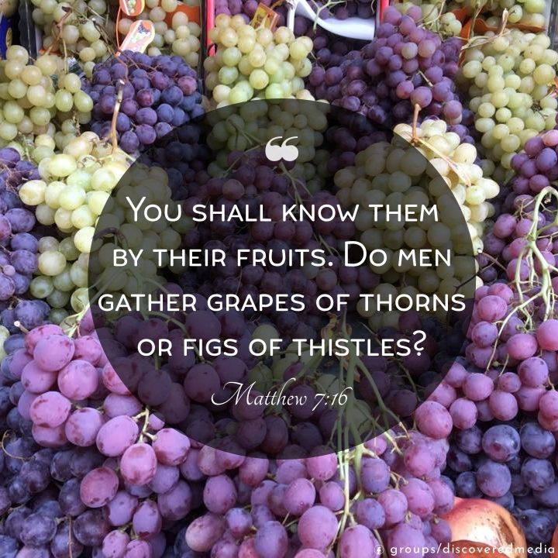

2 Corinthians 5:9-10
⁹ So we make it our goal to please him, whether we are at home in the body or away from it. ¹⁰ For we must all appear before the judgment seat of Christ, so that each of us may receive what is due us for the things done while in the body, whether good or bad.

2 Corinthians 5:14-20
¹⁴ For Christ’s love compels us, because we are convinced that one died for all, and therefore all died. ¹⁵ And he died for all, that those who live should no longer live for themselves but for him who died for them and was raised again.
¹⁶ So from now on we regard no one from a worldly point of view. Though we once regarded Christ in this way, we do so no longer. ¹⁷ Therefore, if anyone is in Christ, the new creation has come:^{[a]} The old has gone, the new is here! ¹⁸ All this is from God, who reconciled us to himself through Christ and gave us the ministry of reconciliation: ¹⁹ that God was reconciling the world to himself in Christ, not counting people’s sins against them. And he has committed to us the message of reconciliation. ²⁰ We are therefore Christ’s ambassadors, as though God were making his appeal through us. We implore you on Christ’s behalf: Be reconciled to God.

Footnotes
- 2 Corinthians 5:17 Or Christ, that person is a new creation.
We are therefore Christ’s ambassadors, as though God were making his appeal through us. 2 Corinthians 5:20

Today's Devotional
On the first day of a camp where Alan teaches teens entrepreneurial skills, a student said, “You’re a Christian, aren’t you? I can tell.” Before Alan said he was a Christian or wore his favorite socks and ties decorated with Christian symbols, the teen said he saw Jesus through Alan’s words, actions, and attitude. They discussed how they could better represent Jesus wherever they go.
Saying we’re Christian and wearing clothes with Christian messages are good things. However, the Bible teaches that the way we live and love as we share the gospel is the true identifier of those who follow Jesus. The apostle Paul and the other believers in Corinth were compelled, or driven, to please God by living with an eternal perspective while sharing Him with others (2 Corinthians 5:9-14).
When we’re committed to living for Christ instead of for ourselves, the Holy Spirit changes our perspective, character, priorities, and ways of interacting with others (vv. 15-17). Our new life in Jesus is intended to represent Him while we point others to Him, “as though God were making his appeal through us” (v. 20).
Empowered by the Spirit, we’re given the joy and responsibility of representing Christ wherever we go.

Reflect & Pray
How have others pointed you to Jesus by the way they lived? How has God’s transforming work in your life helped you become a better ambassador for Christ?
Life-transforming Jesus, please change me by Your Spirit so that I can better represent You wherever You send me.
For further study, read Paul's Pain and His Passion.

Today's Insights
Paul says that the goal for believers in Jesus should be “to please him” (2 Corinthians 5:9). As we share the gospel with others, how we live and love identifies true believers. The pattern Christ established with the twelve disciples is also valid for today. Before witnessing for Him through their words and actions, they looked, listened, and learned from Him. Of two of the twelve it was said, “When they saw the courage of Peter and John and realized that they were unschooled, ordinary men, they were astonished and they took note that these men had been with Jesus” (Acts 4:13). Those who represent Christ best are those who’ve been drawn to Him, forgiven by Him, and empowered by the Spirit to bear witness to His love and grace.

God Calling – 10/3/25

Blessed Assurance
And the work of righteousness shall be peace; and the effect of righteousness quietness and assurance for ever. -- Isaiah 32:17.
Be still and know that I am God. Only when a soul attains this calm can there be true work done, and mind and soul and body be strong to conquer and to bear.
The Peace is the work of righteousness -- living the right life, living with Me. Quietness and assurance follow.
Assurance is the calm born of a deep certainty in Me, in My Promise, in My Power to save and keep. Gain this calm, and at all costs keep this calm. Rest in Me. Live in Me. Calm, quiet, assured -- at Peace.
Elect according to the foreknowledge of God the Father, through sanctification of the Spirit, ... Grace unto you, and peace, be multiplied. 1 Peter 1:2

My Utmost for His Highest – 10/4/25

The Vision and The Reality


…to those who are…called to be saints… —1 Corinthians 1:2
Thank God for being able to see all that you have not yet been. You have had the vision, but you are not yet to the reality of it by any means. It is when we are in the valley, where we prove whether we will be the choice ones, that most of us turn back. We are not quite prepared for the bumps and bruises that must come if we are going to be turned into the shape of the vision. We have seen what we are not, and what God wants us to be, but are we willing to be battered into the shape of the vision to be used by God? The beatings will always come in the most common, everyday ways and through common, everyday people.
There are times when we do know what God’s purpose is; whether we will let the vision be turned into actual character depends on us, not on God. If we prefer to relax on the mountaintop and live in the memory of the vision, then we will be of no real use in the ordinary things of which human life is made. We have to learn to live in reliance upon what we saw in the vision, not simply live in ecstatic delight and conscious reflection upon God. This means living the realities of our lives in the light of the vision until the truth of the vision is actually realized in us. Every bit of our training is in that direction. Learn to thank God for making His demands known.
Our little “I am” always sulks and pouts when God says do. Let your little “I am” be shriveled up in God’s wrath and indignation— “I AM WHO I AM…has sent me to you” (Exodus 3:14). He must dominate. Isn’t it piercing to realize that God not only knows where we live, but also knows the gutters into which we crawl! He will hunt us down as fast as a flash of lightning. No human being knows human beings as God does.
Wisdom From Oswald Chambers
To read the Bible according to God’s providential order in your circumstances is the only way to read it, viz., in the blood and passion of personal life. Disciples Indeed, 387 R

CCEL – 10/4/25
Moses wist not that the skin of his face shone while he talked with him.—EXO. 34:29.
Not unto us, O Lord, not unto us, but unto thy name give glory.—Lord, when saw we thee a hungred, and fed thee? or thirsty, and gave thee drink?—In lowliness of mind, let each esteem other better than themselves.—Be clothed with humility.
[Jesus] was transfigured before them: and his face did shine as the sun, and his raiment was white as the light.—All that sat in the council, looking stedfastly on Stephen, saw his face as it had been the face of an angel.—The glory which thou gavest me, I have given them.—We all, with open face beholding as in a glass the glory of the Lord, are changed into the same image from glory to glory, even as by the Spirit of the Lord.
Ye are the light of the world. A city that is set on a hill cannot be hid. Neither do men light a candle, and put it under a bushel, but on a candlestick; and it giveth light unto all that are in the house.
Psa. 115:1. -Matt. 25:37. -Phi. 2:3. -I Pet. 5:5.Matt. 17:2. -Acts 6:15. -John 17:22. -II Cor. 3:18.Matt. 5:14,15.
“At evening time it shall be light.” Zechariah 14:7
Oftentimes we look forward with forebodings to the time of old age, forgetful that at eventide it shall be light. To many saints, old age is the choicest season in their lives. A balmier air fans the mariner’s cheek as he nears the shore of immortality, fewer waves ruffle his sea, quiet reigns, deep, still and solemn. From the altar of age the flashes of the fire of youth are gone, but the more real flame of earnest feeling remains. The pilgrims have reached the land Beulah, that happy country, whose days are as the days of heaven upon earth. Angels visit it, celestial gales blow over it, flowers of paradise grow in it, and the air is filled with seraphic music. Some dwell here for years, and others come to it but a few hours before their departure, but it is an Eden on earth. We may well long for the time when we shall recline in its shady groves and be satisfied with hope until the time of fruition comes. The setting sun seems larger than when aloft in the sky, and a splendour of glory tinges all the clouds which surround his going down. Pain breaks not the calm of the sweet twilight of age, for strength made perfect in weakness bears up with patience under it all. Ripe fruits of choice experience are gathered as the rare repast of life’s evening, and the soul prepares itself for rest.
The Lord’s people shall also enjoy light in the hour of death. Unbelief laments; the shadows fall, the night is coming, existence is ending. Ah no, crieth faith, the night is far spent, the true day is at hand. Light is come, the light of immortality, the light of a Father’s countenance. Gather up thy feet in the bed, see the waiting bands of spirits! Angels waft thee away. Farewell, beloved one, thou art gone, thou wavest thine hand. Ah, now it is light. The pearly gates are open, the golden streets shine in the jasper light. We cover our eyes, but thou beholdest the unseen; adieu, brother, thou hast light at even-tide, such as we have not yet.

Word Live – 10/4/25

https://content.scriptureunion.org.uk/wordlive/

Scripture Union – 10/4/25

https://scriptureunion.org/encounters/

Today in the Word – 10/4/25

Authenticity in Worship,
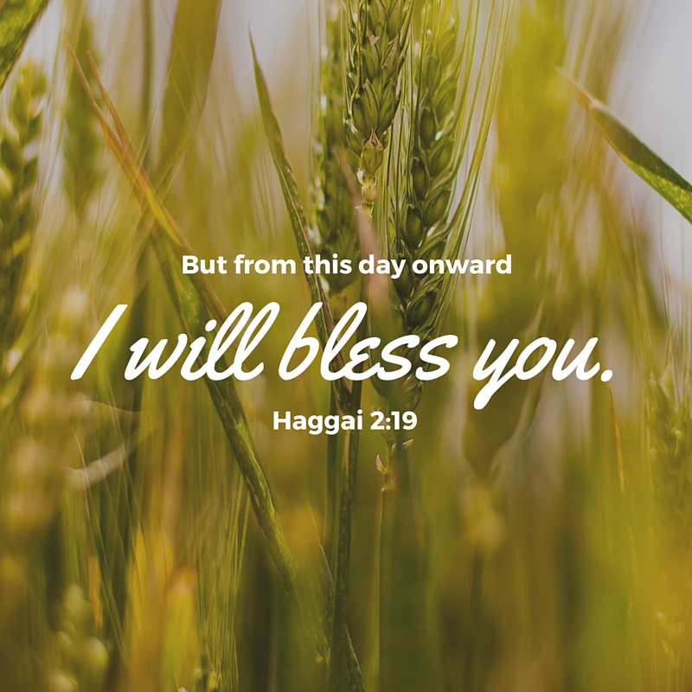

Read Haggai 2:10-19

Blessings for a Defiled People
¹⁰ On the twenty-fourth day of the ninth month, in the second year of Darius, the word of the Lord came to the prophet Haggai: ¹¹ “This is what the Lord Almighty says: ‘Ask the priests what the law says: ¹² If someone carries consecrated meat in the fold of their garment, and that fold touches some bread or stew, some wine, olive oil or other food, does it become consecrated?’”
The priests answered, “No.”
¹³ Then Haggai said, “If a person defiled by contact with a dead body touches one of these things, does it become defiled?”
“Yes,” the priests replied, “it becomes defiled.”
¹⁴ Then Haggai said, “‘So it is with this people and this nation in my sight,’ declares the Lord. ‘Whatever they do and whatever they offer there is defiled.
¹⁵ “‘Now give careful thought to this from this day on^{[a]}—consider how things were before one stone was laid on another in the Lord’s temple. ¹⁶ When anyone came to a heap of twenty measures, there were only ten. When anyone went to a wine vat to draw fifty measures, there were only twenty. ¹⁷ I struck all the work of your hands with blight, mildew and hail, yet you did not return to me,’ declares the Lord. ¹⁸ ‘From this day on, from this twenty-fourth day of the ninth month, give careful thought to the day when the foundation of the Lord’s temple was laid. Give careful thought: ¹⁹ Is there yet any seed left in the barn? Until now, the vine and the fig tree, the pomegranate and the olive tree have not borne fruit.
“‘From this day on I will bless you.’”

Footnotes
- Haggai 2:15 Or to the days past

Until now, the vine and the fig tree, the pomegranate and the olive tree have not born fruit. From this day on I will bless you.— Haggai 2:19

Imagine a husband who every Friday night brought home a bouquet of flowers and a card expressing his love to his wife. The rest of the week, however, he was inattentive, rude, and uncaring. It would not take long before the flowers and card would feel empty and hollow.

Haggai 2:10-19 provides us with the third message the Lord gave the prophet to deliver to the people. Here God asks the priest a question that may seem a bit strange to us. The question is: If someone took a piece of meat that had been made holy by sacrifice and then touched some bread or stew with it, would those items also become holy? The answer
is quite clear according to the Law, “No” (v. 12). But what if someone was ceremonially unclean because they touched a dead body. If they touched something, does it become defiled? The answer is equally clear, “Yes” (v. 13). The Law treats ceremonial holiness and uncleanness like health and sickness. You can catch sickness by being around a sick person, but you can’t catch health by being around a healthy person.

God then makes His point. In the same way that uncleanness is contagious, the people's worship had been corrupted. They had been going through the motions of worship and sacrifice, but their hearts were far from God (v. 14). Their spiritual condition was manifested in their neglect of the Temple (v. 15).

God cares deeply about our motives in worship. Our praise and worship does not mean much if it comes from a heart full of greed, selfish ambition, or pride. As the apostle Paul reminds us, “Offer your bodies as a living sacrifice, holy and pleasing to God—this is your true and proper worship” (Rom. 12:1).

Go Deeper

Do you ever go through the motions of worship? What does today’s reading and Romans 12:1 teach us about worship that God finds acceptable and pleasing?

Pray with Us

Holy God, we love and revere Your name. Cleanse us from hearts of empty praise, changing us to love You deeper. Forgive us for the times we replaced You with idols. You alone deserve our highest praise!

Our Daily Bread – 10/4/25

A Migrating Savior


Read: Matthew 2:13-15

The Escape to Egypt
¹³ When they had gone, an angel of the Lord appeared to Joseph in a dream. “Get up,” he said, “take the child and his mother and escape to Egypt. Stay there until I tell you, for Herod is going to search for the child to kill him.”
¹⁴ So he got up, took the child and his mother during the night and left for Egypt, ¹⁵ where he stayed until the death of Herod. And so was fulfilled what the Lord had said through the prophet: “Out of Egypt I called my son.”^{[a]}

Footnotes
- Matthew 2:15 Hosea 11:1
“Get up,” he said, “take the child and his mother and escape to Egypt.” Matthew 2:13

Today's Devotional
In 1947, with the dissolution of the British Indian Empire, more than 15 million people migrated for religious reasons. The upheaval was worsened by monsoon flooding and the spread of disease. More than a million refugees died.
Throughout history, people have migrated—seeking freedom, safety, or a better life. The urge to move is ingrained in the human experience. The most famous example in Scripture is the exodus story of the Hebrews to the promised land. Migration wasn’t foreign to Jesus either. As a young baby, His parents fled to Egypt to protect His life from the murderous Herod. It’s ironic that, just as the Israelites fled to the promised land (Exodus 3:17) to get away from a king who killed young boys (1:16), Joseph is told to take Jesus “and his mother and escape to Egypt” to flee a tyrant who did the same (Matthew 2:13; see vv. 16-18).
Matthew tells us this journey was to fulfill the prophecy in Hosea 11:1 that “out of Egypt I called my son” (Matthew 2:15). But it’s also a reminder that Christ understands the human experience (Hebrews 4:15). We have a Savior who knows us and has experienced the same kinds of trials and tribulations we have. We can seek Him in our difficult moments. He listens and intercedes on our behalf (Hebrews 4:14-16).

Reflect & Pray
How has migration impacted you personally? How might the story of Jesus be an encouragement to those who’ve had to flee for freedom or safety?
Dear Father, please protect those who are forced to migrate for safety.
For further study, read The God Who Is with Us—The Difference the Incarnation Makes.

Today's Insights
Matthew’s gospel account emphasizes the parallels between the coming of Jesus and God’s deliverance of His people from slavery in Egypt. In Exodus, a tyrannical pharaoh paranoid about perceived threats to his reign ordered that male Jewish babies be killed (1:16, 22). In an unlikely series of events, Moses’ life was spared (2:1-10). In Matthew, King Herod, fearing prophecies of a new king (2:2-3), sought to find the prophesied child through the magi (vv. 7-8). When this plot failed (v. 12), Herod made another attempt to kill the prophesied king by ordering the slaughter of all boys under two years of age in Bethlehem (vv. 16-18). Through fleeing to Egypt, Jesus and His family found safety (vv. 13-15). These parallels between the events of Exodus and Christ’s birth reveal Him to be the new Moses, who understands what it’s like to need to flee to safety. He understands the human experience, and we can trust Him during our times of difficulty.

God Calling – 10/4/25

All You Desire
He hath no form nor comeliness; and when we shall see him, there is no beauty that we should desire him. -- Isaiah 53:2.
My children, in this verse My servant Isaiah spoke of the wonderful illumination given to those who were Spirit-guided.
To those who know Me not, there is in Me nothing to appeal to them, or to attract them.
To those who know Me there is nothing more to be desired. "No beauty they could desire Him."
Oh! My children, draw very near to Me. See Me as I really am, that ever you may have the Joy of finding in Me all you could desire. The fulfillment of all you could desire in Master, Lord, or Friend.
One thing have I desired of the Lord, that will I seek after; that I may dwell in the
house of the Lord all the days of my life, to behold the beauty of the Lord... Psalm 27:4

My Utmost for His Highest – 10/5/25

The Nature of Degeneration

Just as through one man sin entered the world, and death through sin, and thus death spread to all men, because all sinned… —Romans 5:12
The Bible does not say that God punished the human race for one man’s sin, but that the nature of sin, namely, my claim to my right to myself, entered into the human race through one man. But it also says that another Man took upon Himself the sin of the human race and put it away— an infinitely more profound revelation (see Hebrews 9:26). The nature of sin is not immorality and wrongdoing, but the nature of self-realization which leads us to say, “I am my own god.” This nature may exhibit itself in proper morality or in improper immorality, but it always has a common basis— my claim to my right to myself. When our Lord faced either people with all the forces of evil in them, or people who were clean-living, moral, and upright, He paid no attention to the moral degradation of one, nor any attention to the moral attainment of the other. He looked at something we do not see, namely, the nature of man (see John 2:25).
Sin is something I am born with and cannot touch— only God touches sin through redemption. It is through the Cross of Christ that God redeemed the entire human race from the possibility of damnation through the heredity of sin. God nowhere holds a person responsible for having the heredity of sin, and does not condemn anyone because of it. Condemnation comes when I realize that Jesus Christ came to deliver me from this heredity of sin, and yet I refuse to let Him do so. From that moment I begin to get the seal of damnation. “This is the condemnation [and the critical moment], that the light has come into the world, and men loved darkness rather than light…” (John 3:19).
Wisdom From Oswald Chambers
To read the Bible according to God’s providential order in your circumstances is the only way to read it, viz., in the blood and passion of personal life. Disciples Indeed, 387 R

CCEL – 10/5/25
Call upon me in the day of trouble: I will deliver thee, and thou shalt glorify me.—PSA. 50:15.
Why art thou cast down, O my soul? and why art thou disquieted within me? hope thou in God: for I shall yet praise him, who is the health of my countenance, and my God.—Lord, thou hast heard the desire of the humble: thou wilt prepare their heart, thou wilt cause thine ear to hear.—For thou, Lord, art good, and ready to forgive; and plenteous in mercy unto all them that call upon thee.
Jacob said unto his household, . . . Let us arise and go up to Bethel; and I will make there an altar unto God, who answered me in the day of my distress, and was with me in the way which I went.—Bless the Lord, O my soul, and forget not all his benefits.
I love the Lord, because he hath heard my voice and my supplications. Because he hath inclined his ear unto me, therefore will I call upon him as long as I live. The sorrows of death compassed me, and the pains of hell gat hold upon me: I found trouble and sorrow. Then called I on the name of the Lord.
Psa. 42:11. -Psa. 10:17. -Psa. 86:5.Gen. 35:2,3. -Psa. 103:2.Psa. 116:1-4.
“He arose, and did eat and drink, and went in the strength of that meat forty days and forty nights.” 1 Kings 19:8
All the strength supplied to us by our gracious God is meant for service, not for wantonness or boasting. When the prophet Elijah found the cake baked on the coals, and the cruse of water placed at his head, as he lay under the juniper tree, he was no gentleman to be gratified with dainty fare that he might stretch himself at his ease; far otherwise, he was commissioned to go forty days and forty nights in the strength of it, journeying towards Horeb, the mount of God. When the Master invited the disciples to “Come and dine” with him, after the feast was concluded he said to Peter, “Feed my sheep”; further adding, “Follow me.” Even thus it is with us; we eat the bread of heaven, that we may expend our strength in the Master’s service. We come to the passover, and eat of the paschal lamb with loins girt, and staff in hand, so as to start off at once when we have satisfied our hunger. Some Christians are for living on Christ, but are not so anxious to live for Christ. Earth should be a preparation for heaven; and heaven is the place where saints feast most and work most. They sit down at the table of our Lord, and they serve him day and night in his temple. They eat of heavenly food and render perfect service. Believer, in the strength you daily gain from Christ labour for him. Some of us have yet to learn much concerning the design of our Lord in giving us his grace. We are not to retain the precious grains of truth as the Egyptian mummy held the wheat for ages, without giving it an opportunity to grow: we must sow it and water it. Why does the Lord send down the rain upon the thirsty earth, and give the genial sunshine? Is it not that these may all help the fruits of the earth to yield food for man? Even so the Lord feeds and refreshes our souls that we may afterwards use our renewed strength in the promotion of his glory.

Word Live – 10/5/25

https://content.scriptureunion.org.uk/wordlive/

Scripture Union – 10/5/25

https://scriptureunion.org/encounters/

Today in the Word – 10/5/25

Future Hope



Read Haggai 2:20-23

Zerubbabel the Lord’s Signet Ring
²⁰ The word of the Lord came to Haggai a second time on the twenty-fourth day of the month: ²¹ “Tell Zerubbabel governor of Judah that I am going to shake the heavens and the earth. ²² I will overturn royal thrones and shatter the power of the foreign kingdoms. I will overthrow chariots and their drivers; horses and their riders will fall, each by the sword of his brother.
²³ “‘On that day,’ declares the Lord Almighty, ‘I will take you, my servant Zerubbabel son of Shealtiel,’ declares the Lord, ‘and I will make you like my signet ring, for I have chosen you,’ declares the Lord Almighty.”
“1 will make you like my signet ring, for I have chosen you,” declares the Lord Almighty. — Haggai 2:23

It would have been easy for the apostle Paul to get discouraged. He had worked so hard to share the gospel and plant churches. Yet he was regularly imprisoned, the churches he founded were bickering and embracing false teaching, and his own people accused him of defiling the Temple (Acts 21:28). But despite all the hardships, Paul stayed focused on his mission. While sitting in a jail cell, he wrote to the Philippian church: “Forgetting what is behind and straining toward what is ahead, I press on toward the goal to win the prize for which God has called me heavenward in Christ Jesus” (Phil. 3:13—14).

It is this perspective rooted in a future hope that the Lord instilled in Haggai’s final prophetic message. The Lord encouraged Zerubbabel to reflect on the day of the Lord, when God would come to judge the earth (vv. 21-22). At that time, nations would not be saved because of their military might but because of their relationship with the Lord.

The book ends with a particular promise to Zerubbabel. God said, “I will take you, my servant ...and I will make you like my signet ring, for I have chosen you” (v. 23). A signet ring is a marker of identity. If a king sealed a document with his ring, it demonstrated that the document belonged to and came from the king. What is God saying here? Is He talking about Zerubbabel or a future figure? Since the overall context relates to the final judgment, it is best to understand that this verse points forward to a future Davidic king. Zerubbabel represents a future Messiah who would fulfill the Davidic covenant. God's promises to restore Israel would be ultimately fulfilled in Jesus, Lord of the nations (Rev. 7:9). Today we can express this hope by praying, “Come, Lord” (1 Cor. 16:22).

Go Deeper

How does anticipating the return of Jesus change the way we live today? What are some ways we can keep our focus on that purpose?

Pray with Us

Jesus, You are our King. As we eagerly await Your future coming, encourage our hearts that You will accomplish Your purposes. We trust You as the Sovereign Judge who deserves our obedience. Prepare our hearts to see You!

Our Daily Bread – 10/5/25

Sympathy Pain



Read: 1 Corinthians 12:21-26
²¹ The eye cannot say to the hand, “I don’t need you!” And the head cannot say to the feet, “I don’t need you!” ²² On the contrary, those parts of the body that seem to be weaker are indispensable, ²³ and the parts that we think are less honorable we treat with special honor. And the parts that are unpresentable are treated with special modesty, ²⁴ while our presentable parts need no special treatment. But God has put the body together, giving greater honor to the parts that lacked it, ²⁵ so that there should be no division in the body, but that its parts should have equal concern for each other. ²⁶ If one part suffers, every part suffers with it; if one part is honored, every part rejoices with it.
Carry each other’s burdens, and in this way you will fulfill the law of Christ. Galatians 6:2

Today's Devotional
When I injured my ring finger, I expected months of pain before regaining its full function. As I practiced the prescribed exercises, the finger next to it began to throb, so I consulted my doctor. “Sympathy pain,” he said. A branching between the nerves of the ring and pinky fingers causes dependence on one another. If one finger hurts, the other aches in sympathy.
The apostle Paul uses the human body to illustrate the uniqueness and unity of God’s people. In 1 Corinthians 12:21-26, he reinforces how valuable each individual member is to the healthy functioning of the whole. Then he turns his attention to the unity achieved when we connect with each other: “If one part suffers, every part suffers with it” (v. 26). His description of the church’s interconnectedness is echoed in these verses, as we ought to “mourn with those who mourn,” and “carry each other’s burdens” (Romans 12:15; Galatians 6:2).
Today, as I extend my hand to greet someone or grab a spoon to prepare a meal for guests, I notice the strain in both my ring finger and my pinky. The various parts of our physical bodies work together to express pain and to strengthen each other toward health. I thank God that He reveals our need for connection to each other in His spiritual body, the church, through sympathy pain.

Reflect & Pray
How is God inviting you to suffer with another in order to strengthen you both? How have others suffered with you?
Dear God, please help me be open to Your invitation to suffer with my brothers and sisters that we might all be strengthened.
Discover how to best help people through their pain.

Today's Insights
Of the many metaphors Paul uses to describe the church’s identity and mission (for example, temple, fellow citizens, God’s family), “the body” is probably his favorite, using it often to promote the oneness, unity, and solidarity of all believers in Jesus under the headship of Christ (see Ephesians 5:23).
He uses the body metaphor in 1 Corinthians 12:12: “Just as a body, though one, has many parts, but all its many parts form one body, so it is with Christ.” He highlights the church’s unity in diversity and instructs believers to prioritize their mutual concern for each other’s well-being, saying that everyone “should have equal concern for each other” (v. 25). Elsewhere, he instructs believers to “be devoted to one another in love” (Romans 12:10) and to step up to serve each other in practical ways (vv. 3-13). Particularly, he tells believers to “be happy with those who are happy, and weep with those who weep” (v. 15 nlt).

God Calling – 10/5/25

No Chance Meetings
The Lord shall preserve thy going out and thy coming in from this time forth, and even for evermore. -- Psalm 121:8.
All your movements, your goings and comings, controlled by Me. Every visit, all blessed by Me. Every walk arranged by Me. A blessing on all you do, on every interview.
Every meeting not a chance meeting, but planned by Me. All blessed.
Not only now, in the hour of your difficulty, but from this time forth and for evermore.
Led by the Spirit, a proof of Sonship. "As many as are led by the Spirit of God, they are the Sons of God," and if children then heirs -- heirs of God.
What a heritage! Heirs -- no prospect of being disinherited. "Heirs of God and joint heirs with Christ: if so be that you suffer with Him that you may be also glorified together."
So your suffering has its purpose. It is a proof of Sonship. It leads to perfection of character (the being glorified), and to Union with Me, God, too. Think of, and dwell upon, the rapture of this.
According as he hath chosen us in him before the foundation of the world, that we should be holy and without blame before him in love. Ephesians 1:4

My Utmost for His Highest – 10/6/25

The Nature of Regeneration


When it pleased God…to reveal His Son in me… —Galatians 1:15-16

If Jesus Christ is going to regenerate me, what is the problem He faces? It is simply this— I have a heredity in which I had no say or decision; I am not holy, nor am I likely to be; and if all Jesus Christ can do is tell me that I must be holy, His teaching only causes me to despair. But if Jesus Christ is truly a regenerator, someone who can put His own heredity of holiness into me, then I can begin to see what He means when He says that I have to be holy. Redemption means that Jesus Christ can put into anyone the hereditary nature that was in Himself, and all the standards He gives us are based on that nature— His teaching is meant to be applied to the life which He puts within us. The proper action on my part is simply to agree with God’s verdict on sin as judged on the Cross of Christ.

The New Testament teaching about regeneration is that when a person is hit by his own sense of need, God will put the Holy Spirit into his spirit, and his personal spirit will be energized by the Spirit of the Son of God— “…until Christ is formed in you” (Galatians 4:19). The moral miracle of redemption is that God can put a new nature into me through which I can live a totally new life. When I finally reach the edge of my need and know my own limitations, then Jesus says, “Blessed are you…” (Matthew 5:11). But I must get to that point. God cannot put into me, the responsible moral person that I am, the nature that was in Jesus Christ unless I am aware of my need for it.

Just as the nature of sin entered into the human race through one man, the Holy Spirit entered into the human race through another Man (see Romans 5:12-19). And redemption means that I can be delivered from the heredity of sin, and that through Jesus Christ I can receive a pure and spotless heredity, namely, the Holy Spirit.

WISDOM FROM OSWALD CHAMBERS

If a man cannot prove his religion in the valley, it is not worth anything. Shade of His Hand, 1200 L

CCEL – 10/6/25
The Lord God omnipotent reigneth.—REV. 19:6.

I know that thou canst do every thing.—The things which are impossible with men are possible with God.—He doeth according to his will in the army of heaven, and among the inhabitants of the earth: and none can stay his hand, or say unto him, What doest thou?—There is none that can deliver out of my hand: I will work, and who shall let it?—Abba, Father, all things are possible unto thee.

Believe ye that I am able to do this? They said unto him, Yea, Lord. Then touched he their eyes, saying, According to your faith be it unto you.—Lord, if thou wilt, thou canst make me clean. And Jesus put forth his hand and touched him, saying, I will; be thou clean.—The mighty God.—All power is given unto me in heaven and in earth.

Some trust in chariots, and some in horses: but we will remember the name of the Lord our God.—Be strong and courageous, be not afraid nor dismayed, . . . there be more with us than with him.

Job 42:2. -Luke 18:27. -Dan. 4:35.Isa. 43:13. -Mark 14:36.Matt. 9:28,29. -Matt. 8:2,3.Isa. 9:6. -Matt. 28:18.Psa. 20:7. -II Chr. 32:7.

“Whosoever drinketh of the water that I shall give him shall never thirst.” John 4:14

He who is a believer in Jesus finds enough in his Lord to satisfy him now, and to content him for evermore. The believer is not the man whose days are weary for want of comfort, and whose nights are long from absence of heart-cheering thought, for he finds in religion such a spring of joy, such a fountain of consolation, that he is content and happy. Put him in a dungeon and he will find good company; place him in a barren wilderness, he will eat the bread of heaven; drive him away from friendship, he will meet the “friend that sticketh closer than a brother.” Blast all his gourds, and he will find shadow beneath the Rock of Ages; sap the foundation of his earthly hopes, but his heart will still be fixed, trusting in the Lord. The heart is as insatiable as the grave till Jesus enters it, and then it is a cup full to overflowing. There is such a fulness in Christ that he alone is the believer’s all. The true saint is so completely satisfied with the all-sufficiency of Jesus that he thirsts no more—except it be for deeper draughts of the living fountain. In that sweet manner, believer, shalt thou thirst; it shall not be a thirst of pain, but of loving desire; thou wilt find it a sweet thing to be panting after a fuller enjoyment of Jesus’ love. One in days of yore said, “I have been sinking my bucket down into the well full often, but now my thirst after Jesus has become so insatiable, that I long to put the well itself to my lips, and drink right on.” Is this the feeling of thine heart now, believer? Dost thou feel that all thy desires are satisfied in Jesus, and that thou hast no want now, but to know more of him, and to have closer fellowship with him? Then come continually to the fountain, and take of the water of life freely. Jesus will never think you take too much, but will ever welcome you, saying, “Drink, yea, drink abundantly, O beloved.”

Word Live – 10/6/25

https://content.scriptureunion.org.uk/wordlive/

Scripture Union – 10/6/25

https://scriptureunion.org/encounters/

Today in the Word – 10/6/25

A God Who Restores.
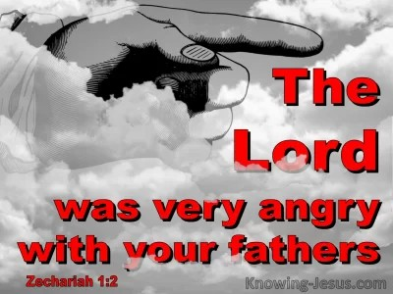

Read Zechariah 1:1-20

A Call to Return to the Lord
1 In the eighth month of the second year of Darius, the word of the Lord came to the prophet Zechariah son of Berekiah, the son of Iddo:
² “The Lord was very angry with your ancestors. ³ Therefore tell the people: This is what the Lord Almighty says: ‘Return to me,’ declares the Lord Almighty, ‘and I will return to you,’ says the Lord Almighty. ⁴ Do not be like your ancestors, to whom the earlier prophets proclaimed: This is what the Lord Almighty says: ‘Turn from your evil ways and your evil practices.’ But they would not listen or pay attention to me, declares the Lord. ⁵ Where are your ancestors now? And the prophets, do they live forever? ⁶ But did not my words and my decrees, which I commanded my servants the prophets, overtake your ancestors?
“Then they repented and said, ‘The Lord Almighty has done to us what our ways and practices deserve, just as he determined to do.’”

The Man Among the Myrtle Trees
⁷ On the twenty-fourth day of the eleventh month, the month of Shebat, in the second year of Darius, the word of the Lord came to the prophet Zechariah son of Berekiah, the son of Iddo.
⁸ During the night I had a vision, and there before me was a man mounted on a red horse. He was standing among the myrtle trees in a ravine. Behind him were red, brown and white horses.
⁹ I asked, “What are these, my lord?”
The angel who was talking with me answered, “I will show you what they are.”
¹⁰ Then the man standing among the myrtle trees explained, “They are the ones the Lord has sent to go throughout the earth.”
¹¹ And they reported to the angel of the Lord who was standing among the myrtle trees, “We have gone throughout the earth and found the whole world at rest and in peace.”
¹² Then the angel of the Lord said, “Lord Almighty, how long will you withhold mercy from Jerusalem and from the towns of Judah, which you have been angry with these seventy years?” ¹³ So the Lord spoke kind and comforting words to the angel who talked with me.
¹⁴ Then the angel who was speaking to me said, “Proclaim this word: This is what the Lord Almighty says: ‘I am very jealous for Jerusalem and Zion, ¹⁵ and I am very angry with the nations that feel secure. I was only a little angry, but they went too far with the punishment.’
¹⁶ “Therefore this is what the Lord says: ‘I will return to Jerusalem with mercy, and there my house will be rebuilt. And the measuring line will be stretched out over Jerusalem,’ declares the Lord Almighty.
¹⁷ “Proclaim further: This is what the Lord Almighty says: ‘My towns will again overflow with prosperity, and the Lord will again comfort Zion and choose Jerusalem.’”

Four Horns and Four Craftsmen
¹⁸ Then I looked up, and there before me were four horns. ¹⁹ I asked the angel who was speaking to me, “What are these?”
He answered me, “These are the horns that scattered Judah, Israel and Jerusalem.”
²⁰ Then the Lord showed me four craftsmen.
Come near to God and he will come near to you.—James 4:8

Most people are deeply shaped by their upbringing. They embody patterns of behavior they saw in their parents and pass that down to their children. It is difficult to break patterns of generational sin and dysfunction. Yet, this is exactly what the Lord called Israel to do in the first prophetic message of Zechariah.

The idolatry, oppression, and unfaithfulness of Israel’s ancestors led to their exile and destruction. In Zechariah 1, the Lord warned Israel, “Do not be like your ancestors, to whom the earlier prophets proclaimed” (v. 4). Instead, He called them to change their ways. The Lord had miraculously allowed Israel to return from exile. He now gave them a chance to start over. The people of Israel resolved to get it right this time (v. 6).

Shortly after the first message, the Lord came again to Zechariah. The message is carefully dated by the reign of a Persian king (v. 7). This reminded Israel that they were still under the thumb of a foreign empire. Yet, the message is hopeful. Zechariah saw angels mounted on horses roaming the earth (v. 10). These angelic beings reported back what they discovered—a world at peace (v.11). This peace was a contrast to the ruin of Jerusalem. The angel of the Lord pleaded on behalf of Judah and Jerusalem (v. 12). The Lord responded by promising a future for Jerusalem in which, “My towns will again overflow with prosperity” (v. 17). This promise looks forward to the time when the Messiah Jesus will return and rule from Jerusalem (Jer. 31:38—40; Isa.60:4-9). The call to believers today is the same as it was to Israel, “Come near to God and he will come near to you” (James 4:8).

Go Deeper

What negative patterns were the people of Israel repeating? What patterns do you need to break in your family or your own history? We can be thankful to serve a God who restores.

Pray with Us

Father, we believe that You can restore all things. Help us to rely on You to change our lives. Redeem us from the patterns of sin in our families and communities and grant us hope for the future.

Our Daily Bread – 10/6/25

Making Room for Others



Read: Philippians 2:1-11

Imitating Christ’s Humility
2 Therefore if you have any encouragement from being united with Christ, if any comfort from his love, if any common sharing in the Spirit, if any tenderness and compassion, ² then make my joy complete by being like-minded, having the same love, being one in spirit and of one mind. ³ Do nothing out of selfish ambition or vain conceit. Rather, in humility value others above yourselves, ⁴ not looking to your own interests but each of you to the interests of the others.
⁵ In your relationships with one another, have the same mindset as Christ Jesus:
⁶ Who, being in very nature^{[a]} God,
did not consider equality with God something to be used to his own advantage;
⁷ rather, he made himself nothing
by taking the very nature^{[b]} of a servant,
being made in human likeness.
⁸ And being found in appearance as a man,
he humbled himself
by becoming obedient to death—
even death on a cross!
⁹ Therefore God exalted him to the highest place
and gave him the name that is above every name,
¹⁰ that at the name of Jesus every knee should bow,
in heaven and on earth and under the earth,
¹¹ and every tongue acknowledge that Jesus Christ is Lord,
to the glory of God the Father.

Footnotes
- Philippians 2:6 Or in the form of
- Philippians 2:7 Or the form
In humility value others above yourselves, not looking to your own interests but each of you to the interests of the others. Philippians 2:3-4

Today's Devotional
At electric vehicle charging stations across the United States, some drivers overstay their time at “fast-chargers,” which are designed to help drivers quickly charge their cars and get back on the road. To resolve this unkind behavior, one of the largest charging networks has implemented strict time limits at some of its busiest stations. When a vehicle’s battery charge reaches eighty-five percent, the driver must make room for the next car in need of a charge.
The apostle Paul encouraged believers in Jesus to humbly “value others above [themselves]” (Philippians 2:3). He addressed an issue that was grating the Philippian church—self-centeredness. The people desired recognition and distinction, not from pure motives but from “selfish ambition” (v. 3). Paul urged the believers to have the mind of Christ and to look “to the interests of the others” (v. 4). This didn’t mean that they should forget their own needs in an unhealthy way, but that they would care for others’ needs as those who “have the same mindset as Christ Jesus” (v. 5). The apostle encouraged the Philippians to empty themselves of pride and to humbly make room for others. The ultimate motivation for making room? Love.
As we seek to imitate Christ’s example each day (vv. 6-11), He can help us make room for others by viewing them with His loving eyes.

Reflect & Pray
How can you place others’ needs above your own? What does it mean to see others through God’s eyes?
Dear God, please help me empty myself and make room for others.

Today's Insights
Paul’s teaching in Philippians 2:1-11 describes the core values that believers in Jesus are to exhibit. Christ exemplified these principles by becoming a man, living as a servant, and surrendering to death by crucifixion (vv. 7-8). Jesus’ example and teaching in John 13 amplify the need for believers to serve others. Hours before His crucifixion, John describes Christ having “a towel around his waist” (v. 4). Jesus ignored His status as their leader and washed the dusty feet of all present: “After that, he poured water into a basin and began to wash his disciples’ feet, drying them with the towel that was wrapped around him” (v. 5). His actions were complemented with these words: “Now that I, your Lord and Teacher, have washed your feet, you also should wash one another’s feet” (v. 14). Christ calls us to imitate His example of love and humility and serve others.

God Calling – 10/6/25

A Child's Hand

Dear Lord, we cling to Thee.

Yes, cling. Your faith shall be rewarded. Do you not know what it means to feel a little trusting hand in yours, to know a child's confidence?

Does that not draw out your Love and desire to protect, to care? Think what My Heart feels, when in your helplessness you turn to Me, clinging, desiring My Love and Protection.

Would you fail that child, faulty and weak as you are? Could I fail you? Just know it is not possible. Know all is well. You must not doubt. You must be sure. There is no miracle I cannot perform, nothing I cannot do. No eleventh-hour rescue I cannot accomplish.

And now, O Lord my God, thou hast made thy servant king instead of David my father: and I am but a little child: I know not how to go out or come in. 1 Kings 3:7

