My Utmost for His Highest – 10/7/25

The Nature of Reconciliation
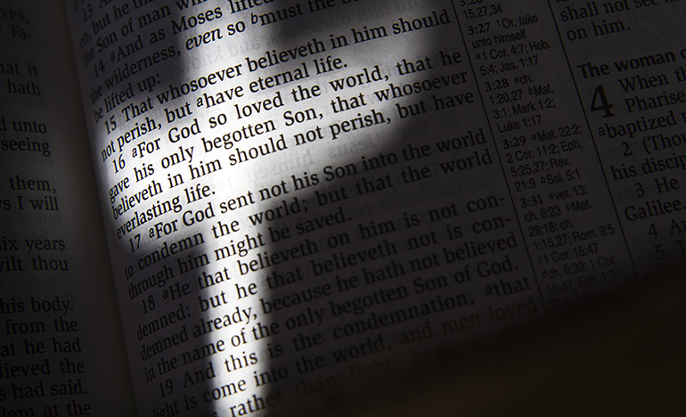

He made Him who knew no sin to be sin for us, that we might become the righteousness of God in Him. —2 Corinthians 5:21

Sin is a fundamental relationship— it is not wrongdoing, but wrong being— it is deliberate and determined independence from God. The Christian faith bases everything on the extreme, self-confident nature of sin. Other faiths deal with sins— the Bible alone deals withsin. The first thing Jesus Christ confronted in people was the heredity of sin, and it is because we have ignored this in our presentation of the gospel that the message of the gospel has lost its sting and its explosive power.

The revealed truth of the Bible is not that Jesus Christ took on Himself our fleshly sins, but that He took on Himself the heredity of sin that no man can even touch. God made His own Son “to be sin” that He might make the sinner into a saint. It is revealed throughout the Bible that our Lord took on Himself the sin of the world through identification with us, not through sympathy for us. He deliberately took on His own shoulders, and endured in His own body, the complete, cumulative sin of the human race. “He made Him who knew no sin to be sin for us…” and by so doing He placed salvation for the entire human race solely on the basis of redemption. Jesus Christ reconciled the human race, putting it back to where God designed it to be. And now anyone can experience that reconciliation, being brought into oneness with God, on the basis of what our Lord has done on the cross.

A man cannot redeem himself— redemption is the work of God, and is absolutely finished and complete. And its application to individual people is a matter of their own individual action or response to it. A distinction must always be made between the revealed truth of redemption and the actual conscious experience of salvation in a person’s life.

WISDOM FROM OSWALD CHAMBERS

Civilization is based on principles which imply that the passing moment is permanent. The only permanent thing is God, and if I put anything else as permanent, I become atheistic. I must build only on God (John 14:6). The Highest Good—Thy Great Redemption, 565 L

CCEL – 10/7/25
The meek will he teach his way.—PSA. 25:9.

Blessed are the meek.

I returned, and saw under the sun, that the race is not to the swift, nor the battle to the strong, neither yet bread to the wise, nor yet riches to men of understanding, nor yet favour to men of skill.—A man's heart deviseth his way: but the Lord directeth his steps.

Unto thee lift I up mine eyes, O Thou that dwellest in the heavens. Behold, as the eyes of servants look unto the hand of their masters, and as the eyes of a maiden unto the hand of her mistress; so our eyes wait upon theLord our God.—Cause me to know the way wherein I should walk; for I lift up my soul unto thee.

O our God, wilt thou not judge them? for we have no might against this great company that cometh against us; neither know we what to do: but our eyes are upon thee.

If any of you lack wisdom, let him ask of God, that giveth to all men liberally, and upbraideth not; and it shall be given him.

When he, the Spirit of truth, is come, he will guide you into all truth.

Matt. 5:5.Eccl. 9:11. -Prov. 16:9.Psa. 123:1,2. –Psa.143:8.II Chr. 20:12.Jas. 1:5.John 16:13.

“Wherefore hast thou afflicted thy servant?” Numbers 11:11

Our heavenly Father sends us frequent troubles to try our faith. If our faith be worth anything, it will stand the test. Gilt is afraid of fire, but gold is not: the paste gem dreads to be touched by the diamond, but the true jewel fears no test. It is a poor faith which can only trust God when friends are true, the body full of health, and the business profitable; but that is true faith which holds by the Lord’s faithfulness when friends are gone, when the body is sick, when spirits are depressed, and the light of our Father’s countenance is hidden. A faith which can say, in the direst trouble, “Though he slay me, yet will I trust in him,” is heaven-born faith. The Lord afflicts his servants to glorify himself, for he is greatly glorified in the graces of his people, which are his own handiwork. When “tribulation worketh patience; and patience, experience; and experience, hope,” the Lord is honoured by these growing virtues. We should never know the music of the harp if the strings were left untouched; nor enjoy the juice of the grape if it were not trodden in the winepress; nor discover the sweet perfume of cinnamon if it were not pressed and beaten; nor feel the warmth of fire if the coals were not utterly consumed. The wisdom and power of the great Workman are discovered by the trials through which his vessels of mercy are permitted to pass. Present afflictions tend also to heighten future joy. There must be shades in the picture to bring out the beauty of the lights. Could we be so supremely blessed in heaven, if we had not known the curse of sin and the sorrow of earth? Will not peace be sweeter after conflict, and rest more welcome after toil? Will not the recollection of past sufferings enhance the bliss of the glorified? There are many other comfortable answers to the question with which we opened our brief meditation, let us muse upon it all day long.

Word Live – 10/7/25

https://content.scriptureunion.org.uk/wordlive/

Scripture Union – 10/7/25

https://scriptureunion.org/encounters/

Today in the Word – 10/7/25

Hope in the Ruins


Read Zechariah 2:1–13

Third Vision: The Man with a Measuring Line
2 ^{[a]} I looked up and saw a man with a measuring line in his hand. ² Then I asked, ‘Where are you going?’ He answered me, ‘To measure Jerusalem, to see what is its width and what is its length.’ ³ Then the angel who talked with me came forward, and another angel came forward to meet him, ⁴ and said to him, ‘Run, say to that young man: Jerusalem shall be inhabited like villages without walls, because of the multitude of people and animals in it. ⁵ For I will be a wall of fire all round it, says the Lord, and I will be the glory within it.’

Interlude: An Appeal to the Exiles
⁶ Up, up! Flee from the land of the north, says the Lord; for I have spread you abroad like the four winds of heaven, says the Lord. ⁷ Up! Escape to Zion, you that live with daughter Babylon. ⁸ For thus said the Lord of hosts (after his glory^{[b]} sent me) regarding the nations that plundered you: Truly, one who touches you touches the apple of my eye.^{[c]} ⁹ See now, I am going to raise^{[d]} my hand against them, and they shall become plunder for their own slaves. Then you will know that the Lord of hosts has sent me. ¹⁰ Sing and rejoice, O daughter Zion! For lo, I will come and dwell in your midst, says the Lord. ¹¹ Many nations shall join themselves to the Lord on that day, and shall be my people; and I will dwell in your midst. And you shall know that the Lord of hosts has sent me to you. ¹² The Lord will inherit Judah as his portion in the holy land, and will again choose Jerusalem.
¹³ Be silent, all people, before the Lord; for he has roused himself from his holy dwelling.

Footnotes
- Zechariah 2:1 Ch 2.5 in Heb
- Zechariah 2:8 Cn: Heb after glory he
- Zechariah 2:8 Heb his eye
- Zechariah 2:9 Or wave
“Shout and be glad, Daughter Zion. For I am coming, and I will live among you,” declares the LORD. Zechariah 2:10
According to a recent Gallup poll, 69 percent of Americans believe in angels. That number is down from 79 percent in 2001. The Bible clearly teaches that there is a spiritual realm that does include angels. In Zechariah 2, we read about two different angels who delivered a message from the Lord to Zechariah. This chapter focuses on the message of the second angel.
The angel came with an encouraging message. Despite the seemingly small and powerless appearance of the city of Jerusalem, it had a bright future. The city did not have any walls, the Temple was under construction, and many Israelites had decided to stay in Babylon instead of returning to their homeland. Yet the angel said the future Jerusalem would be a city without walls—not because it was so small but because it was so large! There would be so many people they could not be contained within walls (v. 4). Instead, the Lord “will be a wall of fire around it” (v. 5).
God would dwell with His people: “Many nations will be joined with the Lord in that day and will become my people” (v. 11). The promise God made to Abraham would be fulfilled, “all peoples on earth” would be blessed through him (Gen. 12:3).
Today, the church is called to take the gospel to all the nations (Matt. 28:19). During the millennial kingdom, Jesus will reign over a renewed Israel in Jerusalem and the nations will stream to His presence (Isa. 2:2–4; 49:22–23; 60:10–11). This future hope should inspire us to faithfulness and gospel proclamation. Our hope is in the coming of the Lord Jesus! We can “be still before the LORD” (v. 13), trusting in God’s promised future.
Go Deeper
Look again at the description of the future promised by God. How does (or should) this change our perspective on anxiety over the state of the world for those who trust in Jesus?
Pray with Us
O Lord, we thank You for making a way for us to dwell with You. May we seek to proclaim this good news to our hurting world as we look forward to Your kingdom.

Our Daily Bread – 10/7/25

What God Will Do

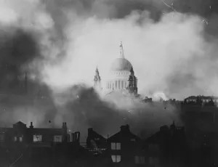

Read: John 16:31-33
³¹ Jesus answered them, ‘Do you now believe? ³² The hour is coming, indeed it has come, when you will be scattered, each one to his home, and you will leave me alone. Yet I am not alone because the Father is with me. ³³ I have said this to you, so that in me you may have peace. In the world you face persecution. But take courage; I have conquered the world!’
In this world you will have trouble. But take heart! I have overcome the world. John 16:33

Today's Devotional
During the Blitz on London on December 29, 1940, a bomb destroyed a warehouse near St. Paul’s Cathedral. When Biddy Chambers received the news that all 40,000 copies of Oswald Chambers’ books stored there were lost—which she had compiled and edited but not insured—she set down her teacup and remarked to her daughter, “Well, God has used the books for His glory, but now that is over. We’ll wait and see what God will do now.”
Perhaps Biddy was remembering what her late husband, Oswald, had written at the start of the First World War. He noted how Jesus had spoken to His disciples about “the inevitability of peril” so that when horrible things happened, they would “not be scared” because He was with them.
Jesus told His friends, “In this world you will have trouble. But take heart! I have overcome the world” (John 16:33). He wanted them to remain strong in their faith in His Father so they could withstand the trials and challenges they would endure.
Biddy’s quiet confidence in God carried her through, and eventually the books were reprinted and became classics for generations. We too can find encouragement and hope in Jesus’ promises that He has overcome the world. We know that He won’t leave us (14:18) and will give us peace (v. 27), no matter what we face.

Reflect & Pray
How do you respond to Biddy’s reaction when she heard the devastating news of the books burning? How could you follow her example of trusting God?
Loving Jesus, please help me to “overcome the world” in my daily life as I share Your love with others.
For further study, listen to A Psalm of Trust.

Today's Insights
As we face uncertainty in this world (as was the case with the disciples in John 16), receiving words of comfort can be like a two-sided coin. One side is stamped with the words, “Take heart!” (v. 33) or “Fear not!” We can take this command seriously and trust God in the face of all kinds of fears. Then we see the other side of the comfort coin: “I [Jesus] have overcome the world” (v. 33). The words of Christ, prophetic and anticipatory at the time they were spoken, have even greater meaning today on this side of the cross and resurrection. Jesus was indeed victorious! He conquered death, and because He did, “We are more than conquerors through him who loved us” (Romans 8:37). No matter what we face, because of our faith in Christ, God will be with us and will give us peace.

God Calling – 10/7/25

Rejoice at Weakness

Savior, breathe forgiveness o'er us. All our weakness thou dost know.

Yes! I know all. Every cry for mercy. Every eye of weariness. Every plea for help. Every sorrow over failure. Every weakness.

I am with you through all. My tender sympathy is yours. My strength is yours.

Rejoice at your weakness, My children. My strength is made perfect in weakness. When you are weak then I am strong. Strong to help, to cure, to protect.

Trust Me, My children. I know all. I am beside you. Strong, strong, strong to save. Lean on My Love, and know that all is well.

Hast thou not heard, that the everlasting God, the Lord, the Creator of the ends of the earth, fainteth not, neither is weary? There is no searching of his understanding. Isaiah 40:28

My Utmost for His Highest – 10/8/25

Coming to Jesus


Come to Me… —Matthew 11:28

Isn’t it humiliating to be told that we must come to Jesus! Think of the things about which we will not come to Jesus Christ. If you want to know how real you are, test yourself by these words— “Come to Me….” In every dimension in which you are not real, you will argue or evade the issue altogether rather than come; you will go through sorrow rather than come; and you will do anything rather than come the last lap of the race of seemingly unspeakable foolishness and say, “Just as I am, I come.” As long as you have even the least bit of spiritual disrespect, it will always reveal itself in the fact that you are expecting God to tell you to do something very big, and yet all He is telling you to do is to “Come….”

“Come to Me….” When you hear those words, you will know that something must happen in you before you can come. The Holy Spirit will show you what you have to do, and it will involve anything that will uproot whatever is preventing you from getting through to Jesus. And you will never get any further until you are willing to do that very thing. The Holy Spirit will search out that one immovable stronghold within you, but He cannot budge it unless you are willing to let Him do so.

How often have you come to God with your requests and gone away thinking, “I’ve really received what I wanted this time!” And yet you go away with nothing, while all the time God has stood with His hands outstretched not only to take you but also for you to take Him. Just think of the invincible, unconquerable, and untiring patience of Jesus, who lovingly says, “Come to Me….”

WISDOM FROM OSWALD CHAMBERS

There is no condition of life in which we cannot abide in Jesus. We have to learn to abide in Him wherever we are placed. Our Brilliant Heritage

CCEL – 10/8/25
I will not fear what man shall do unto me.—HEB. 13:6.

Who shall separate us from the love of Christ? shall tribulation, or distress, or persecution, or famine, or nakedness, or peril, or sword? Nay, in all these things we are more than conquerors through him that loved us.

Be not afraid of them that kill the body, and after that have no more that they can do. But I will forewarn you whom ye shall fear: Fear him, which after he hath killed hath power to cast into hell: yea, I say unto you, Fear him.

Blessed are they which are persecuted for righteousness' sake: for theirs is the kingdom of heaven. Blessed are ye, when men shall revile you and persecute you, and shall say all manner of evil against you falsely, for my sake. Rejoice, and be exceeding glad: for great is your reward in heaven.—None of these things move me, neither count I my life dear unto myself, so that I might finish my course with joy.—I will speak of thy testimonies . . . before kings, and will not be ashamed.

Rom. 8:35,37.Luke 12:4,5.Matt. 5:10-12. -Acts 20:24. -Psa. 119:46.

“Launch out into the deep, and let down your nets for a draught.” Luke 5:4

We learn from this narrative, the necessity of human agency. The draught of fishes was miraculous, yet neither the fisherman nor his boat, nor his fishing tackle were ignored; but all were used to take the fishes. So in the saving of souls, God worketh by means; and while the present economy of grace shall stand, God will be pleased by the foolishness of preaching to save them that believe. When God worketh without instruments, doubtless he is glorified; but he hath himself selected the plan of instrumentality as being that by which he is most magnified in the earth. Means of themselves are utterly unavailing. “Master, we have toiled all the night and have taken nothing.” What was the reason of this? Were they not fishermen plying their special calling? Verily, they were no raw hands; they understood the work. Had they gone about the toil unskilfully? No. Had they lacked industry? No, they had toiled. Had they lacked perseverance? No, they had toiled all the night. Was there a deficiency of fish in the sea? Certainly not, for as soon as the Master came, they swam to the net in shoals. What, then, is the reason? Is it because there is no power in the means of themselves apart from the presence of Jesus? “Without him we can do nothing.” But with Christ we can do all things. Christ’s presence confers success. Jesus sat in Peter’s boat, and his will, by a mysterious influence, drew the fish to the net. When Jesus is lifted up in his Church, his presence is the Church’s power—the shout of a king is in the midst of her. “I, if I be lifted up, will draw all men unto me.” Let us go out this morning on our work of soul fishing, looking up in faith, and around us in solemn anxiety. Let us toil till night comes, and we shall not labour in vain, for he who bids us let down the net, will fill it with fishes.

Word Live – 10/8/25

https://content.scriptureunion.org.uk/wordlive/

Scripture Union – 10/8/25
https://scriptureunion.org/encounters/

Today in the Word – 10/8/25

Satan Silenced
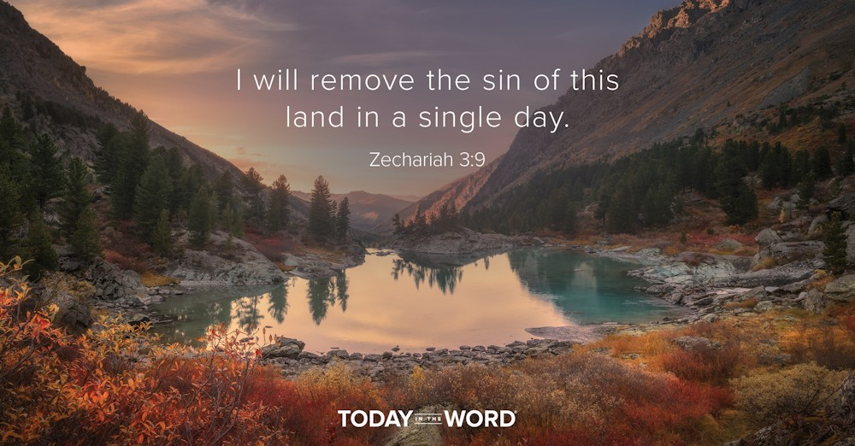

Read Zechariah 3:1–10

Fourth Vision: Joshua and Satan
3 Then he showed me the high priest Joshua standing before the angel of the Lord, and Satan^{[a]} standing at his right hand to accuse him. ² And the Lord said to Satan,^{[b]} ‘The Lord rebuke you, O Satan!^{[c]} The Lord who has chosen Jerusalem rebuke you! Is not this man a brand plucked from the fire?’ ³ Now Joshua was dressed in filthy clothes as he stood before the angel. ⁴ The angel said to those who were standing before him, ‘Take off his filthy clothes.’ And to him he said, ‘See, I have taken your guilt away from you, and I will clothe you in festal apparel.’ ⁵ And I said, ‘Let them put a clean turban on his head.’ So they put a clean turban on his head and clothed him in the apparel; and the angel of the Lord was standing by.
⁶ Then the angel of the Lord assured Joshua, saying ⁷ ‘Thus says the Lord of hosts: If you will walk in my ways and keep my requirements, then you shall rule my house and have charge of my courts, and I will give you the right of access among those who are standing here. ⁸ Now listen, Joshua, high priest, you and your colleagues who sit before you! For they are an omen of things to come: I am going to bring my servant the Branch. ⁹ For on the stone that I have set before Joshua, on a single stone with seven facets, I will engrave its inscription, says the Lord of hosts, and I will remove the guilt of this land in a single day. ¹⁰ On that day, says the Lord of hosts, you shall invite each other to come under your vine and fig tree.’

Footnotes
- Zechariah 3:1 Or the Accuser; Heb the Adversary
- Zechariah 3:2 Or the Accuser; Heb the Adversary
- Zechariah 3:2 Or the Accuser; Heb the Adversary
I will remove the sin of this land in a single day.Zechariah 3:9
When I was driving down a rural Michigan road, I was pulled over by a county sheriff. I had not noticed that I had entered a small town and the speed limit had dropped to 35mph. There was nothing I could say to defend myself. I was clearly guilty.
In Zechariah 3, Joshua—the high priest—is on trial before the angel of the Lord (v. 1). In this vision, Joshua represents the people of Israel, accused by Satan. He is clearly guilty. Joshua was dressed in “filthy clothes,” representing the sin of the people (v. 3). There was nothing Joshua could do to save himself. Yet, Satan was rebuked by the Lord. Despite Israel’s sin, God had chosen and delivered them (v. 2).
The angel of the Lord removed Joshua’s filthy clothing and replaced it with festive garments (v. 3). The Lord charged Joshua to “walk in obedience to me and keep my requirements” (v. 7). Despite Israel’s sin, they were given another opportunity to be faithful to the Lord. In verses 8–10, we read about a future Servant called the Branch (v. 8). This servant is also called a stone (v. 9). “Servant, “Branch,” and “stone” are references to a future messianic figure (Isa. 42:1–4; Jer. 33:15; Isa. 28:16). When that figure comes, the Lord declared, “I will remove the sin of this land in a single day” (v. 9).
This passage powerfully illustrates that we cannot save ourselves. Our sin has separated us from God, and we stand before Him guilty. It is only through the work of the Messiah Jesus that our sin can be forgiven and our relationship with God restored. God has done for us what we could never do for ourselves (Rom. 5:8). We can trust in the finished work of Jesus (John 3:16).
Go Deeper
Do you know Jesus Christ as your Savior? Have you accepted His gift of salvation? Talk to a pastor or go to moodybible.org/knowing-christ/ to take that important step today!
Pray with Us
God, I confess that I am guilty before You. I thank You for offering the gift of salvation through Your Son’s sacrifice on the cross. I trust in You alone to remove my sin and grant me righteousness in Your eyes.

Our Daily Bread – 10/8/25

Jesus’ Work



Read: Ephesians 4:1-6

Unity in the Body of Christ
4 I therefore, the prisoner in the Lord, beg you to lead a life worthy of the calling to which you have been called, ² with all humility and gentleness, with patience, bearing with one another in love, ³ making every effort to maintain the unity of the Spirit in the bond of peace. ⁴ There is one body and one Spirit, just as you were called to the one hope of your calling, ⁵ one Lord, one faith, one baptism, ⁶ one God and Father of all, who is above all and through all and in all.
Read: Ephesians 4:11-16
¹¹ The gifts he gave were that some would be apostles, some prophets, some evangelists, some pastors and teachers, ¹² to equip the saints for the work of ministry, for building up the body of Christ, ¹³ until all of us come to the unity of the faith and of the knowledge of the Son of God, to maturity, to the measure of the full stature of Christ. ¹⁴ We must no longer be children, tossed to and fro and blown about by every wind of doctrine, by people’s trickery, by their craftiness in deceitful scheming. ¹⁵ But speaking the truth in love, we must grow up in every way into him who is the head, into Christ, ¹⁶ from whom the whole body, joined and knitted together by every ligament with which it is equipped, as each part is working properly, promotes the body’s growth in building itself up in love.
I urge you to live a life worthy of the calling you have received. Ephesians 4:1

Today's Devotional
In 1997, Iowa State University named its football stadium after the school’s first black athlete: Jack Trice. Tragically, Trice had never even played in Ames, Iowa—he died from internal injuries sustained during a play in his second college game, played in Minneapolis, Minnesota on October 6, 1923.
Trice wrote a note to himself the night before the game, bearing witness to his determination:
“The honor of my race, family, and self are at stake. Everyone is expecting me to do big things. I will! My whole body and soul are to be thrown recklessly about on the field tomorrow. Every time the ball is snapped, I will be trying to do more than my part.” Trice profoundly understood that what he did flowed from the honor and dignity of who he was, infusing his character with courage.
The apostle Paul says something similar in his letter to the Ephesians, challenging believers to let who they were in Christ influence every decision: “As a prisoner for the Lord, then, I urge you to live a life worthy of the calling you have received” (Ephesians 4:1). Paul challenges us to embrace a way of living shaped by Jesus’ work for us, in us, and through us, which yields humility, gentleness, patience, unity, love, and peace (vv. 2-3) as we use our God-given gifts to serve one another (vv. 15-16).

Reflect & Pray
What’s the connection between our beliefs and actions? What gifts has God given you to serve others?
Dear Father, thank You for inviting me into a life filled with meaning and significance. Please help me to love and serve others with the gifts You’ve given.
Discover 4 Simple Ways to Serve Others.

Today's Insights
God’s love poured out through the creation of a new community made up of believing Jews and gentiles—something Paul calls “the mystery of Christ” (Ephesians 3:4)—is the foundation for the apostle’s encouragement to “live a life worthy of the calling you have received” (4:1). Jews and gentiles—two groups long estranged from each other—were called to devote themselves to cultivating the unity created through Christ’s Spirit (v. 3). They needed to serve one another “with all humility and gentleness, with patience, bearing with one another in love” (v. 2 esv). Today, we’re also called to love and serve others with the gifts we’ve been given.

God Calling – 10/8/25

The Dark Places
Jesus, the very thought of Thee with Sweetness fills us.

Yes. Love Me until just to think of Me means Joy and rapture. Gladness at the thought of One very near and dear.

It is the balm for all sorrows, the thought of Me. Healing for all physical, mental, and spiritual ills you can always find in thinking of Me, and speaking to Me.

Are doubts and fears in your Hearts? Then think of Me, speak to Me. Instead of those fears and doubts there will flow into your hearts and beings such sweet Joy as is beyond any joy of earth.

This is unfailing. Never doubt it. Courage. Courage. Courage. Fear nothing. Rejoice even in the darkest places. Rejoice.

As he sat at meat, there came a woman having an alabaster box of ointment of spikenard very precious; and she brake the box, and poured it on his head. Mark 14:3

My Utmost for His Highest – 10/9/25

Building on the Atonement


…present…your members as instruments of righteousness to God. —Romans 6:13

I cannot save and sanctify myself; I cannot make atonement for sin; I cannot redeem the world; I cannot right what is wrong, purify what is impure, or make holy what is unholy. That is all the sovereign work of God. Do I have faith in what Jesus Christ has done? He has made the perfect atonement for sin. Am I in the habit of constantly realizing it? The greatest need we have is not to do things, but to believe things. The redemption of Christ is not an experience, it is the great act of God which He has performed through Christ, and I have to build my faith on it. If I construct my faith on my own experience, I produce the most unscriptural kind of life— an isolated life, with my eyes focused solely on my own holiness. Beware of that human holiness that is not based on the atonement of the Lord. It has no value for anything except a life of isolation— it is useless to God and a nuisance to man. Measure every kind of experience you have by our Lord Himself. We cannot do anything pleasing to God unless we deliberately build on the foundation of the atonement by the Cross of Christ.

The atonement of Jesus must be exhibited in practical, unassuming ways in my life. Every time I obey, the absolute deity of God is on my side, so that the grace of God and my natural obedience are in perfect agreement. Obedience means that I have completely placed my trust in the atonement, and my obedience is immediately met by the delight of the supernatural grace of God.

Beware of the human holiness that denies the reality of the natural life— it is a fraud. Continually bring yourself to the trial or test of the atonement and ask, “Where is the discernment of the atonement in this, and in that?”

WISDOM FROM OSWALD CHAMBERS

The life of Abraham is an illustration of two things: of unreserved surrender to God, and of God’s complete possession of a child of His for His own highest end. Not Knowing Whither, 901 R

CCEL – 10/9/25
Thou art a God ready to pardon, gracious and merciful.—NEH. 9:17.

The Lord is not slack concerning his promise, as some men count slackness; but is longsuffering to us-ward, not willing that any should perish, but that all should come to repentance.—The longsuffering of our Lord is salvation.

For this cause I obtained mercy, that in me first Jesus Christ might shew forth all longsuffering for a pattern to them which should hereafter believe on him to life everlasting.—Whatsoever things were written aforetime were written for our learning, that we through patience and comfort of the scriptures might have hope.

Despisest thou the riches of his goodness and forbearance and longsuffering; not knowing that the goodness of God leadeth thee to repentance?—Rend your heart, and not your garments, and turn unto the Lord your God: for he is gracious and merciful, slow to anger, and of great kindness, and repenteth him of the evil.

II Pet. 3:9. –II Pet. 3:15.I Tim. 1:16. -Rom. 15:4.Rom. 2:4. -Joel 2:13.

“Able to keep you from falling.” Jude 24

In some sense the path to heaven is very safe, but in other respects there is no road so dangerous. It is beset with difficulties. One false step (and how easy it is to take that if grace be absent), and down we go. What a slippery path is that which some of us have to tread! How many times have we to exclaim with the Psalmist, “My feet were almost gone, my steps had well nigh slipped.” If we were strong, sure-footed mountaineers, this would not matter so much; but in ourselves, how weak we are! In the best roads we soon falter, in the smoothest paths we quickly stumble. These feeble knees of ours can scarcely support our tottering weight. A straw may throw us, and a pebble can wound us; we are mere children tremblingly taking our first steps in the walk of faith, our heavenly Father holds us by the arms or we should soon be down. Oh, if we are kept from falling, how must we bless the patient power which watches over us day by day! Think, how prone we are to sin, how apt to choose danger, how strong our tendency to cast ourselves down, and these reflections will make us sing more sweetly than we have ever done, “Glory be to him, who is able to keep us from falling.” We have many foes who try to push us down. The road is rough and we are weak, but in addition to this, enemies lurk in ambush, who rush out when we least expect them, and labour to trip us up, or hurl us down the nearest precipice. Only an Almighty arm can preserve us from these unseen foes, who are seeking to destroy us. Such an arm is engaged for our defence. He is faithful that hath promised, and he is able to keep us from falling, so that with a deep sense of our utter weakness, we may cherish a firm belief in our perfect safety, and say, with joyful confidence,

“Against me earth and hell combine,
But on my side is power divine;
Jesus is all, and he is mine!”

Word Live – 10/9/25

https://content.scriptureunion.org.uk/wordlive/

Scripture Union – 10/9/25
https://scriptureunion.org/encounters/

Today in the Word – 10/9/25

Powered by the Spirit
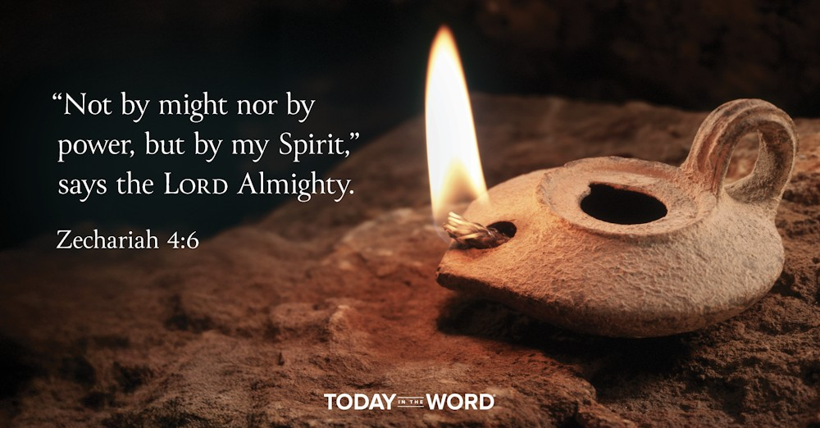
Read Zechariah 4:1–14

Fifth Vision: The Lampstand and Olive Trees
4 The angel who talked with me came again, and wakened me, as one is wakened from sleep. ² He said to me, ‘What do you see?’ And I said, ‘I see a lampstand all of gold, with a bowl on the top of it; there are seven lamps on it, with seven lips on each of the lamps that are on the top of it. ³ And by it there are two olive trees, one on the right of the bowl and the other on its left.’ ⁴ I said to the angel who talked with me, ‘What are these, my lord?’ ⁵ Then the angel who talked with me answered me, ‘Do you not know what these are?’ I said, ‘No, my lord.’ ⁶ He said to me, ‘This is the word of the Lord to Zerubbabel: Not by might, nor by power, but by my spirit, says the Lord of hosts. ⁷ What are you, O great mountain? Before Zerubbabel you shall become a plain; and he shall bring out the top stone amid shouts of “Grace, grace to it!”’
⁸ Moreover, the word of the Lord came to me, saying, ⁹ ‘The hands of Zerubbabel have laid the foundation of this house; his hands shall also complete it. Then you will know that the Lord of hosts has sent me to you. ¹⁰ For whoever has despised the day of small things shall rejoice, and shall see the plummet in the hand of Zerubbabel.
‘These seven are the eyes of the Lord, which range through the whole earth.’ ¹¹ Then I said to him, ‘What are these two olive trees on the right and the left of the lampstand?’ ¹² And a second time I said to him, ‘What are these two branches of the olive trees, which pour out the oil^{[a]} through the two golden pipes?’ ¹³ He said to me, ‘Do you not know what these are?’ I said, ‘No, my lord.’ ¹⁴ Then he said, ‘These are the two anointed ones who stand by the Lord of the whole earth.’

Footnotes
- Zechariah 4:12 Cn: Heb gold
“Not by might nor by power, but by my Spirit,” says the LORD Almighty. Zechariah 4:6
Have you ever been given a job that felt impossible? Many years ago, I volunteered to help a Christian summer camp prepare their grounds for the upcoming season. The director took a small group and tasked us with picking up all the sticks in the woods! After we had worked for hours, we stopped for lunch. Looking back on where we had been working, you could hardly tell what we had done.
Israel was called to be a light to the nations. After the exile, God commanded Israel to rebuild the Temple. But the community was small, impoverished, and powerless. How could they live up to God’s calling? To encourage Israel, the Lord gave Zechariah a vision. The central image was a lampstand. The stand was topped with a bowl that had seven lamps (v. 2). On either side were two olive trees (v. 3). The idea seems to be that the olive trees would provide the oil, filtered through the bowl to the lamp and ensuring a continuing supply of fuel.
The lamp represented the people of Israel. The Lord’s message is clear: Israel should know that their success is not “by might nor by power, but by my Spirit” (v. 6). Instead of trusting in their own strength, Israel was to rely on the power of the Spirit. The same Spirit that could bring life from the dead was at work in them (Ezek. 37:1–14). The completed Temple would be a witness to the world. The Lord provided not only His Spirit but also His anointed leaders—Zerubbabel and Joshua (v. 14).
The church has also been entrusted with an “impossible” task: to proclaim the gospel to all nations (Matt. 28:18–20). Our power comes from the Holy Spirit (Acts 2), as we follow the Anointed One—the Messiah Jesus (Eph. 2:20).
Go Deeper
Are you facing an “impossible” task? How does Zechariah’s vision encourage you to recognize the Holy Spirit power available to you?
Pray with Us
Father, thank You for equipping me with the Holy Spirit. May Your work be evident in my life, as You teach and guide me for the purposes You have called me to. I submit to Your leading.

Our Daily Bread – 10/9/25

A Cautionary Tale



Read: Ecclesiastes 5:13-20
¹³ There is a grievous ill that I have seen under the sun: riches were kept by their owners to their hurt, ¹⁴ and those riches were lost in a bad venture; though they are parents of children, they have nothing in their hands. ¹⁵ As they came from their mother’s womb, so they shall go again, naked as they came; they shall take nothing for their toil, which they may carry away with their hands. ¹⁶ This also is a grievous ill: just as they came, so shall they go; and what gain do they have from toiling for the wind? ¹⁷ Besides, all their days they eat in darkness, in much vexation and sickness and resentment.
¹⁸ This is what I have seen to be good: it is fitting to eat and drink and find enjoyment in all the toil with which one toils under the sun the few days of the life God gives us; for this is our lot. ¹⁹ Likewise all to whom God gives wealth and possessions and whom he enables to enjoy them, and to accept their lot and find enjoyment in their toil—this is the gift of God. ²⁰ For they will scarcely brood over the days of their lives, because God keeps them occupied with the joy of their hearts.
I have seen a grievous evil under the sun: wealth hoarded to the harm of its owners. Ecclesiastes 5:13

Today's Devotional
In the classic film Citizen Kane, Charles Foster Kane amasses wealth and power by building a newspaper empire. In a story reminiscent of Ecclesiastes 2:4-11, Kane spares himself no pleasure, building a castle with grand gardens full of artistic treasures.
Like other tycoons, what Kane really wants is adulation. He bankrolls his own political career and, when it fails, he blames the defeat on voter “fraud” to save face. He builds his wife an opera house and forces her into an ill-suited singing career to make him look good. Here too Kane’s story echoes Ecclesiastes, where wealth is found to harm those who chase and hoard it (5:10-15), leaving them eating “in darkness, with great frustration” (5:17). By the end of his life, Charlie Kane lives in that castle alone, isolated and angry.
Citizen Kane ends with the revelation that Charlie’s pursuits have been driven to fill a void in his heart—the parental love he lost as a child. I can imagine the author of Ecclesiastes agreeing. Our Father God has “set eternity in the human heart” (3:11), and life can only be enjoyed with Him (2:25). Charlie Kane’s cautionary tale speaks to us all: Don’t seek spiritual fulfilment through wealth and power, but through the one who pours His love into our hearts (Romans 5:5).

Reflect & Pray
How do you see yourself imitating Charlie Kane? What spiritual need does God need to meet in you today?
Loving God, please forgive my attempts to feel important through buying things or seeking praise. My spiritual need can only be met by You!
For further study read, Translucent Fruit: The Cost of Wealth.

Today's Insights
In Ecclesiastes, Solomon seeks to answer the perplexing question of the meaning of life. He shows that life without God is futile, unfulfilling, miserable, and meaningless “under the sun” (see 1:3, 13-14; 12:8). Then he explains how and why God must fit into our lives (2:24-26; 3:11-14; 5:7, 18-20). He examines human accomplishments, pleasures, and intellectual pursuits (chs. 1-2); the repetitive mundane existential/experiential life (ch. 3); and social interactions and community (ch. 4). Though accumulating wealth through hard work in itself isn’t wrong, pursuing materialism for its own sake brings disillusionment and despair (chs. 5-6). But the person who reverently worships and fears God (5:1-7) will see and enjoy the fruit of his labor as a gift from God (vv. 18-20). Solomon offers us this recipe for a fulfilled life: “Fear God and keep his commandments, for this is the duty of all mankind” (12:13).
See how the wisdom of Ecclesiastes matches the teaching of Jesus.

God Calling – 10/9/25

Love Me More

Jesus, our Lord, we Thee adore. Oh, make us love Thee more and more.

Yes! I would draw you closer and closer to Me by bonds of Love. The Love of the sinner for the Savior, of the rescued for the Rescuer, of the sheep for the Loving Shepherd, of the child for its Father.

So many ties of Love there are to bind you to Me.

Each experience in your life of Joy, and sorrow, of difficulty or success, of hardship or ease, of danger or safety, each makes its own particular demand on Me. Each serves to answer the prayer: "Make me love Thee more and more."

Whom having not seen, ye love; in whom, though now ye see him not, yet believing, ye rejoice with joy unspeakable and full of glory. 1 Peter 1:8

My Utmost for His Highest – 10/10/25

How Will I Know?


Jesus answered and said, "I thank You, Father…that You have hidden these things from the wise and prudent and have revealed them to babes." —Matthew 11:25

We do not grow into a spiritual relationship step by step— we either have a relationship or we do not. God does not continue to cleanse us more and more from sin— “But if we walk in the light,” we are cleansed “from all sin” (1 John 1:7). It is a matter of obedience, and once we obey, the relationship is instantly perfected. But if we turn away from obedience for even one second, darkness and death are immediately at work again.

All of God’s revealed truths are sealed until they are opened to us through obedience. You will never open them through philosophy or thinking. But once you obey, a flash of light comes immediately. Let God’s truth work into you by immersing yourself in it, not by worrying into it. The only way you can get to know the truth of God is to stop trying to find out and by being born again. If you obey God in the first thing He shows you, then He instantly opens up the next truth to you. You could read volumes on the work of the Holy Spirit, when five minutes of total, uncompromising obedience would make things as clear as sunlight. Don’t say, “I suppose I will understand these things someday!” You can understand them now. And it is not study that brings understanding to you, but obedience. Even the smallest bit of obedience opens heaven, and the deepest truths of God immediately become yours. Yet God will never reveal more truth about Himself to you, until you have obeyed what you know already. Beware of becoming one of the “wise and prudent.” “If anyone wills to do His will, he shall know…” (John 7:17).

WISDOM FROM OSWALD CHAMBERS

Defenders of the faith are inclined to be bitter until they learn to walk in the light of the Lord. When you have learned to walk in the light of the Lord, bitterness and contention are impossible. Biblical Psychology

CCEL – 10/10/25
The whole family in heaven and earth.—EPH. 3:15.

One God and Father of all, who is above all, and through all, and in you all.—Ye are all the children of God by faith in Christ Jesus.—That in the dispensation of the fulness of times, he might gather together in one all things in Christ, both which are in heaven, and which are on earth; even in him.

He is not ashamed to call them brethren.—Behold my mother and my brethren! Whosoever shall do the will of my Father which is in heaven, the same is my brother, and sister, and mother.—Go to my brethren, and say unto them, I ascend unto my Father, and your Father.

I saw under the altar the souls of them that were slain for the word of God, and for the testimony which they held: . . . and white robes were given unto every one of them; and it was said unto them, that they should rest for a little season, until their fellow-servants also and their brethren, that should be killed as they were, should be fulfilled.—That they without us should not be made perfect.

Eph. 4:6. -Gal. 3:26. -Eph. 1:10.Heb. 2:11. -Matt. 12:49,50. -John 20:17.Rev. 6:9-11. -Heb. 11:40.

“Faultless before the presence of his glory.” Jude 24

Revolve in your mind that wondrous word, “faultless!” We are far off from it now; but as our Lord never stops short of perfection in his work of love, we shall reach it one day. The Saviour who will keep his people to the end, will also present them at last to himself, as “a glorious church, not having spot, or wrinkle, or any such thing, but holy and without blemish.” All the jewels in the Saviour’s crown are of the first water and without a single flaw. All the maids of honour who attend the Lamb’s wife are pure virgins without spot or stain. But how will Jesus make us faultless? He will wash us from our sins in his own blood until we are white and fair as God’s purest angel; and we shall be clothed in his righteousness, that righteousness which makes the saint who wears it positively faultless; yea, perfect in the sight of God. We shall be unblameable and unreproveable even in his eyes. His law will not only have no charge against us, but it will be magnified in us. Moreover, the work of the Holy Spirit within us will be altogether complete. He will make us so perfectly holy, that we shall have no lingering tendency to sin. Judgment, memory, will—every power and passion shall be emancipated from the thraldom of evil. We shall be holy even as God is holy, and in his presence we shall dwell forever. Saints will not be out of place in heaven, their beauty will be as great as that of the place prepared for them. Oh the rapture of that hour when the everlasting doors shall be lifted up, and we, being made meet for the inheritance, shall dwell with the saints in light. Sin gone, Satan shut out, temptation past forever, and ourselves “faultless” before God, this will be heaven indeed! Let us be joyful now as we rehearse the song of eternal praise so soon to roll forth in full chorus from all the blood-washed host; let us copy David’s exultings before the ark as a prelude to our ecstasies before the throne.

Word Live – 10/10/25

https://content.scriptureunion.org.uk/wordlive/

Scripture Union – 10/10/25
https://scriptureunion.org/encounters/

Today in the Word – 10/10/25

Flying Scrolls and Baskets!
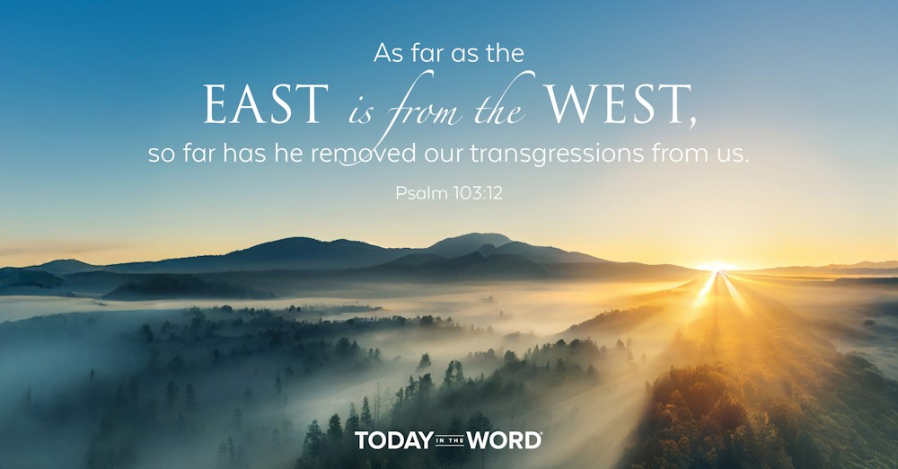

Read Zechariah 5:1–11

Sixth Vision: The Flying Scroll
5 Again I looked up and saw a flying scroll. ² And he said to me, ‘What do you see?’ I answered, ‘I see a flying scroll; its length is twenty cubits, and its width ten cubits.’ ³ Then he said to me, ‘This is the curse that goes out over the face of the whole land; for everyone who steals shall be cut off according to the writing on one side, and everyone who swears falsely^{[a]} shall be cut off according to the writing on the other side. ⁴ I have sent it out, says the Lord of hosts, and it shall enter the house of the thief, and the house of anyone who swears falsely by my name; and it shall abide in that house and consume it, both timber and stones.’

Seventh Vision: The Woman in a Basket
⁵ Then the angel who talked with me came forward and said to me, ‘Look up and see what this is that is coming out.’ ⁶ I said, ‘What is it?’ He said, ‘This is a basket^{[b]} coming out.’ And he said, ‘This is their iniquity^{[c]} in all the land.’ ⁷ Then a leaden cover was lifted, and there was a woman sitting in the basket!^{[d]} ⁸ And he said, ‘This is Wickedness.’ So he thrust her back into the basket,^{[e]} and pressed the leaden weight down on its mouth. ⁹ Then I looked up and saw two women coming forward. The wind was in their wings; they had wings like the wings of a stork, and they lifted up the basket^{[f]} between earth and sky. ¹⁰ Then I said to the angel who talked with me, ‘Where are they taking the basket?’^{[g]} ¹¹ He said to me, ‘To the land of Shinar, to build a house for it; and when this is prepared, they will set the basket^{[h]} down there on its base.’

Footnotes
- Zechariah 5:3 The word falsely added from verse 4
- Zechariah 5:6 Heb ephah
- Zechariah 5:6 Gk Compare Syr: Heb their eye
- Zechariah 5:7 Heb ephah
- Zechariah 5:8 Heb ephah
- Zechariah 5:9 Heb ephah
- Zechariah 5:10 Heb ephah
- Zechariah 5:11 Heb ephah
As far as the east is from the west, so far has he removed our transgressions from us.Psalm 103:12
The book of Zechariah is one of the most quoted books of the Old Testament in the New Testament. Despite this, it is not well known. If you asked someone—“What’s your favorite passage in Zechariah?”— you’re likely to get a blank stare! One reason is that the book contains visions that seem strange to us.
In Zechariah 5, the prophet saw a flying scroll (v. 1). The scroll was huge—thirty feet long and fifteen feet wide (v. 2)! Today we see airplanes towing banners as a form of advertising. That is the idea here. The scroll was unrolled and visible to all. On the scroll were two commands— one against stealing and one against swearing falsely (v. 3). These two commands represent the two tablets of the Law—laws related to relationships with other people and laws related to God. The message is that Israel was still responsible to obey the covenant. If they failed in this, they would be under the curse of the Law (v. 3). Just because the people had been exiled did not mean the covenant was no longer in effect.
The second vision contains a large basket (v. 6). Inside sat a woman who represented the iniquity of the people (vv. 6–7). Despite the warning of the previous vision, Israel would still not be able to fully obey the Law. The message is that what the people could not do for themselves, the Lord would do. Two angels carried the basket far to the east (v. 11). Their sin would be removed as far as the east is from the west (Ps. 103:11–12). This points forward to the work of the Lord Jesus on the cross. Praise the Lord that in Christ, “the grace of God has appeared that offers salvation to all people” (Titus 2:11).
Go Deeper
Consider Zechariah’s vision of a basket. Fill it with the sins that weigh you down and then confess those sins to God, praying aloud the words of Psalm 103:11–12.
Pray with Us
Dear Lord, forgive us for our sin. We acknowledge that You alone can provide redemption in our lives. We praise You for removing our sins “as far as the east is from the west” (Ps. 103:12).

Our Daily Bread – 10/10/25

Prayer of the Desperate

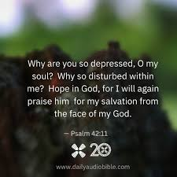

Read: Psalms 88:1^{[a]}

A song. A psalm of the Sons of Korah. For the director of music. According to mahalath leannoth.^{[b]} A maskil^{[c]} of Heman the Ezrahite.
¹ Lord, you are the God who saves me;
day and night I cry out to you.

Footnotes
- Psalm 88:1 In Hebrew texts 88:1-18 is numbered 88:2-19.
- Psalm 88:1 Title: Possibly a tune, “The Suffering of Affliction”
- Psalm 88:1 Title: Probably a literary or musical term

Read: Psalm 88:6-18
⁶ You have put me in the lowest pit,
in the darkest depths.
⁷ Your wrath lies heavily on me;
you have overwhelmed me with all your waves.^{[a]}
⁸ You have taken from me my closest friends
and have made me repulsive to them.
I am confined and cannot escape;
⁹ my eyes are dim with grief.
I call to you, Lord, every day;
I spread out my hands to you.
¹⁰ Do you show your wonders to the dead?
Do their spirits rise up and praise you?
¹¹ Is your love declared in the grave,
your faithfulness in Destruction^{[b]}?
¹² Are your wonders known in the place of darkness,
or your righteous deeds in the land of oblivion?
¹³ But I cry to you for help, Lord;
in the morning my prayer comes before you.
¹⁴ Why, Lord, do you reject me
and hide your face from me?
¹⁵ From my youth I have suffered and been close to death;
I have borne your terrors and am in despair.
¹⁶ Your wrath has swept over me;
your terrors have destroyed me.
¹⁷ All day long they surround me like a flood;
they have completely engulfed me.
¹⁸ You have taken from me friend and neighbor—
darkness is my closest friend.

Footnotes
- Psalm 88:7 The Hebrew has Selah (a word of uncertain meaning) here and at the end of verse 10.
- Psalm 88:11 Hebrew Abaddon
You have taken from me friend and neighbor—darkness is my closest friend. Psalm 88:18

Today's Devotional
Charles had sunk into depression. Despite having a loving family, he felt all alone. “The overwhelming pressure of supporting them was continuing to build,” he said, “and I felt like taking my own life.” Surprisingly—or perhaps not—Charles Morris also led a Christian ministry.
A wise friend told him that when faced with depression, “We should soak in the Psalms.” Charles got through his deep despondency by reading relatable Bible passages, accepting prudent medical care, and pouring his heart out to God.
The Psalms are often brutally honest. Heman the Ezrahite wrote one of the most bitter. Hope is found only in the opening lines: “Lord, you are the God who saves me” (88:1). Heman seems to accuse God: “You have put me in the lowest pit” (v. 6). “You have overwhelmed me” (v. 7). And he had questions: “Why, Lord, do you reject me and hide your face from me?” (v. 14). Most psalms end with a message of hope. Not this one. Heman concludes, “Darkness is my closest friend” (v. 18). This is the prayer of a truly desperate man. Yet Heman directed all his pain to God.
When we read psalms such as this one, we realize we’re not alone. Others have experienced desperate feelings and have dared to put voice to them. God could take such honesty from Heman. He can take it from you too. He’s there, and He’s listening.

Reflect & Pray
What part of Psalm 88 do you most relate to? What will you ask God today?
Heavenly Father, sometimes I hurt too much even to pray. Thank You that You’re big enough to take all my pain and honesty.
Learn how to take wisdom from the book of Psalms.

Today's Insights
Psalm 88 is an unusual song of lament. Lament psalms typically include a call for God’s help, a specific complaint or reason for lamenting, and an expression of trust in God. Some also offer thanksgiving after He responds. (Psalm 44 is a lament psalm that contains all these elements.) Psalm 88 includes the call for God’s aid (vv. 1-2) and reasons for lament (vv. 3-9, 15-18) but omits any expressions of trust in God. Instead, the psalmist asks accusatory questions (vv. 10-12, 14) and describes being completely alone and in excruciating pain (v. 18). That this psalm is part of inspired Scripture demonstrates that God welcomes complete honesty before Him when we’re struggling. In our pain, we can be assured that He’s there and He’s listening.

God Calling – 10/10/25

Extra Work

Our Lord and our God. Help us through poverty to plenty. Through unrest to rest, through sorrow to Joy, through weakness to Power.

I am your Helper. At the end of your present path lie all these blessings. So trust and know that I am leading you.

Step with a firm step of confidence in Me into each unknown day. Take every duty and every interruption as of My appointment.

You are My servant. Serve Me as simply, cheerfully, and readily as you expect others to serve you.

Do you blame the servant who avoids extra work, who complains about being called from one task to do one less liked? Do you feel you are ill served by such a one?

Then what of Me? Is not that how you so often serve Me? Think of this. Lay it to heart and view your day's work in this light.

But the Comforter, which is the Holy Ghost, ... he shall teach you all things, and bring all things to your remembrance, whatsoever I have said unto you. John 14:26

My Utmost for His Highest – 10/11/25

God’s Silence— Then What?
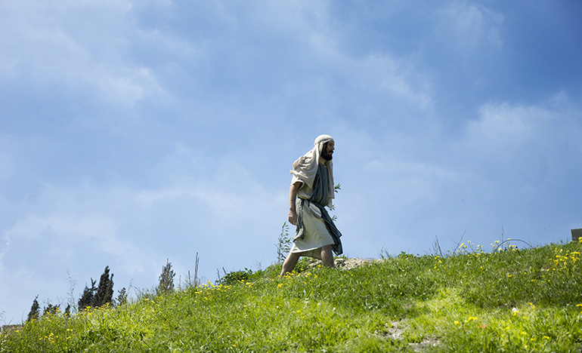

When He heard that he was sick, He stayed two more days in the place where He was. —John 11:6

Has God trusted you with His silence— a silence that has great meaning? God’s silences are actually His answers. Just think of those days of absolute silence in the home at Bethany! Is there anything comparable to those days in your life? Can God trust you like that, or are you still asking Him for a visible answer? God will give you the very blessings you ask if you refuse to go any further without them, but His silence is the sign that He is bringing you into an even more wonderful understanding of Himself. Are you mourning before God because you have not had an audible response? When you cannot hear God, you will find that He has trusted you in the most intimate way possible— with absolute silence, not a silence of despair, but one of pleasure, because He saw that you could withstand an even bigger revelation. If God has given you a silence, then praise Him— He is bringing you into the mainstream of His purposes. The actual evidence of the answer in time is simply a matter of God’s sovereignty. Time is nothing to God. For a while you may have said, “I asked God to give me bread, but He gave me a stone instead” (see Matthew 7:9). He did not give you a stone, and today you find that He gave you the “bread of life” (John 6:35).

A wonderful thing about God’s silence is that His stillness is contagious— it gets into you, causing you to become perfectly confident so that you can honestly say, “I know that God has heard me.” His silence is the very proof that He has. As long as you have the idea that God will always bless you in answer to prayer, He will do it, but He will never give you the grace of His silence. If Jesus Christ is bringing you into the understanding that prayer is for the glorifying of His Father, then He will give you the first sign of His intimacy— silence.

WISDOM FROM OSWALD CHAMBERS

God created man to be master of the life in the earth and sea and sky, and the reason he is not is because he took the law into his own hands, and became master of himself, but of nothing else. The Shadow of an Agony, 1163 L

CCEL – 10/11/25
Be not far from me; for trouble is near.—PSA. 22:11.

How long wilt thou forget me, O Lord? for ever? how long wilt thou hide thy face from me? How long shall I take counsel in my soul, having sorrow in my heart daily?—Hide not thy face far from me; put not thy servant away in anger: thou hast been my help; leave me not, neither forsake me, O God of my salvation.

He shall call upon me, and I will answer him: I will be with him in trouble; I will deliver him, and honour him.—The Lord is nigh unto all them that call upon him, to all that call upon him in truth. He will fulfil the desire of them that fear him: he also will hear their cry, and will save them.

I will not leave you comfortless: I will come to you.—Lo, I am with you alway, even unto the end of the world.

God is our refuge and strength, a very present help in trouble.—Truly my soul waiteth upon God: from him cometh my salvation.—My soul, wait thou only upon God; for my expectation is from him.

Psa. 13:1,2. -Psa. 27:9.Psa. 91:15. -Psa. 145:18,19.John 14:18. -Matt. 28:20.Psa. 46:1. -Psa. 62:1. -Psa. 62:5.

“Let us lift up our heart with our hands unto God in the heavens.” Lamentations 3:41

The act of prayer teaches us our unworthiness, which is a very salutary lesson for such proud beings as we are. If God gave us favours without constraining us to pray for them we should never know how poor we are, but a true prayer is an inventory of wants, a catalogue of necessities, a revelation of hidden poverty. While it is an application to divine wealth, it is a confession of human emptiness. The most healthy state of a Christian is to be always empty in self and constantly depending upon the Lord for supplies; to be always poor in self and rich in Jesus; weak as water personally, but mighty through God to do great exploits; and hence the use of prayer, because, while it adores God, it lays the creature where it should be, in the very dust. Prayer is in itself, apart from the answer which it brings, a great benefit to the Christian. As the runner gains strength for the race by daily exercise, so for the great race of life we acquire energy by the hallowed labour of prayer. Prayer plumes the wings of God’s young eaglets, that they may learn to mount above the clouds. Prayer girds the loins of God’s warriors, and sends them forth to combat with their sinews braced and their muscles firm. An earnest pleader cometh out of his closet, even as the sun ariseth from the chambers of the east, rejoicing like a strong man to run his race. Prayer is that uplifted hand of Moses which routs the Amalekites more than the sword of Joshua; it is the arrow shot from the chamber of the prophet foreboding defeat to the Syrians. Prayer girds human weakness with divine strength, turns human folly into heavenly wisdom, and gives to troubled mortals the peace of God. We know not what prayer cannot do! We thank thee, great God, for the mercy-seat, a choice proof of thy marvellous lovingkindness. Help us to use it aright throughout this day!

Word Live – 10/11/25

https://content.scriptureunion.org.uk/wordlive/

Scripture Union – 10/11/25
https://scriptureunion.org/encounters/

Today in the Word – 10/11/25

Judgment and Peace
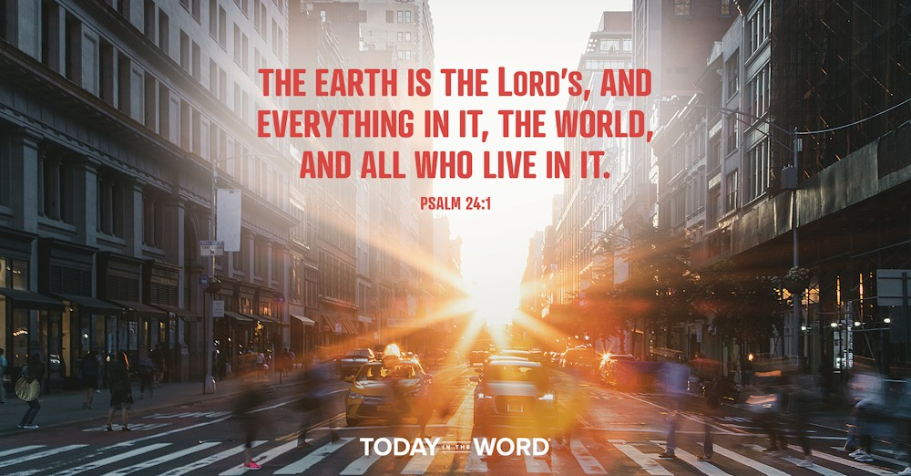

Read Zechariah 6:1–8

Four Chariots
6 I looked up again, and there before me were four chariots coming out from between two mountains—mountains of bronze. ² The first chariot had red horses, the second black, ³ the third white, and the fourth dappled—all of them powerful. ⁴ I asked the angel who was speaking to me, “What are these, my lord?”
⁵ The angel answered me, “These are the four spirits^{[a]} of heaven, going out from standing in the presence of the Lord of the whole world. ⁶ The one with the black horses is going toward the north country, the one with the white horses toward the west,^{[b]} and the one with the dappled horses toward the south.”
⁷ When the powerful horses went out, they were straining to go throughout the earth. And he said, “Go throughout the earth!” So they went throughout the earth.
⁸ Then he called to me, “Look, those going toward the north country have given my Spirit^{[c]} rest in the land of the north.”

Footnotes
- Zechariah 6:5 Or winds
- Zechariah 6:6 Or horses after them
- Zechariah 6:8 Or spirit
The earth is the LORD’s, and everything in it, the world, and all who live in it. Psalm 24:1
Until the advent of the automobile, horses were essential to everyday life. Today we use horses mainly for recreation and racing. But not long ago they were the main source of transportation, used in key roles in the military, on farms, and in cities.
Zechariah 6 describes a vision of four chariots. These chariots came out from between mountains of bronze (v. 1). These mountains represent the gateway to heaven. These chariots are coming from the throne room of God. The chariot was a feared and fearsome military weapon, which indicates that this would bring judgment. They are pulled by horses of different colors. If you are confused by this imagery, you’re in good company, so was Zechariah! He asked, “What are these, my lord?” (v. 4).
The angel replied that the chariots represented the “four spirits of heaven” (v. 5). They were powerful angels sent from the presence of God to go out to the whole world to bring judgment (vv. 5–6). Through their judgment, they would bring rest and peace (v. 8). The primary message is that the whole earth belongs to the Lord (Ps. 24:1). He will one day bring judgment and peace to the nations. This vision looks forward to a future time of tribulation, leading up to the Second Coming of the Messiah (Rev. 9:15).
This is a message we need to hear. Often when we look out at the world, things seem chaotic and uncertain. This vision reminds us that God has a plan. He will be faithful to carry it out. Until that day, may the Lord “strengthen your hearts so that you will be blameless and holy in the presence of our God and Father when our Lord Jesus comes with all his holy ones” (1 Thess. 3:13).
Go Deeper
Why will God’s judgment ultimately bring peace? How does Zechariah’s prophecy change the way we live today? How does it affect our state of mind as we react to world events?
Pray with Us
As we anticipate Your coming, help us trust that You will bring rest to Your people. We give You thanks for Your righteous judgments and ultimate sovereignty. Everything is in Your hands!

Our Daily Bread – 10/11/25

Access Through Christ


Read: Hebrews 4:14-16

Jesus the Great High Priest
¹⁴ Therefore, since we have a great high priest who has ascended into heaven,^{[a]} Jesus the Son of God, let us hold firmly to the faith we profess. ¹⁵ For we do not have a high priest who is unable to empathize with our weaknesses, but we have one who has been tempted in every way, just as we are—yet he did not sin. ¹⁶ Let us then approach God’s throne of grace with confidence, so that we may receive mercy and find grace to help us in our time of need.

Footnotes
- Hebrews 4:14 Greek has gone through the heavens

Read: Hebrews 5:1-6
5 Every high priest is selected from among the people and is appointed to represent the people in matters related to God, to offer gifts and sacrifices for sins. ² He is able to deal gently with those who are ignorant and are going astray, since he himself is subject to weakness. ³ This is why he has to offer sacrifices for his own sins, as well as for the sins of the people. ⁴ And no one takes this honor on himself, but he receives it when called by God, just as Aaron was.
⁵ In the same way, Christ did not take on himself the glory of becoming a high priest. But God said to him,
“You are my Son;
today I have become your Father.”^{[a]}
⁶ And he says in another place,
“You are a priest forever,
in the order of Melchizedek.”^{[b]}

Footnotes
- Hebrews 5:5 Psalm 2:7
- Hebrews 5:6 Psalm 110:4

Let us then approach God’s throne . . . with confidence, so that we may receive mercy and find grace to help us. Hebrews 4:16

Today's Devotional
As a young journalist, I quickly learned about the power of a “press pass.” That one credential—displaying my name, picture, and media outlet—granted me access to meet and interview athletes and celebrities before or after major events.
However, after I received Jesus as my Savior, I realized sports and my career had become my idols. Following God’s call elsewhere, I lost my press pass but gained access to God’s heavenly throne room through prayer because of Jesus’ sacrificial death and resurrection.
The writer of Hebrews points out that a high priest was selected from among the Israelites, specifically one of Aaron’s descendants, and appointed as the go-between representing the people before God. He alone could enter the Most Holy Place in the temple once a year “to offer gifts and sacrifice” to atone for his and the people’s sins (5:1), for he too was a mortal man.
Then Christ came, our great and perfect high priest. When He died, the veil in the temple was torn and the barrier that existed between God and humanity was removed (Matthew 27:51).
Because our loving Redeemer has reconciled us to His Father, we can freely pray to God: “Let us then approach God’s throne of grace with confidence, so that we may receive mercy and find grace to help us in our time of need” (Hebrews 4:16).
What a privilege to have access to God’s throne room as we talk to Him in prayer.

Reflect & Pray
How can you make time to pray more often? What stops you from praying?
Dear Jesus, thank You for giving me access to the Father.
Discover why we pray and why it is important.

Today's Insights
Jesus, our “great high priest” (Hebrews 4:14), is able to sympathize with us because He’s lived as a man, although without sin (vv. 14-15; 5:1-2). Christ took on “flesh and blood . . . for only as a human being could he die, and only by dying could he break the power of the devil” and offer “a sacrifice that would take away the sins of the people” (2:14, 17 nlt). “Because of what Christ has done for us” (Ephesians 2:18 nlt), “we can now come boldly and confidently into God’s presence” (3:12 nlt). What a great privilege to offer prayers before “God’s throne of grace” (Hebrews 4:16), for He’s our King and our Father.

God Calling – 10/11/25

Shame and Distress
I will bless the Lord at all times: His praise shall continually be in my mouth. I sought the Lord, and he heard me, and delivered me from all my fears. They looked unto him, and were lightened: and their faces were not ashamed. -- Psalm 34:1, 4, 5.

See, My children, that even in distress, the first step is Praise. Before you cry in your distress, bless the Lord; even when troubles seem to overwhelm you.

That is My Divine order of approach. Observe this always. In the greatest distress, search until you find cause for thankfulness. Then bless and thank.

You have thus established a line of communication between yourself and Me. Along that line to let your cry of distress follow.

Thus you will find I do My part, and deliverance will be sure. Oh! The gladness of heart.

Lightened you will be, the burden rolled away, as the result of looking to Me.

The shame and distress will be lifted too. That is always the second step. First right with Me, and then you will be righted too in the eyes of men.

So will I compass thine altar, O Lord: that I may publish with the voice of thanksgiving, and tell of all thy wondrous works. Psalm 26:6, 7

My Utmost for His Highest – 10/12/25

Getting into God’s Stride


Enoch walked with God… —Genesis 5:24

The true test of a person’s spiritual life and character is not what he does in the extraordinary moments of life, but what he does during the ordinary times when there is nothing tremendous or exciting happening. A person’s worth is revealed in his attitude toward the ordinary things of life when he is not under the spotlight (see John 1:35-37 and John 3:30). It is painful work to get in step with God and to keep pace with Him— it means getting your second wind spiritually. In learning to walk with God, there is always the difficulty of getting into His stride, but once we have done so, the only characteristic that exhibits itself is the very life of God Himself. The individual person is merged into a personal oneness with God, and God’s stride and His power alone are exhibited.

It is difficult to get into stride with God, because as soon as we start walking with Him we find that His pace has surpassed us before we have even taken three steps. He has different ways of doing things, and we have to be trained and disciplined in His ways. It was said of Jesus— “He will not fail nor be discouraged…” (Isaiah 42:4) because He never worked from His own individual standpoint, but always worked from the standpoint of His Father. And we must learn to do the same. Spiritual truth is learned through the atmosphere that surrounds us, not through intellectual reasoning. It is God’s Spirit that changes the atmosphere of our way of looking at things, and then things begin to be possible which before were impossible. Getting into God’s stride means nothing less than oneness with Him. It takes a long time to get there, but keep at it. Don’t give up because the pain is intense right now— get on with it, and before long you will find that you have a new vision and a new purpose.

WISDOM FROM OSWALD CHAMBERS

Seeing is never believing: we interpret what we see in the light of what we believe. Faith is confidence in God before you see God emerging; therefore the nature of faith is that it must be tried. He Shall Glorify Me, 494 R

CCEL – 10/12/25
God was in Christ, reconciling the world unto himself, not imputing their trespasses unto them.—II COR. 5:19.

It pleased the Father, that in him should all fulness dwell; and, having made peace through the blood of his cross, by him to reconcile all things unto himself.—Mercy and truth are met together; righteousness and peace have kissed each other.

I know the thoughts that I think toward you, saith the Lord, thoughts of peace, and not of evil.—Come now, and let us reason together, saith the Lord: though your sins be as scarlet, they shall be as white as snow; though they be red like crimson, they shall be as wool.

Who is a God like unto thee, that pardoneth iniquity?

Acquaint now thyself with him, and be at peace.—Work out your own salvation with fear and trembling. For it is God which worketh in you both to will and to do of his good pleasure.—Lord, thou wilt ordain peace for us: for thou also hast wrought all our works in us.

Col. 1:19,20. -Psa. 85:10.Jer. 29:11. -Isa. 1:18.Mic. 7:18.Job 22:21. -Phi. 2:12,13. -Isa. 26:12.

“I will meditate in thy precepts.” Psalm 119:15

There are times when solitude is better than society, and silence is wiser than speech. We should be better Christians if we were more alone, waiting upon God, and gathering through meditation on his Word spiritual strength for labour in his service. We ought to muse upon the things of God, because we thus get the real nutriment out of them. Truth is something like the cluster of the vine: if we would have wine from it, we must bruise it; we must press and squeeze it many times. The bruiser’s feet must come down joyfully upon the bunches, or else the juice will not flow; and they must well tread the grapes, or else much of the precious liquid will be wasted. So we must, by meditation, tread the clusters of truth, if we would get the wine of consolation therefrom. Our bodies are not supported by merely taking food into the mouth, but the process which really supplies the muscle, and the nerve, and the sinew, and the bone, is the process of digestion. It is by digestion that the outward food becomes assimilated with the inner life. Our souls are not nourished merely by listening awhile to this, and then to that, and then to the other part of divine truth. Hearing, reading, marking, and learning, all require inwardly digesting to complete their usefulness, and the inward digesting of the truth lies for the most part in meditating upon it. Why is it that some Christians, although they hear many sermons, make but slow advances in the divine life? Because they neglect their closets, and do not thoughtfully meditate on God’s Word. They love the wheat, but they do not grind it; they would have the corn, but they will not go forth into the fields to gather it; the fruit hangs upon the tree, but they will not pluck it; the water flows at their feet, but they will not stoop to drink it. From such folly deliver us, O Lord, and be this our resolve this morning, “I will meditate in thy precepts.”

Word Live – 10/12/25

https://content.scriptureunion.org.uk/wordlive/

Scripture Union – 10/12/25
https://scriptureunion.org/encounters/

Today in the Word – 10/12/25

Act of Hope


Read Zechariah 6:9–15

A Crown for Joshua
⁹ The word of the Lord came to me: ¹⁰ “Take silver and gold from the exiles Heldai, Tobijah and Jedaiah, who have arrived from Babylon. Go the same day to the house of Josiah son of Zephaniah. ¹¹ Take the silver and gold and make a crown, and set it on the head of the high priest, Joshua son of Jozadak.^{[a]} ¹² Tell him this is what the Lord Almighty says: ‘Here is the man whose name is the Branch, and he will branch out from his place and build the temple of the Lord. ¹³ It is he who will build the temple of the Lord, and he will be clothed with majesty and will sit and rule on his throne. And he^{[b]} will be a priest on his throne. And there will be harmony between the two.’ ¹⁴ The crown will be given to Heldai,^{[c]} Tobijah, Jedaiah and Hen^{[d]} son of Zephaniah as a memorial in the temple of the Lord. ¹⁵ Those who are far away will come and help to build the temple of the Lord, and you will know that the Lord Almighty has sent me to you. This will happen if you diligently obey the Lord your God.”

Footnotes
- Zechariah 6:11 Hebrew Jehozadak, a variant of Jozadak
- Zechariah 6:13 Or there
- Zechariah 6:14 Syriac; Hebrew Helem
- Zechariah 6:14 Or and the gracious one, the
Here is the man whose name is the Branch, and he will branch out from his place and build the temple of the LORD. Zechariah 6:12
Symbolic acts are an important part of everyday life. Some are so common we hardly notice them—a handshake, a hug, or a wave goodbye. Others occur at meaningful moments in our lives—a wedding ceremony, baptism, or placing flowers by a grave. They all communicate something deeper and more meaningful than the act itself.
Zechariah 6:9–15 includes a rich symbolic act. The Lord told Zechariah that a deputation of exiled Jews would arrive from Babylon bearing gifts (vv. 9–10). Zechariah was to take the silver and gold from these gifts and fashion two crowns (v. 11). The Hebrew word “crown” is plural although many translations render it as singular. These crowns were to be placed on the high priest, Joshua (v. 11). After the crowning, a prophetic pronouncement was to be made: “Here is the man whose name is the Branch, and he will branch out from his place and build the temple of the LORD” (v. 12).
This event was symbolic for two reasons. First, after the ceremony, the crown was to be removed from Joshua and placed in the Temple as a memorial (v. 14). It was not Joshua’s to keep. Second, the Temple that Zerubbabel started was already almost complete. Clearly, this act pointed forward to a future Davidic King. The two crowns represented the roles of priest and king, indicating that this future Messiah would unite the two offices. This future Messiah would build a new Temple fulfilling Old Testament prophecy (Ezek. 40–48). As in many other places, the Messianic figure was called the “Branch” (Isa. 4:2; 11:1; Jer. 23:5; 33:15).
This ceremony and the crown would serve as symbols for the Jewish people to look forward to a coming Messiah. When we take communion, we engage in a symbolic act that looks forward to Jesus’ return (1 Cor. 11:26).
Go Deeper
In addition to the Lord’s Supper, what symbols do we use in the church? Can you identify one or two and trace their meaning in Scripture?
Pray with Us
O Lord, thank You for traditions and rituals of the church that direct our focus to You. We praise You for the work You have done and anticipate the work You will do. Thank You for the hope these reminders bring to our daily lives.

Our Daily Bread – 10/12/25

Communion with God



Read: Psalms 15:1-5

A psalm of David.
¹ Lord, who may dwell in your sacred tent?
Who may live on your holy mountain?
² The one whose walk is blameless,
who does what is righteous,
who speaks the truth from their heart;
³ whose tongue utters no slander,
who does no wrong to a neighbor,
and casts no slur on others;
⁴ who despises a vile person
but honors those who fear the Lord;
who keeps an oath even when it hurts,
and does not change their mind;
⁵ who lends money to the poor without interest;
who does not accept a bribe against the innocent.
Whoever does these things
will never be shaken.
Who may worship in your sanctuary, Lord? Who may enter your presence on your holy hill? Psalm 15:1 nlt

Today's Devotional
In his book Man of Honor, Ray Pritchard shares the story of his stroll in a cemetery where he discovered a man’s grave marker with a wordy tribute. But he then describes a more eye-catching epitaph on the gravestone of the man’s son: “A man of unquestioned integrity.” As Pritchard wrote: “Five words to sum up an entire life. Sixty-plus years distilled into five words. But, oh what truth they tell.”
In Psalm 15:1, we find questions asking after a certain kind of person: “Who may worship in your sanctuary, Lord? Who may enter your presence on your holy hill?” (v. 1 nlt). The answer involves integrity and is captured in the word blameless found in verse 2: “Those who lead blameless lives and do what is right, speaking the truth from sincere hearts” (v. 2 nlt). The question (v. 1) and answer (v. 2) combination refers to communion with God. The rest of the psalm summarizes—in positive and negative terms—what a God-honoring life looks like.
When we have intimate communion with God, it’s displayed in a life of integrity, particularly in how we treat others as the Spirit helps us (see Matthew 22:34-40; 1 John 3:16-18). It’s the posture of life that we assume when we believe in and follow Jesus—the one who lived in perfect communion with His Father.

Reflect & Pray
What does your life say about your closeness to God? What spiritual disciplines might you need to adopt to have a closer relationship with Jesus?
Dear Father, please give me strength to love You with all my heart and to demonstrate this by integrity in my life.
For further study, read Going the Distance.

Today's Insights
David asks, “Who may dwell in your sacred tent?” (Psalm 15:1). If we answer this question honestly, we’ll admit we often fall short of the high standards enumerated here. Who among us can claim to be “blameless” (v. 2)? The writer to the Hebrews sheds light on this. Of Jesus, that New Testament letter says, “Such a high priest truly meets our need—one who is holy, blameless, pure, set apart from sinners, exalted above the heavens” (Hebrews 7:26). Our high priest Christ “sacrificed for [our] sins once for all when he offered himself” (v. 27). This meant that He “entered the Most Holy Place once for all by his own blood, thus obtaining eternal redemption” (9:12). His once-for-all sacrifice on our behalf enables us to follow and obey Jesus as we treat others with the love and respect that honors our Father.

God Calling – 10/12/25

You Are My Joy
Thine they were, and thou gavest them me; and they have kept thy word. -- John 17:6.

Remember, that just as you thank God for Me, so I thank God for His Gift to Me of you. In that hour of My agony on earth, one note of Joy thrilled through the pain. The thought of the souls, given Me by My Father, who had kept My Word.

They had not done great deeds, as they did later, for, and in, My Name. They were simple doers of My Word, not hearers only. Just in their daily tasks and ways they kept My Word.

You, too, can bring Joy to My Heart by faithful service. Faithful service in the little things. Be faithful.

Do your simple tasks for Me.

Well done, thou good and faithful servant: thou hast been faithful over a few things, I will make thee ruler over many things: enter thou into the joy of thy lord. Matthew 25:21

My Utmost for His Highest – 10/13/25

Individual Discouragement and Personal Growth


…when Moses was grown…he went out to his brethren and looked at their burdens. —Exodus 2:11
Moses saw the oppression of his people and felt certain that he was the one to deliver them, and in the righteous indignation of his own spirit he started to right their wrongs. After he launched his first strike for God and for what was right, God allowed Moses to be driven into empty discouragement, sending him into the desert to feed sheep for forty years. At the end of that time, God appeared to Moses and said to him, “ ‘…bring My people…out of Egypt.’ But Moses said to God, ‘Who am I that I should go…?’ ” (Exodus 3:10-11). In the beginning Moses had realized that he was the one to deliver the people, but he had to be trained and disciplined by God first. He was right in his individual perspective, but he was not the person for the work until he had learned true fellowship and oneness with God.
We may have the vision of God and a very clear understanding of what God wants, and yet when we start to do it, there comes to us something equivalent to Moses’ forty years in the wilderness. It’s as if God had ignored the entire thing, and when we are thoroughly discouraged, God comes back and revives His call to us. And then we begin to tremble and say, “Who am I that I should go…?” We must learn that God’s great stride is summed up in these words— “I AM WHO I AM…has sent me to you” (Exodus 3:14). We must also learn that our individual effort for God shows nothing but disrespect for Him— our individuality is to be rendered radiant through a personal relationship with God, so that He may be “well pleased” (Matthew 3:17). We are focused on the right individual perspective of things; we have the vision and can say, “I know this is what God wants me to do.” But we have not yet learned to get into God’s stride. If you are going through a time of discouragement, there is a time of great personal growth ahead.
Wisdom From Oswald Chambers
To live a life alone with God does not mean that we live it apart from everyone else. The connection between godly men and women and those associated with them is continually revealed in the Bible, e.g., 1 Timothy 4:10. Not Knowing Whither, 867 L

CCEL – 10/13/25
From the first day that thou didst set thine heart to understand, and to chasten thyself before thy God, thy words were heard. DAN. 10:12.
Thus saith the high and lofty One that inhabiteth eternity, whose name is Holy; I dwell in the high and holy place, with him also that is of a contrite and humble spirit, to revive the spirit of the humble, and to revive the heart of the contrite ones.—The sacrifices of God are a broken spirit: a broken and a contrite heart, O God, thou wilt not despise.—Though the Lord be high, yet hath he respect unto the lowly: but the proud he knoweth afar off.—Humble yourselves therefore under the mighty hand of God, that he may exalt you in due time.—God resisteth the proud, but giveth grace unto the humble.
Submit yourselves therefore to God.
Thou, Lord, art good, and ready to forgive; and plenteous in mercy unto all them that call upon thee. Give ear, O Lord, unto my prayer; and attend to the voice of my supplications. In the day of my trouble I will call upon thee: for thou wilt answer me.
Isa. 57:15. -Psa. 51:17. -Psa. 138:6. -I Pet. 5:6. -Jas. 4:6. -Jas. 4:7.Psa. 86:5-7.
“Godly sorrow worketh repentance.” 2 Corinthians 7:10
Genuine, spiritual mourning for sin is the work of the Spirit of God. Repentance is too choice a flower to grow in nature’s garden. Pearls grow naturally in oysters, but penitence never shows itself in sinners except divine grace works it in them. If thou hast one particle of real hatred for sin, God must have given it thee, for human nature’s thorns never produced a single fig. “That which is born of the flesh is flesh.”
True repentance has a distinct reference to the Saviour. When we repent of sin, we must have one eye upon sin and another upon the cross, or it will be better still if we fix both our eyes upon Christ and see our transgressions only, in the light of his love.
True sorrow for sin is eminently practical. No man may say he hates sin, if he lives in it. Repentance makes us see the evil of sin, not merely as a theory, but experimentally—as a burnt child dreads fire. We shall be as much afraid of it, as a man who has lately been stopped and robbed is afraid of the thief upon the highway; and we shall shun it—shun it in everything—not in great things only, but in little things, as men shun little vipers as well as great snakes. True mourning for sin will make us very jealous over our tongue, lest it should say a wrong word; we shall be very watchful over our daily actions, lest in anything we offend, and each night we shall close the day with painful confessions of shortcoming, and each morning awaken with anxious prayers, that this day God would hold us up that we may not sin against him.
Sincere repentance is continual. Believers repent until their dying day. This dropping well is not intermittent. Every other sorrow yields to time, but this dear sorrow grows with our growth, and it is so sweet a bitter, that we thank God we are permitted to enjoy and to suffer it until we enter our eternal rest.

Word Live – 10/13/25

https://content.scriptureunion.org.uk/wordlive/

Scripture Union – 10/13/25
https://scriptureunion.org/encounters/

Today in the Word – 10/13/25

True Repentance


Read Zechariah 7:1–14

Justice and Mercy, Not Fasting
7 In the fourth year of King Darius, the word of the Lord came to Zechariah on the fourth day of the ninth month, the month of Kislev. ² The people of Bethel had sent Sharezer and Regem-Melek, together with their men, to entreat the Lord ³ by asking the priests of the house of the Lord Almighty and the prophets, “Should I mourn and fast in the fifth month, as I have done for so many years?”
⁴ Then the word of the Lord Almighty came to me: ⁵ “Ask all the people of the land and the priests, ‘When you fasted and mourned in the fifth and seventh months for the past seventy years, was it really for me that you fasted? ⁶ And when you were eating and drinking, were you not just feasting for yourselves? ⁷ Are these not the words the Lord proclaimed through the earlier prophets when Jerusalem and its surrounding towns were at rest and prosperous, and the Negev and the western foothills were settled?’”
⁸ And the word of the Lord came again to Zechariah: ⁹ “This is what the Lord Almighty said: ‘Administer true justice; show mercy and compassion to one another. ¹⁰ Do not oppress the widow or the fatherless, the foreigner or the poor. Do not plot evil against each other.’
¹¹ “But they refused to pay attention; stubbornly they turned their backs and covered their ears. ¹² They made their hearts as hard as flint and would not listen to the law or to the words that the Lord Almighty had sent by his Spirit through the earlier prophets. So the Lord Almighty was very angry.
¹³ “‘When I called, they did not listen; so when they called, I would not listen,’ says the Lord Almighty. ¹⁴ ‘I scattered them with a whirlwind among all the nations, where they were strangers. The land they left behind them was so desolate that no one traveled through it. This is how they made the pleasant land desolate.’”
Was it really for me that you fasted? Zechariah 7:5
Do our motives matter to God? Sometimes people get the idea that in the Old Testament, Israel’s relationship with God was simply all about following external rules. Nothing could be further from the truth.
Chapter 7 introduces a new section in the book of Zechariah. We have jumped forward a couple of years. The rebuilding of the Temple is well under way. This situation raises an important question for Israel. A group of Jewish leaders asked the prophet, “Should I mourn and fast in the fifth month, as I have done for so many years?” (v. 3). During the exile, the Jewish people had regular periods of fasting and mourning over the destruction of the Temple. The question now was, “With the Temple nearing completion, do we still need to fast?”
This simple question sparks a passionate response from the Lord that will continue through chapter 8. God’s first message was to question the people’s motives for fasting in the first place, “Was it really for me that you fasted?” (v. 5). They had practiced fasting to get something from the Lord, not out of genuine repentance over their sin. There had been no genuine turning to the Lord. There was nothing wrong with their outward act of fasting, but it had not reached their heart.
The evidence for this? They had not obeyed the Law. True repentance requires more than simply fasting and mourning over sin but results in a changed life. Instead of fasting from food, they should have fasted from mistreating the vulnerable around them, “Do not oppress the widow or the fatherless, the foreigner or the poor” (v. 10). As followers of Christ, we are also called to have a faith that evidences itself in a changed life.
Go Deeper
Do your outward acts of worship match what is happening in your heart? How might God be challenging you to align what you say with what you do?
Pray with Us
God, forgive us for acting out of self-service rather than love for You. We ask that You renew our hearts to grieve over our sin and help us turn from it with sincerity.

Our Daily Bread – 10/13/25

Gratitude to God


Read: 1 Chronicles 16:8-14
⁸ Give praise to the Lord, proclaim his name;
make known among the nations what he has done.
⁹ Sing to him, sing praise to him;
tell of all his wonderful acts.
¹⁰ Glory in his holy name;
let the hearts of those who seek the Lord rejoice.
¹¹ Look to the Lord and his strength;
seek his face always.
¹² Remember the wonders he has done,
his miracles, and the judgments he pronounced,
¹³ you his servants, the descendants of Israel,
his chosen ones, the children of Jacob.
¹⁴ He is the Lord our God;
his judgments are in all the earth.

Read: 1 Chronicles 16:19-24
¹⁹ When they were but few in number,
few indeed, and strangers in it,
²⁰ they^{[a]} wandered from nation to nation,
from one kingdom to another.
²¹ He allowed no one to oppress them;
for their sake he rebuked kings:
²² “Do not touch my anointed ones;
do my prophets no harm.”
²³ Sing to the Lord, all the earth;
proclaim his salvation day after day.
²⁴ Declare his glory among the nations,
his marvelous deeds among all peoples.

Footnotes
- 1 Chronicles 16:20 One Hebrew manuscript, Septuagint and Vulgate (see also Psalm 105:12); most Hebrew manuscripts inherit, / ¹⁹ though you are but few in number, / few indeed, and strangers in it.” / ²⁰ They
Give thanks to the Lord, for he is good; his love endures forever. 1 Chronicles 16:34

Today's Devotional
Canada and the island of Saint Lucia celebrate a Thanksgiving holiday in October. Liberia sets aside a day for giving thanks at the beginning of November, while the United States and Australia mark the annual holiday at the end of the month. Other countries, including the United Kingdom, Brazil, Rwanda, and the Philippines, have unofficial days to foster gratitude.
There’s something powerful about a nation collectively expressing gratitude. It’s a picture we see when King David assembled the nation of Israel to give thanks to God for His presence, protection, and promises. The celebration marked the return of the “ark of God” (1 Chronicles 16:1). The people rejoiced that the ark, a symbol of God’s presence with them, was in Jerusalem. As David led Israel in praise, he reminded them of God’s protection as the nation conquered the land of Canaan (vv.18-22) and celebrated His faithfulness to fulfill His promises (v. 15).
If you celebrate a Thanksgiving holiday with friends and family, consider making it a gratitude gathering and reflecting together on the ways you’ve experienced God’s presence, protection, and promises over the past year. Whether or not you live in a country that officially celebrates Thanksgiving, each of us can take time to “give thanks to the Lord, for he is good; his love endures forever” (v. 34).

Reflect & Pray
How have you experienced God’s presence, protection, or promises? How can you express gratitude?
Dear God, please cultivate within me a spirit of gratitude as I remember all You’ve done.

Today's Insights
To celebrate the return of the ark of the covenant to Jerusalem, David composed this worship song in 1 Chronicles 16:8-36, a “song of thanksgiving to the Lord” (v. 7 nlt). The lyrics of this praise song are also presented as two different songs in the Psalms: Psalm 105:1-15 (1 Chronicles 16:8-22) and Psalm 96:1-13 (1 Chronicles 16:23-33). In 1 Chronicles 16, to show his gratitude to God for being the God of Israel, David recalled aspects of their history where God acted favorably and mightily to fulfill His covenant promises to His chosen people (vv. 8-22). He calls on the nations to worship God because He’s the true and holy God who is Creator, sovereign King, and righteous Judge (vv. 23-36). We too have many reasons to be grateful and thankful to God. Like the psalmist, when we gratefully recall who He is and what He’s done for us, we can respond in worship and praise.

God Calling – 10/13/25

The Sculpture's Skill
Lord, we believe, help Thou our unbelief. Lord, hear our prayers and let our cries come unto Thee.
Along the road of praise, as I told you. Yes! I will indeed help your unbelief, and in answer to your prayers grant you so great a faith, such an increasingly great faith, that each day you will look back, from the place of your larger vision, and see the faith of the day before as almost unbelief.
The Beauty of My Kingdom is its growth. In that Kingdom there is always progress, a going on from strength to strength, from glory to glory. Be in My Kingdom, and of My Kingdom, and there can be no stagnation. Eternal Life, abundant Life is promised to all in it, and of it.
No misspent time over failures and shortcomings. Count the lessons learnt from them but as rungs in the ladder. Step up, and then cast away all thought of the manner of the making of the rung. Fashioned of joy and sorrow, of failure or success, of wounds or healing balm, what matter, My children, so long as it served its purpose?
Learn another lesson. The Sculptor who finds a faulty marble casts it aside. Because it has no fashioning, it may regard itself as perfect; and it may look with scorn upon the marble the Sculptor is cutting and shaping into perfection. From this, My children, learn a lesson for your lives.
Then touched he their eyes, saying, "According to your faith be it unto you." Matthew 9:29

