The Bottle Builders: A Caribbean Adventure
Chapter 1: The Problem
Maya wiped sweat from her forehead as she walked home from school on the island of St. Lucia. The hot Caribbean sun beat down on the dusty road, and plastic bottles crunched under her feet with every step. They were everywhere – in the ditches, caught in the bushes, floating in the crystal-clear streams that should have been beautiful.
"This is getting ridiculous," she muttered, kicking a bright blue bottle that rolled into her path.
Her best friend Carlos caught up with her, his backpack bouncing as he jogged. "What's ridiculous?"
"All this trash!" Maya gestured at the bottles scattered around them. "And meanwhile, my grandmother's roof is leaking again. We can't afford the metal sheets to fix it properly."
Their friend Kira appeared from behind a mango tree, her arms full of bottles she'd been collecting. "My dad says the same thing. Building materials cost too much to import, but we have mountains of this plastic stuff nobody wants."
The three friends had grown up together in the small village of Choiseul, where everyone knew everyone. They were all 14 years old and in their final year at the local school. Maya was the problem-solver of the group – she never met a broken thing she couldn't fix. Carlos was the artist who could make anything look beautiful. Kira was the researcher who always had interesting facts from the internet.
"You know what's crazy?" Kira said, setting down her armload of bottles. "I read online that people in other places actually turn plastic bottles into useful stuff. Like, really useful stuff."
Maya's eyes lit up. "What kind of stuff?"
"Building materials, containers for farming, even roofing. But I couldn't figure out how they do it."
Carlos picked up a clear bottle and turned it in the sunlight. "This plastic is actually pretty strong. Remember when we tried to break that old bottle with rocks? It just bounced around."
"Exactly!" Maya said, her mind already racing. "What if we could figure out how to turn all this trash into something we actually need?"
The three friends looked around at the sea of bottles surrounding them, then at each other. Without saying a word, they all knew they were thinking the same thing.
"We have plenty of trash," Kira said.
"We have plenty of sunlight," Carlos added, squinting up at the blazing sun.
"And we have plenty of time after school," Maya finished. "Let's figure this out."
Chapter 2: The Discovery
The next day, Kira burst into Maya's backyard workshop with her tablet clutched in her hands. Maya and Carlos were already there, surrounded by dozens of plastic bottles they'd collected that morning.
"I found it!" Kira announced breathlessly. "Look at this!"
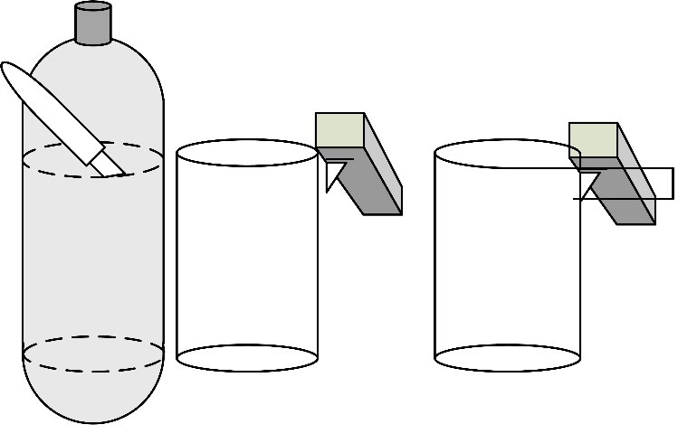
Figure 1- bottle cutters
She showed them a video of someone using a simple wooden tool to cut a plastic bottle into one long, continuous strip – like peeling an apple, but with plastic.
"That's brilliant," Maya said, studying the screen. "It's just a piece of wood with a sharp edge and a guide. We could totally make this. We could use those blades from the ‘disposable’ razors that get disposed on our beaches.”
Carlos watched as the bottle in the video transformed into yards and yards of plastic rope. "Look how much string comes from just one bottle. We could get hundreds of feet from all these bottles."
Maya was already sketching in her notebook. "The tool is super simple. We need a board, a sharp blade – maybe from Dad's old razor – and something to guide the bottle."
"But what would we do with all that plastic string?" Kira asked.
Maya grinned. "Remember how your grandmother taught us to weave those grass mats last summer? What if we could weave these plastic strips the same way?"
An hour later, they had their first bottle-cutting tool. Maya had attached an old razor blade to a piece of wood at just the right angle. Carlos had smoothed and painted it to look professional. Kira had calculated the perfect width for the strips.
Maya picked up their first bottle – a red one that had once held fruit juice. She pressed it against the blade and started turning it slowly. Like magic, a bright red strip began to emerge, curling around her hand.
"It works!" Carlos shouted.
"Keep going," Kira said, measuring the strip. "Let's see how long we can make it."
When they finished, they had twelve feet of strong, flexible plastic strip from just one bottle.
"This is amazing," Maya said, holding up the coiled strip. "But now what?"
Carlos was already gathering the plastic strips they'd made. "Now we weave. Just like your grandmother taught us, Kira, but with plastic instead of grass."
Chapter 3: Learning to Weave
Kira's grandmother, whom everyone called Granny Rose, was delighted when the three friends showed up at her house with arms full of colorful plastic strips.
"You want to learn weaving again?" she asked, her eyes twinkling. "Last time, you children got more grass in your hair than in your mats!"
"This time it's different, Granny Rose," Kira explained, showing her the plastic strips. "We made these from old bottles."
Granny Rose examined the strips carefully, pulling on them to test their strength. "Well, I'll be. These are stronger than grass, and they won't rot or get eaten by bugs. Clever children."
She led them to her back porch, where her old wooden loom sat in the shade. "The principle is the same," she explained. "Over, under, over, under. But you'll need to decide how tight you want your weave."
"What do you mean?" Maya asked.
"Loose weave lets air through – good for drying things or making shade. Tight weave keeps water out – good for roofing or containers." Granny Rose demonstrated with some grass strips. "See the difference?"
Carlos caught on quickly. "So we can make different kinds of mats for different jobs?"
"Exactly, young artist. What are you planning to make with your plastic strips?"
The friends looked at each other. They hadn't really thought that far ahead.
"Well," Maya said slowly, "my grandmother's roof leaks..."
"And the school garden needs something to keep weeds away from the vegetables," Kira added.
"And during hurricane season, everyone needs better ways to protect their houses," Carlos finished.
Granny Rose nodded approvingly. "Then you'll need to learn to make tight weaves, loose weaves, and very strong weaves. This will take practice."

For the next two weeks, the friends spent every afternoon at Granny Rose's house. Maya learned to keep her weave tight and even – perfect for making water-resistant materials. Carlos experimented with patterns, creating beautiful designs with different colored strips. Kira focused on making the strongest possible weaves, layering strips in different directions.

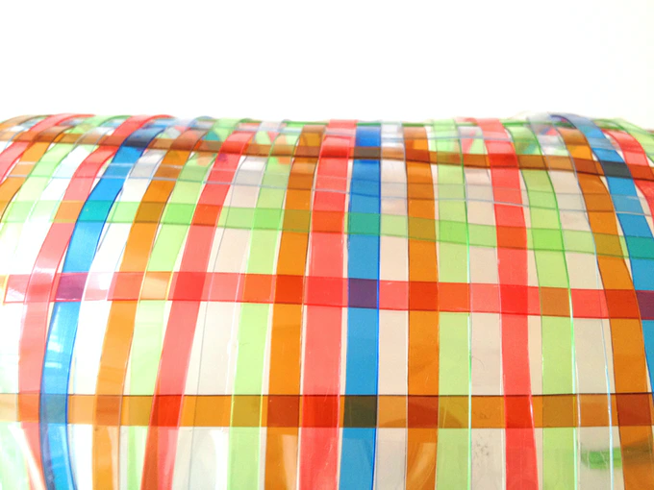
"This is harder than it looks," Carlos said one afternoon, untangling a mess of plastic strips for the third time.
Figure 2-woven plastic
"That's because you're trying to make it too fancy," Maya laughed. "Sometimes simple is better."
"But simple is boring," Carlos protested.
"Not if it works," Kira said, holding up a small, tightly woven mat. "Look – this one is completely waterproof. I poured water on it and not a drop went through."
Granny Rose examined Kira's work. "Excellent, child. But now you need to think bigger. These little mats are good for practice, but if you want to solve real problems, you need real-sized solutions."
She was right. Their practice mats were only about a foot square. To make roofing or garden covers, they'd need much larger pieces.
"We need a bigger loom," Maya realized.
"Or a way to connect small pieces together," Carlos suggested.
Kira was already thinking ahead. "What if we could somehow melt or fuse the edges together? Plastic melts, right?"
Maya's eyes got that excited look they always got when she was solving a problem. "Kira, you're a genius. But how do we melt plastic without electricity?"
All three friends looked up at the blazing Caribbean sun beating down on them.
"I think I know," Maya said slowly. "But we're going to need some help."
Chapter 4: The Sun's Power
Mr. Thompson, the school's science teacher, was intrigued when Maya, Carlos, and Kira approached him with their idea.
"You want to use solar energy to fuse plastic?" he asked, adjusting his glasses. "That's actually quite advanced engineering."
"We know it sounds crazy," Maya said, "but we've been researching it. People use solar concentrators to melt metal. Plastic melts at much lower temperatures."
Carlos spread out the drawings he'd made. "We could use mirrors or shiny metal to focus the sun's rays into a narrow line. Then we could run the plastic strips through that hot spot."
Mr. Thompson studied their sketches. "The physics is sound. A parabolic reflector concentrates sunlight to create intense heat. But you'll need the right materials."
"What kind of materials?" Kira asked, taking notes.
"Something highly reflective – mirrors would be ideal, but they're expensive. Old car mirrors, maybe? Or polished metal?"
Maya snapped her fingers. "What about aluminum cans? We have tons of those in the trash too. We could flatten them and polish them up."
"Or," Carlos added excitedly, "what about the reflective emergency blankets from the first aid kits? They're super shiny, and we could even use the inside of the chip bags!"
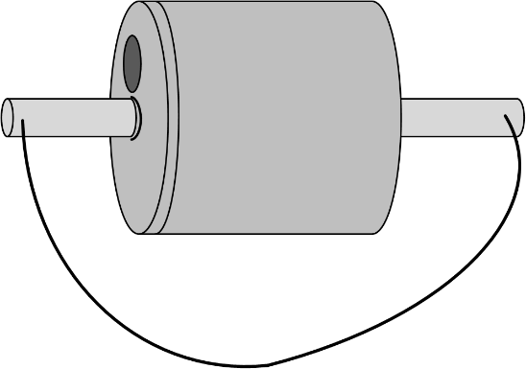
Mr. Thompson nodded approvingly. "You three are thinking like real engineers – using available materials to solve problems. But be careful with concentrated sunlight. It can get extremely hot."
Figure 3- Carlo's tumbler
That weekend, the friends set up their first solar concentrator in Maya's backyard. They had flattened dozens of aluminum cans and arranged them in a curved shape, like a smile. Tumbling them in a line-pulled tub of sand and water, Carlos had polished them until they gleamed like mirrors.
"OK, let's test it," Maya said, positioning a small piece of plastic in the focal point of their reflector.
Within seconds, the plastic began to curl and smoke.
"It's working!" Kira shouted.
"Too well," Carlos said, watching the plastic catch fire. "We need to control the heat better."
They spent the next few days adjusting their setup. They learned to move the plastic quickly through the hot spot, just long enough to soften and fuse the edges without burning them. They discovered that different colors of plastic needed different amounts of heat. They figured out how to create a long, narrow focus-line instead of a single hot point.
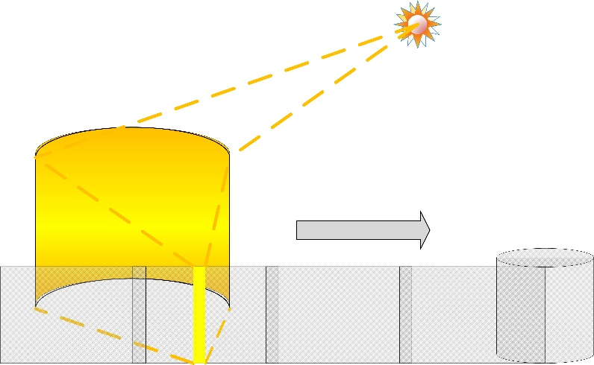
"This is it," Maya said, successfully fusing two strips of their woven mat together. The joint was strong and watertight. "Now we can make pieces as big as we want."
Figure 4 - Caribbean fusion
But as they worked, they realized they had created a new problem.
"We can't keep doing this one strip at a time," Kira pointed out. "It'll take forever to make anything useful."
Carlos was already sketching again. "What if we made our reflector longer? Like a trough instead of a dish?"
"And what if we made it so we could adjust the angle?" Maya added. "The sun moves across the sky, so we need to track it."
Mr. Thompson was impressed when they showed him their improved design. "You've essentially invented a solar oven. This could work for all kinds of things, not just fusing plastic."
"Really?" Kira asked.
"Really. You could cook food, heat water, even generate electricity with the right equipment. You're learning principles that engineers use for solar power plants."
Maya felt a thrill of excitement. They weren't just solving their own problems – they were learning skills that could help their whole community.
Chapter 5: The First Success
Three weeks later, Maya stood on her grandmother's roof with a large section of fused plastic matting in her hands. It was made from dozens of bottles, cut into strips, woven tightly together, and fused into a strong, waterproof sheet.
"You sure this will work, child?" her grandmother asked from below.
"Only one way to find out, Grandma," Maya called back. She carefully positioned the plastic sheet over the section of roof that leaked the worst.
Carlos and Kira helped her secure the edges with strips of plastic rope they'd braided together. The whole repair took less than an hour.
That night, the tropical rain that had been threatening all week finally arrived. Maya lay in bed listening to the heavy drops pounding on the roof. But for the first time in months, there was no drip-drip-drip into the bucket by her grandmother's bed.
The next morning, her grandmother was beaming. "Dry as a bone!" she announced. "That plastic roof of yours works better than expensive metal sheets."
Word spread quickly through the village. By the end of the week, Maya, Carlos, and Kira had requests from six different families who wanted plastic roofing repairs.
"We need to organize this better," Kira said, looking at her list of requests. "And we need help. We can't cut and weave and fuse enough material for everyone by ourselves."
Maya nodded. "What if we taught other kids how to do it? We could set up an assembly line."
"I like it," Carlos said. "Different people could specialize in different parts. Some could cut bottles, some could weave, some could fuse."
They decided to start with their classmates. Maya demonstrated the bottle-cutting tool, Carlos taught the weaving techniques, and Kira explained how the solar concentrator worked.
Soon they had a team of twelve kids working together. Some were better at cutting precise strips. Others had patience for weaving. A few showed real talent for operating the solar concentrator safely.
"This is amazing," said their classmate Jerome, holding up a perfectly woven mat. "We're actually making something useful from trash."
"And earning money too," added his sister Marie, who had become their best bottle-cutter. They had started charging a small fee for their roofing services – enough to buy better tools and materials for their next projects.
But their biggest success came when Hurricane Preparedness Week arrived.
Chapter 6: Storm Ready
"Every year, we lose roofs to the hurricanes," explained Mrs. Patterson, the village emergency coordinator. "Metal sheets are expensive to replace, and they can become dangerous projectiles in high winds."
She had come to see the students' plastic roofing project after hearing about its success.
"Show me what you've made," she said.
Maya, Carlos, and Kira led her to their workshop, which had grown from Maya's backyard to a covered area behind the school. Dozens of plastic mats hung drying in the sun, and three solar concentrators were fusing new pieces.
"This is impressive," Mrs. Patterson said, examining their work. "But how does it hold up in high winds?"
"We've been testing that," Kira said, pulling out her notebook. "We set up a fan to simulate wind and tested different weaving patterns. The tighter the weave, the stronger it is, but the heavier it gets."
Carlos showed her their latest innovation – mats with built-in reinforcement strips woven in different directions. "These are super strong, but they still weigh less than metal roofing."
"And if a piece does get damaged in a storm," Maya added, "we can repair it with our solar concentrator. Metal sheets have to be completely replaced."
Mrs. Patterson was taking notes. "What about securing the roofing? That's always been our biggest problem."
The friends exchanged excited glances. They had been working on this problem for weeks.
"We make anchor ropes from braided plastic strips," Carlos explained. "They're incredibly strong and they don't rust like metal cables."
"Plus," Maya said, "since we're making the roofing and the anchor ropes from the same material, they bond together really well when we fuse them."
Mrs. Patterson watched as they demonstrated their complete system – waterproof roofing secured with strong anchor ropes, all made from plastic bottles that would otherwise be trash.
"I want to see this tested before hurricane season," she said. "If it works, we could teach this to other communities across the Caribbean."
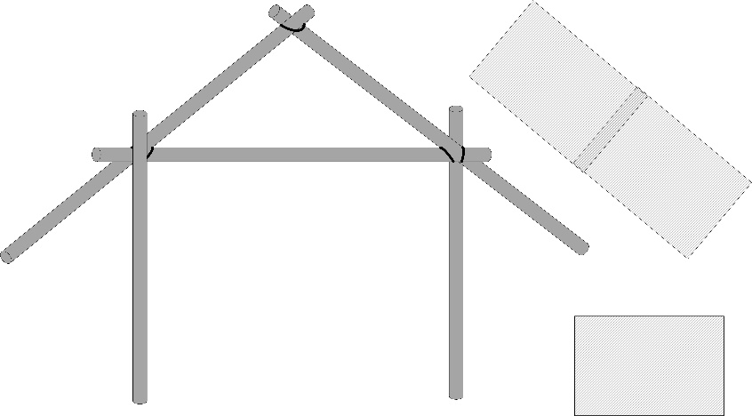
The test came sooner than expected. Two weeks later, Tropical Storm Marcus headed straight for their island.
Figure 5 - mats, and rolled and fussed tubes

Chapter 7: The Real Test
As Marcus approached, Maya felt nervous for the first time since they'd started their project. It was one thing to test their materials with fans and buckets of water. It was another to trust them in a real storm.
"What if our calculations were wrong?" she asked Carlos as they watched the weather reports.
"What if the fusing doesn't hold?" Carlos worried.
"What if the whole thing just falls apart?" Kira added.
But it was too late for doubts now. Fifteen families in their village were depending on their plastic roofing systems. Some had replaced damaged metal sheets entirely. Others had used their system to reinforce existing roofs.
As the storm approached, the friends checked on each installation. The anchor ropes were holding tight. The fused seams looked solid. The weaving was still intact.
"All we can do now is wait," Maya said.
Marcus hit the island that night with winds up to 85 miles per hour. Maya, Carlos, and Kira rode out the storm at the school, which served as the community shelter. They listened to the wind howling outside and wondered if their neighbors' roofs were holding.
When morning came, they rushed outside to survey the damage.
"Look!" Carlos shouted, pointing to the house across the street. The traditional metal roofing was scattered across the yard, but the plastic reinforcement strips they'd installed were still holding the structure together.
They ran from house to house, checking on their installations. Some had minor damage – a corner that needed re-fusing, an anchor rope that had stretched. But not a single complete failure.
Maya's grandmother met them at her door with a huge smile. "Dry as a desert!" she announced. "That plastic roof of yours didn't budge."
By afternoon, word had spread beyond their village. Mrs. Patterson arrived with a film crew from the regional news station and a representative from the Caribbean Disaster Preparedness Agency.
"We need to document this," the agency representative said, examining their installations. "This could be a game-changer for hurricane preparedness across the region."
Chapter 8: Growing Impact
Six months later, Maya, Carlos, and Kira found themselves presenting their "Trash to Wealth" project to a conference of Caribbean engineers and government officials.
"We started with a simple problem," Maya explained to the audience. "Plastic bottle trash everywhere, and expensive building materials we couldn't afford."
Carlos showed slides of their process – from cutting bottles to weaving mats to fusing them with solar energy. "We learned that the materials we needed were literally lying around us. We just had to change how we looked at them."
Kira presented their results: "In eight months, we've processed over 3,000 plastic bottles. We've created roofing for 25 families, garden covers for the school and three local farms, and erosion control barriers for the watershed project."
But their impact had grown beyond just roofing.
Their woven mats were now being used as growing containers for the school garden. The loose-weave versions allowed plant roots to grow through while keeping soil in place. The tight-weave containers held water for plants during dry periods.
Local farmers had started using their mats as weed barriers – placing them around crops to prevent weeds while allowing water and nutrients to reach the soil.
The erosion control project was maybe their biggest success. The island's watershed had been damaged by years of storms washing away soil. Their woven plastic barriers were helping to catch and hold soil while new plants grew to stabilize the hillsides naturally.
"But the most important thing we learned," Maya told the conference, "is that engineering isn't just about having the right materials or tools. It's about looking at problems differently and not giving up when the first solution doesn't work."
Carlos nodded. "We failed a lot. Our first bottle-cutter barely worked. Our first weaving attempts fell apart. Our first solar concentrator caught our material on fire."
"But every failure taught us something," Kira added. "And every small success made us want to solve bigger problems."
The conference attendees were impressed, but Maya, Carlos, and Kira were already thinking about their next challenges.
Chapter 9: New Challenges
Back home, the friends gathered in their expanded workshop. What had started as a simple solution to a roofing problem had become a small business employing a dozen students and serving communities across three islands.
"We've gotten requests from Jamaica and Barbados," Kira reported, checking her email. "They want to learn our techniques."
"And the agricultural ministry wants us to develop larger-scale solutions for commercial farming," Carlos added.
Maya was sketching again, her notebook filled with new ideas. "I've been thinking about our next problem. We've figured out roofing and agriculture, but what about the bigger picture?"
"What do you mean?" Kira asked.
"Think about it. We're still importing most of our food, most of our building materials, most of our tools. What if we could use the same principles – local materials, solar energy, manual labor – to make more of what we need right here?"
Carlos got excited. "Like what?"
"Furniture. Containers. Maybe even bigger structures – workshops, greenhouses, community centers."
Kira was already researching on her tablet. "There are people making incredible things from recycled materials. Look at this – a whole house made from plastic bottles filled with sand."
"And this," Carlos said, looking over her shoulder. "Solar ovens that can cook for a whole family."
Maya stood up and walked to the window, looking out at the Caribbean Sea sparkling in the afternoon sun. "You know what I love most about what we've done?"
"What?" her friends asked.
"We proved that we don't have to wait for someone else to solve our problems. We have everything we need – we just have to be creative about how we use it."
Carlos and Kira joined her at the window. Their small village looked different now than it had eight months ago. There was less plastic trash scattered around. More roofs looked solid and well-maintained. The school gardens were thriving. The hillsides were showing new green growth where their erosion barriers were working.
"What's our next big challenge?" Carlos asked.
Maya grinned. "I think we need to help other kids learn what we learned. Not just the techniques, but the thinking. The idea that they can solve problems with what they have."
"A school?" Kira suggested.
"Or a program," Carlos added. "Something that travels to different communities."
Maya nodded. "Something that helps other kids see that engineering isn't just for people with expensive equipment and fancy degrees. It's for anyone who's willing to try, fail, learn, and try again."
Chapter 10: Passing It On
One year later, Maya, Carlos, and Kira stood in front of a new group of students – this time in a village on the island of Dominica that had been devastated by Hurricane Maria.
"Who can tell me what engineering is?" Maya asked the group of curious 12 and 13-year-olds.
A girl named Lucia raised her hand. "Building bridges and roads?"
"That's part of it," Carlos said. "But engineering is really about solving problems with the materials and tools you have available."
Kira held up a plastic bottle. "Like this. What do you see?"
"Trash," said a boy named Pedro.
"Exactly what we thought too," Maya laughed. "But what if I told you this could become part of a roof? Or a container for growing food? Or material for controlling erosion?"
The students looked skeptical, just like Maya, Carlos, and Kira had been skeptical when they first started.
Over the next week, they taught the Dominican students everything they had learned. How to cut bottles into strips. How to weave the strips into mats. How to build solar concentrators. How to fuse the materials together.
But more importantly, they taught them how to think like engineers.
"When something doesn't work, what do you do?" Carlos asked during one of their workshops.
"Try again!" the students called back.
"When you don't have the right materials, what do you do?" Kira asked.
"Find another way!" they responded.
"When a problem seems too big to solve, what do you do?" Maya asked.
"Break it into smaller pieces!" the students shouted.
By the end of the week, the Dominican students had built their own workshop, complete with bottle-cutting stations, weaving looms made from local wood, and a solar concentrator built from salvaged car mirrors and aluminum cans.
"You know what the best part is?" Lucia said as she showed off her first woven mat. "We're cleaning up our community and solving problems at the same time."
Pedro nodded, holding up a strip of plastic he'd cut from a bottle. "And we're learning that we don't have to wait for someone else to help us. We can help ourselves."
As Maya, Carlos, and Kira prepared to leave Dominica, they felt proud of what they'd accomplished. But they also felt excited about what was still to come.
"I heard from the kids in Jamaica," Kira said, checking her messages. "They've started their own program, and now they want to teach communities in Belize."
"And the agricultural project in St. Vincent is working so well that they want to scale it up for commercial farming," Carlos added.
Maya smiled, watching the Dominican students continue working in their new workshop. "You know what's amazing? We started this just trying to fix my grandmother's roof. And now..."
"Now kids all over the Caribbean are solving problems we never even thought of," Carlos finished.
"And using materials we never imagined," Kira added.
Maya picked up one more plastic bottle from the ground – there were always more bottles to be found. But now, instead of seeing trash, she saw possibility.
"Come on," she said to her friends. "Let's go home and figure out our next challenge."
As their boat pulled away from Dominica, Maya, Carlos, and Kira could see the students still working in their workshop, cutting bottles, weaving mats, and learning that with creativity, determination, and teamwork, even the biggest problems could be solved.
They had started their adventure wanting to turn trash into wealth. They had ended up turning young people into engineers, problem-solvers, and leaders.
And that, they realized, was the most valuable transformation of all.

Epilogue: The Ripple Effect
Two years after Maya, Carlos, and Kira first cut their first plastic bottle into strips, the "Trash to Wealth" movement had spread to over 50 communities across the Caribbean.
Students from Haiti to Trinidad were building solar concentrators, weaving plastic mats, and solving local problems with local materials. Some focused on hurricane preparation. Others worked on agricultural solutions. Still others developed new applications the original three friends had never imagined.
Maya was now studying engineering at the University of the West Indies, but she still spent her summers traveling to new communities, teaching the fundamentals of creative problem-solving.
Carlos had started a design program that helped communities create beautiful, functional items from recycled materials. His patterns and techniques were being used across the region.
Kira had become the coordinator of a research network that documented successful projects and shared innovations between communities. She had also started working with environmental scientists to measure the impact of keeping plastic out of the ocean and landfills.
But perhaps the most important result was something none of them had expected: a generation of young people who believed that they could solve problems, that they could make a difference, and that they didn't have to wait for someone else to improve their communities.
As Maya often told new groups of students: "We didn't just learn to turn trash into useful materials. We learned to turn problems into opportunities, challenges into adventures, and obstacles into stepping stones."
"And most importantly," Carlos would add, "we learned that the best solutions often come from the most unexpected places – including your own backyard."
"The materials you need are probably already around you," Kira would conclude. "You just have to learn to see them differently."
The End

Author's Note: This story is based on real techniques and technologies that are being used in developing communities around the world. While the characters are fictional, the methods described for converting plastic bottles into useful materials are practical and have been successfully implemented in many locations.

https://makezine.com/2016/01/14/how-to-make-string-from-plastic-bottles/ & https://gizmodo.com/simple-tool-turns-plastic-bottles-into-nearly-indestruc-1762601114

