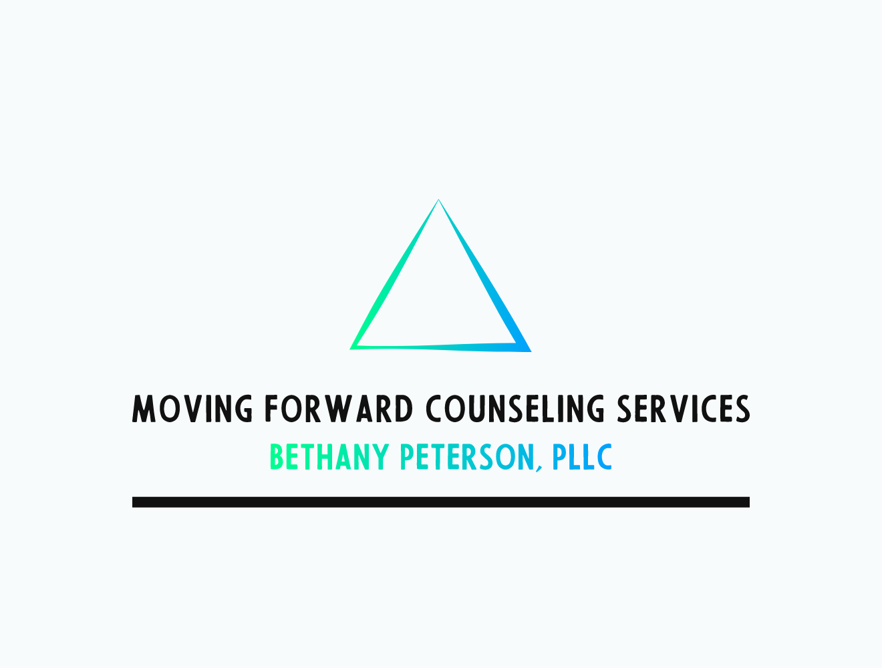

3523 45t St S, Suite 149 **Phone:** 701.289.4809

Fargo, ND 58104 **Email:** bethany@moving-forwardcs.com

**Website**:<http://moving-forwardcs.com>

**____________________________________________________________________________**

**Notice of Privacy Practice**

**THIS NOTICE DESCRIBES HOW MEDICAL INFORMATION ABOUT YOU MAY BE USED AND DISCLOSED AND HOW YOU CAN GET ACCESS TO THIS INFORMATION. PLEASE REVIEW THIS NOTICE CAREFULLY.**

Your health record contains personal information about you and your health. This information about you that may identify you and that relates to your past, present and future physical or mental health or condition and related health care services is referred to as **Protected Health Information** (“PHI”). This Notice of Privacy Practices describes how Moving Forward Counseling Services will use and disclose your protected health information in accordance with applicable law, including the **Health Insurance Portability Accountability Act** (“HIPAA”), the regulations promulgated under HIPAA including the HIPAA Privacy and Security rules and the NASW (National Association of Social Work) Code of Ethics. It also describes how you may gain access to and control your PHI.

We are required by law to maintain the privacy of PHI and to provide you with notice of our legal duties and privacy practices with respect to PHI. We are required to abide by the terms of this Notice of Privacy Practices. We reserve the right to change the terms of our Notice of Practices at any time. We will provide you with a copy of the revised Notice of Privacy Practices by posting a copy on our website, sending a copy to you in the mail upon request or providing one to you at your next appointment.

The terms of this Notice apply to all health information generated or received by Moving Forward Counseling Services whether recorded in your health record, billing invoices, paper forms, emails, or in other ways.

**North Dakota Patient Consent for Disclosures**

For most disclosures of your health information we are required by the State of North Dakota Laws to obtain a written consent from you unless the disclosure is authorized by Law. This consent may be obtained at the beginning of your treatment, during the delivery of health care services or at a later point in your care, when/if the need arises to disclose your health information to others.

**Minnesota Patient Consent for Disclosures**

For most disclosures of your health information we are required by the State of Minnesota Laws to obtain a written consent from you, unless the disclosure is authorized by Law. This consent may be obtained at the beginning of your treatment, during the delivery of health care services or at a later point in your care, when/if the need arises to disclose your health information to others.

**HOW WE MAY USE AND DISCLOSE HEALTH INFORMATION ABOUT YOU**

**For the purpose of Treatment, Payment and Health Care Operations**

Treatment: Your protected health information may be used and disclosed by those who are involved in your treatment and related services. This includes when your therapist consults with another health care provider such as your primary care provider or another therapist. We may disclose protected health information to another health care professional only with your authorization.

Payment: We may use and share your protected health information to bill and receive payment for the healthcare services you receive. This will only be done with your authorization. Examples of payment related activities include; making a determination of eligibility or coverage for insurance benefits, processing claims with your insurance company, reviewing services provided to you to determine medical necessity or undertaking utilization review activities. If you have paid for services out-of-pocket in full we will accommodate your request that the protected health information related solely to those services paid for out-of-pocket not be disclosed to a health plan for payment or health care operations. If it becomes necessary to use collection processes due to lack of payment for services, we will disclose only the minimum amount of protected health information necessary for the purpose of collection.

For Health Care Operations: We may use and share your protected health information as needed in order to support our business activities including, but not limited to, quality assessment activities, employee review activities, licensing and conducting or arranging for other business activities. For example we may share your protected health information with third parties that perform various business activities (i.e. billing services) provided we have a written contract with the business that requires it to safeguard the privacy of your protected health information. For training or teaching purposes protected health information will be disclosed only with your authorization.

**Uses and Disclosures Requiring Your Authorization**

In addition to our use of your health information for treatment, payment or health care operations, you may give us written authorization to use your health information or to disclose it to anyone for any purpose. If you give authorization for release of information you may revoke it in writing at any time. Your revocation will not affect any use or discloses permitted by your authorization while it was in effect. Unless you give us written authorization we cannot use or disclose your protected health information for any reason except those described in this notice. Additionally, we will need to obtain a written authorization before releasing *psychotherapy notes. Psychotherapy notes* are notes your therapist made about your conversation during a private, group, joint or family therapy session, which your therapist might have kept separate from the rest of your health record. These notes are given a greater degree of protection than Protected Health information.

**LIMITS TO YOUR CONFIDENTIALITY**

The following is a list of the categories of uses and disclosures permitted by HIPAA without an authorization. Applicable law and ethical standards permit health service providers to disclose information about you without authorization only in a limited number of situations.

As a social worker licensed in both the state of North Dakota and Minnesota it is my practice to adhere to more stringent privacy requirements for disclosure without an authorization. The following language addresses these categories to the extent consistent with the NASW (National Association of Social Worker) code of Ethics and HIPAA.

**Child or Elder Abuse or Neglect:**

North Dakota and Minnesota Law **require** a health care provider to report to the correct agency if

they believe a person is neglecting or abusing a minor child.

**North Dakota Law** states a health care provider **can** report to the correct agency, if they believe a person is neglecting and/or abusing a vulnerable adult.

**Minnesota Law** states a health care provider is **required** to report to the correct agency, if they believe a person is neglecting and/or abusing a vulnerable adult.

A health care provider may take actions to begin involuntary treatment for the protection of a person whose condition creates a serious risk of harm to that person, others or property. This may involve the disclosure of information to others involved in the process such as;

* Law enforcement
* The courts
* Other people / other providers

North Dakota Law, Minnesota Law and NASW ethical standards **require** a health care provider to tell the intended victim and/or law enforcement if a person states they plan to do harm to some other person. This is done to protect the intended victim and there may be a disclosure of confidential information.

**Medical Emergencies:**

I may use or disclose your protected health information in a medical emergency situation to medical personnel only in order to prevent serious harm.

**Family Involvement in Care:**

I may disclose information to close family members or friends directly involved in your treatment, based on your consent, or as necessary to prevent serious harm.

**Lawsuits and Legal Actions:**

I may disclose your protected health information in response to a subpoena (with your written consent), court or administrative order or similar process.

**Law Enforcement:**

I may share your protected health information to law enforcement as required by law, in compliance with court subpoenas (with your written consent), court order, administrative order or similar document, for the purpose of identifying a suspect, material witness or missing person, in connection with the victim of a crime, in connection with a deceased person, in connection with reporting a crime in an emergency or in connection with a crime on the premises.

**Deceased Patients:**

I may disclose protected health information regarding deceased patients as mandated by state law, or to a family member or friend that was involved in your care or payment for care prior to death, based on your prior consent. A release of information regarding deceased patients may be limited to an executor or administrator of a deceased person’s estate or the person identified as next-of-kin. Protected health information of persons deceased for more than fifty (50) years is not protected under HIPAA.

**Health Oversight:**

If required I may disclose protected health information to a health oversight agency for activities authorized by law, such as audits, investigations and inspections. Oversight agencies seeking this information include government agencies and organizations that provide financial assistance to the program (such as third-party payor’s based on your prior consent) and peer review organizations performing utilization and quality control.

**Specialized Government Functions:**

I may review requests from U.S. military command authorities if you have served as a member of the armed forces, authorized officials for national security and intelligence reasons and to the Department of State for medical suitability determinations, and disclose your protected health information based on your written consent, mandatory disclosure laws and the need to prevent serious harm.

**Public Health:**

If required, I may disclose your protected health information for mandatory public health activities to a public health authority authorized by law to collect or receive such information for the purpose of preventing or controlling disease, injury or disability, or if directed by a public health authority, to a government agency that is collaborating with that public health authority.

**Public Safety:**

I may disclose your protected health information if necessary to prevent or lessen a serious and imminent threat to the health or safety of a person or the public. If information is disclosed to prevent or lessen a serious threat it will be disclosed to a person or persons reasonably able to prevent or lessen the threat, including the target of the threat.

**Research:**

Protected health information may only be disclosed after a special approval process or with authorization.

**Verbal Permission:**

I may also use or disclose your protected health information to family members that are directly involved in your treatment with your verbal permission.

**YOUR RIGHTS REGARDING YOUR PROTECTED HEALTH INFORMATION**

You have the following rights regarding your protected health information I maintain about you. To exercise any of these rights, please submit your request in writing to my privacy officer, Bethany Peterson, 3523 45th St S Fargo, ND 58104

**Right of Access to Inspect and Copy:**

You have the right, which may be restricted only in exceptional circumstances, to inspect and copy protected health information that is maintained in a “designated record set”. A designated record set contains mental health / medical information, billing records and any other records that are used to make decisions about your care. Your right to inspect and copy protected health information will be restricted only in those situations where there is compelling evidence that access would cause serious harm to you or if the information is contained in separately maintained psychotherapy notes. I may charge a reasonable, cost based fee for copies. If your records are maintained electronically, you may also request an electronic copy of your protected health information. You may also request that a copy of your protected health information be provided to another person.

**Right to Amend:**

If you feel that the protected health information I have about you is incorrect or incomplete, you may ask me to amend the information, although I am not required to agree to the amendment. If I deny your request for amendment, you have the right to file a statement of disagreement with me. I may prepare a rebuttal to your statement and will provide you with a copy. Please contact the privacy officer if you have any questions.

**Right to Accounting of Disclosures:**

You have the right to request an accounting of the disclosures I make about your protected health information for which you have neither provided consent nor authorization (as described above in this form). I may charge you a reasonable fee if you request more than one accounting in a 12-month period.

**Right to Request Restrictions:**

You have the right to request a restriction or limitation on the use or disclosure of your protected health information for treatment, payment or health care operations. I am not required to agree with your request unless the request is to restrict disclosure of protected health information to a health plan for purposes of carrying out payment or health care operations and the protected health information pertains to a health care item or service that you paid for out of pocket. In that case, I am required to honor your request for the restriction.

**Right to Request Confidential Communication:**

You have the right to request that I communicate with you about health matters in a certain way or at a certain location. I will accommodate reasonable requests. I may require information regarding how payment will be handled or specification of an alternative address or other method of contact as a condition of accommodating your request. I will not ask you for an explanation of why you are making the request.

**Breach Notification:**

If there is a breach of unsecured protected health information concerning you, I may be required to notify you of this breach, including what happened and what you can do to protect yourself.

**Right to a Copy of this Notice:**

You have the right to a copy of this notice.

**MY RESPONSIBILITIES REGARDING YOUR PROTECTED HEALTH INFORMATION**

I have and will uphold the following responsibilities regarding your protected health information.

* I am required by law to maintain the privacy and security of your protected health information.
* I will let you know promptly if a breach occurs that may have compromised the privacy or security of your health information.
* I must follow the duties and privacy practices described in this Notice and offer to give you a copy.
* I will not use or share your information other than as described in this Notice unless you tell me to in writing.
* You may change your mind at any time by letting me know in writing.

**YOUR CHOICES**

For certain health information, you can tell me your choices about what I share. If you have a clear preference for how I share your information in the situations described below please talk to me. Tell me what you want me to do and I will follow your instructions.

**Notification:**

I may use or disclose information to notify or assist in notifying a family member, personal representative or another person responsible for your care, your location and general condition.

**Communication with family:**

Health professionals, using their best judgment, may disclose to a family member, other relatives, close personal friend or any other person you identify, health information relevant to that person’s involvement in your care or payment related to your care.

**CHANGES TO THIS NOTICE**

I may change the terms of this Notice, and the changes will apply to all information I have about you. The new Notice will be available upon request and available on my website at:

www.moving-forwardcs.com.

**The effective date of this Notice is October 1, 2022.**