The Top 5 reasons You Need a CRM Right Now!
All businesses at some level begin with a basic supply-demand, seller-to-customer, relationship. In the beginning, it might be okay to just maximize an Excel spreadsheet or jot down notes about customers and incoming orders. But as your business grows, this sort of record-keeping simply won’t do.
It’s time to trade in those old ways and start managing your customer relationships more effectively

[Cite your source here.]
Remember to give your sales associates the advantage of a singe view of customer contact info., orders, and interactions. Gone are the days of storing your customer and order info in more than one location, such as on sticky notes or on white boards, give your sales team the benefit of doubt.
Empower your salesforce and keep them accountable.
If there’s little to no visibility when it comes to knowing exactly what your customers are doing and who they are interacting with, you as a business owner could be lacking visibility into how your customers are connecting with your employees. Along with missing key insights into what your salespeople are up to.
Find Reports Can Be Hard to Share
Being able to discover, interpret, and communicate all your sales team’s monthly improvements statistics against their monthly quota; now that would be ideal. But find creating reports manually is cumbersome and often results in no tracking at all.
Not Having a Mobile Solution Can Have Devastating Outcomes Now a Days.
With your sales force out in the field, doing what they do best, meeting prospects and discovering valuable leads. They are generating tons of new and valuable data. But all this new info gets stored in multiple locations and in various formats. Great meetings can happen anywhere, but the sales teams don’t always transfer their notes and important details can get lost. Not to mention what happens when an employee leaves the company.

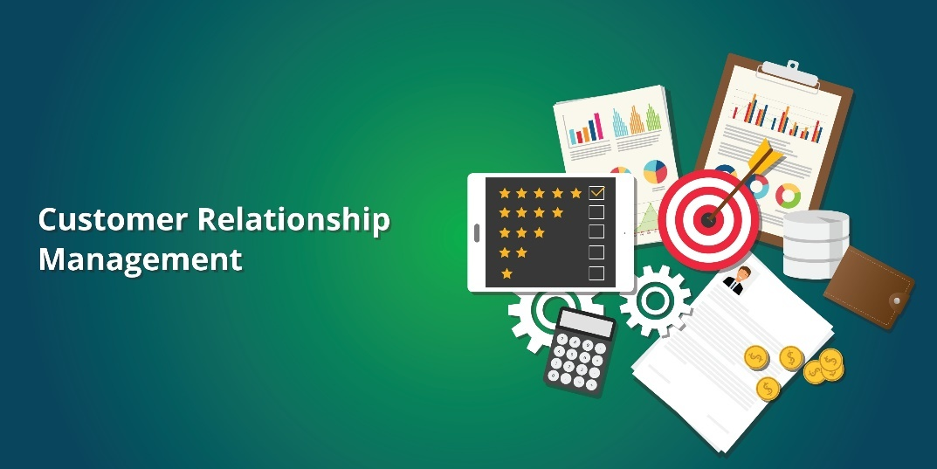
So, Resell and Upsell Solutions Can Be Lost at Every Turn
Make sure you are targeting prospects based on their value to the business. Stop sending the same types of offers and messages across the board – to customers and prospects in very different stages of the buying process, as well as in different industries and/or geographies.
And you might be lacking a plan or even the slightest idea of how to scale fast
What if your business is growing by leaps and bounds? Great, but will your current processes grow to scale? Are you concerned about keeping up productivity while scaling up? If any of these apply to you or your team, no worries, these are exactly the issues that your CRM system can solve for you.

Want to learn more about how these solutions free your business from itself? Get in contact with MyOps by following this LINK.

