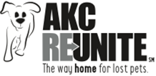 | AKC Reunite  Adopt a K-9 Cop  Matching Grant  Guidelines and Application  2024 | 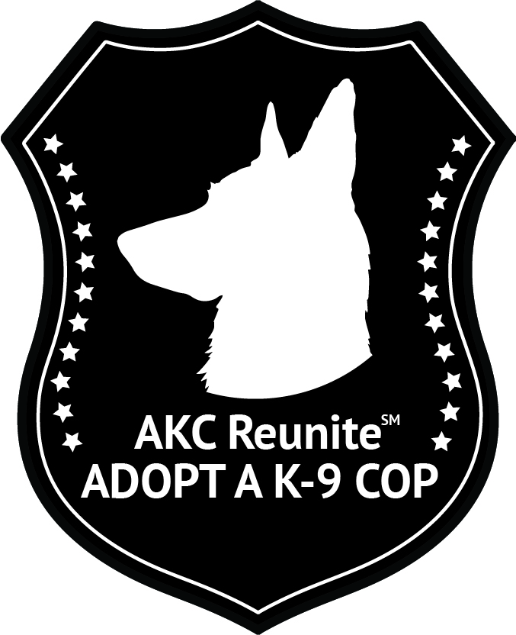

AKC Reunite Adopt a k-9 COP Matching Grant Program

AKC Reunite is working with AKC Clubs to donate K-9 police dogs to police departments around the United States. Many police department K-9 units are suffering budget cuts and they are unable to solicit money due to town and municipality codes. The donations from AKC Reunite and AKC Clubs allow the police department’s need for a new K-9 to become a reality. AKC Reunite will match the funds raised by AKC Clubs three to one, not exceeding $7,500. A maximum of one grant per department and a total of 200 grants will be awarded in 2024.

APPLICATION OVERVIEW:

• Applicant must be a qualified Police Department
• Applicant must work with an American Kennel Club (“AKC”) member or licensed club(s) to raise funds for the K-9.
• Applicant must agree to display the AKC Reunite logo on the K9 unit vehicle(s).
- Applicant must not have previously been awarded a grant through AKC Reunite in the same year.
• AKC Reunite’s contribution shall not exceed the lesser of 75% of the total cost or $7,500.

APPLICATION INSTRUCTIONS:

• Applications must be in writing on the designated form or in the approximate format provided. Do not remove or omit any of the application’s questions. If a question is not applicable to your organization, please answer with N/A.
• To apply, submit the following application in a hard-copy format (Sections A, B, C D and E) Emailed versions are acceptable in portable document format (PDF) form only. Do not fax the grant application.
• Retain one copy of the application for your records. Multiple copies, videotapes or other attachments will not be accepted.
• Do not bind the application with staples or folders or put into binders, as we must be able to separate and copy the application. Paper clips and binder clips are permitted.
• You will be contacted by telephone or email if there are any discrepancies or concerns regarding the application.
- Applicants will receive a Grant Follow Up email from AKC REUNITE annually.

Applications can be sent to:
Megan Trierweiler – Programs Manager
AKC Reunite
8051 Arco Corporate Drive, Suite 200
Raleigh, NC 27617
relief@akcreunite.org phone: 919-816-3980 fax: 919-816-3828

AKC Reunite
Adopt a K-9 Cop
Matching Grant
Guidelines and Application

Please type or print clearly. Please complete all sections. If a section is not applicable to your organization, answer with N/A.

Section A: GENERAL INFORMATION

1. Date of Application: ___________________

2. Department Name: ___________________________________________________

3. Mailing Address: ______________________________________________________

______________________________________________________

Web Site: _____________________________

Email:_________________________________ Phone Number: _________________________

4. Department Leader: __________________________________

Title: ________________________________________________

Email:_________________________________ Phone Number: _________________________

5. Primary Grant Application Contact Person (if other than above):

Name: _____________________________ Title: ___________________________________

Mailing Address:
______________________________________________________

______________________________________________________

Email:_________________________________ Phone Number: _________________________

6. Federal Tax ID# (EIN): _____________________________________

7. Tax-exempt status: _____________________________________

8. Has your department received any previous support from The American Kennel Club or AKC Reunite? List the specific year(s) and please explain.

9. Territory or area served: _________________________________________________________

Section B: SPONSORING CLUB INFORMATION

1. Sponsoring AKC Club(s):

______________________________________________________

______________________________________________________

2. Primary Club Grant Contact:

___________________________________________________________
Mailing Address:
______________________________________________________

______________________________________________________

Email:_________________________________ Phone Number: _________________________

Section C: K-9 PROGRAM DESCRIPTION

1. Please describe the department’s K-9 Officer program:

2. What is your target price for a K-9?

Section D: CERTIFICATION

All of the statements I have made in this application are true and accurate.

Signature: __________________________________

Name: _____________________________________

Title: ____________________________________

Organization: ________________________________________________

Date: ___________________

Section E: ATTACHMENTS AND AGREEMENTS

Please include the following documentation/confirmation with your application:

€ Completed W-9

€ Proof of 501(c)(3) status, if applicable.

€ Agreement to display the AKC Reunite logo on the K9 unit vehicle(s).

€ Agreement to notify AKC Reunite once K-9 is purchased.

